**Exercise 1: Setting Up JUnit**

**Code:**

**CalulatorTest.java**

import org.junit.jupiter.api.Test;  
  
import static org.junit.jupiter.api.Assertions.*;  
  
class CalculatorTest {  
  
 public int add(int a, int b) {  
 return a + b;  
 }  
  
 @Test  
 public void testAddition() {  
 CalculatorTest calc = new CalculatorTest();  
 int result = calc.add(5,3);  
 *assertEquals*(8, result);  
 }  
  
}

**pom.xml**

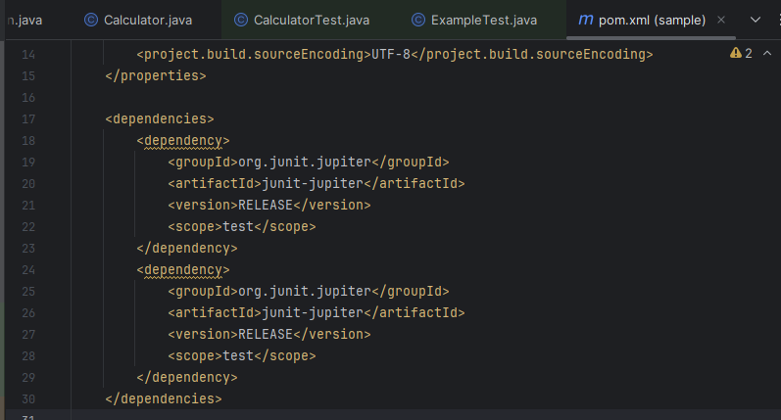

**Output:**

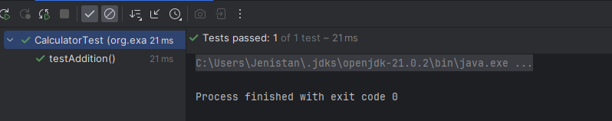

**Exercise 3: Assertions in JUnit**

**Code:**

package org.example;  
import org.junit.jupiter.api.Test;  
import static org.junit.Assert.*;

public class AssertionsTset {  
 @Test  
 public void testAssertions() {  
 // Assert that two values are equal  
 *assertEquals*("Sum should be 5", 5, 2 + 3);  
  
 // Assert that a condition is true  
 *assertTrue*("5 is greater than 3", 5 > 3);  
  
 // Assert that a condition is false  
 *assertFalse*("5 is not less than 3", 5 < 3);  
  
 // Assert that an object is null  
 *assertNull*("This should be null", null);  
  
 // Assert that an object is not null  
 *assertNotNull*("This should not be null", new Object());  
 }  
}

**Output:**

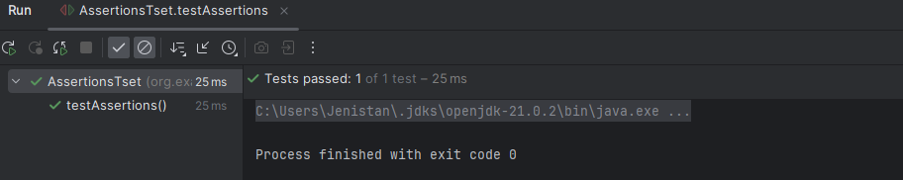

**Exercise 4: Arrange-Act-Assert (AAA) Pattern, Test Fixtures, Setup and**

**Teardown Methods in JUnit**

**Code:**

**Calculator.java**

package org.example;  
  
public class Calculator {  
 public int add(int a, int b) {  
 return a + b;  
 }  
  
 public int multiply(int a, int b) {  
 return a * b;  
 }  
}

**CalculatorTest.java**

package org.example;  
  
import org.junit.Before;  
import org.junit.After;  
import org.junit.Test;  
import static org.junit.Assert.*;  
  
public class CalculatorTest {  
  
 private Calculator calculator;  
  
 @Before // Setup: runs before each test  
 public void setUp() {  
 calculator = new Calculator();  
 System.*out*.println("Setup completed");  
 }  
  
 @After // Teardown: runs after each test  
 public void tearDown() {  
 calculator = null;  
 System.*out*.println("Teardown completed");  
 }  
  
 @Test  
 public void testAddition() {  
 // Arrange  
 int a = 5;  
 int b = 3;  
 // Act  
 int result = calculator.add(a, b);  
 // Assert  
 *assertEquals*("5 + 3 should be 8", 8, result);  
 }  
  
 @Test  
 public void testMultiplication() {  
 // Arrange  
 int a = 4;  
 int b = 6;  
 // Act  
 int result = calculator.multiply(a, b);  
 // Assert  
 *assertEquals*("4 * 6 should be 24", 24, result);  
 }  
}

**Output:**

