**Exercise 1: Control Structures**

**Scenario 1:** The bank wants to apply a discount to loan interest rates for customers above 60 years old.

**Code:**

DECLARE

    CURSOR cur_senior IS

        SELECT customerid

        FROM   CUSTOMERS

        WHERE  TRUNC(MONTHS_BETWEEN(SYSDATE, dob)/12) > 60;

BEGIN

    FOR c IN cur_senior LOOP

        UPDATE LOANS

        SET    interestrate = interestrate - 1      --1% discount

        WHERE  customerid = c.customerid;

    END LOOP;

    COMMIT;

END;

/

**Output:**

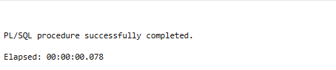

**Scenario 2:** A customer can be promoted to VIP status based on their balance.

**Code:**

first **add it**:

ALTER TABLE Customers ADD IsVIP CHAR(1);

DECLARE

    CURSOR cur_highbal IS

        SELECT customerid

        FROM   customers

        WHERE  balance > 10000;

BEGIN

    FOR c IN cur_highbal LOOP

        UPDATE customers

        SET    isvip = 'Y'

        WHERE  customerid = c.customerid;

    END LOOP;

    COMMIT;

END;

**Output:**

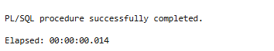

**Scenario 3:** The bank wants to send reminders to customers whose loans are due within the next 30 days.

**Code:**

DECLARE

    CURSOR cur_due IS

        SELECT loanid,

               customerid,

               enddate

        FROM   Loans

        WHERE  enddate BETWEEN TRUNC(SYSDATE)

                              AND TRUNC(SYSDATE) + 30;

    v_name  customers.name%TYPE;

BEGIN

    FOR r IN cur_due LOOP

        SELECT name

        INTO   v_name

        FROM   customers

        WHERE  customerid = r.customerid;

        DBMS_OUTPUT.PUT_LINE(

           'Reminder → ' || v_name || ': Loan ' || r.loanid ||

           ' is due on ' || TO_CHAR(r.enddate,'DD-Mon-YYYY'));

    END LOOP;

END;

**Output:**



**Exercise 3: Stored Procedures**

**Scenario 1:** The bank needs to process monthly interest for all savings accounts.

**Code:**

CREATE OR REPLACE PROCEDURE ProcessMonthlyInterest

IS

    l_rows_updated INTEGER;

BEGIN

    UPDATE accounts

       SET balance = balance * 1.01

     WHERE UPPER(accounttype) = 'SAVINGS'

     RETURNING COUNT(*) INTO l_rows_updated;

    COMMIT;

    DBMS_OUTPUT.PUT_LINE(l_rows_updated || ' savings accounts updated with 1% interest.');

EXCEPTION

    WHEN OTHERS THEN

        ROLLBACK;

        RAISE;

END ProcessMonthlyInterest;

/

EXECUTE ProcessMonthlyInterest

**Output:**

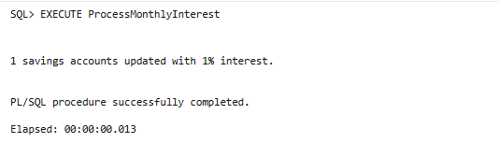

**Scenario 2:** The bank wants to implement a bonus scheme for employees based on their performance.

**Code:**

CREATE OR REPLACE PROCEDURE UpdateEmployeeBonus

(

    p_department IN employees.department%TYPE,

    p_bonus_pct     IN NUMBER

)

IS

    l_rows_updated INTEGER;

BEGIN

    UPDATE employees

       SET salary = salary * (1 + p_bonus_pct/100)

     WHERE department = p_department

     RETURNING COUNT(*) INTO l_rows_updated;

    COMMIT;

    DBMS_OUTPUT.PUT_LINE(

        l_rows_updated || ' employee(s) received a ' ||

        p_bonus_pct    || '% bonus in department ' || p_department

    );

EXCEPTION

    WHEN OTHERS THEN

        ROLLBACK;

        RAISE;

END UpdateEmployeeBonus;

/

EXECUTE UpdateEmployeeBonus('IT', 10);

**Output:**

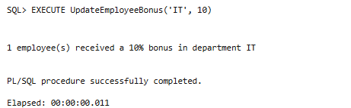

**Scenario 3:** Customers should be able to transfer funds between their accounts.

**Code:**

CREATE OR REPLACE PROCEDURE TransferFunds

(

    p_from_acct  IN accounts.accountid%TYPE,

    p_to_acct    IN accounts.accountid%TYPE,

    p_amount     IN NUMBER

)

IS

    e_insufficient_funds EXCEPTION;

    l_from_balance       accounts.balance%TYPE;

BEGIN

    IF p_amount <= 0 THEN

        RAISE_APPLICATION_ERROR( -20001,'Transfer amount must be positive.');

    END IF;

    -- Lock the source row first to prevent race conditions

    SELECT balance

      INTO l_from_balance

      FROM accounts

     WHERE accountid = p_from_acct

       FOR UPDATE;

    IF l_from_balance < p_amount THEN

        RAISE e_insufficient_funds;

    END IF;

    UPDATE accounts

       SET balance = balance - p_amount

     WHERE accountid = p_from_acct;

    UPDATE accounts

       SET balance = balance + p_amount

     WHERE accountid = p_to_acct;

    COMMIT;

    DBMS_OUTPUT.PUT_LINE(

        '₹' || p_amount || ' transferred from account id:(' || p_from_acct ||

        ') to account id(' || p_to_acct ||')'

    );

EXCEPTION

    WHEN e_insufficient_funds THEN

        ROLLBACK;

        RAISE_APPLICATION_ERROR(-20001, 'Your error message here');

    WHEN NO_DATA_FOUND THEN

        ROLLBACK;

        RAISE_APPLICATION_ERROR(-20003, 'One or both account IDs not found.');

    WHEN OTHERS THEN

        ROLLBACK;

        RAISE;

END TransferFunds;

/

EXECUTE TransferFunds(1,2,500);

**Output:**

