**Issue Documentation: NFID Not Reflected in Status Field on Project Summary**

**JIRA Ticket**

<https://onejira.verizon.com/browse/PEDS-771>

**Issue Summary**

The ‘status’ field in the **Project Summary** is not being updated correctly for the given **NFID**.

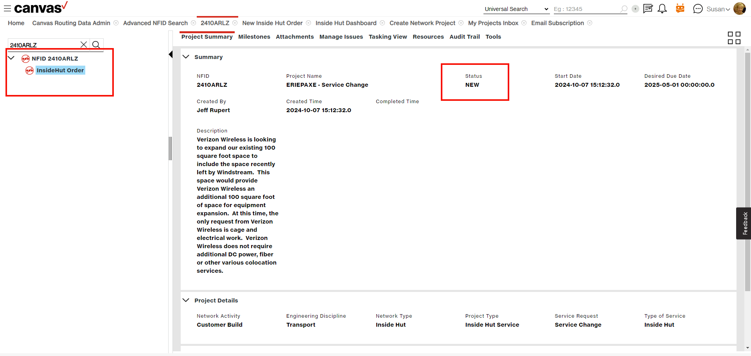

Canvas -> NF Tree -> Change status -> Tools tab

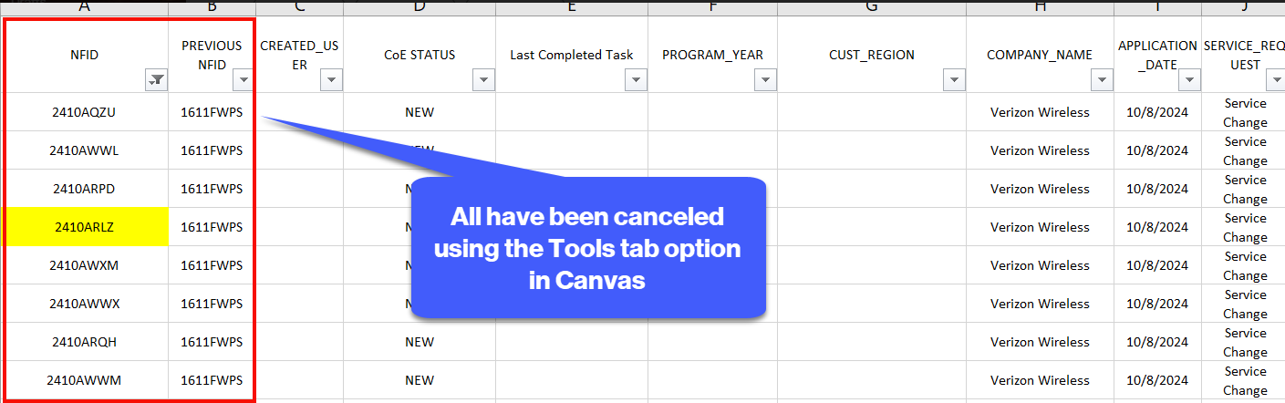

**Root Cause Analysis**

*Understand the Expected behavior*

* The cancellation is correctly reflected in the **NF tree**, but not in the **status field** on the **project Summary**

*Identify the Data Flow*

* Check whether the NF tree and project summary get data from the same source or different ones
* Finally find out **inside-hut service** only way to update NFTree and DB   
  API call “/updateNftreeNodeStatus”

*Debugging With Data Flow*

* This is the query to get status of an NFID to display in project summary section. The issue here is when an NFID is cancelled, this might not have been updated due to which it still says 'NEW'.
* *select o.* , pd.* from wfm_nf.nf_ihut_order o left outer join wfm_nf.nf_ihut_order_process_data pd on o.ihut_order_id = pd.ihut_order_id where nfid = '24***RLZ';*
* check prod team still is happening or not, then confirmed the issue still exists in prod. This needs to be debugged from API that we call when we cancel an NFID..

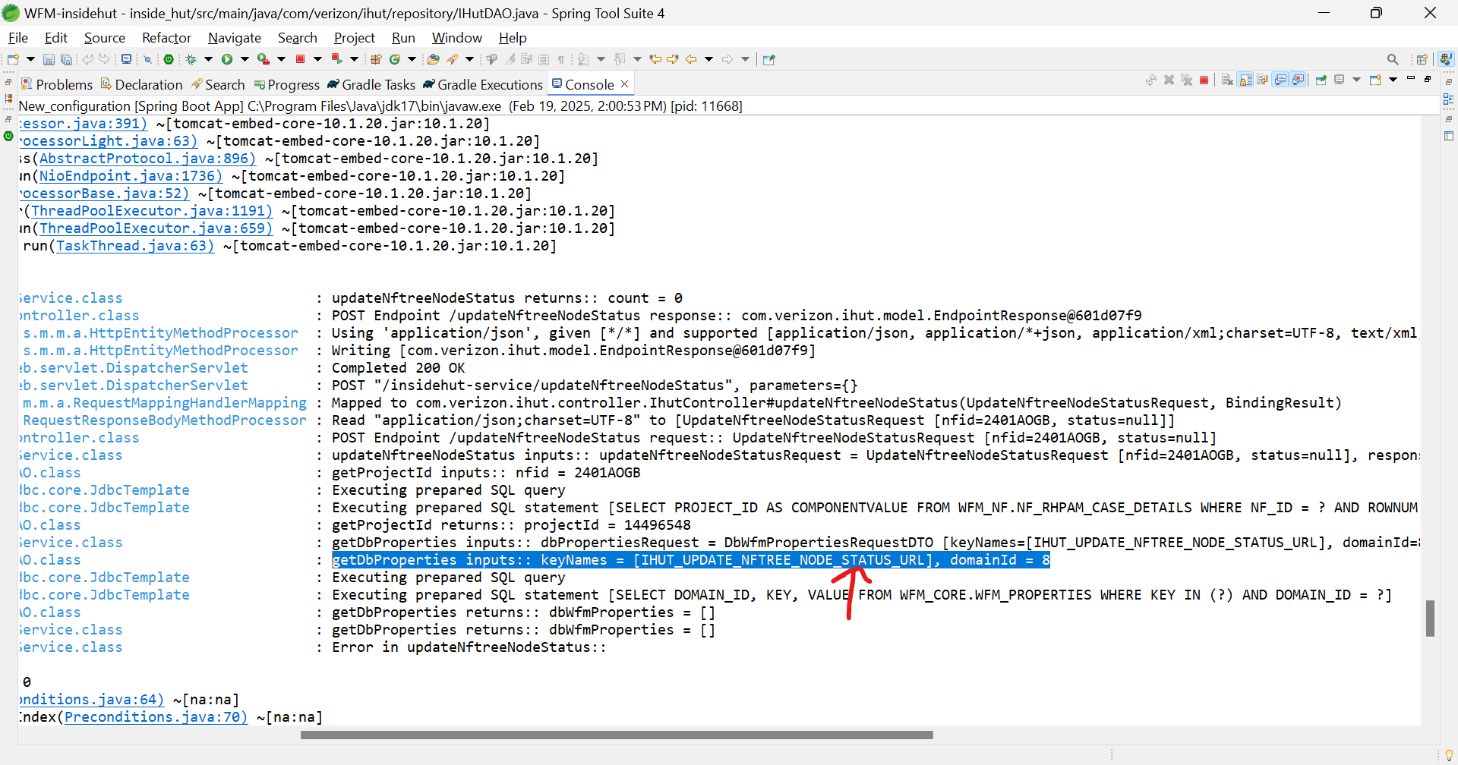

**dbWfmProperties** returns null data what’s why it can’t go through data flow

then check in DB Domain_id and key data is missing, we gave one insert query to T2 team

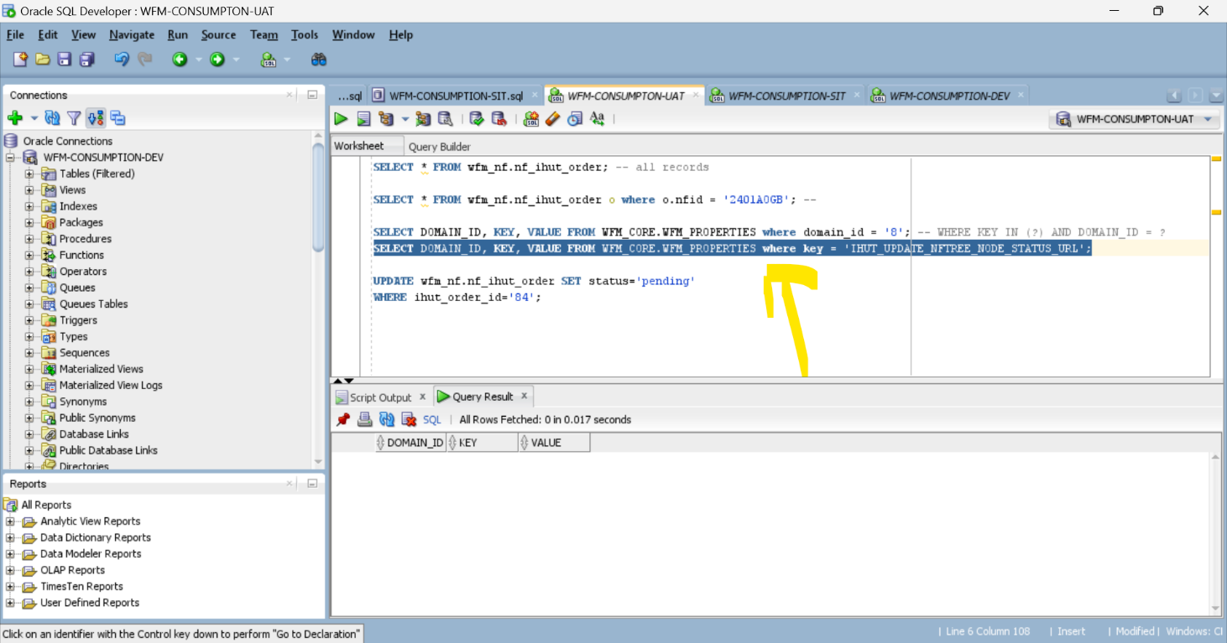

The query is failing because there are no relevant records in the **WFM_CORE.WFM_PROPERTIES** table.

Since the required configuration values are missing, the system is unable to fetch the necessary data for updating the **status**.

**Summary of Execution Flow**

|  |  |  |
| --- | --- | --- |
| Step | Layer | Operation |
| 1 | Client | Sends **POST** request with nfid and status |
| 2 | Controller | Validates request and calls Service layer |
| 3 | Service layer | Fetches projectId for nfid |
| 4 | Service layer | Fetches external API URL from WFM_PROPERIES table |
| 5 | Service layer | Calls external API ( updateComponentStatus ) |
| 6 | Service layer | If API is successful, updates STATUS field in DB |
| 7 | DAO layer | Runs SQL UPDATE query on WFM_NF.NF_IHUT_ORDER |
| 8 | Service layer | Returns update result to Controller |
| 9 | Controller | Sends response back to the client |

**Actions Taken**

1. DB Investigation:

- Checked the WFM_PROPERTIES table and confirmed that the expected records are missing.

2. DB Team Notified:

- The DB team has been informed to insert the required records into the WFM_PROPERTIES table.

- DB team to insert required values in the WFM_PROPERTIES table.

- Retest the functionality after the DB update.

- Monitor logs and confirm if the NFID status is being correctly reflected or not

3. Scheduled a call:

- Shaik Salma schedule a call with Mohan, Jeevitha then they confirmed this comes as an enhancement as **inside hut** was a legacy application and this was **integrated into consumption** services 6-8 months ago as confirmed by Jeevitha, when this was done, **parts of cancellation functionality** might have gone missing.

This issue exists in SIT, UAT and prod.

To update the component status of a cancelled NFID, we are supposed to call "/**updateNftreeNodeStatus**" API

->>>>>>> This is the only API where we update the status of an NFID via code. <<<<<-

Two solutions proposed.

1) Add a cancel button on UI and invoke the above URL for cancellation

2) If cancellation has to be done only via Tools section, then invoke the URL again at PAM level so we have the cancellation working.

Business needs to confirm on this. Once confirmed, we can attach the story created for this functionality in NTSCR dashboard and mention that over here before closing this story.