Onderzoek Agile Methoden

Mike van den Hoef

Fontys ICT

Inhoud

What is agile development? 2

What Is something else than agile? 3

**Which methods are most popular?** 4

Welke agile methodes zijn er? 4

Scrum 4

Lean 4

Kanban 4

Which are most popular? 5

**What are the difference between Scrum and other methods?** 6

Scrum 6

Lean 6

Kaban 6

Which agile management tool do we use? 7

**Sources** 8

# What is agile development?

Agile development is away of managing project progress. This way of managing helps teams deliver deliverables to their customers more frequently. This contrasts with the traditional "all at once" way. Agile teams deliver in smaller, but working pieces, so the customer is informed of progress every time. Requirements, plans and deliverables are reviewed at each delivery so that the team can properly tune to changes.

# What Is something else than agile?

People used to use waterfall for software development. We are told this constantly on Fontys.

But waterfall has a lot of flaws. Such as lack of communication within teams.

And the problem where projects can take years without ever having a working product.

Agile methods solve these issues by having lots more communication within teams trough meetings. And by splitting work up in periods, and starting with a MVP and just adding more stuff trough time.

# **Which methods are most popular?**

## Welke agile methodes zijn er?

During the start of agile methods, there were several 'lightweight' agile development processes. Since then, many methods have emerged and evolved into groups of agile methods. The best-known names are, Scrum, Kanban, Lean, XP, etc.

## Scrum

Scrum gets its name from the 'rugby scrum'. Scrum has small sprints that focus on delivering software and backlog. At each sprint, the product owner will set his priorities again.

## Lean

Leans originated from the industrial manufacturing side in the 1970s, but was applied to software development, aka Lean software development, by Mary and Tom Poppendieck in 2003.

## Kanban

Kanban is an adaptation of Lean development, but further elaborated by David Anderson in 2010. It is often a visual or physical board representing current problems (looks a lot like a Trello board, for example).

## Which are most popular?

A survey of 300 companies in 2020 came to the following conclusion:

Scrum is by far the most widely used agile method, followed by Kaban and Lean.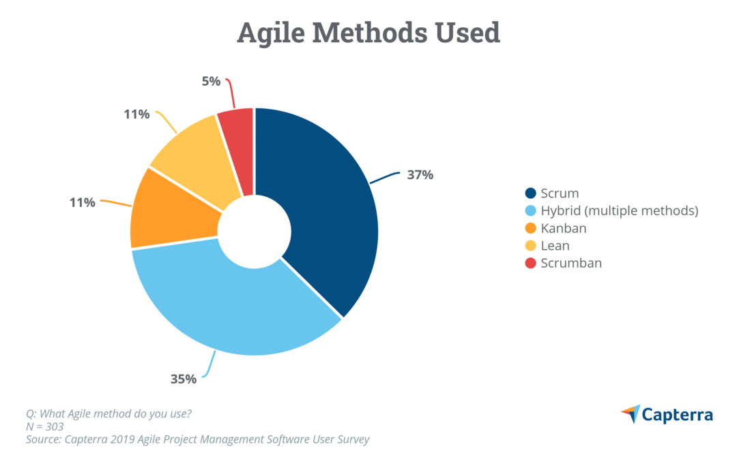

# **What are the difference between Scrum and other methods?**

## Scrum

Scrum is a framework for applying Agile, where you split a larger project into smaller sprints of about 1 to 4 weeks and work in team of about 3 to 9 people.

The point of Scrum is to downscale and do the production process over and over again. You plan, test and reflect a few times with your customer, rather than all at once.

This creates a feedback loop that guides you to the right path.

## Lean

Lean is not a framework, but more of a mindset. It provides guiding principles, but it cannot be compared to a framework. The main principle of lean is to reduce wasted time by continuously improving your process.

## Kaban

Kaban is mainly about visualising your work and limiting the number of processes going on in a moment. The aim is to complete the project faster. It is achieved through a kanban board and continuously improving the workflow.

## Which agile management tool do we use?

* We need a tool that works with scrum principles and is free for us as students.
* A tool that supports agile methods as a burnout chart or velocity trend.
* And the tool needs to be accepted for use by professionals in software development.

Members of our group have used with Azure before, which is a tool accepted by professionals, free and works with scrum principles. So we decided to use Azure for our group project.

# **Sources**

*History: The Agile Manifesto*. (2001). Agile Manifesto. <https://agilemanifesto.org/history.html>

*The Top 7 Popular Agile Development Approaches*. (2022). Agile Methods. <https://www.visual-paradigm.com/scrum/the-top-7-popular-agile-development-approaches/>

O’Loughlin, E. (2020, February 5). *Agile Project Management Software User Report: 2020*. Capterra. <https://blog.capterra.com/agile-project-management-software-user-report/>

Atlassian. (2022). *What is Scrum?*

<https://www.atlassian.com/agile/scrum>

Wikipedia-bijdragers. (2022, February 11). *Scrum (projectmanagementmethode)*. Wikipedia.

<https://nl.wikipedia.org/wiki/Scrum_(projectmanagementmethode)>

All of us at monday.com. (2022, February 1). *Lean vs Scrum comparison [2022]*. Monday.Com Blog. <https://monday.com/blog/project-management/lean-vs-scrum/>