**RESULTS**

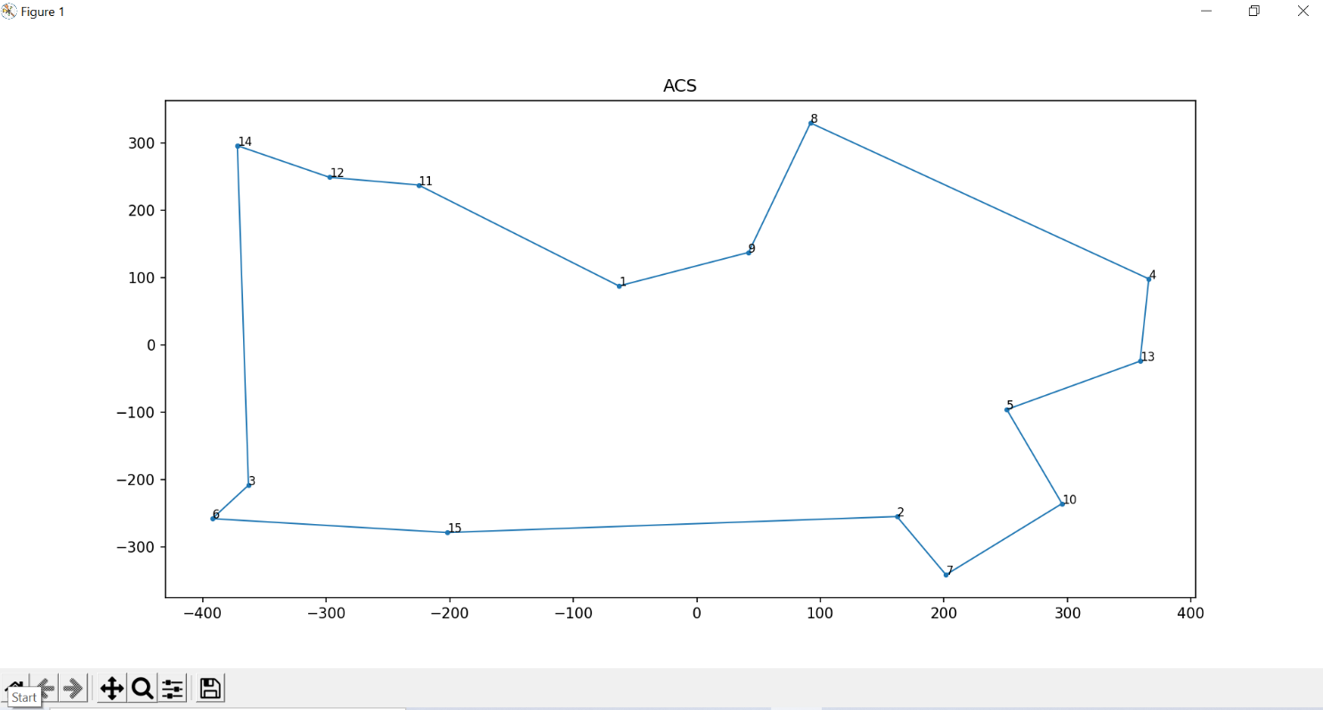

Figure 1 : ACS

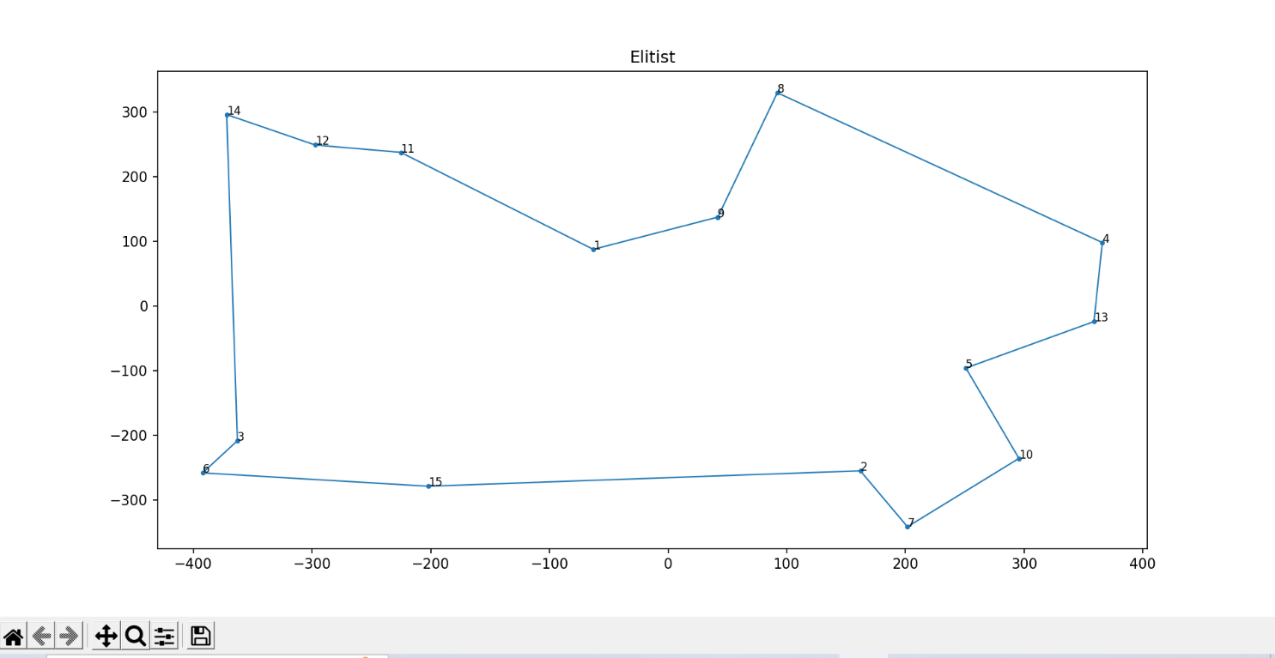

Figure 2 : Elitist

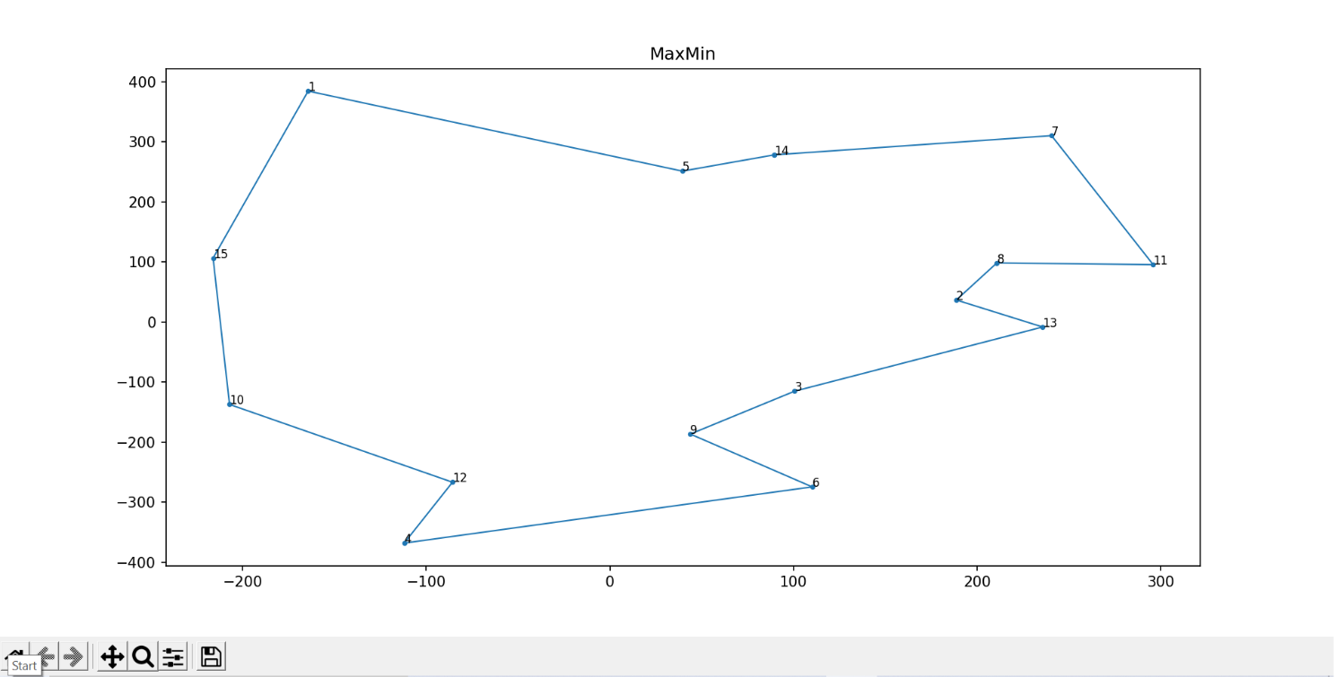

Figure 3 : MaxMin

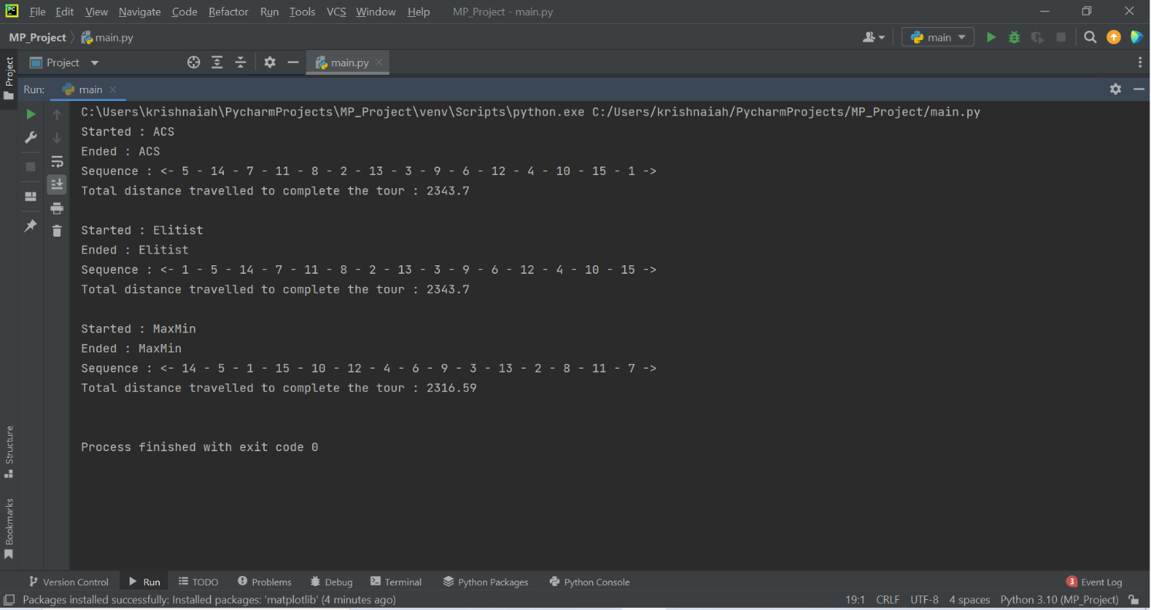

Figure 4 : Output