**NAME:L.Indra Venkata surya teja**

**BATCH:AI-B07**

**ROLL NO:2403A52185**

**TASK 1:**

**PROMPT:**

**generate a python code for a factorial of a number using recursion but give me a syntax error.**

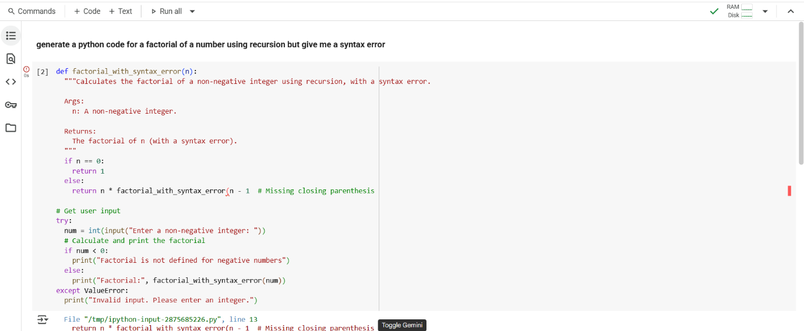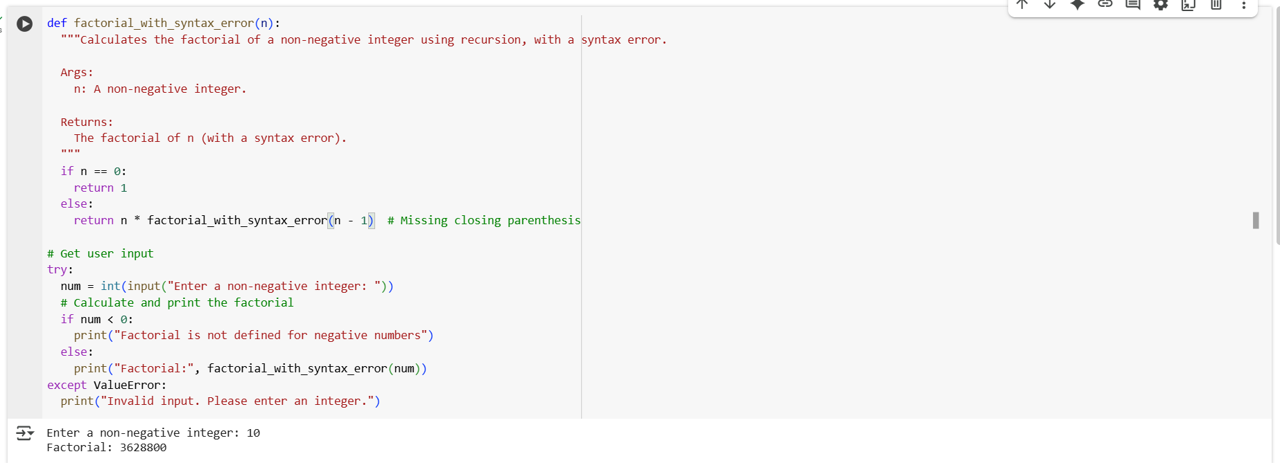

**TASK 2 :**

**PROMPT:**

**generate a Python code to sort the list [3, "10", 5, "2", 8]. The current version fails with a TypeError because of mixed integers and strings. Detect the issue and fix it so the list sorts consistently.**

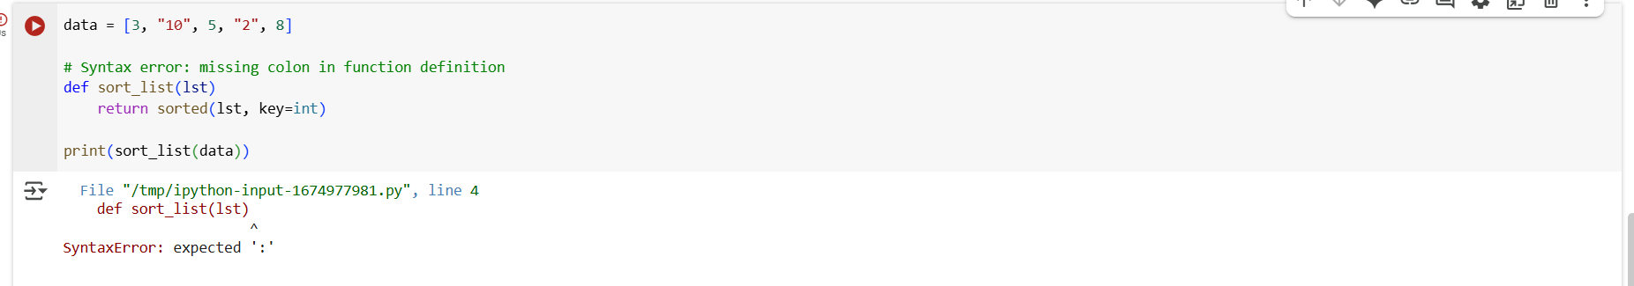

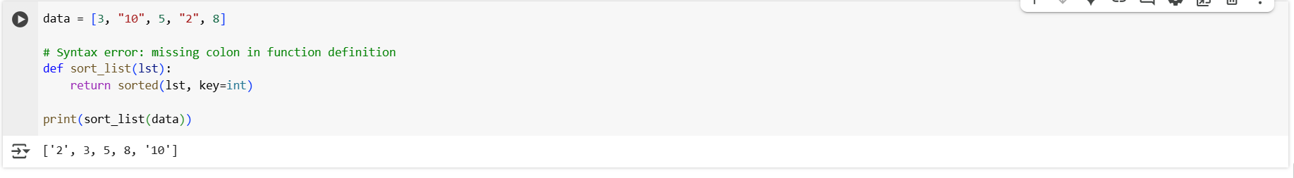

**TASK 3:**

**PROMPT:**

**generate a Python snippet that opens a file for reading but forgets to close it. Then, improve the code using best practices for file handling (like using a with open() block).**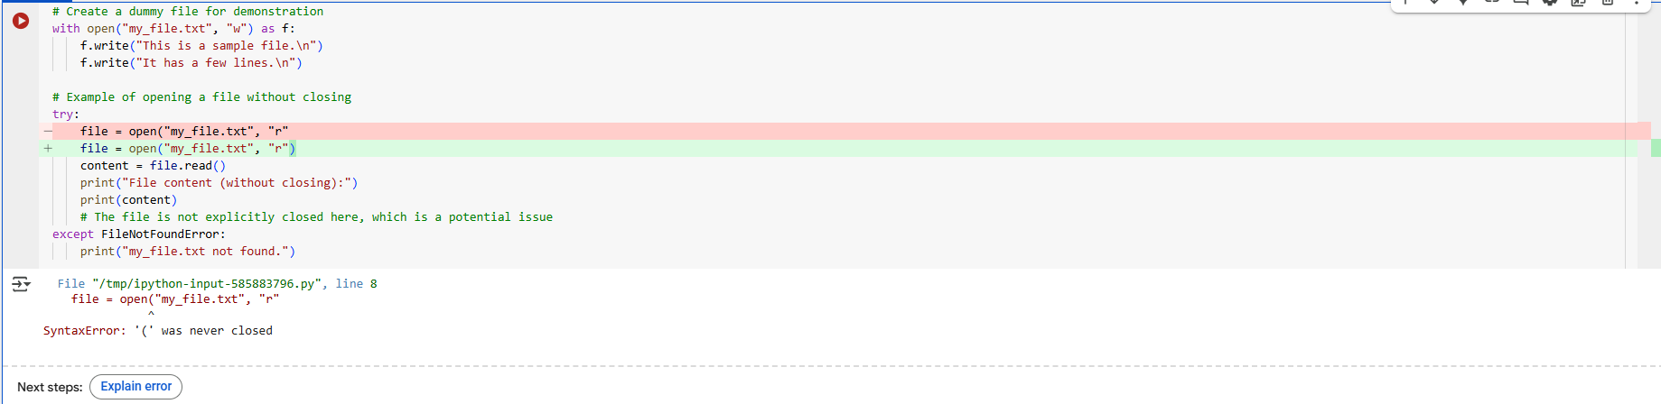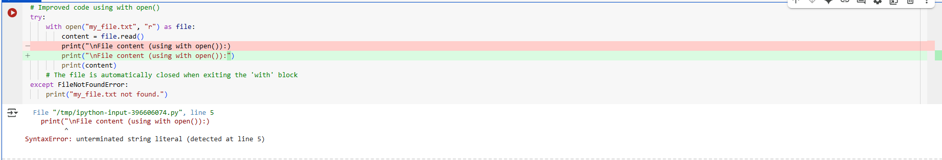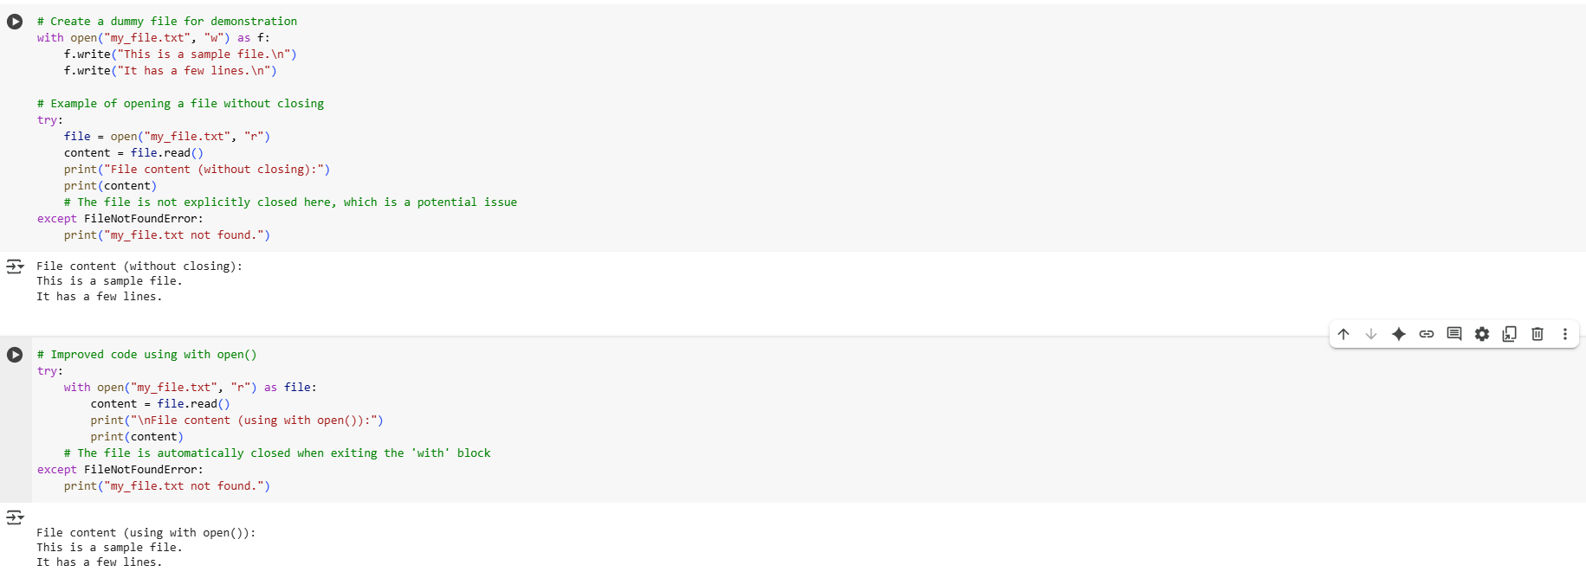

**TASK 4:**

**PROMPT:**

**generate a Python snippet with a loop that causes a ZeroDivisionError (e.g., dividing numbers in a list). Then, improve it by adding try-except so the loop continues execution safely without crashing**

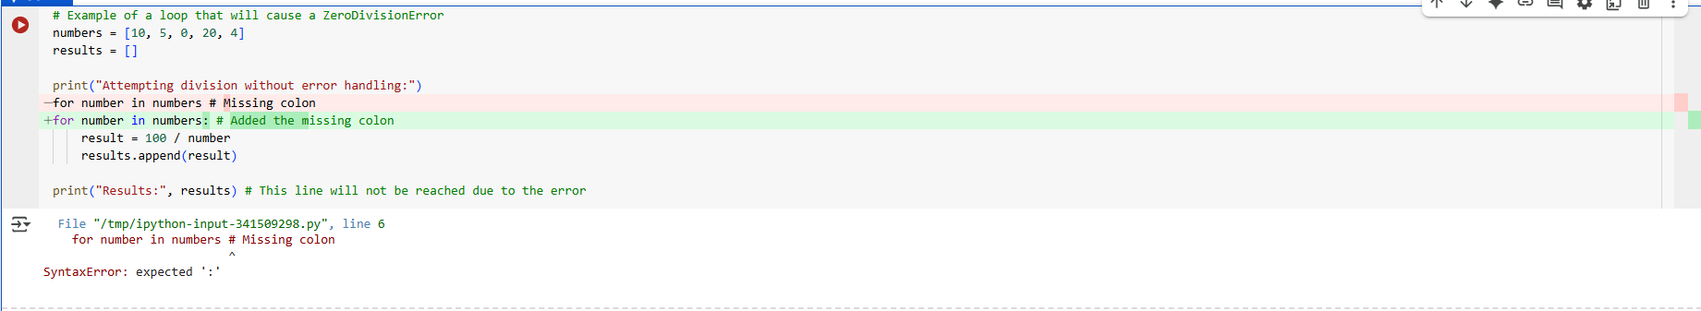

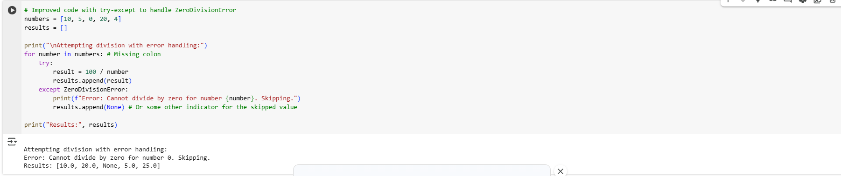

**TASK 5:**

**PROMPT:**

**generate a Python class definition that contains a bug in its __init__ method, such as mismatched parameters or incorrect attribute references. Then, analyze the issue and rewrite the class with a corrected constructor and proper attribute usage.**

