**Challenge1**

**Index.html**

<!DOCTYPE html>

<html lang="en">

<head>

    <meta charset="UTF-8">

    <meta http-equiv="X-UA-Compatible" content="IE=edge">

    <meta name="viewport" content="width=device-width, initial-scale=1.0">

    <title>Arrays</title>

</head>

<body>

    <script src="challenge1.js"></script>

</body>

</html>

**Challenge1.js**

const myArray=[true,null];

myArray.unshift("Hello");

myArray.unshift(100);

console.log(myArray);

**Result**

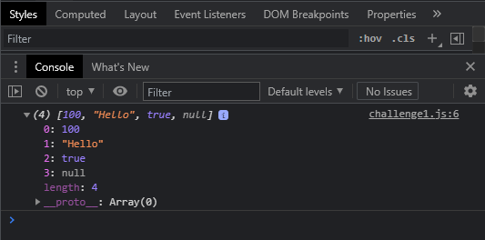

**Challenge2**

**Index.html**

<!DOCTYPE html>

<html lang="en">

<head>

    <meta charset="UTF-8">

    <meta http-equiv="X-UA-Compatible" content="IE=edge">

    <meta name="viewport" content="width=device-width, initial-scale=1.0">

    <title>Arrays</title>

</head>

<body>

    <script src="challenge2.js"></script>

</body>

</html>

**Challenge2.js**

const myArray=[1,2];

myArray[10]="abc";

console.log(myArray);//[1, 2, empty × 8, "abc"]

// length: 11

**Result**

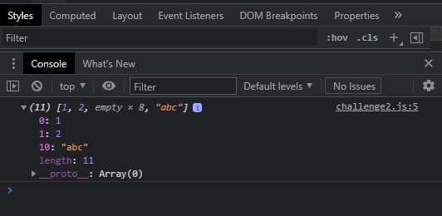

**Challenge3**

**Index.html**

<!DOCTYPE html>

<html lang="en">

<head>

    <meta charset="UTF-8">

    <meta http-equiv="X-UA-Compatible" content="IE=edge">

    <meta name="viewport" content="width=device-width, initial-scale=1.0">

    <title>Arrays</title>

</head>

<body>

    <script src="challenge3.js"></script>

</body>

</html>

**Challenge3.js**

const carArray=[

    {

        name:"Hyundai",

        price:1400000

    },

    {

        name: "Suzuki",

        price:1200000

    },

    {

        name: "KIA",

        price:1400000

    }

];

console.log(carArray);

carArray.push({

    name:"Lamborgini",

    price: 40000000

});

console.log(carArray);

**Result**

