**Challenge1**

**Index.html**

<!DOCTYPE html>

<html lang="en">

<head>

    <meta charset="UTF-8">

    <meta http-equiv="X-UA-Compatible" content="IE=edge">

    <meta name="viewport" content="width=device-width, initial-scale=1.0">

    <title>JavaScriptBasics-Objects</title>

</head>

<body>

    <script src="challenge1.js"></script>

</body>

</html>

**Challenge1.js**

var myPost={};

console.log(myPost);

myPost.postTitle="Object is reference type";

console.log(myPost);

myPost.postLikes=0;

console.log(myPost);

myPost.shared=false;

console.log(myPost);

myPost.postLikes=myPost.postLikes+1;

console.log(myPost);

delete myPost.shared

console.log(myPost);

**result**

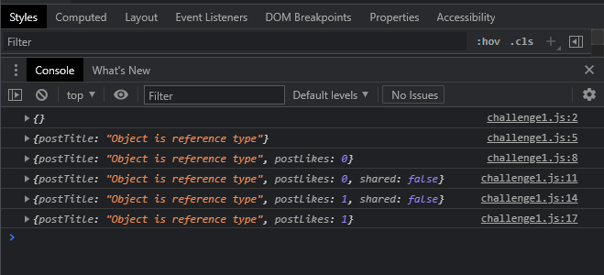

**Challenge2**

**Index.html**

<!DOCTYPE html>

<html lang="en">

<head>

    <meta charset="UTF-8">

    <meta http-equiv="X-UA-Compatible" content="IE=edge">

    <meta name="viewport" content="width=device-width, initial-scale=1.0">

    <title>JavaScriptBasics-Objects</title>

</head>

<body>

    <script src="challenge2.js"></script>

</body>

</html>

**Challenge2.js**

var myObject={

    a:10

};

var copyOfMyObject=myObject;

copyOfMyObject.b=false;

console.log(myObject);

console.log(copyOfMyObject);

**Result**

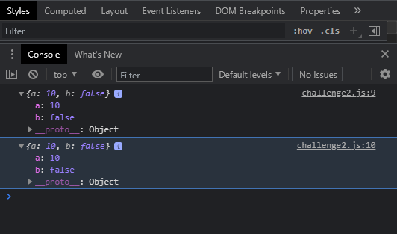

**Challenge3**

**Index.html**

<!DOCTYPE html>

<html lang="en">

<head>

    <meta charset="UTF-8">

    <meta http-equiv="X-UA-Compatible" content="IE=edge">

    <meta name="viewport" content="width=device-width, initial-scale=1.0">

    <title>JavaScriptBasics-Objects</title>

</head>

<body>

    <script src="challenge3.js"></script>

</body>

</html>

**Challenge3.js**

var objectWithNestedObject={};

objectWithNestedObject["nestedObject"]={};

console.log(objectWithNestedObject);

objectWithNestedObject.nestedObject.a=null;

const name="b";

objectWithNestedObject["nestedObject"][name]=true;

console.log(objectWithNestedObject)

**Result**

