**Challenge1**

**Index.html**

<!DOCTYPE html>

<html lang="en">

<head>

    <meta charset="UTF-8">

    <meta http-equiv="X-UA-Compatible" content="IE=edge">

    <meta name="viewport" content="width=device-width, initial-scale=1.0">

    <title>JavaScript Basics Operators</title>

</head>

<body>

    <script src="challenge1.js"></script>

</body>

</html>

**Challenge1.js**

let myVariable1="10";

let myVariable2="30";

console.log(+myVariable1 <= +myVariable2);

**Result**

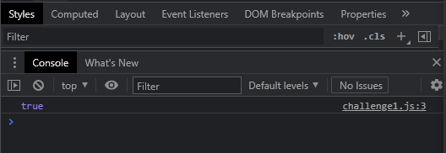

**Challenge2**

**Index.html**

<!DOCTYPE html>

<html lang="en">

<head>

    <meta charset="UTF-8">

    <meta http-equiv="X-UA-Compatible" content="IE=edge">

    <meta name="viewport" content="width=device-width, initial-scale=1.0">

    <title>JavaScript Basics Operators</title>

</head>

<body>

    <script src="challenge2.js"></script>

</body>

</html>

**Challenge2.js**

let myNumber1=10;

let myNumber2=20;

console.log(myNumber1%myNumber2);

// Left - Right Precedence

**Result**

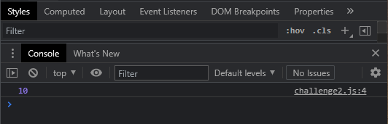

**Challenge3**

**Index.html**

<!DOCTYPE html>

<html lang="en">

<head>

    <meta charset="UTF-8">

    <meta http-equiv="X-UA-Compatible" content="IE=edge">

    <meta name="viewport" content="width=device-width, initial-scale=1.0">

    <title>JavaScript Basics Operators</title>

</head>

<body>

    <script src="challenge3.js"></script>

</body>

</html>

**Challenge3.js**

console.log(3 || true && null || false);

**Result**

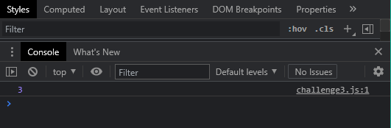

**Challenge4**

**Index.html**

<!DOCTYPE html>

<html lang="en">

<head>

    <meta charset="UTF-8">

    <meta http-equiv="X-UA-Compatible" content="IE=edge">

    <meta name="viewport" content="width=device-width, initial-scale=1.0">

    <title>JavaScript Basics Operators</title>

</head>

<body>

    <script src="challenge4.js"></script>

</body>

</html>

**Challenge4.js**

let a=10;

// a=a+1;

a+=1;

console.log(a);

a=10;

a++;

console.log(a);

a=10;

++a;

console.log(a);

// a=a*2;

a=10;

a*=2;

console.log(a);

// a=a-5;

a=10;

a-=5;

console.log(a);

// a=a/2;

a=10;

a/=2;

console.log(a);

**Result**

