

**PROJECT**

**OF**

**SALESFORCE DEVELOPER**

**A CRM Application to Manage the Services offered by an Institution**

**Submitted by**

KONDI INDRA VEERA BABU

**Roll Number**: 21131A0573

Gayatri Vidya Parishad College of Engineering(A), Visakhapatnam

**Email I’d: -** 21131A0573@gvpce.ac.in

**Project Abstract**

This project delivers a comprehensive **Salesforce CRM solution**, **EduConsultPro**, designed to address the diverse challenges encountered by EduConsultPro Institute in managing the student lifecycle—from initial inquiry and application through enrollment and ongoing support. The platform provides a **centralized and efficient system** for managing courses, consultants, student data, appointments, and communication.

**EduConsultPro** leverages Salesforce's robust features to **automate key processes**, such as the admission application and appointment scheduling. Prospective students can easily **navigate the online application process**, select desired courses, and submit their information seamlessly. Current students benefit from a **streamlined appointment booking system** with consultants, enabled by automated workflows and notifications.

The CRM enhances **communication between students, consultants, and administrative staff** through timely email notifications and updates across the student lifecycle. This transparency ensures that all stakeholders stay well-informed and can access the necessary information conveniently.

By **centralizing all student-related data** within the platform, EduConsultPro empowers the institution to gain **insights into student behavior, course trends, and program effectiveness**. This **data-driven approach** facilitates better decision-making and continuous improvement in the institute’s services. Additionally, the CRM's **reporting tools** enable tracking of key performance indicators (KPIs) to measure success and identify areas for optimization.

The custom-built solution boosts **operational efficiency** by reducing manual data entry, minimizing errors, and automating previously time-consuming tasks. This automation frees up administrative staff to focus on **strategic activities**, such as student advising and program enhancement.

In conclusion, the **EduConsultPro CRM project** significantly improves **efficiency, communication, and the overall experience** for students and staff, creating a **scalable and sustainable platform** to manage the institute's operations while fostering student success.

**Introduction to Salesforce**

Salesforce, a leading cloud-based CRM platform, empowers businesses to manage sales, customer service, and marketing operations effectively. Its comprehensive suite of tools enables automation, data analysis, and enhanced customer engagement. The platform's flexibility, customization options via AppExchange, and integration capabilities make it a powerful solution for organizations of all sizes and industries, making it a well-suited choice for EduConsultPro Institute.

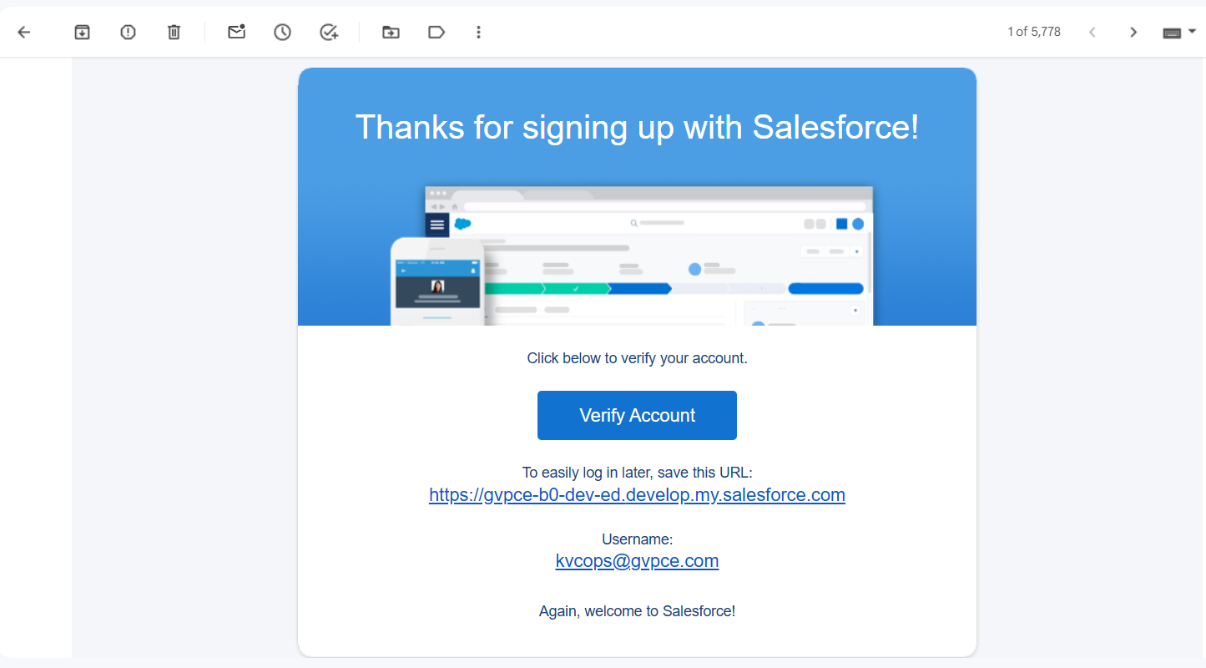

**Project Components and Implementation**

**Create Objects From Spreadsheet**

* **Create Course Object:** A custom object named "Course" was created using the data provided in the 'Course' spreadsheet. This involved mapping the spreadsheet columns to the Salesforce fields in the Course object.

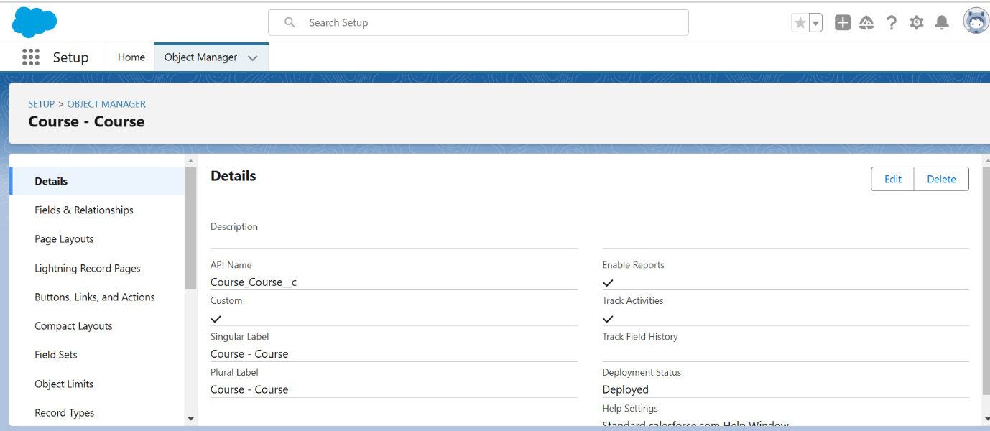

* **Create Remaining Objects:** Similar to the Course object, custom objects were created for Consultant, Student, Appointment, and Registration using the provided spreadsheets. Field mapping ensured data integrity during the import process.

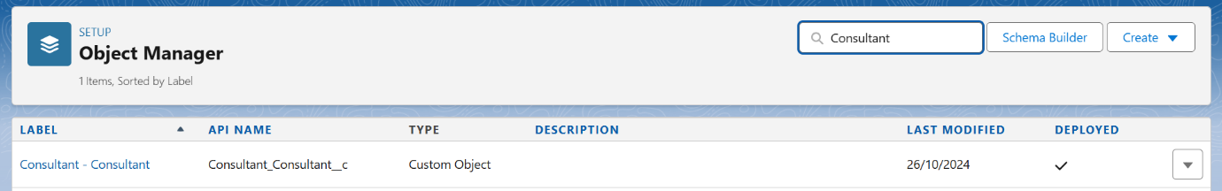

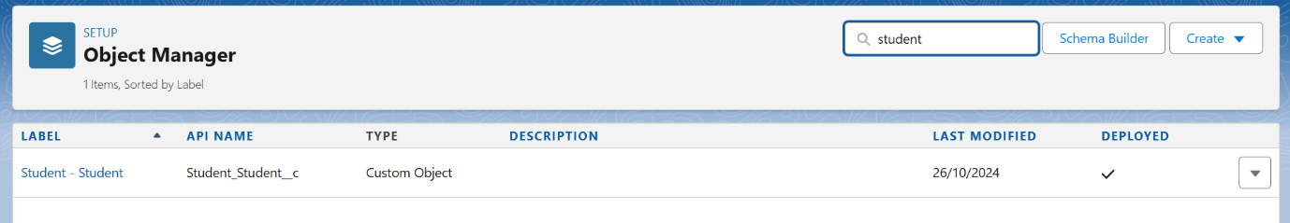

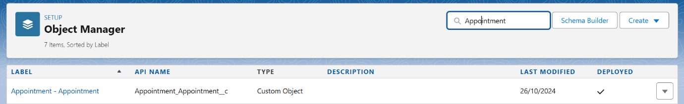

* **Create Relationship Among the Objects:** Lookup relationships were established between the objects to connect related data:
  + Appointment to Student (Student lookup on Appointment object)
  + Appointment to Consultant (Consultant lookup on Appointment object)
  + A custom object, "Registration," was created to store student and course details. Lookup relationships were added:
    - Registration to Student
    - Registration to Course
  + A lookup relationship was also established between Student and Case objects.

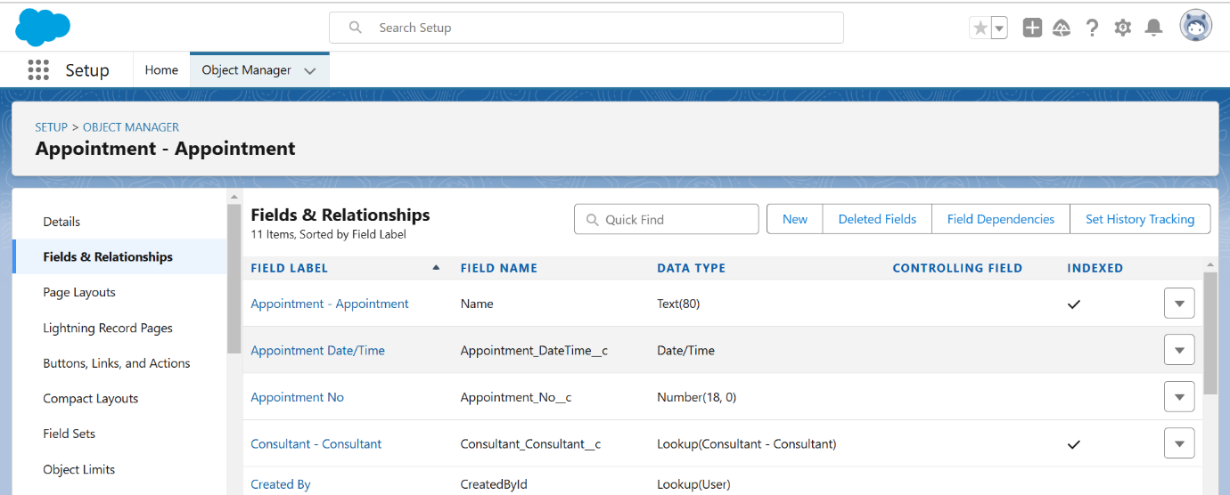

**Configure The Case Object**

The standard Case object was configured to include custom picklist values:

* **Type Field:** 'Immigration' and 'Visa Application' values added.
* **Status Field:** 'Open' and 'In-Progress' values added. (Consider adding 'Closed' or similar for completeness).

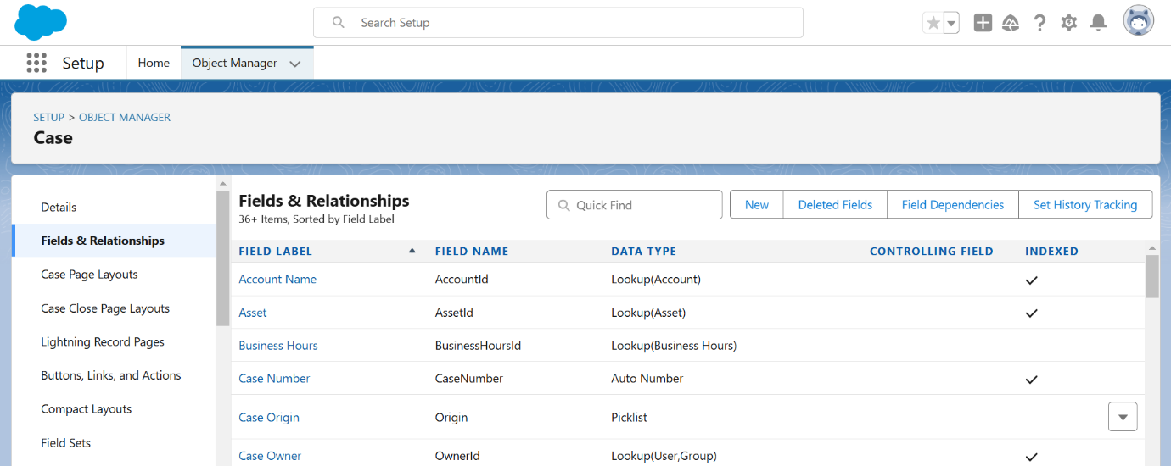

**Create A Lightning App**

A Lightning App named “EduConsultPro” was created. This app included tabs for Home, Students, Courses, Consultants, Appointments, Registrations, and Cases, providing users with a centralized location to access all functionalities. The app was made available to the System Administrator profile.

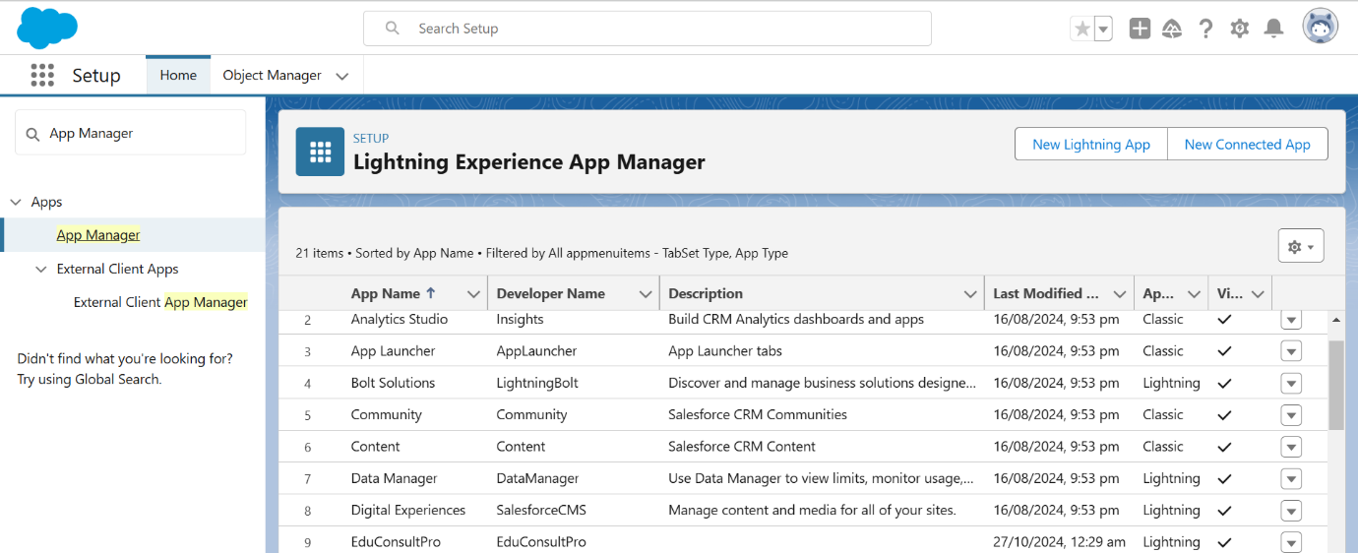

**Create A ScreenFlow For Student Admission Application Process**

* **Add Screen Element (Student Info):** A screen element was added to collect student information. This element displayed fields from the Student object. A record variable resource StudentRecordRes was created.
* **Create Student Record Using Create Element:** A create element, “Create Student Record,” was added to create a new Student record using the data collected from the “Student Info” screen.
* **Add Screen Element (Course Screen):** This screen allows students to select a course (IELTS, GRE, GMAT, Duolingo, TOEFL) from a picklist. Choice variables were created for each course option.
* **Add Decision Element (Selecting Course):** A decision element checks the selected course from the "Course Screen" and routes the flow based on the selection. Outcomes were defined for each course option (e.g., "Selected IELTS").
* **Add GET Record Element:** For each course outcome, a Get Record element retrieves the corresponding Course record based on the selected course name.
* **Create Registration Record Using Create Records Element:** A create element creates a Registration record, linking the newly created Student record and the retrieved Course record. This was done for each course outcome path.
* **Create Email Text Template Variables For Email Body And Subject:** Two text template resources were created:
  + StuRegistrationEmailTextTempBody for the email body content.
  + StuRegistrationEmailTextTempSub for the email subject.
* **Add An Action Element (Send Email to Student):** An email alert action was added to send a registration confirmation email to the student. It utilizes the email templates created in the previous step.
* **Add Screen Element (Success Screen):** A final screen displays a success message to the student.

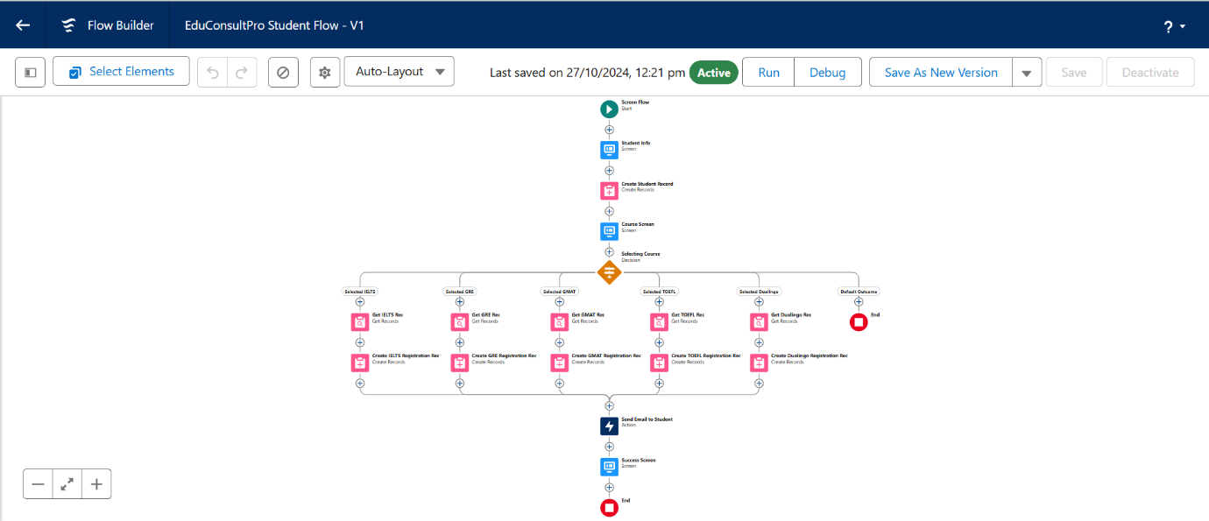

**Create Users**

* **User:** A new user with the Standard Platform User profile was created.
* **Configure The User Settings:** The new user was assigned a manager in their user settings, essential for the approval process.

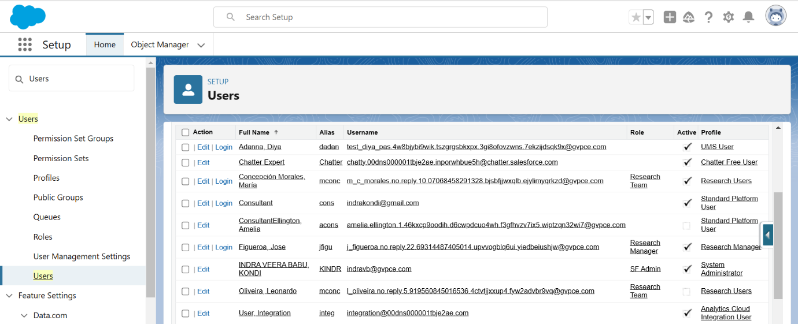

**Create An Approval Process For Property Object (Should be Appointment Object)**

* **Create An Email Template:** Email templates were created for Submission, Approval, and Rejection stages of the Appointment approval process.

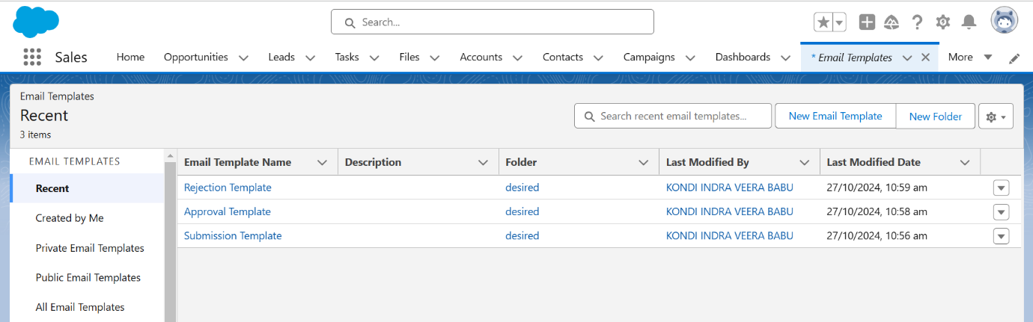

* **Create An Approval Process:** An approval process for the Appointment object was configured. The manager of the submitting user was designated as the approver. Record editability properties were set to allow administrators or the assigned approver to edit records during the approval process. Initial Submission, Final Approval, and Final Rejection actions were configured to update the Appointment record's status and send email notifications using the respective templates.

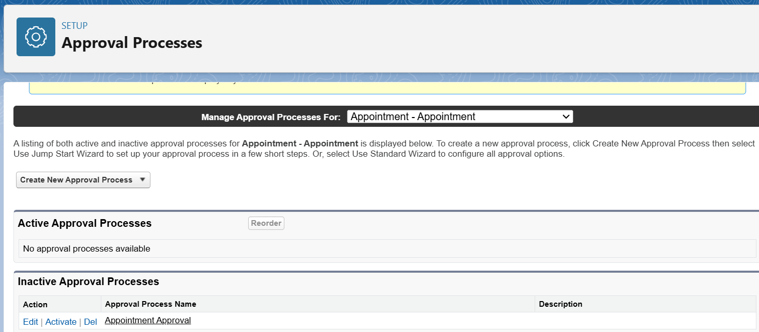

**Create A Record Triggered Flow**

* **Configure The Start Element:** A record-triggered flow was initiated, triggering when an Appointment record is created.
* **Add An Action Element:** An action element was added to submit the newly created Appointment record for approval using the Submit for Approval action.

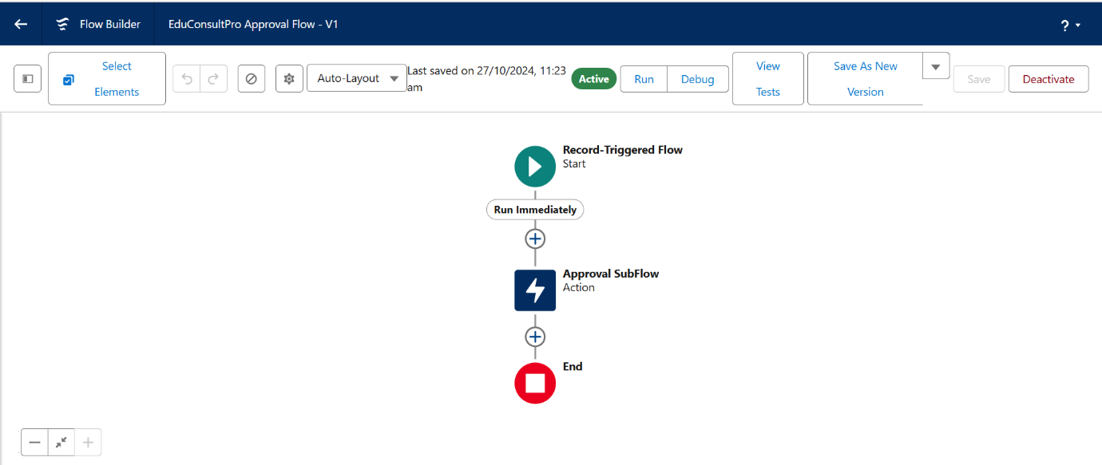

**Create A ScreenFlow For Existing Student To Book An Appointment**

* **Add Screen Element (Get Student Info):** Collects existing student's name and email.
* **Add GET Record Element (Get Rec):** Retrieves the Student record matching the entered name and email.
* **Add Decision Element (Appointment or Case):** Determines whether the student wants to book an appointment or create a case (this branch of the flow wasn't fully described in the original instructions, so requires further definition). Presumably, a screen would be needed before this decision element to offer those choices.
* **Add Screen Element (Appointment Booking Screen):** Displays fields from the Appointment object for the student to fill in. AppointmentRecordRes resource is used.
* **Add GET Record Element (Get Consultant Rec):** Retrieves the Consultant record based on the selected consultant name.
* **Create Appointment Record Using Create Records Element (Create Appointment):** Creates an Appointment record with details provided.
* **Add Screen Element (Confirmation Screen):** Displays confirmation message with appointment details.
* **Add An SubFlow Element (Create Student Case):** (This was under the "Case" path of the Decision element and requires further definition, assuming it involves creating a Case record if the student chose that option).

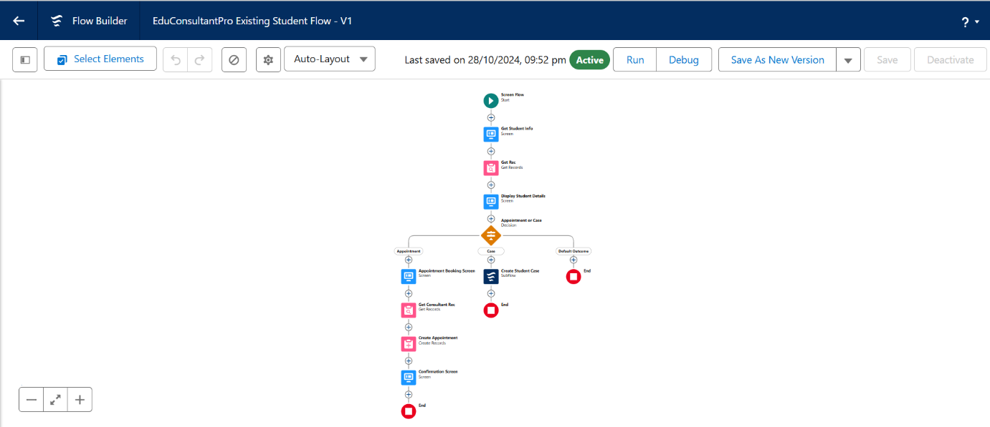

**Create A ScreenFlow To Combine All The Flows At One Place**

* **Add Screen Element (Welcome Screen):** Displays a welcome message.
* **Add Screen Element (Existing or New Student Confirmation Screen):** Asks the user if they are an existing student.
* **Add Decision Element (Decision 1):** Routes the flow based on user input (Existing/New Student).
* **Add An SubFlow Element (Existing Student Flow / New Student Flow):** Calls the respective Subflow based on the decision element outcome (Student Admission flow or Existing Student Appointment booking flow).

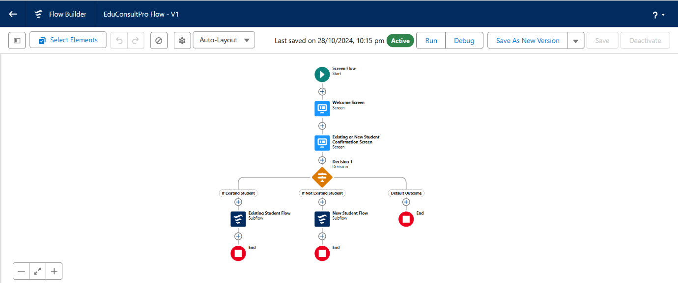

**Create A Lightning App Page**

* **Create a Lightning App Page:** A Lightning app page "EduConsultPro Home Page" was created and configured as the default Home page for the "Sales" app and assigned to the System Administrator profile. This page displayed the Combined Flow.

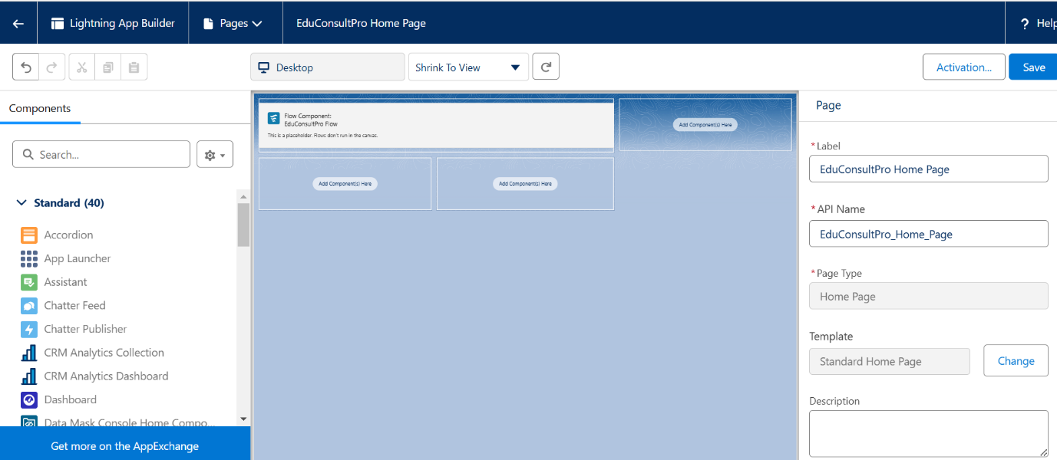

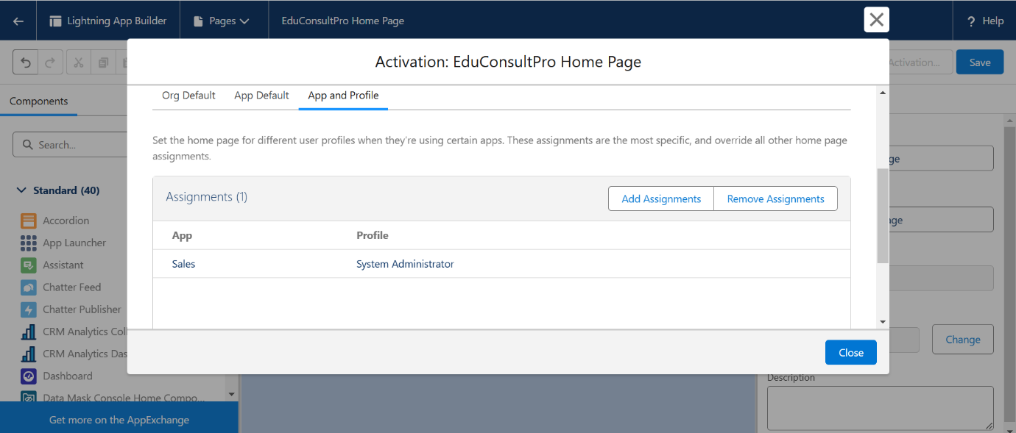

Conclusion

The **"A CRM Application to Manage the Services Offered by an Institution"** project successfully delivered a **robust and customized Salesforce CRM solution**, addressing the specific challenges faced by **EduConsultPro Institute**. By leveraging the power and flexibility of Salesforce, the project achieved its primary objectives of **streamlining operations, improving communication**, and **centralizing critical data** related to students, courses, and consultants.

The implemented CRM offers an **intuitive and user-friendly interface** for managing institutional services efficiently. **Automation** of key processes—such as student admissions and appointment scheduling—has reduced manual workload, minimized errors, and significantly improved staff productivity.

Automated **email notifications** ensure **timely communication** with students throughout their journey, from initial inquiry to enrollment and continued support. This contributes to an **enhanced student experience** by providing transparent and relevant updates at every stage of their interaction with the institute.

The **centralized data management system** empowers the institute with **advanced reporting and analytics tools**, offering insights into **student trends, program effectiveness, and operational performance**. This **data-driven approach** facilitates informed decision-making and supports continuous service improvement to meet evolving needs.

Beyond addressing immediate challenges, the project establishes a strong foundation for **future scalability and adaptability**. The flexibility of the Salesforce platform ensures that EduConsultPro can **expand functionalities and integrate new features** as needed, ensuring **long-term relevance and sustainability**.

The **successful deployment** of this CRM solution demonstrates the **transformative potential of technology in education**. It equips EduConsultPro Institute with the tools needed to adopt a **student-centric, data-driven approach** to service management. By **optimizing operations** and enabling seamless communication, the CRM project enhances the overall experience for both students and staff, positioning the institute for **sustained growth and success** in the ever-evolving educational landscape.

THANK YOU