**Approach2: Extraction of points will be used on complemented version of the contrasted image. All trees cannot be extracted with either of the approaches as the intensity varies from part to part in the image itself.**

clear all;

close all;

clc

% Read the ortho Tiff image

% Somehow MATLAB has problems reading the tiff format,

% so had to convert the layers into dicom format which

% is a medical imaging standard

obj = Tiff('TASK_2_OTRHO.tif','r');

i = 1;

while 1

subimage = obj.read();

subimages(:,:,:,i) = subimage(:,:,1:3);

if (obj.lastDirectory())

break;

end

obj.nextDirectory()

i = i+1;

end

dicomwrite( subimages, 'output_image.dcm');

dicomanon('output_image.dcm', 'output_anon.dcm');

I = dicomread('output_image.dcm');

imshow (I)

% Image shown below as fig.1

hold on

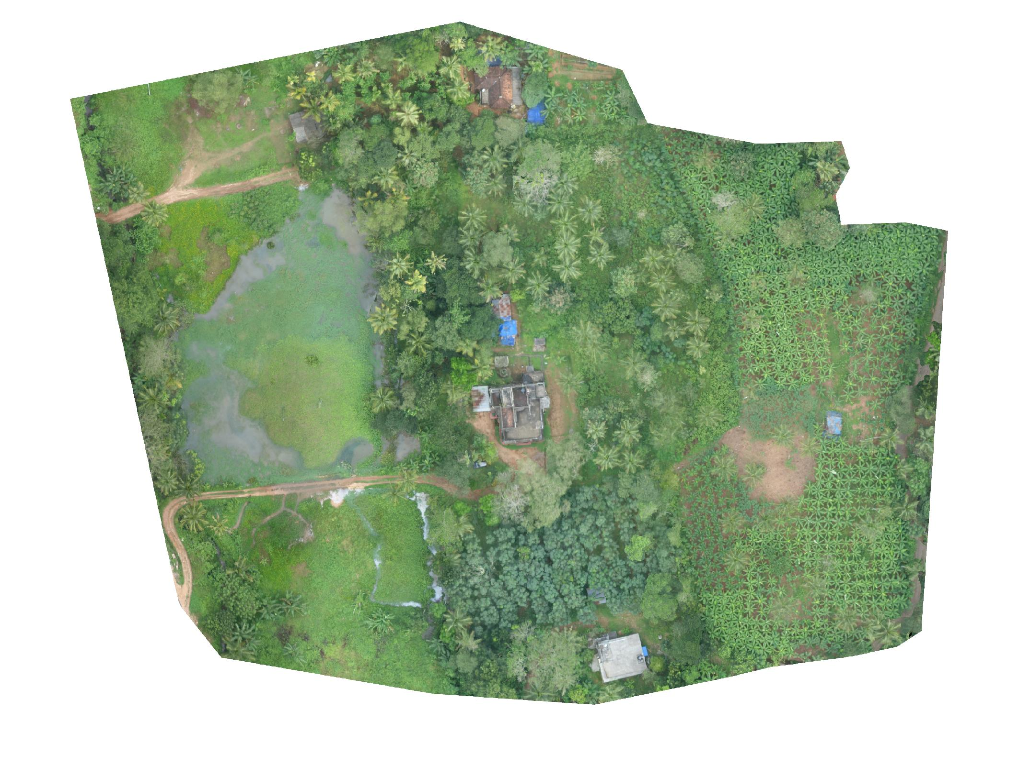

Fig.1 Actual Image

imshow(I,'DisplayRange',[])

I = imadjust(I,[0.88 0.6 0.88 ; 0.92 1 0.92],[]);

imshow (I);

%Adjusting the image here by saturating the top8% and bottom 88% of the

%R and B pixels which will enhance the green contrast of the trees from the background.

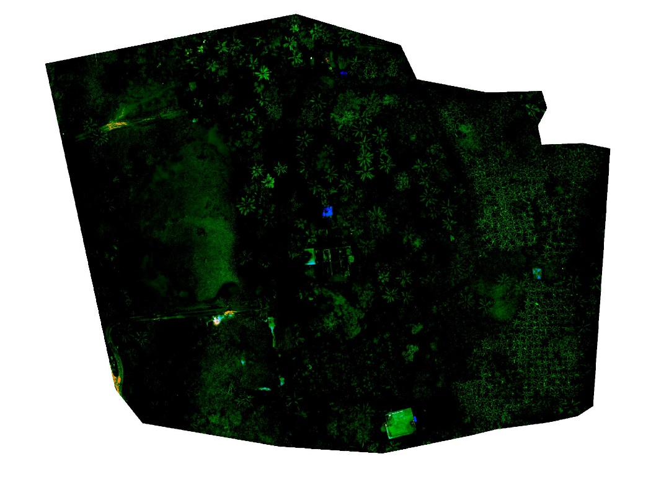

Fig.2 Highly contrasted image top 8% and bottom 88% of R and B channels saturated.

I = imcomplement(I);

imshow(I);

%Complementing the image here so that the middle of the trees which was the

%weakest point earlier now appears as the strongest point for further mapping.

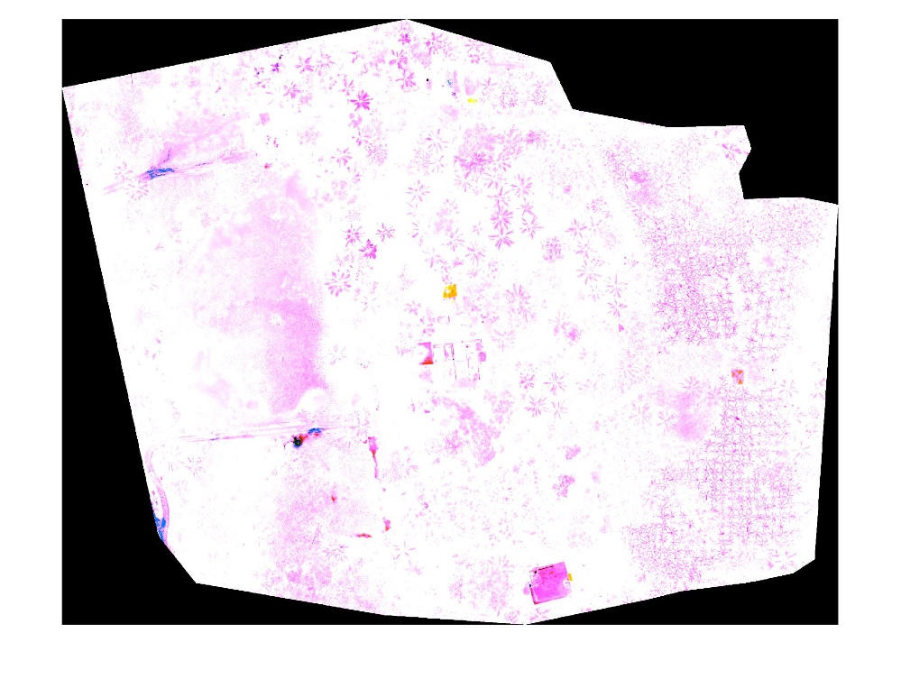

Fig. 3 Complement of the contrasted image.

%Complementing the image here so that the middle of the trees which was the

%weakest point earlier now appears as the strongest point for further mapping

D= imgaussfilt(D,2);

%Gaussian function will smoothen out the noises further from the image.

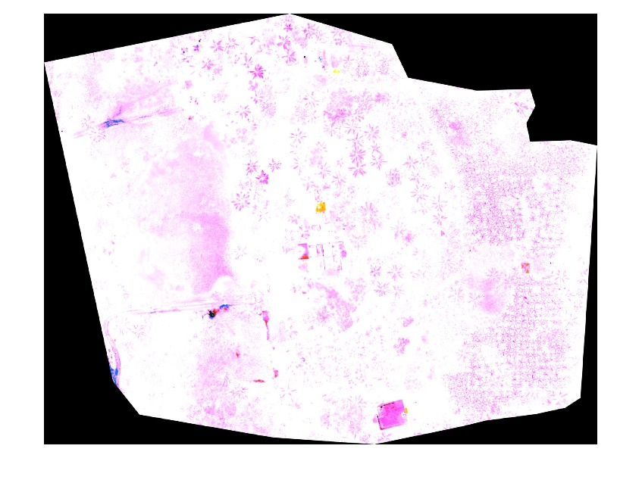

Fig. 4 Gaussian of the complemented image to take out some unnecessary noise.

D=rgb2gray (D);

imshow(D);

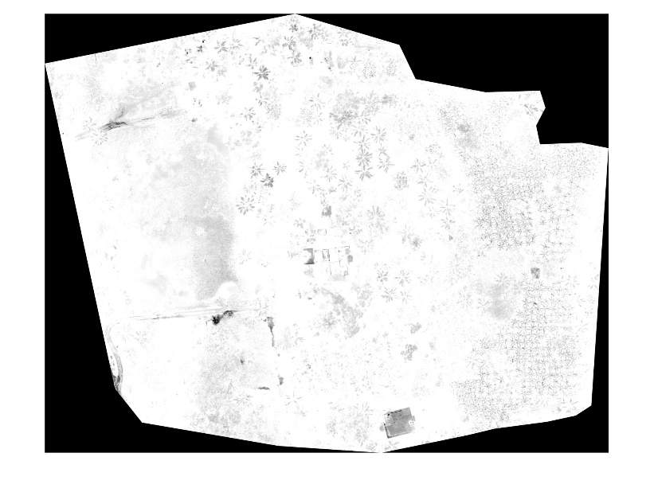

Fig. 5 Grayscale of the complemented image

boxPoints = detectSURFFeatures(D);

figure;

imshow (D);

title ('3000 Strongest Feature Points from Box Image');

hold on;

plot (selectStrongest (boxPoints, 3000));

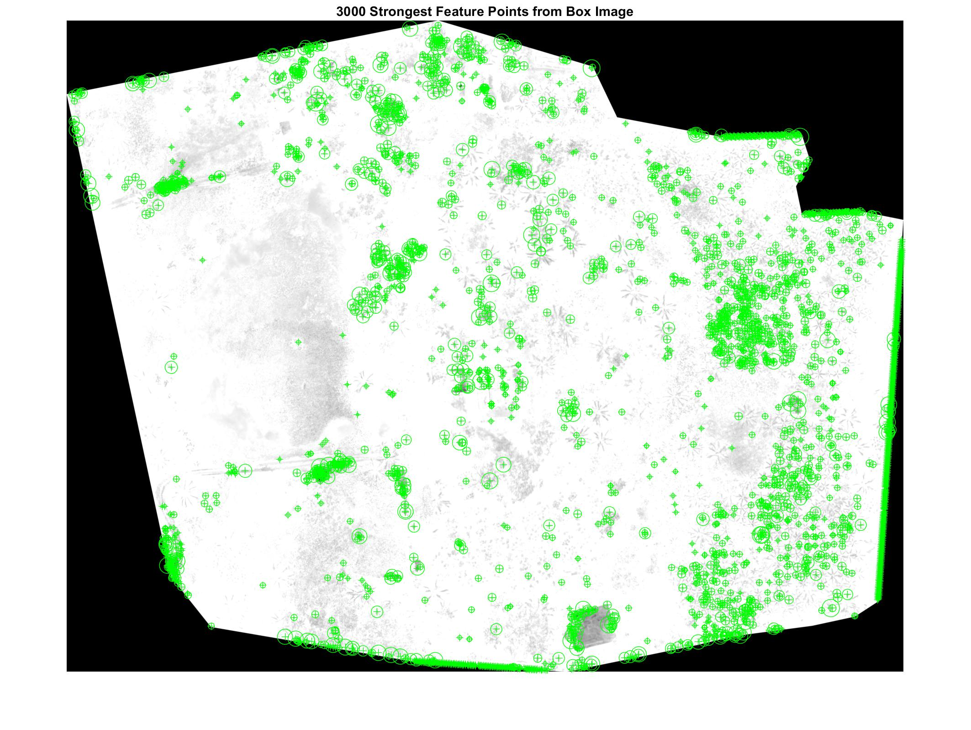

Fig.6 3000 points selected from main image for mapping to cropped image points.

**Overall, 50 to 60% of the trees are extracted from the image by this approach. However, for a fullproof way of getting almost 90% accuracy machine learning tools such as Segnets might be applied. This will however, need good amount of training and validation with several similar images of the two types of trees in the image.**