Axios

**Axios** is a popular JavaScript library

axios is a **promise-based HTTP client** for JavaScript. It's commonly used to **send HTTP requests** (GET, POST, PUT, DELETE, etc.) from the **browsers** (like in React apps) or **Node.js server.**

It helps you **communicate with APIs** — like fetching data, sending form submissions, or updating a resource on a server.

🧪 Example

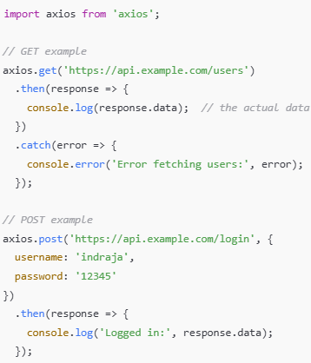

**🧠 Common Use Cases**

* Fetching data for React components
* Submitting forms (e.g. login/signup)
* Uploading files
* Communicating with REST APIs or JSON servers
* Adding authentication headers (like JWT tokens)

