**Redux**

**Redux** is a **state management library** used mostly with **any** **JavaScript frameworks like React, Angular, Vue or even vanilla JS and also in** Plain JavaScript (Node.js). It helps manage and centralize the **application state** in a predictable way.

**💡 Simple Definition:**

**Redux** is like a **central data store** for your app. Instead of components managing their own data separately, Redux stores all the data in **one place** and updates it in a controlled, predictable way.

### ✅ ****State ante enti?****

* **State** **of component** ante component lo unde **data** (samacharam).

Example:

* + If we have a LoginForm component → then **state of component** is simple an **object** with **username**, **password**, **submitting** properties  
    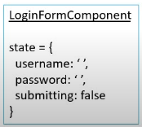

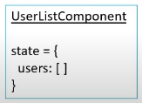

Usually ee data ni component lo useState tho manage chestam. Kaani, pedda apps lo **chaala components ki common data kavali**. Appudu confusion avutundi.

* **State of an app is the state represented by all the individual components of that app. This includes the data and UI logic.**

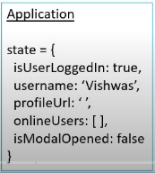

Redux will store and manage the **application state**.

✅ **Predictable in what way?**

* In any JS application, the state of application can change.

**Ex:** In **TodoList** application, a **Todo item** can go from being in **a** **state of pending** to **a state of completed.**

* **In Redux all such state transitions are explicit and it is possible to keep track of them. In other words changes to your application’s state become predictable.**

**👩‍💻 Example:**

👍 Normal JS lo (**Implicit**):

****Ikkada todo object lo state (completed) maarindi, **kani ekkada enduku maarindhi ani manaku clarity ledu** (not traceable easily).

👍 Redux lo (**explicit**):



Ikkada state change ki **oka action type** untundi: "MARK_COMPLETED".

Ah action dispatch aindi anedi clear ga telustundi.

**DevTools lo history track cheyyachu:**

PENDING → MARK_COMPLETED → COMPLETED

**Hence, Redux** is **predictable state container.**

**Redux will help you, if you want to manage the state of your application in predictable way.**

✅ **React is UI library, Redux is state management library.**

**They both work independently of each other. Which means, the core redux library is not tied to React or any other frontend framework like Angular, Vue etc.**

**Hence, to directly use Redux in React application is bit difficult and confusing.  
This is the reason Redux has a separate react-redux package specifically for React application.**

**For React + Redux application, you should install:**

npm install redux react-redux

redux – The core Redux state management library

react-redux – The official react bindings for Redux. Which means, it provides useful tools/functions which helps you bind **React** and **Redux** together in React application.

### 🎯 ****Why would we want to use Redux in React application? When React Components have their****

### ****own state then why do we need another tool to help manage that state.****

**In medium to large apps:**

* Data needs to be shared between components. React lo components chala levels lo untay (parent → child → child…). Data ni okka component nunchi inko component ki pampadam kastam avutundi.
* Components might become messy with too much state.
* Updating and debugging becomes harder.

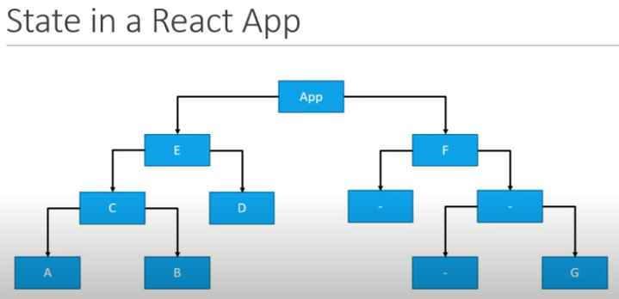  
**Fig:** React application with nested components.

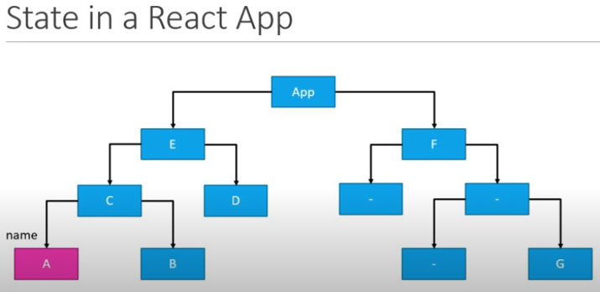  
**Fig:** Assume Component **A**  has an input field to accept the user’s name, which is stored locally within the **component State.**

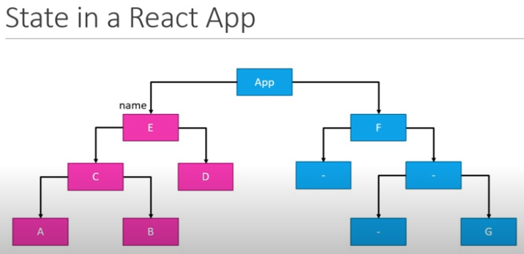

**Fig:** Suppose the siblings components **B**, **D** needs to display the user’s name, we have to lift the component **A** state to component **C** and then tocomponent **E** in a React’s `**props**` context way.

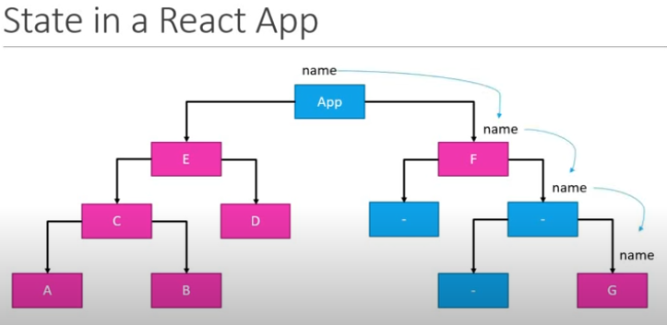

**Fig:** Parent to child.

**NOTE:** Username avasarm leni sibling (parent/child) component kuba still have to aware of username to pass the value to its siblings.

**Redux solves this** by giving:

* **Centralized State,** Redux valla data **okkate place lo** untundi (central ga store avutundi). Andaru akkadinunchi teesukovachu, update cheyyavachu.

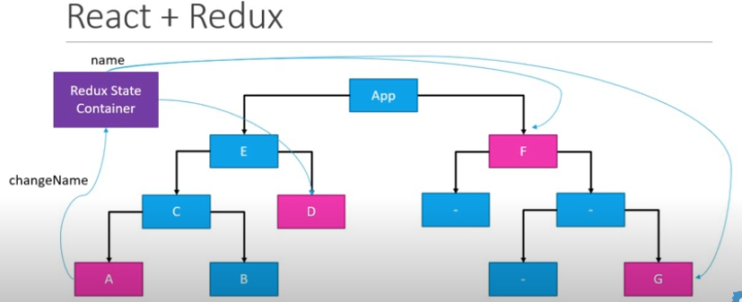

* **Predictable State Updates**
* **Time-travel Debugging (via Redux DevTools)**

**Three core concepts of Redux – Store, Action, and Reducer:**

1. The **store** is a **JavaScript object** that holds the **entire state** of your application. It’s created using createStore() function from the **Redux** library.  
   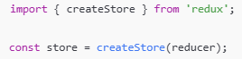
2. An **action** is a **plain JavaScript object** that describes **changes happened** in the state of app. It must have a type property defined as string constants.



You can also add a payload for passing data:  


Functions that return action objects which you define in code:

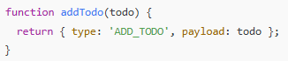

### ✅ Purpose:

* Tell the store **what to do.**
* Dispatched using store.dispatch(action)

1. A **reducer** is a **pure user defined function** that **takes in** the **current state** and an **action**, and **returns a new state**.

## 🔄 How They Work Together:

1. You call store.dispatch(action)
2. Redux calls the **reducer** with the current state and the action
3. The reducer returns a **new state**
4. The **store** updates with this new state

**Three principles:**

Redux is built on **three core principles** that make state management predictable and manageable, especially for large applications.

1. **1st principle - Redux tells to store/maintain your entire application state in a single JS object which would be managed by the Redux Store.  
   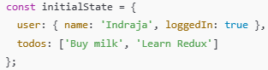**
2. **2nd principle: State is Read-Only -** The **only way to change the state** is to **dispatch/emit an action**, which is an object describing what happened. It must have a type property defined as string constants.

**To update the state of app, you need to let Redux know about that with an action.  
**

You are not allowed to directly update the state object.  


1. **3rd principle: Changes are Made with Pure Functions (Reducers)** - To specify how the state tree is transformed by actions, you write **pure reducers**.

**Redux Store:**

The **Redux store** is the **central place** where your entire application state lives.

**One store for the entire application  
Holds application state.**

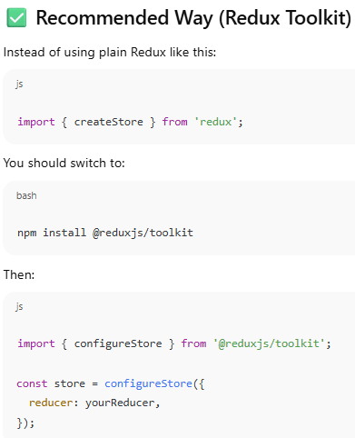

**Following are the functions that Redux store has:**

**getState()** is a method provided by the **Redux store** that lets you access the **current state** of the application at any time.



dispatch(action) is a method provided by the **Redux store** and is used to **send an action to the Redux store**.



Redux forwards this action to the **reducer.** The reducer returns a **new state.** The store updates with that new state.

subscribe(listener) - This **registers a listener function** that gets called **every time the store's state changes**. It’s useful when you want to run some code **whenever the state changes** (like updating UI or logging)

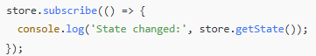

Here, Inside the callback, you're logging the updated state using store.getState().

unsubscribe() is a function that **stops your listener** from getting called when the Redux store state changes. It is the method returned by the store.subscribe() method.

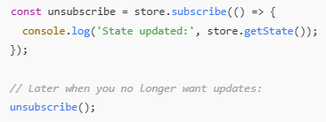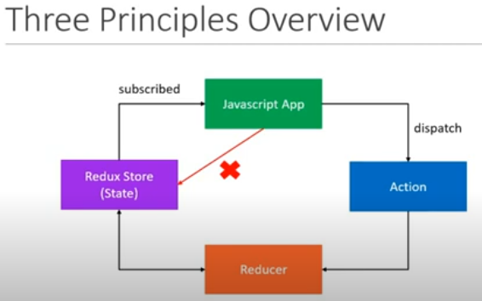

**Fig: How Redux principles work with React**

* 1. **The state of react app is maintained separately in Redux store.**
  2. **Our React app always subscribe to this Redux store which holds the React App state.**
  3. **App can not directly update its state stored in Redux store.**
  4. **If App wants to update its state, it has to emit/dispatch an action.**
  5. **Once an action has been dispatched, the reducer then handles that action and updates the current state stored in Redux store.**
  6. **As soon as the state is updated, the value is then passed on to the application because the App is subscribed to the store.**

**Project Creation:**

**Node.js project: You either find in local system or Git repo**

1. Prerequisites – Node.js
2. Assume we are building a Cake Shop Application
3. npm init -y – creates package.json
4. npm install react
5. Create an **action** for cake shop application in index.js:

  
Defining a **string constant** that indicates the **type of the action**.

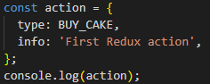

Defining an **action**, which is an object that has `**type**` property.

**Recommended way to create an action** – defining a function which returns an action:  
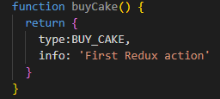

**Here,**

✅ type - Required in **every Redux action**. It tells the reducer **what kind of action** is being dispatched. Reducers use it to decide how to update the state.

📝 info - Optional. It’s just **extra metadata or comments** for developers or for debugging/logging. It is **not used by the reducer**, unless you specifically write logic to use it.

1. Now defining reducer function which tells Redux **how to update the state** based on the action received.  
   **Syntax:**

  
**What our cake shop application state looks like?**  
As I shopkeeper, all I want to keep track of the number of cakes on the shelf.   
Hence, our app state is to be a simple numeric. **But remember** according to Redux principle, app state has to be represented by a single object.  


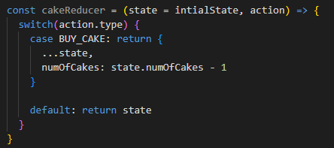  
Let's break this **reducer** function **line by line** to clearly understand:

1. **cakeReducer** – constant that holds the Redux reducer function
2. **state** - Current state of that part of the Redux store.
3. **action** - Object that was dispatched, e.g. { type: 'BUY_CAKE' }.
4. **switch** - A control structure (like multiple if...else if) used to compare action.type against many possible action types.  
   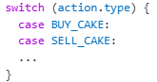  
   **action.type -** A string that describes what the action wants to do.   
   Example: 'BUY_CAKE', 'ADD_TODO', 'LOGOUT_USER'.  
   If the action’s type is 'BUY_CAKE', then this block will execute. We return a **new state object** here.
5. return { ...state, numCakes: state.numCakes - 1 }  
   ...state - Copies everything from the previous state.  
   numCakes: state.numCakes – 1 - Overrides numOfCakes with one less cake.  
   **NOTE:** ✅ Redux always expects a **new state object**, not a mutated one.
6. default: return state  
   If the action’s type doesn't match any case, we **must return the current state as-is**.  
   This prevents Redux from losing the state when unrelated actions are dispatched.
7. **Create redux store** to store/hold the application state.  
   We already define const variable called **initalState** which sets the application state.  
   **Now,** create redux store which will hold **initialState** value.  
   Hence we required to import `**redux**` library which provides a method called **createStore()** for creating the store.

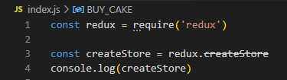



**NOTE: createStore is deprecated.**

**Instead import,**

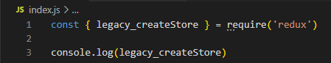



Here **legacy_createStore()** takes **reducer** method as input.



**Output:**

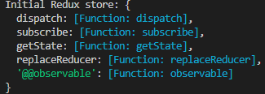

**NOTE:**

1. **Redux in plain Node.js environment:**

**createStore is deprecated** because the createStore method from the redux package is now considered **legacy**. The Redux team strongly recommends using configureStore from @reduxjs/toolkit (RTK), which simplifies store setup and helps avoid common mistakes.



* + `redux` code package come with this Redux tool kit, You should not need to be using the redux core package by itself today, except for learning purposes.

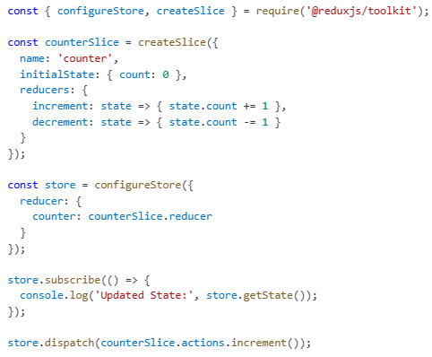

* For more details, please read this Redux docs page: <https://redux.js.org/introduction/why-rtk-is-redux-today>
* The createStore method from the core redux package **will not be removed** - just marked as deprecated, but we encourage all users to migrate to using **Redux Toolkit** for all Redux code.
* If you want to keep using createStore (for learning/testing in Node.js), update your import like this:

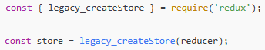

This way, the deprecation warning will not show up in editors like VSCode.

1. **React+Redux:**



The redux library **only provides named exports**, like createStore, combineReducers, etc.  
'redux' does not contain a default export or it **does not export a default object**.

✅ Correct Way to Import for **React+Redux** application:

Instead of importing the whole **redux** module as an object, just import what you need directly:

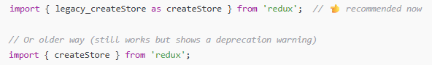

✅ But, If you're working with React or a modern frontend stack, Redux team **recommends using Redux Toolkit (RTK)** instead.



1. Create Redux store has a **getState()** method which lets us access current state of application at any time.  
   
2. Created Redux store has subscribe(listener) method which lets you **listen for state changes** in the Redux store. It’s useful when you want to run some code **whenever the state changes** (like updating UI or logging)  
   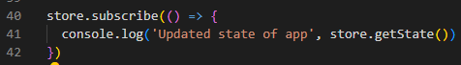
3. Created Redux store has dispatch(action) method which is used to **send an action to the Redux store**.  
   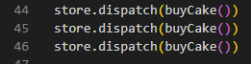
4. unsubscribe() is a function that **stops your listener** from getting called when the Redux store state changes. It is the method returned by the store.subscribe() method.

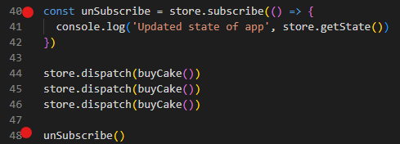

1. when I run **index.js**, the output which I got is:

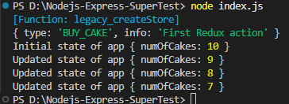

1. Now, I want to enhance the **cake shop application** to handle Ice creams also.  
   **Hence**, **state of application** is now has **No. of cakes** and **No. of ice-creams.  
   However,** in future application may also need to handle cookies, desserts etc.  
   Best practice is to create multiple **reducer** to handle each item in an application.  
     
   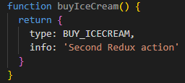  
   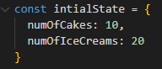  
   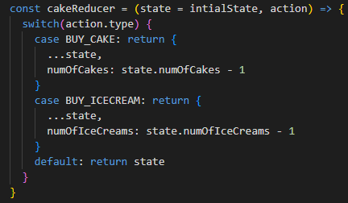

  
When you run the **index.js**:  
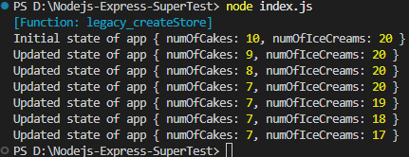  
Here,  
When user but a cake only No. of cakes has decreased.  
When user buy an ice-cream only No. of Ice-creams got decreased.

This is due to single **reducer** handling all items in a cake shop application

Let’s create multiple **reducers** to handle each item:

First maintain separate initial states for cake and ice-cream  
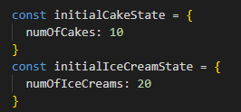

Now, create separate reducer functions for each action  
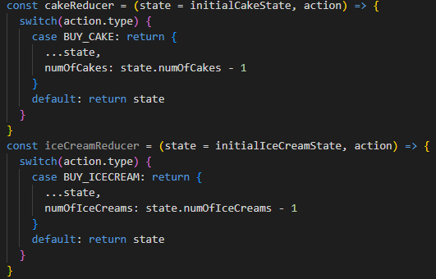  
**NOTE:** **Redux store accepts only one reducer** (i.e., **const store = legacy_createStore(reducer)**)

So, We need to combine multiple reducer into single reducer.

**combineReducers()** from **core redux** accepts an object with reducer functions.  
  
Before passing **reducer** to **legacy_createStore(),** combine multiple reducers using **redux**’s **combineReducers()** method:  
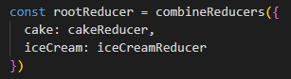



When I run **index.js**:  
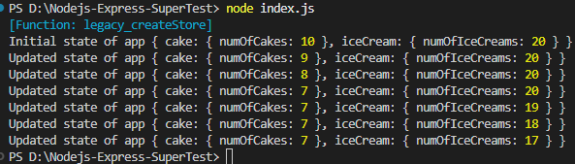

**Another Redux concepts:**

**Middleware  
A way to extend Redux with custom functionality.  
Middleware in Redux** is a function that intercepts every action before it reaches the reducer.  
Use **Middleware** for logging, crash reporting, performing asynchronous tasks etc.

**applyMiddleware** is a **function (method)** provided by the **redux** package. It is used to **add middleware to a Redux store.**

**📦 redux-logger Middleware Package:**

[redux-logger](https://github.com/LogRocket/redux-logger) is a popular middleware that **automatically logs** Redux actions and the resulting state changes to the console — great for debugging!

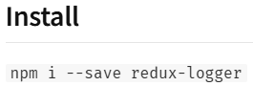

Usage:

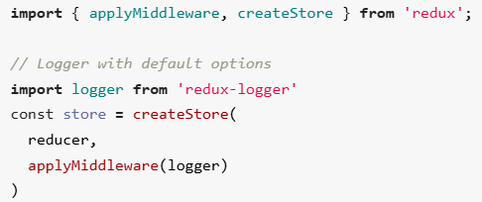

you can create your own logger with custom [**options**](https://github.com/evgenyrodionov/redux-logger#options):

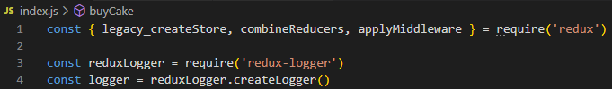  
 or

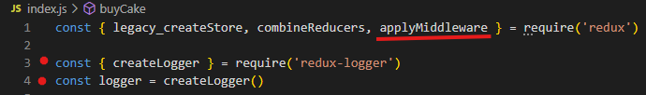



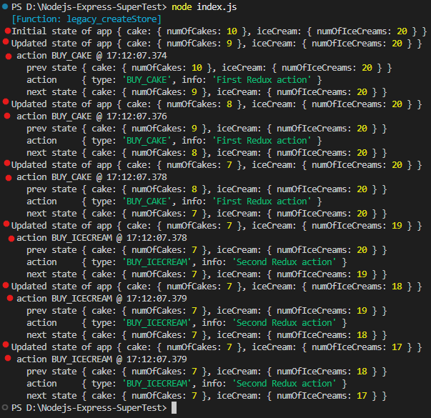

**Async Actions:**

By **default**, **Redux actions are synchronous**.   
**Synchronous actions** are **plain JavaScript objects**, dispatched immediately, and the reducer updates the state **right away**.

Example:  
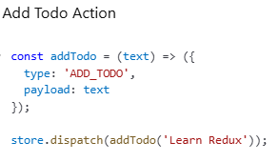  
 Here, The **state of app** is updated **synchronously** after this dispatch.

To handle **async logic** (Ex: async API calls to fetch data from an endpoint and use that data in your application), Redux needs **middleware** — usually:

* + **redux-thunk** (most common used middleware)
  + **redux-saga**
  + **redux-observable**

**Assume,** our user application has to fetch a list of user from an API end point and stores it in the redux store.

For this scenario,

* **State of application for data fetching would be:**  
  state = {  
   loading: true, // property to indicate whether data is currently being fetched or not  
   // While build UI for a component this flag would help to show

loading spinner for data being fetch.

data: [ ], // property to store users after fetch

error: ‘ ‘ // property to store fetch error message if API call fail. This would

help to show the error in UI

}

* **Actions in our application would be:**
  + **FETCH_USER_REQUEST -** Fetch list of user from API endpoint
  + **FETCH_USER_SUCCESS -** Fetched successfully. This action depends

on above fetch user request action.

* + **FETCH_USER_SUCCESS -** Error fetching the data. This action depends

on above fetch user request action.

* **Reducers of our application would be:**

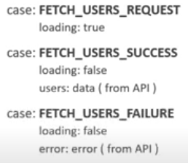

**Code Implementation:**

1. **Create** asyncActions.js
2. Defining **initial state of app  
   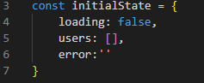**
3. Defining **Actions  
   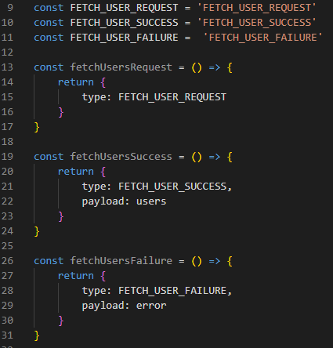**
4. Defining reducer function  
   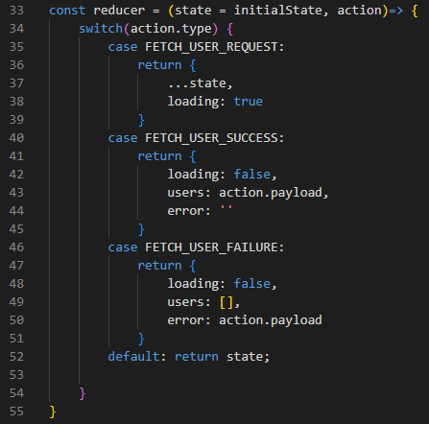
5. Importing **legacy_createStore** from **redux** library to create a Redux **store  
   **
6. Creating a Redux **store** to hold the entire state of app.  
   

So far, we set up our Node.JS application with Redux **state**, **actions** and **reducer**.  
Now, let’s see how to use **action** creators **asynchronously** with **network requests**(i.e., making an API call when working with Redux).

1. Install and import **axios** **package** which can help to make request to an API endpoint.





1. Install and import **redux-thunk** **middleware** which helps to define an **async action creators** in your application.   
   **🧠 redux-thunk**:  
   **redux-thunk** is a **middleware** package that lets you **write action creators function that return a function instead of an action(i.e., plain object)**.   
   These return functions called `**thunks**` which can handle **async logic**, such as fetching data from API or performing delayed actions, and then dispatch regular action objects once the asynchronous operation is complete.  
   This return function, the "**thunk**," receives dispatch and getState as arguments.   
   Example:  
   1. Way to define **synchronous Increment action**  
   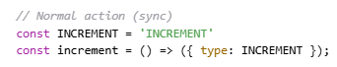  
   You can **only return plain objects**, no async logic allowed.  
   2. Way to define **Asynchronous API action**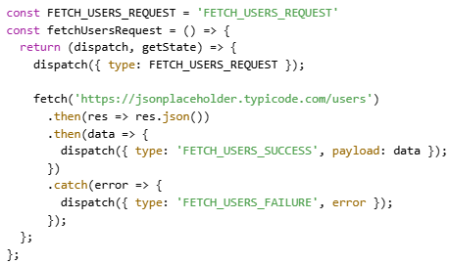
2. **applyMiddleware** is a **function (method)** provided by the **redux** package. It is used to **add middleware to a Redux store.**



1. **Install and Import thunk from a `redux-thunk` library**



But when you use require() (CommonJS) to import an ES module, the result is:

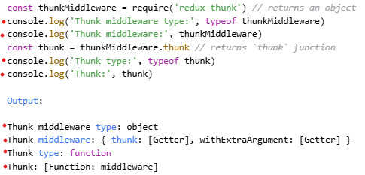

**Or**



1. Now, pass`thunk` function to `applyMiddleware()` to apply to Redux store.



1. Now, creating action creator function that returns a **function/thunk** that handle async login.  
    This **return function** has `**dispatch**` method as its argument so we can use this **dispatch()** to  
    dispatch the action.  
    **NOTE:**   
    <https://jsonplaceholder.typicode.com/users> - this endpoint gives the random user data.  
    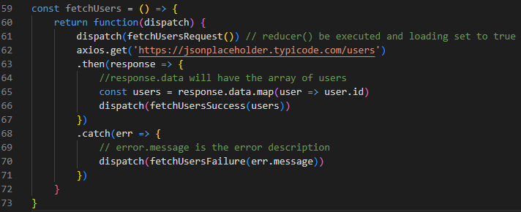
2. **Subscribed to the store and dispatching** the action which returns thunk (i.e., a function()).

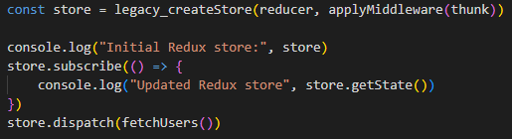

**Output:**

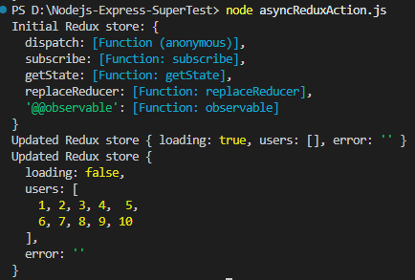

1. If we are passing invalid URL to axios like:



then output be like:

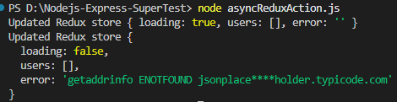

**Finally Remember:**

* Node.js **does not have built-in state like React**.
* But you **can define variables** (in memory) to hold state:  
  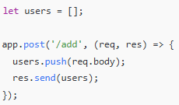  
  Here, users is an **in-memory state** in Node, but it's:
  + **Volatile** (resets if the server restarts),
  + **Not structured** like Redux store.
  + You **don’t need Redux** in Node to define or manage basic state.
  + You might use Redux in Node when You want to **share Redux logic between frontend and backend.**

**React+Redux project:**

1. Created a branch (**React+Redux**) from Git Hub React project Repo **IndrajaBrishRepo**
2. npm install @reduxjs/toolkit  
   **NOTE:** **core redux** library already included with **Redux Toolkit(RTK)**
3. 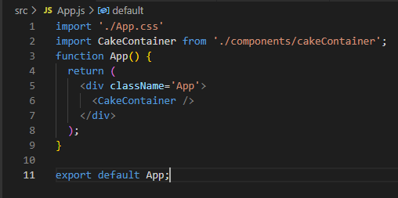

Fig: App.js

1. 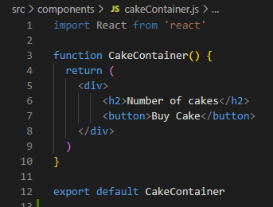

Fig: **CakeContainer** component

**Steps for creating a redux store and providing it to our React application:**

1. We are **defining** all action types in `**cakeTypes.js**`

  
Fig: cakeTypes.js

1. We are **creating** each action for each action type in `**cakeActions.js**`

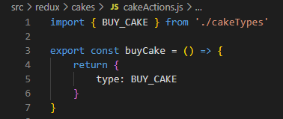

1. Defining **Redux Reducer** **function** and **initial state of App  
   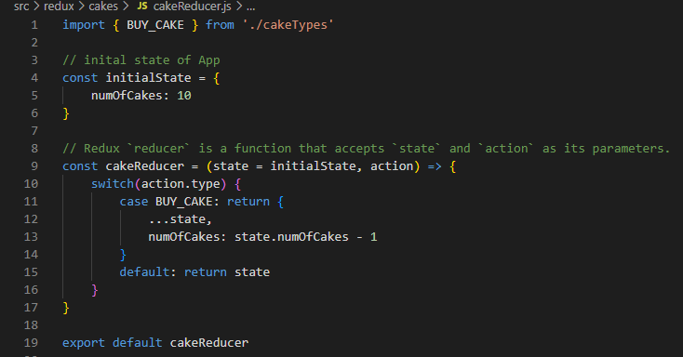**
2. Within this file, we create our store.  
   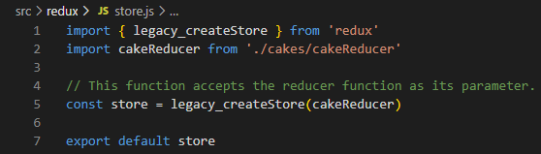
3. **<Provider>** is a **React component** provided by the **react-redux** library.  
   It is used to **connect the Redux store to the React application**.  
   **✅ Why do we need it?**  
   Redux is a **state management library**, but it doesn't know anything about React directly. To make Redux's store available to all React components in your app, we wrap the root of our component tree with <Provider> and **pass the store to it**: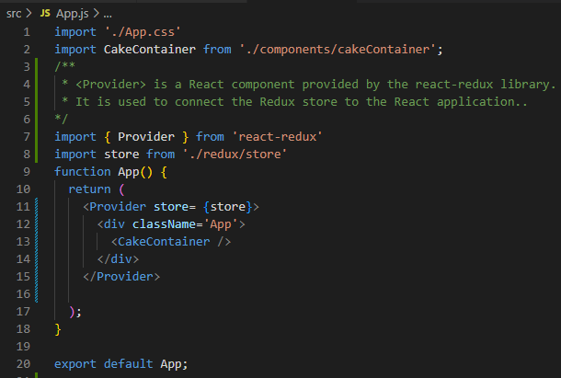
4. In React, how do we hold the redux state? And how to dispatch an action from within a React component?

 **Here** in **cakecontainer** component, we are just showing text and button.

Now, let’s show that when `**Buy Cake**` button click happen an action should be dispatched and currnet number of cakes should be dispalyed.

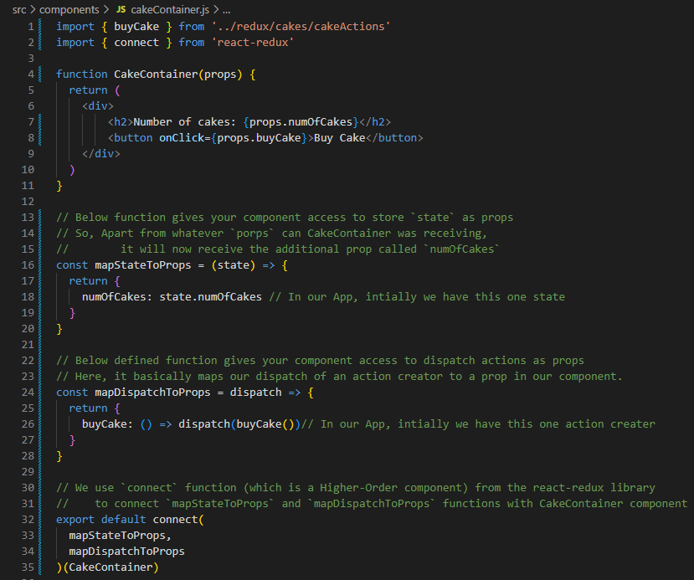

**Explanation:**

**mapDispatchProps**

* Defined a function that gets the redux state as parameter and returns an object
* Here the state from the Redux store is mapped to our component props  
  We are mapping state.numOfCakes to numOfCakes as a prop to CakeContainer Component
* So, Apart from whatever `porps` can CakeContainer was receiving, it will now receive the additional prop called `numOfCakes`

**mapDispatchToProps**

* Defining a function that gets the dispatch as a parameter and returns an object.
* Here, it basically maps our dispatch of an action creator to a prop in our component.

**Connect** from **react-redux**

* Function(which is also a Higher-order component) that connects **Redux** with **React**
* Takes a component as input
* Returns a new component with additional functionality
* In above case, connect() takes your component and gives it access to: Redux **state** and Redux **dispatch**
* You don’t need to call React Hooks useSelector() or useDispatch() manually — connect() gives everything as props.  
  But,

connect() - Good for class components

useSelector(), useDispatch() – Best for modern function components.

**Output when we run npm start:**

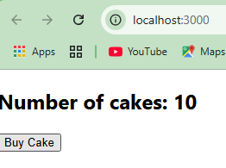

**Important:**

If we take a look at official **react-redux** documentation, they maintain a separate file called `selectors.js`.

Just like we maintaining, file for all **actions** and file for all **reducers**, there would be **selectors.**

A **selector** is a plain JS **function** that takes the **Redux state** and returns **some part of** state information from the Redux **store.**

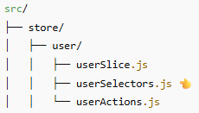



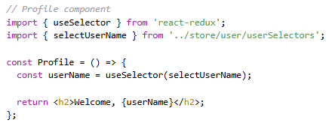

ఈ function లో state అనేది మొత్తం redux state, state.user అంటే అందులో ఉన్న user slice.

✅ Why do we use selectors:

* Avoid repetition - ప్రతి చోటా state.user.name లాంటి కోడ్ రాయకుండా ఒకేసారి select చెయ్యడం కోసం.
* **State structure మారినా**, component లో changes చేయాల్సిన అవసరం ఉండదు.
* **Performance** ( **Memoization** - **performance optimization technique**) కోసం, reselect లాంటి libraries తో selectors ను optimize చేయవచ్చు.  
    
  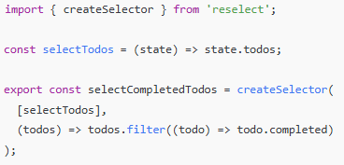  
  **Memoization** వల్ల unnecessary renders తగ్గుతాయి.  
  meaning : ఒక function ఒకే inputs తో మళ్లీ మళ్లీ పిలవబడితే, ఆ function రిజల్ట్‌ను గుర్తుపెట్టి (cache చేసి), తర్వాత direct గా ఫలితాన్ని ఇచ్చేయడం. అంటే function calculations మళ్లీ చేయాల్సిన అవసరం లేదు → వేగంగా (fast) జరుగుతుంది.

**Remember,**

**React-Redux pattern be like:**

* Action creators, reducers, provide the store and connect the components.
* Components can access state and dispatch actions.
* Now, react-redux **also offers set of APIs as an alternative to the** connect **Higher- Order component**

**useSelector + useDispatch**:

**useSelector** and **useDispatch**, which are **React-Redux Hooks** introduced to simplify Redux usage in **function components**.

They are used **inside function components only** and are the modern replacement for the connect() **Higher- Order component(**HOC**)**.

📌 Syntax and Usage:

useSelector – Read **state** from store (Redux store నుండి state ని చదవడానికి ఉపయోగించే Hook)

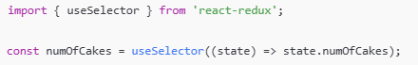

* This reads numOfCakes from the Redux **store** and stores it in a variable.

useDispatch – Send actions to store (Redux store కి actions పంపడానికి (dispatch చేయడానికి) ఉపయోగించే Hook)

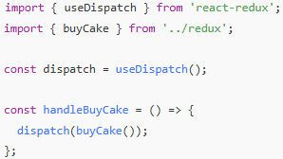

* This allows your component to **dispatch** an action (like buying a cake).

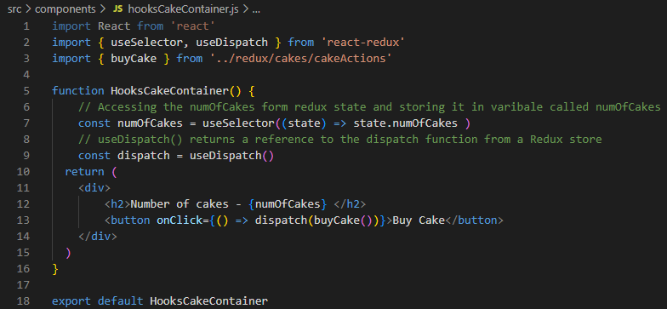

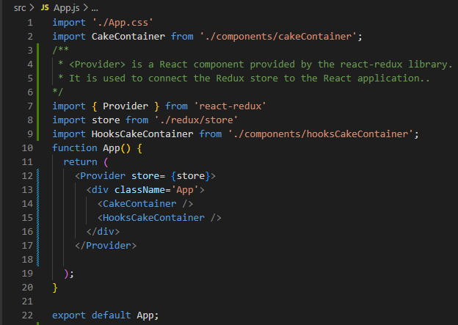

**Assume App has Ice-cream:**



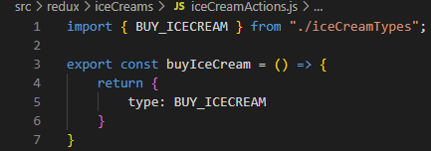

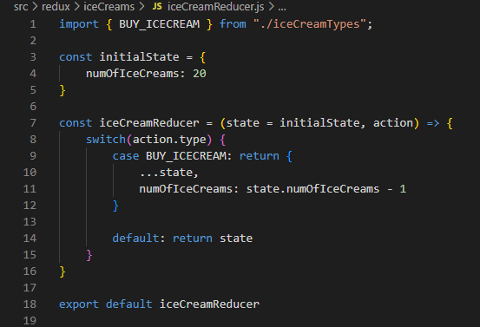This ice-cream reducer to **perform state transitions** based on the **action.**

**Now,** lets make sure our redux store aware about this ice-cream reducer.

**Remember,** legacy_createStore()function accepts only one reducer function.

However, if your application has **multiple slices of state** (like customers, policies, and claims in your project), you can **combine them into a single root reducer** using combineReducers.

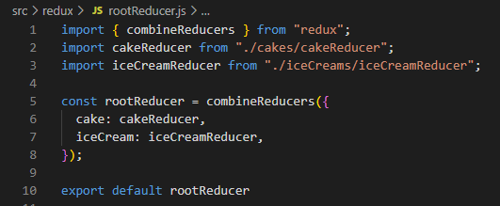

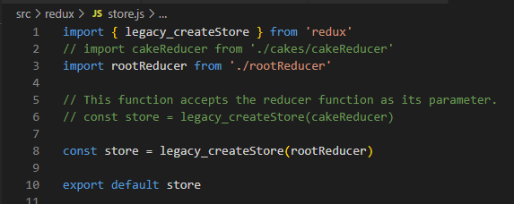

**Now,** Let’screate **IceCreamContainer** component

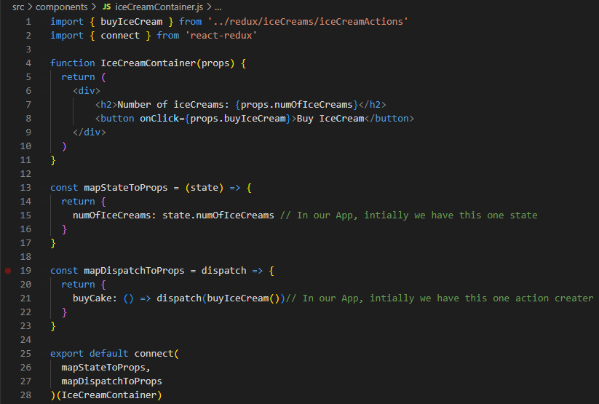

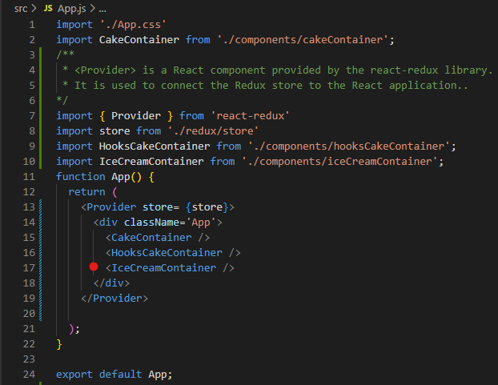

**When you run npm start the output you get:**

**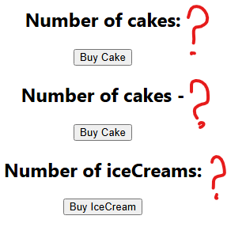  
This is because**, we have split global state into state that is individually managed by separate reducers.

Explanation:

import { createSlice, createAsyncThunk } from '@reduxjs/toolkit';

Here,

createSlice and createAsyncThunk — these are **core tools** for **managing state and async logic** in modern Redux apps.

**createSlice:**

Creates a **slice** of your Redux state — including:

* Initial state
* Reducers (for sync logic)
* Automatically generated action creators and action types

Syntax:

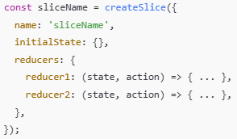

✅ What it gives you:

* A **reducer** function for the Redux store
* Auto-generated **action creators**
* Clean, concise, and organized structure

Example:

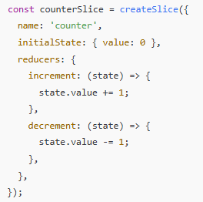

You get:

• counterSlice.reducer → use in store

• counterSlice.actions.increment() → dispatch in UI

**createAsyncThunk:**

It helps you handle **async API calls** (like fetching data) using Redux.

It generates:

* Pending / Fulfilled / Rejected **action types**
* Simplified logic for API handling

**Syntax:**

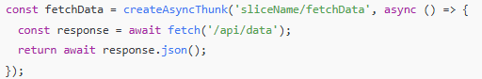

**✅ Behind the scenes:**

It dispatches:

* fetchData.pending when request starts
* fetchData.fulfilled if successful
* fetchData.rejected if error occurs

You handle these cases inside your extraReducers in createSlice.