Vite

1. pronounced "veet".
2. **modern build tool** developed by the creator of Vue.js, , but it works great with **React**, **Vanilla JS**, and more.

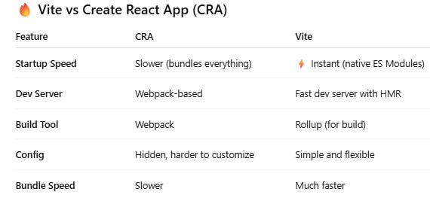

1. **How to Create a React Project with Vite**

**NOTE:** Creates React Application without vite

**npx create-react-app my-app** --- CRA command.

The built-in dependencies, tools, and setups comes along with above command:

| **Tool / Package** | **Purpose** |
| --- | --- |
| **React** | Core library for building UIs |
| **ReactDOM** | Renders React components to the DOM |
| **Babel** | Transpiles modern JavaScript/JSX → older JavaScript for browser support |
| **Webpack** | Bundler that builds, optimizes, and serves your app |
| **Jest** | Built-in testing framework |
| **React Testing Library** | For writing tests for React components |
| **ESLint** | Linter for JavaScript code quality |
| **PostCSS** | CSS processor used internally |
| **Autoprefixer** | Adds vendor prefixes to CSS rules |
| **Fast Refresh** | Live reload of React components during development |
| **Service Worker (optional)** | For PWA support |

**Remember,** Git repo is initialized automatically.

✅ Step-by-Step Vite React Setup:

* 1. Create a Vite + React app:  
     npm create vite@latest my-vite-app
  2. It will ask:  
     Project name → (e.g., my-vite-app)  
     Framework → Select: React  
     Variant → Select: JavaScript or TypeScript.

The built-in dependencies, tools, and setups comes along with above command:

| **Tool / Package** | | | **Purpose** | |
| --- | --- | --- | --- | --- |
| **React** | **Core UI library (if you selected React)** | |
| **ReactDOM** | **DOM rendering** | |
| **Vite** | **Fast dev server and build tool** | |
| **ESBuild (dev)** | **Used by Vite for fast dev mode (or SWC/Rollup depending on variant)** | |
| **Rollup (prod)** | **Used for production builds** | |
| **No testing library** | **You must manually install Jest or Vitest if needed** | |
| **No ESLint by default** | **You can add manually** | |

* 1. Go into project folder:  
     cd my-vite-app
  2. Install dependencies:  
     npm install
  3. Run the dev server:  
     npm run dev  
     Output:  
     VITE v5.0.0 ready in 300ms

Local: <http://localhost:5173>

Practical Example of React project creation using vite build tool:

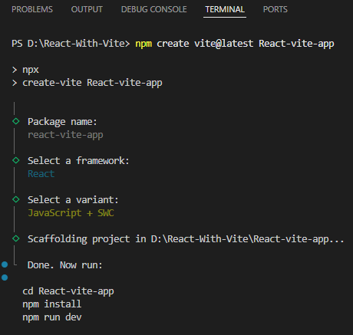

* NOTE: SWC (Speedy Web Compiler) a **super-fast JavaScript/TypeScript compiler** written in **Rust**. It's **much faster** than Babel when building and transforming JS code. It gives you **faster dev build and production compile times**.

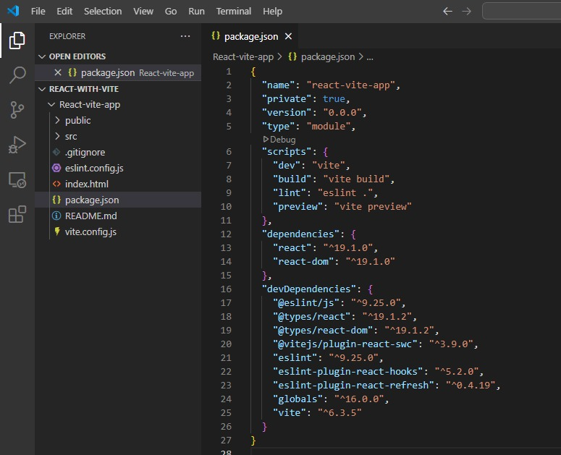

* Above is the package.json file and file and folders that are created before npm install command.

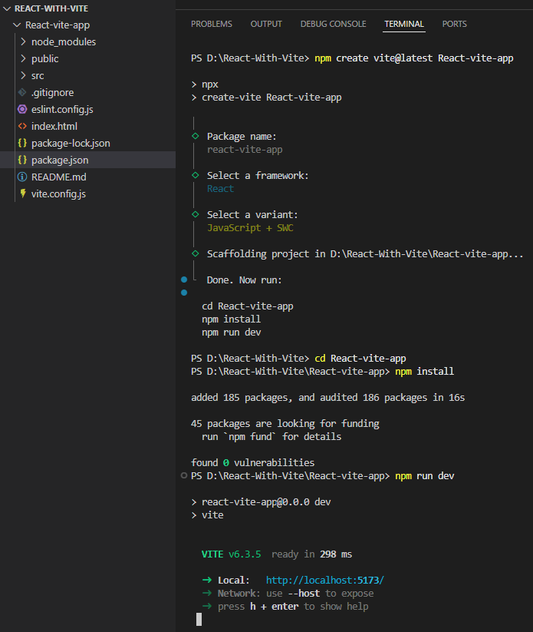

* Above is the picture depicting after npm install command that creates **node_modules** folder along with **package_lock.json**

**🧠 Key Points to Remember About Vite:**

* Vite serves files via **native ES Modules** — no bundling at dev time.
* It has **Hot Module Replacement (HMR)** out of the box — faster updates on file changes.
* Uses **Rollup** under the hood for production builds (highly optimized).
* It creates a simpler folder structure than CRA.

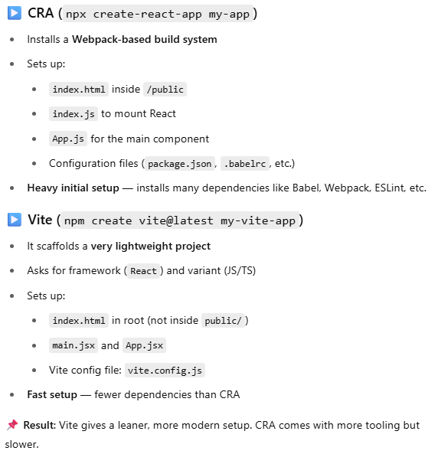

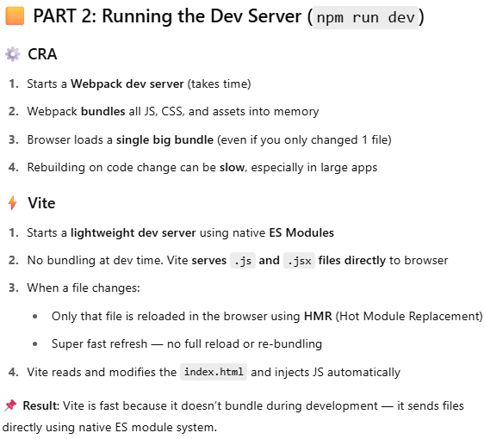

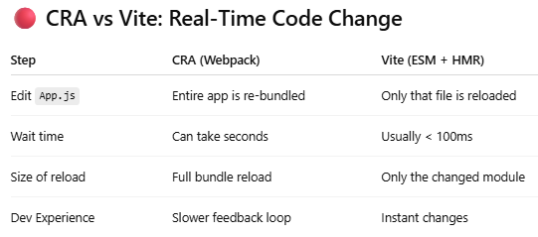

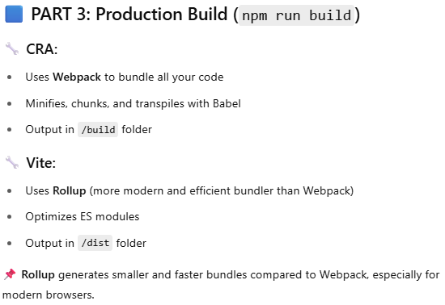

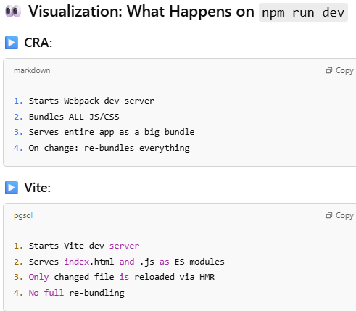

* + CRA was built for the older web ecosystem (pre-ES Modules).
  + Vite is built for **modern browsers** and **modern development**.