QUERY
CREATE TABLE STUDENT (
sid INT PRIMARY KEY,
sname VARCHAR(50),
dept VARCHAR(50),
marks INT
);
describe STUDENT;

SET SERVEROUTPUT ON;
SHOW SERVEROUT;
CREATE OR REPLACE TRIGGER trg_check1_marks
BEFORE INSERT ON STUDENT
FOR EACH ROW
BEGIN
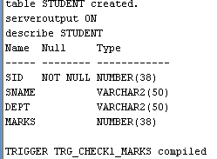

QUERY
INSERT INTO STUDENT VALUES (1, 'Anu', 'CSE', -85);
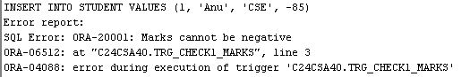
QUERY
INSERT INTO STUDENT VALUES (1, 'Anu', 'CSE', 85);
1.QUERY
CREATE OR REPLACE TRIGGER tri
AFTER INSERT ON customer_details
FOR EACH ROW
BEGIN
DBMS_OUTPUT.PUT_LINE('A row is inserted');
END;
/
INSERT INTO customer_details (cust_id, cust_name, address)
VALUES (1, 'Anu', 'Kochi');
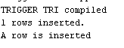
2.QUERY
CREATE OR REPLACE TRIGGER trig
AFTER INSERT ON emp_details
FOR EACH ROW
WHEN (NEW.salary > 20000)
BEGIN
DBMS_OUTPUT.PUT_LINE('Salary is greater than 20000');
END;
/

INSERT INTO emp_details(empid, empname, salary)
VALUES (2, 'Alen', 30000);

INSERT INTO emp_details(empid, empname, salary)
VALUES (2, 'Alen', 30000);
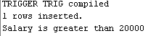

3.QUERY
INSERT INTO cust_count VALUES (0);
CREATE OR REPLACE TRIGGER trigg
BEFORE INSERT OR DELETE ON customer_details
FOR EACH ROW
BEGIN
IF DELETING THEN
UPDATE cust_count
SET count_row = count_row - 1;
ELSE
UPDATE cust_count
SET count_row = count_row + 1;
END IF;
END;
/
INSERT INTO customer_details VALUES (1, 'Anu', 'Kochi');
DELETE FROM customer_details WHERE cust_id = 1;
INSERT INTO customer_details VALUES( 2, 'arun', 'Kottayam');

SELECT * FROM cust_count;
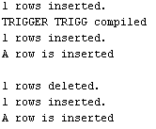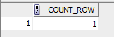

4.QUERY
CREATE TABLE deleted (
empid INT,
empname VARCHAR(30),
salary INT
);

CREATE TABLE updated (
empid INT,
empname VARCHAR(30),
salary INT
);
CREATE OR REPLACE TRIGGER trigge
BEFORE DELETE OR UPDATE ON emp_details
FOR EACH ROW
BEGIN
IF DELETING THEN
INSERT INTO deleted
VALUES (:OLD.empid, :OLD.empname, :OLD.salary);
ELSE
INSERT INTO updated
VALUES (:NEW.empid, :NEW.empname, :NEW.salary);
END IF;
END;
/
DELETE FROM emp_details WHERE empid = 2;
SELECT * FROM deleted;
UPDATE emp_details
SET salary = 10000
WHERE empid = 1;
SELECT * FROM updated;
