//1. Check prime and Armstrong number by using functions.
#include <stdio.h>
#include <stdio.h>
#include <math.h>

// Function to check if a number is prime
int isPrime(int num) {
if (num <= 1) return 0;

for (int i = 2; i <= sqrt(num); i++) {
if (num % i == 0) return 0;
}
return 1;
}

// Function to count digits in a number
int countDigits(int num) {
int count = 0;
while (num > 0) {
num /= 10;
count++;
}
return count;
}

// Function to check if a number is Armstrong
int isArmstrong(int num) {
int original = num;
int digits = countDigits(num);
int sum = 0;

while (num > 0) {
int digit = num % 10;
sum += pow(digit, digits);
num /= 10;
}

return (sum == original);
}

int main() {
int num;

// Input number
printf("Enter a number: ");
scanf("%d", &num);

// Check prime
if (isPrime(num))
printf("%d is a prime number.\n", num);
else
printf("%d is not a prime number.\n", num);

// Check Armstrong
if (isArmstrong(num))
printf("%d is an Armstrong number.\n", num);
else
printf("%d is not an Armstrong number.\n", num);

return 0;
}
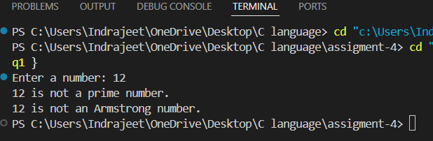//2. Convert a binary number to decimal and vice-versa
#include <stdio.h>
#include <math.h>

// Function to convert binary to decimal
long long binaryToDecimal(long long binary) {
long long decimal = 0, i = 0, remainder;

while (binary != 0) {
remainder = binary % 10;
decimal += remainder * pow(2, i);
binary /= 10;
i++;
}
return decimal;
}

// Function to convert decimal to binary
long long decimalToBinary(int decimal) {
long long binary = 0;
int i = 1, remainder;

while (decimal != 0) {
remainder = decimal % 2;
binary += remainder * i;
decimal /= 2;
i *= 10;
}
return binary;
}

int main() {
long long binary;
int decimal;

// Binary to Decimal
printf("Enter a binary number: ");
scanf("%lld", &binary);
printf("Decimal equivalent: %lld\n", binaryToDecimal(binary));

// Decimal to Binary
printf("\nEnter a decimal number: ");
scanf("%d", &decimal);
printf("Binary equivalent: %lld\n", decimalToBinary(decimal));

return 0;
}

