The results revealed a main effect of condition (see Figure XX). Participants rated compensators to be the most moral and trustworthy of all third-party actors. The *post hoc* tests revealed that all comparisons – except comparison between mixed and punisher conditions – were significant.

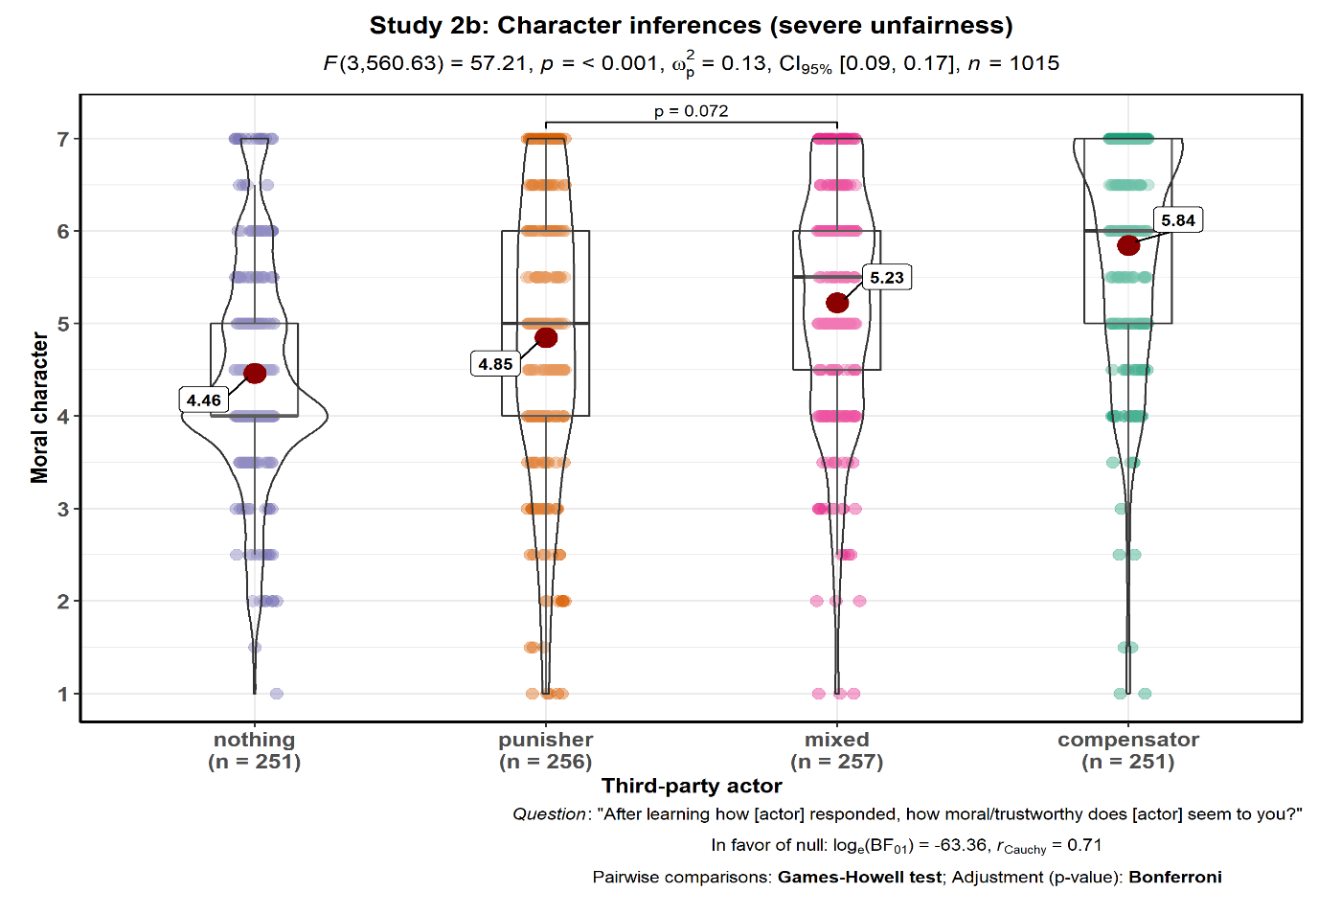

The one-way Welch’s ANOVA revealed a main effect of condition (*F*(3,560.63) = 57.21, *p* < 0.001, *pω*2 = 0.13, 95% CI [0.10, 0.17], *n* = 1015). Bayes factor test (with Cauchy prior width of 0.71) to quantify evidence for the alternative hypothesis relative to the null hypothesis of no mean differences across groups (BF10) was 4.36 × 1028. Participants rated compensators (*n* = 251, mean = 4.46) to be the more moral and trustworthy than other third-party actors that chose to do nothing (*n* = 251, mean = 4.46), punish (*n* = 256, mean = 4.85), or engaged in a mixed response (*n* = 257, mean = 5.23). The Bonferroni-corrected *post hoc* Games-Howell test revealed that all comparisons – except comparison between mixed and punisher conditions (*p* = 0.072) – were significant (*p* < 0.05).