**1.Write a program to find out the prime numbers.**

num = int(input())

if num > 1:

for i in range(2, int(num/2)+1):

if (num % i) == 0:

print(num, "is not a prime number")

break

else:

print(num, "is a prime number")

elif num == 1:

print(num, "is a prime number")

else:

print(num, "is not a prime number")

**Output:**

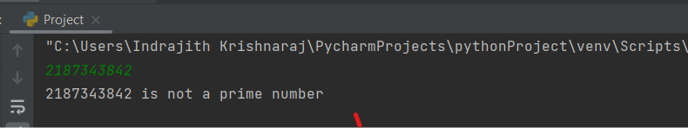

**2. Write a program to create the equation (a+b+c) * (a-b-c) * ab + a^2 + b ^2 + (abc)^3.**

a = int(input())

b = int(input())

c = int(input())

x = (a+b+c)*(a-b-c)*a*b+a**2+b**2+(a*b*c)**3

print(x)

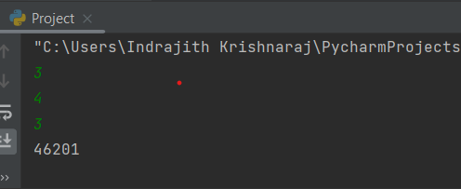

**3. Urlist = ['wood','knife','axe'] , mylist = ['tree', 'apple', 'mango', 'melon'] – combine two lists.**

urlist = ['wood','knife','axe']

mylist = ['tree', 'apple', 'mango', 'melon']

Wholelist = urlist + mylist

print(Wholelist)

Output:

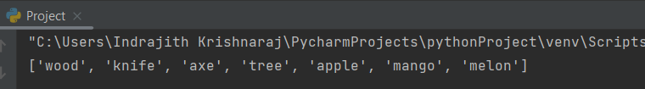

**4.write a program for natural number based on user input.**

Number = int(input())

if Number > 0 :

print('natural number')

else:

print('Not a Natural number')

Output:

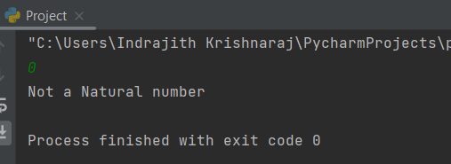

**5.write class and function for the equation sqrt(x1-x2) ^ 2 + sqrt( y1 – y2 ) ^2 using try except handling.**

class distance1:

def dist_Val(p1,p2,q1,q2):

try:

distance = (((p1 - p2) ** 2) + ((q1-q2) ** 2)) ** 0.5

return distance

except TypeError:

print('Invalid Input: Check the input is int')

d1 = distance1.dist_Val(3,5,3,4)

print(d1)

**Or** we can import math and use sqrt function by the below code:

class distance:

def distance_values(x1,x2,y1,y2):

distance = math.sqrt(((x1 - x2) ** 2) + ((y1 - y2) ** 2))

return distance

import math

a1 = int(input())

b2 = int(input())

c1 = int(input())

d2 = int(input())

d = distance.distance_values(a1,b2,c1,d2)

print(d)

**Output:**

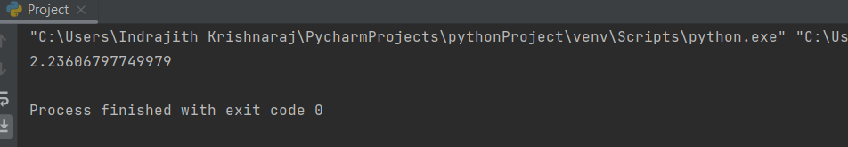

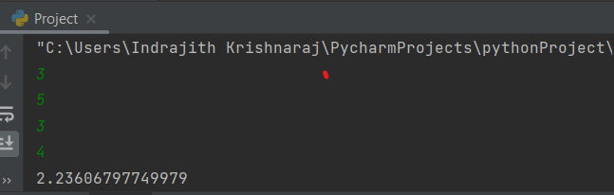

**6. Name = “Guvi python” - write a program to get “python” word from the string.**

Name = 'Guvi python'

print(Name[5:])

Output:

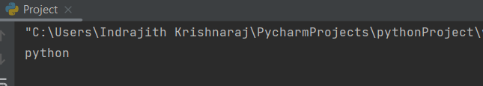

**7.Using class and function - Write a program for palindrome Ex. Madam.**

class palin:

def val(text):

x = text[:]

y = text[::-1]

if x == y :

print("Palindrome")

else:

print("Not a Palindrome")

ob = input()

Word = palin.val(ob)

**Output:**

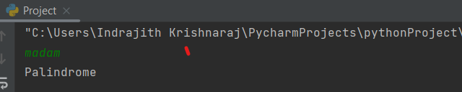

**8. Using file handling – write a text file in ur system with “hello world”**

Method : 1

f = open('Myfile.txt','x')

f = open('Myfile.txt', 'w')

f.write('Hello World')

f.close()

Method 2:

f = open('Myfile2.txt','w')

f.write('Hi Python')

f.close()

Output:

A file contains a word Hello World.

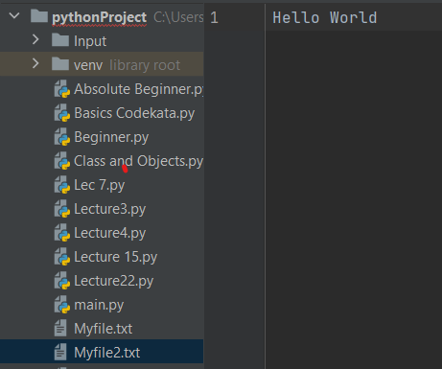

**9. Create option button using tkinter GUI in python.**

from tkinter import *

window = Tk()

window.title("Frames")

font = ('Times New Roman', 30)

frm_A = Frame()

frm_A = Frame(relief=RAISED)

lbl_A = Button(master=frm_A, bg = 'silver', text='Button', font= font, width=15)

lbl_A.pack()

frm_A.pack(side = BOTTOM)

window.mainloop()

**Output:**

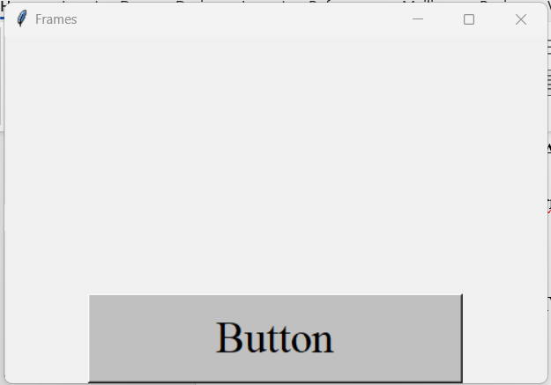

**10. Keep only numbers from the following string x = “89e9jcd^o38829@3%3,/mkl$w1”**

import re

x = " 89e9jcd^o38829@3%3,/mkl$w1"

Num = re.findall('\d', x)

print(Num)

print(len(Num))

Output:

