Model question paper

1. List the process needed for the mapping of regular entities from ER to relational model. [2,8]
  
  
2. One of the desirable property of a transaction is atomicity. Comment on it. [5,2]
  
  
3. Define entity and attribute in ER model. [1,8]
  
  
4. Write the syntax for creating a FOREIGN KEY in SQL. [3,2]
  
  
5. What is primary index? [4,9]
  
  
6. What are views? Explain with an example how to create views in SQL. [3,9]
  
  
7. Explain the concept of Data owner in data management. [5,6]
  
  
8. Draw the transition diagram to show the various states for transaction execution. [5,1]
  
  
9. Explain PROJECT operation in relational algebra. Show with an example PROJECT operation is not commutative. [2,4]
  
  
10. Explain the relational model concepts of DBMS. [2,1]
  
  
11. With a proper example show that Union operation is commutative. [2,5]
  
  
12. Explain the process needed for the mapping of weak entities from ER to relational model. [2,8]
  
  
13. Briefly describe the initial conceptual design of the company database. [1,8]
  
  
14. Create the following tables:
Write SQL queries for the following.
a. Insert 5 records in each table
b. Update the contact number of Manager with id=’M201’
c. Find the number of departments
d. Display the department names with the manager’s name
e. Display the details of managers belonging to the department having dept-IDs between 101and 105.
f. Create a view from MANAGER table.
[3,7]
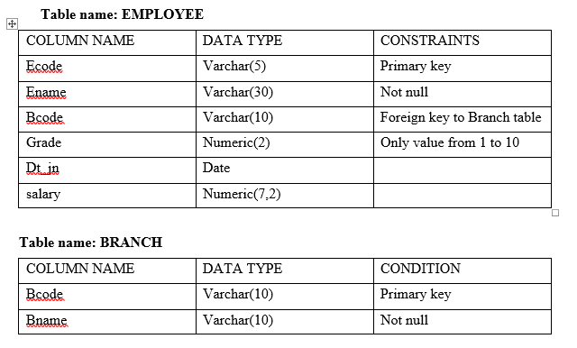  
  
15. Consider the following relation for LOTS(country_name,LotNo,Area, Price, Tax_rate) The primary key is (country_name,lotNo). Suppose the following dependencies exist: country_name --> Taxrate and Area --> price. What normal form is the relation in? Explain your answer. Apply normalization until you cannot decompose the relation further. State the reasons behind each decomposition. [4,6]
  
  
16. Define the following terms as they apply to the relational model of data: domain, entity, attribute, relation schema, relation state, degree of a relation, relational database schema, and relational database state. [2,2]
  
  
17. What is the need of providing security to database? Explain. [5,4]