***Domain Expertise Workshop***

***Indrajith R Nair***

***24PMC121***

***Screenshots:***

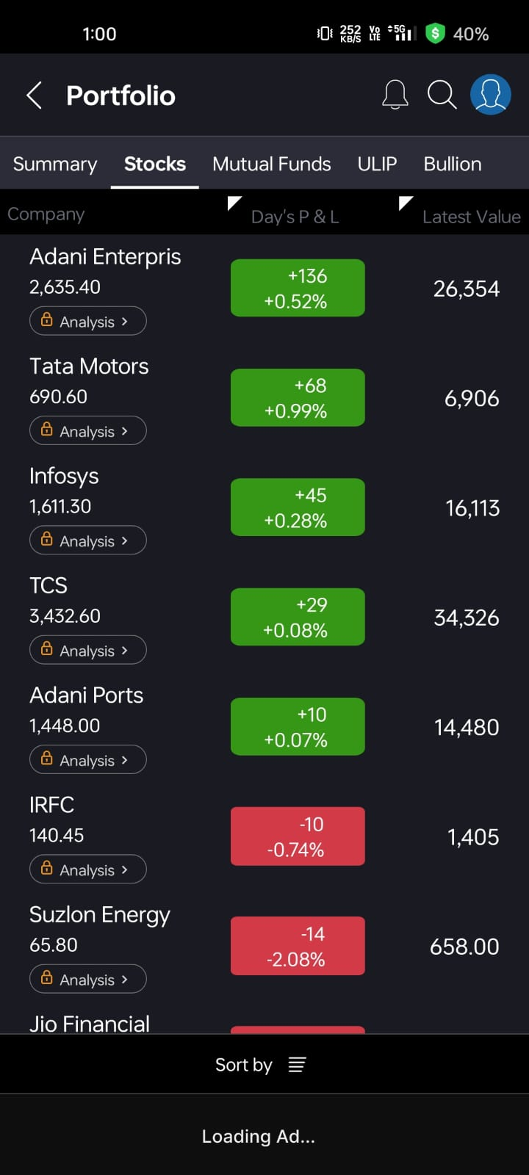 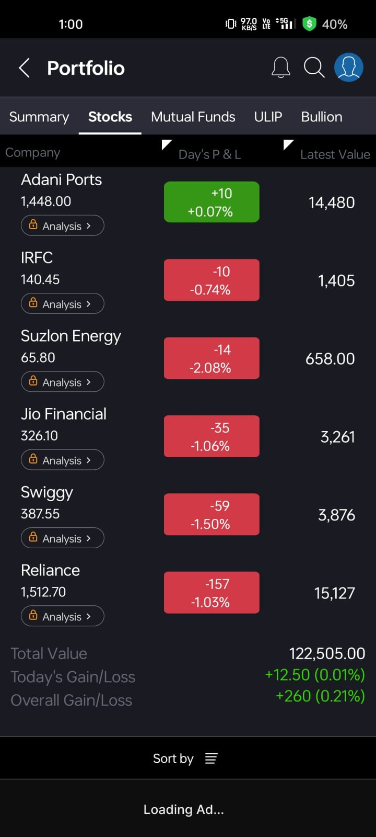

***Portfolio Report – Share Selection & Justification***

*I have selected a diverse set of 10+ shares for my portfolio, with a focus on companies from different sectors to balance risk and growth potential. Below is a summary of the shares chosen and the reasons behind each selection:*

***1. Adani Enterprises***

* ***Sector****: Infrastructure & Energy*
* ***Reason****: It is a flagship company of the Adani Group, showing consistent growth and diversification into sectors like airports, roads, and green energy.*

***2. Tata Motors***

* ***Sector****: Automotive*
* ***Reason****: A major player in the Indian and global auto market, especially in the EV space with Tata EV models gaining popularity.*

***3. Infosys***

* ***Sector****: IT Services*
* ***Reason****: A reliable performer in the IT industry, known for innovation and strong financials. Good for long-term growth.*

***4. TCS (Tata Consultancy Services)***

* ***Sector****: IT Services*
* ***Reason****: One of India’s top IT companies with global operations and consistent dividend payouts.*

***5. Adani Ports***

* ***Sector****: Logistics / Infrastructure*
* ***Reason****: India’s largest private port operator with high strategic value and expansion in trade logistics.*

***6. IRFC (Indian Railway Finance Corporation)***

* ***Sector****: Public Sector Finance*
* ***Reason****: A PSU involved in funding Indian Railways; considered stable and dividend-yielding.*

***7. Suzlon Energy***

* ***Sector****: Renewable Energy*
* ***Reason****: A turnaround story in the clean energy sector with growing relevance amid India’s green energy push.*

***8. Jio Financial Services***

* ***Sector****: Financial Services*
* ***Reason****: A new entrant from the Reliance group, expected to grow significantly with its digital financial ecosystem.*

***9. Swiggy***

* ***Sector****: Food Delivery / Tech*
* ***Reason****: High growth potential in India’s fast-expanding digital and food-tech economy.*

***10. Reliance Industries***

* ***Sector****: Conglomerate (Oil, Telecom, Retail)*
* ***Reason****: A strong player with diversified investments in telecom (Jio), retail, and green energy. Long-term growth stock.*

***Summary***

*I chose this portfolio to maintain sectoral diversity and include a mix of established companies (Infosys, TCS, Reliance), growth-oriented stocks (Swiggy, Jio Financial), and green energy prospects (Suzlon). This combination aims to provide stability, returns, and future growth.*