**Domain Expertise Workshop**

**Indrajith R Nair**

**24PMC121**

**Screenshots:**

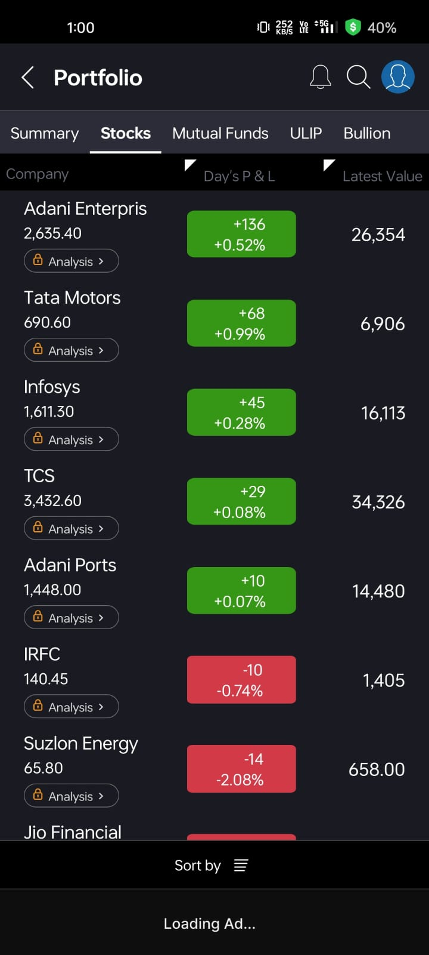 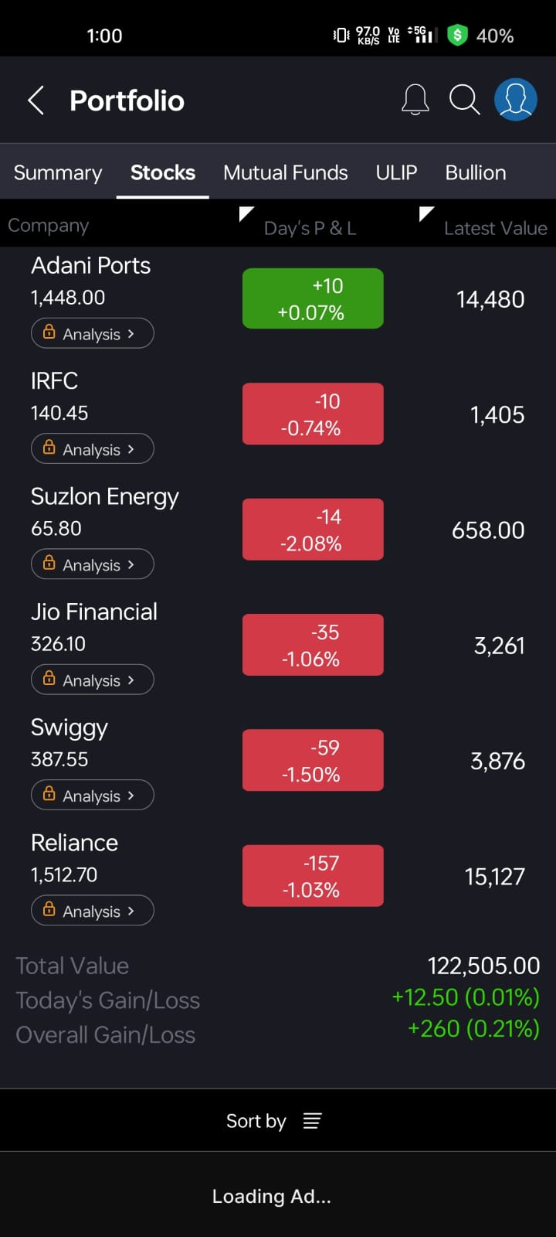

**Portfolio Report – Share Selection & Justification**

I have selected a diverse set of 10+ shares for my portfolio, with a focus on companies from different sectors to balance risk and growth potential. Below is a summary of the shares chosen and the reasons behind each selection:

**1. Adani Enterprises**

* **Sector**: Infrastructure & Energy
* **Reason**: It is a flagship company of the Adani Group, showing consistent growth and diversification into sectors like airports, roads, and green energy.

**2. Tata Motors**

* **Sector**: Automotive
* **Reason**: A major player in the Indian and global auto market, especially in the EV space with Tata EV models gaining popularity.

**3. Infosys**

* **Sector**: IT Services
* **Reason**: A reliable performer in the IT industry, known for innovation and strong financials. Good for long-term growth.

**4. TCS (Tata Consultancy Services)**

* **Sector**: IT Services
* **Reason**: One of India’s top IT companies with global operations and consistent dividend payouts.

**5. Adani Ports**

* **Sector**: Logistics / Infrastructure
* **Reason**: India’s largest private port operator with high strategic value and expansion in trade logistics.

**6. IRFC (Indian Railway Finance Corporation)**

* **Sector**: Public Sector Finance
* **Reason**: A PSU involved in funding Indian Railways; considered stable and dividend-yielding.

**7. Suzlon Energy**

* **Sector**: Renewable Energy
* **Reason**: A turnaround story in the clean energy sector with growing relevance amid India’s green energy push.

**8. Jio Financial Services**

* **Sector**: Financial Services
* **Reason**: A new entrant from the Reliance group, expected to grow significantly with its digital financial ecosystem.

**9. Swiggy**

* **Sector**: Food Delivery / Tech
* **Reason**: High growth potential in India’s fast-expanding digital and food-tech economy.

**10. Reliance Industries**

* **Sector**: Conglomerate (Oil, Telecom, Retail)
* **Reason**: A strong player with diversified investments in telecom (Jio), retail, and green energy. Long-term growth stock.

**Summary**

I chose this portfolio to maintain sectoral diversity and include a mix of established companies (Infosys, TCS, Reliance), growth-oriented stocks (Swiggy, Jio Financial), and green energy prospects (Suzlon). This combination aims to provide stability, returns, and future growth.