**INTERNSHIP REPORT**

**ON**

**PYTHON COMPITATIVE CODEING**

**Internship Report is submitted**

**In accordance with requirement of degree of**

**BACHELOR OF TECHNOLOGY**

**IN**

**ELECTRICAL AND ELECTRONICS ENGINEERING**

Submitted by

P.INDRANI

21KQ1A0269

Under the Mentorship of

**SRAVAN MANTRI**



**DEPARTMENT OFELECTRICAL AND EL ECTRONICS ENGINEERING**

PACE INSTITUTE OF TECNOLOGY AND SCIENCES (AUTONOMOUS)

(AffiliatedtoJawaharlalNehruTechnologicalUniversityKakinada,Kakinada&

Accredited by NAAC ‘A’ GRADE,An ISO 9001-2015 Certified Institution)

NH-16, Valluru Post , Prakasam District, A.P-523272.

(2024-2025)

# PROJECT TITTLE

# PATIENT PULSE ANALYSIS

**Date:**june 11th 2024

**Name**:p.Indrani

ABSTRACT: This project is about brief explination and display about patient pulse analysis. In this analysis we verify how many female patients and male patients are there with there age differences and heart rate, blood pressure, sugar level differences and who has maximum and minimum heart rate and blood pressure and sugar level.

DESCRIPTION: This project is about patient pulse analysis . we take the input as the patient health details .we analysis the patient health conditions based on heart rate, blood pressure and sugar levels.

**Requirements:**

**Functional requirements:**

.patient details: user can take input as number of patients

gender: user can take gender differences and store

.condition of patient: user can take the maximum health rate and blood pressure and sugar level

**Non functional requirements:**

**Performance**: The system is provide real time analysis with minimal latency to ensure timely patient monitoring

**Reliability**: It should be highly dependable ensuring accurate pulse measurements consistently

**Scalability**: The system should be able to handle varying loads from individual patient monitoring to large scale health care facilities

**Security**: protecting patient data is crucial so the system must comply with health care privacy regulations and employ robust encryption methods.

**Usability**: The interface should be intuitive and user friendly and health care professionals to easily interpret and utilize the pulse analysis data.

**Accuracy**: The analysis should be highly accurate with minimal margin of error to ensure the reliability of the diagnostic information provided.

**APPROACH:**

**1.Data acquisition**: obtain the pulse data from the patient using sensors such as photo plethysmo graphy (ppg) sensors which measure changes in blood volume in the microvascular bed of tissue .

**2.signal processing** : pre process the raw pulse data to remove noise and artifacts and extract relevant features such as pulse rate ,pulse wave form morphology and variability .

**3.Features extraction:** Identify key features from the processed pulse that are indicative of the patients health status.

**4.Pattren Recognition**: Analyze the extracted features using pattern Recognition algorithms to identify patterns associated with specific health condition or anomalies

**5.descriptive analytics:** use statistical methods to summarize and describe historical data .This includes calculating the average health rate and blood pressure and sugar levels and other relevant matrics.

**6**.**Continuous monitoring**: Implement continuous monitoring machanisms to track changes in the patients pulse over time , enabling early detection of abnormalities or trends indicative of deteriorating health.

**7. Coding** : To perform this project to create patient health condition details and analysis of patient pulse .here we can perform a coding using python language.

**Program or source code:**

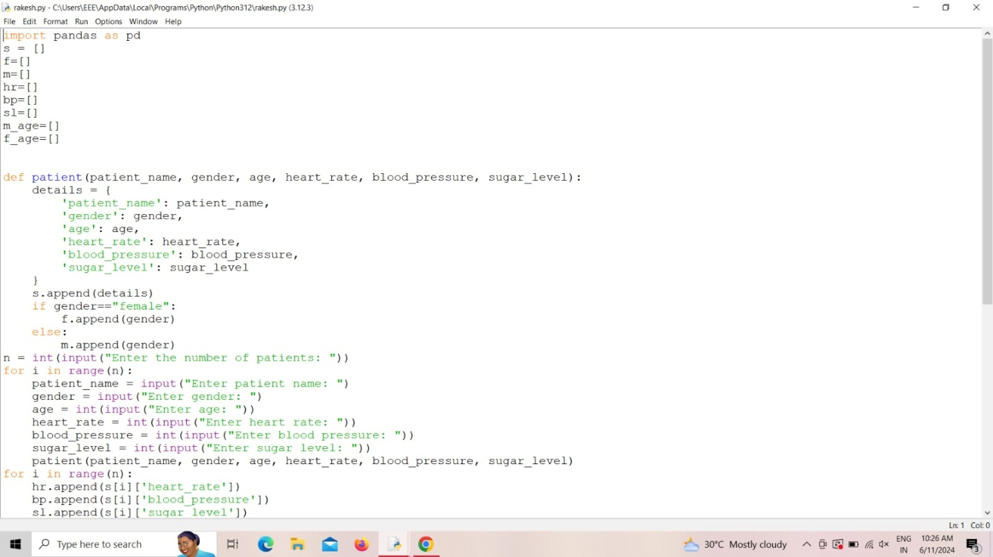

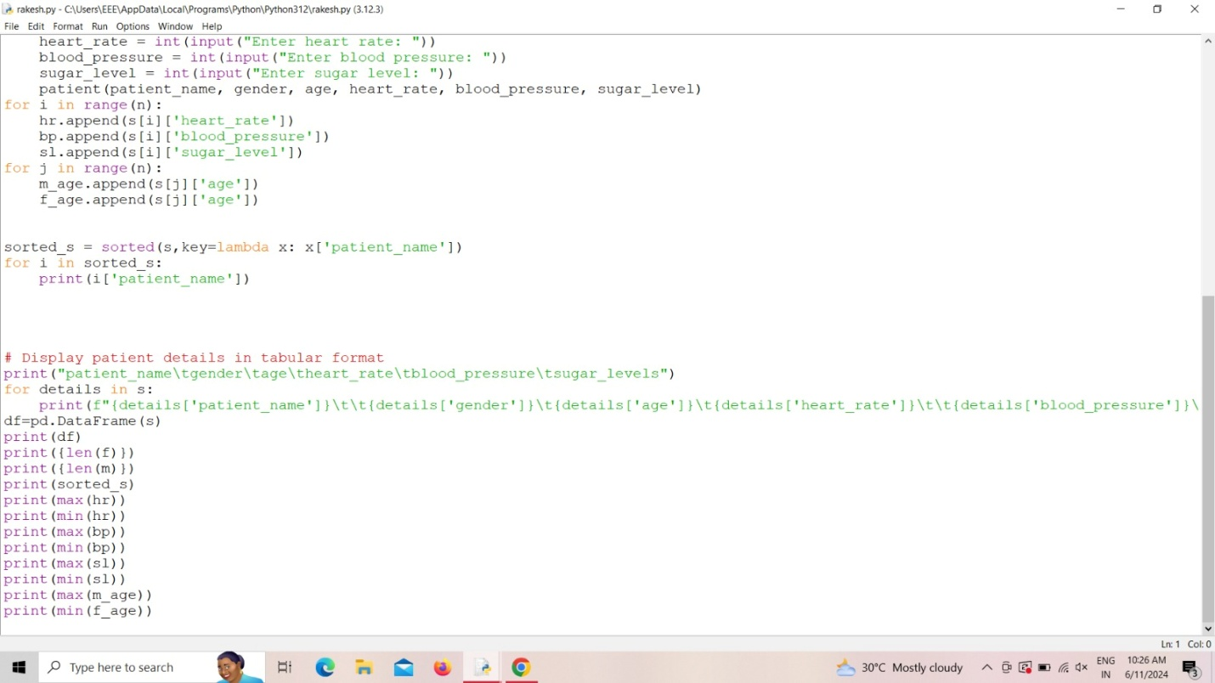

**OUTPUT:**

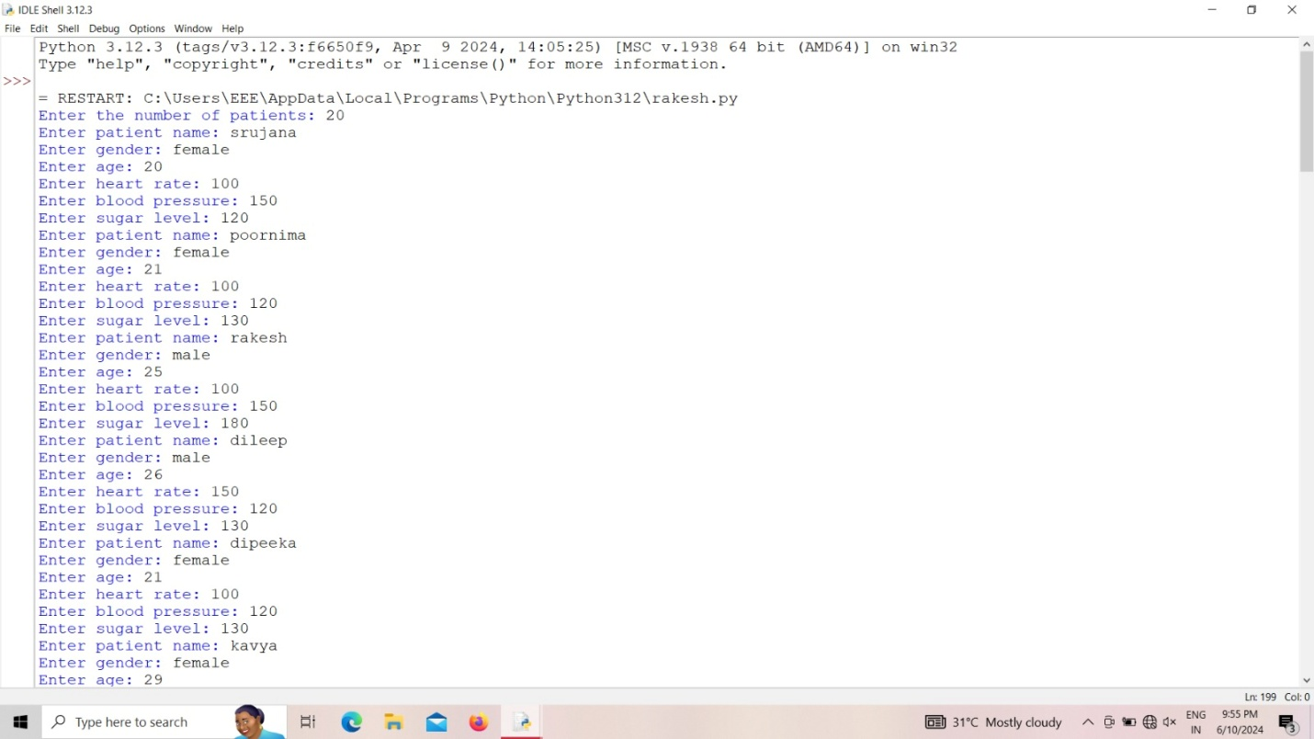

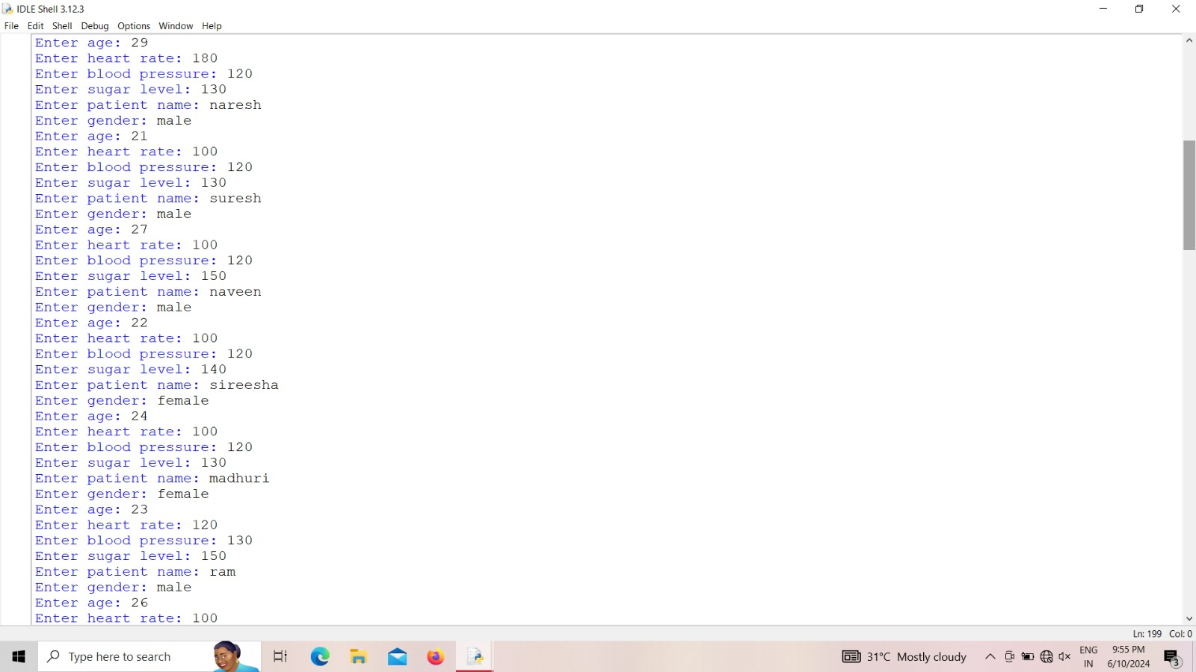

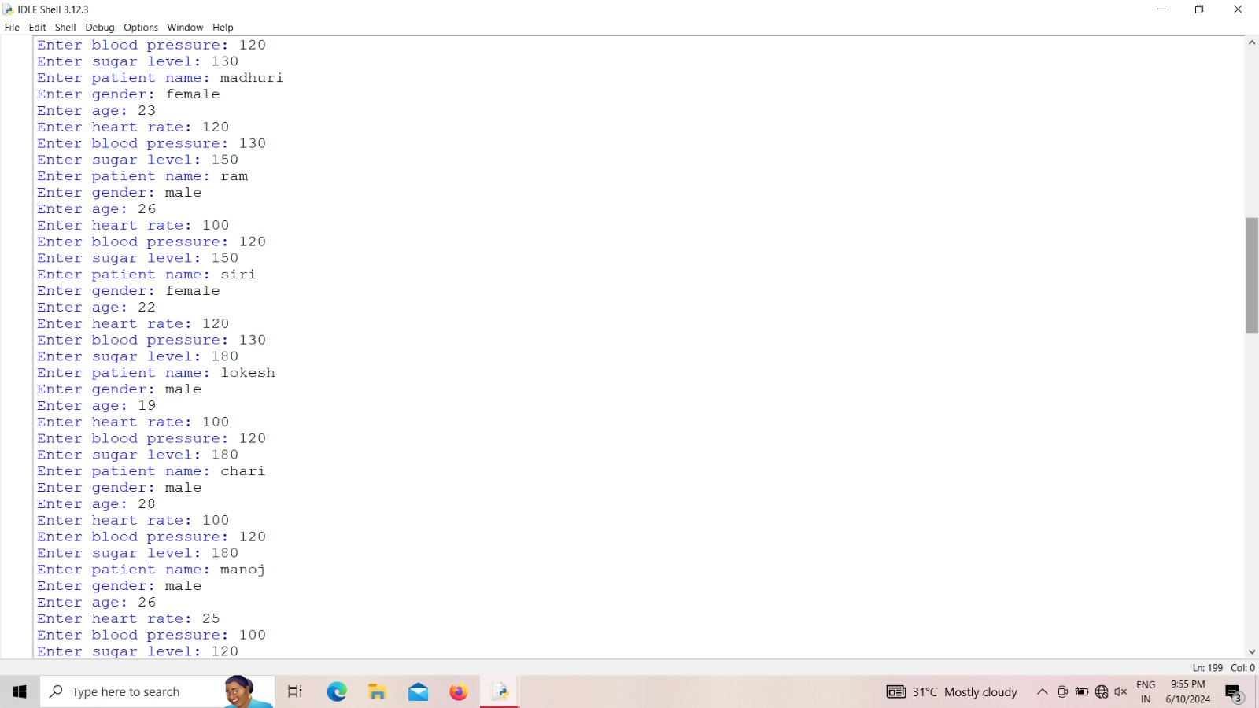

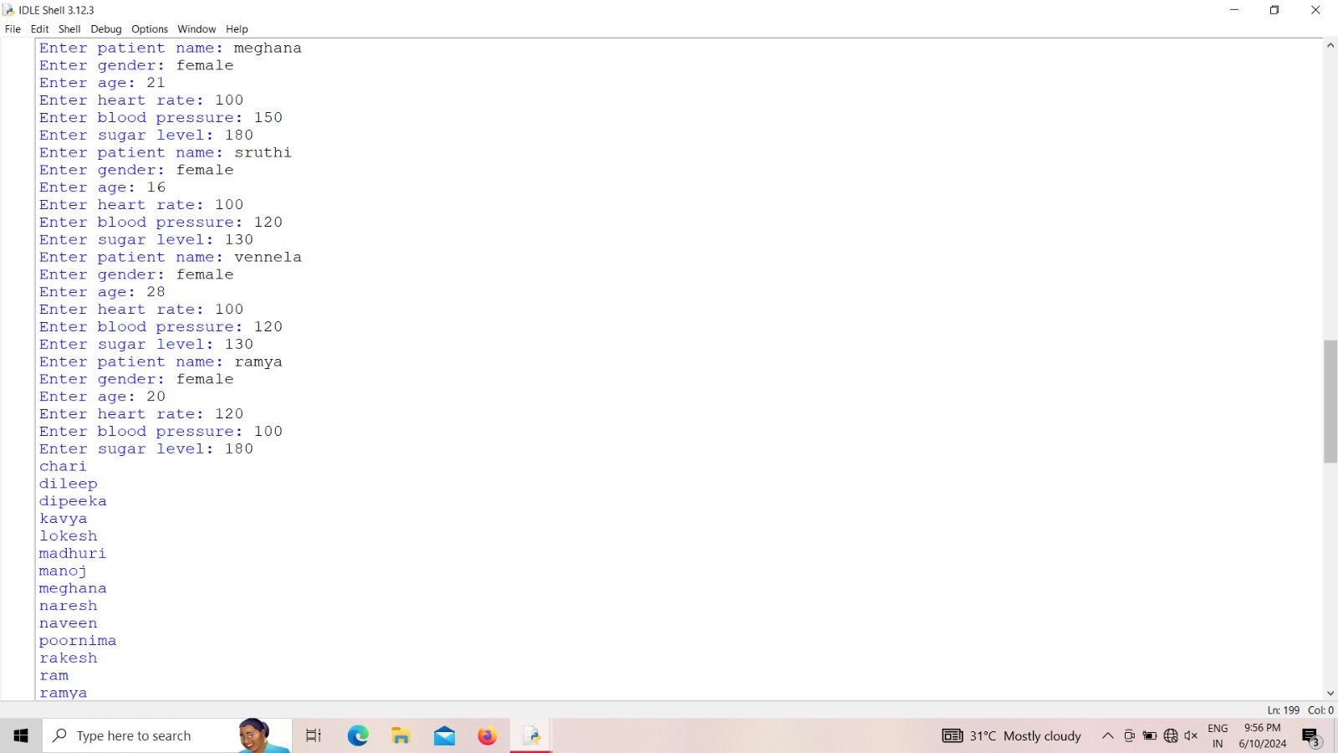

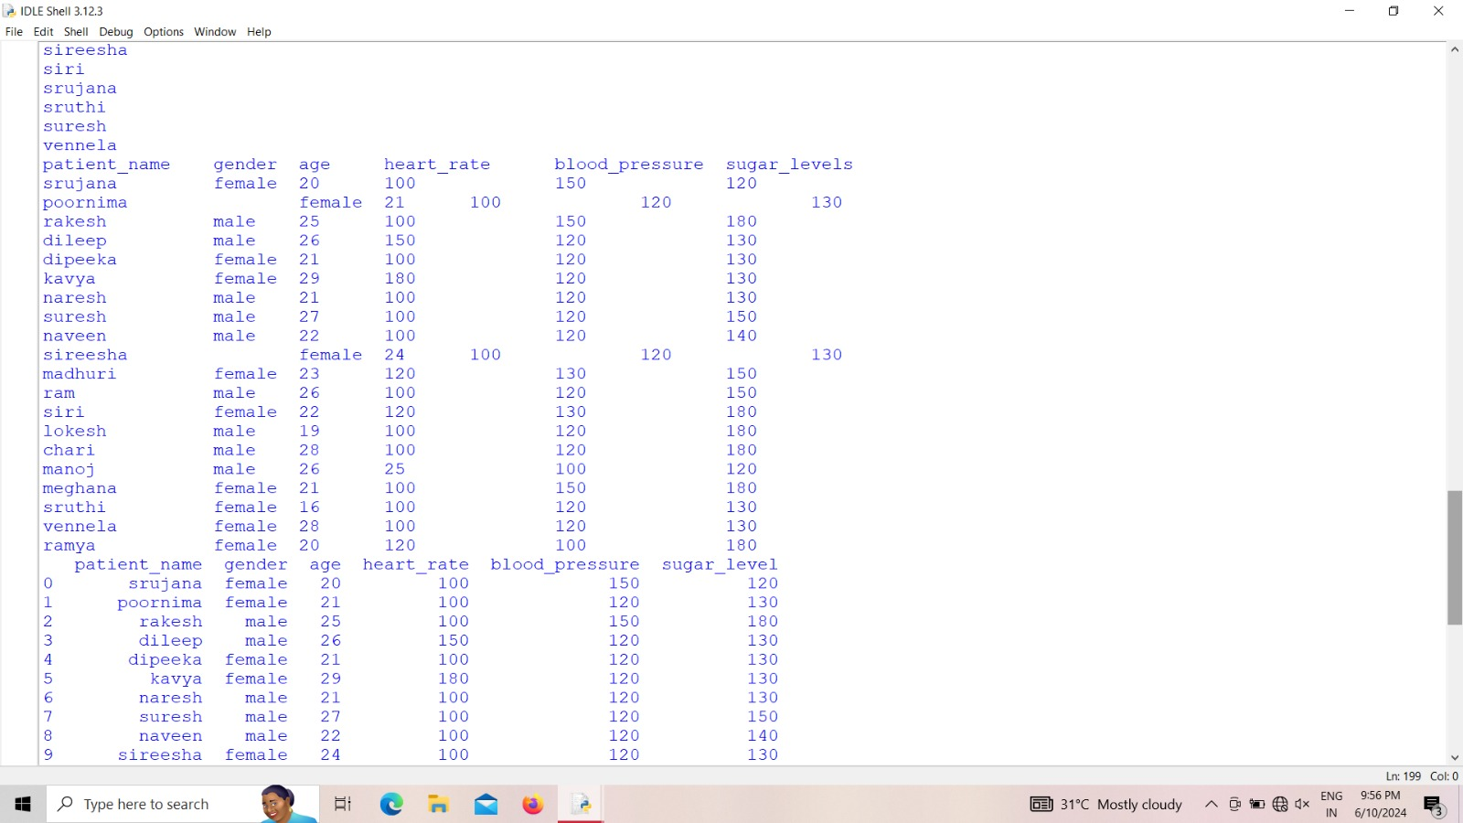

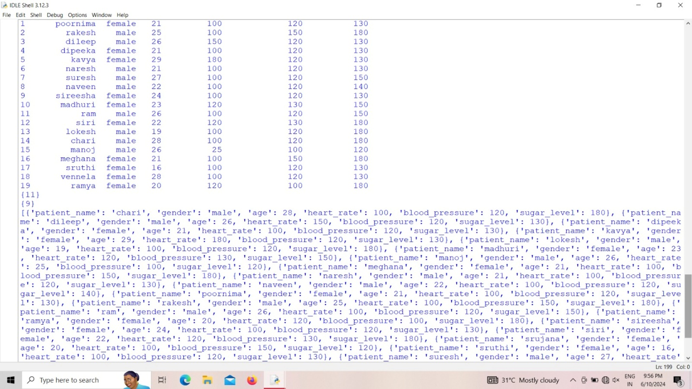

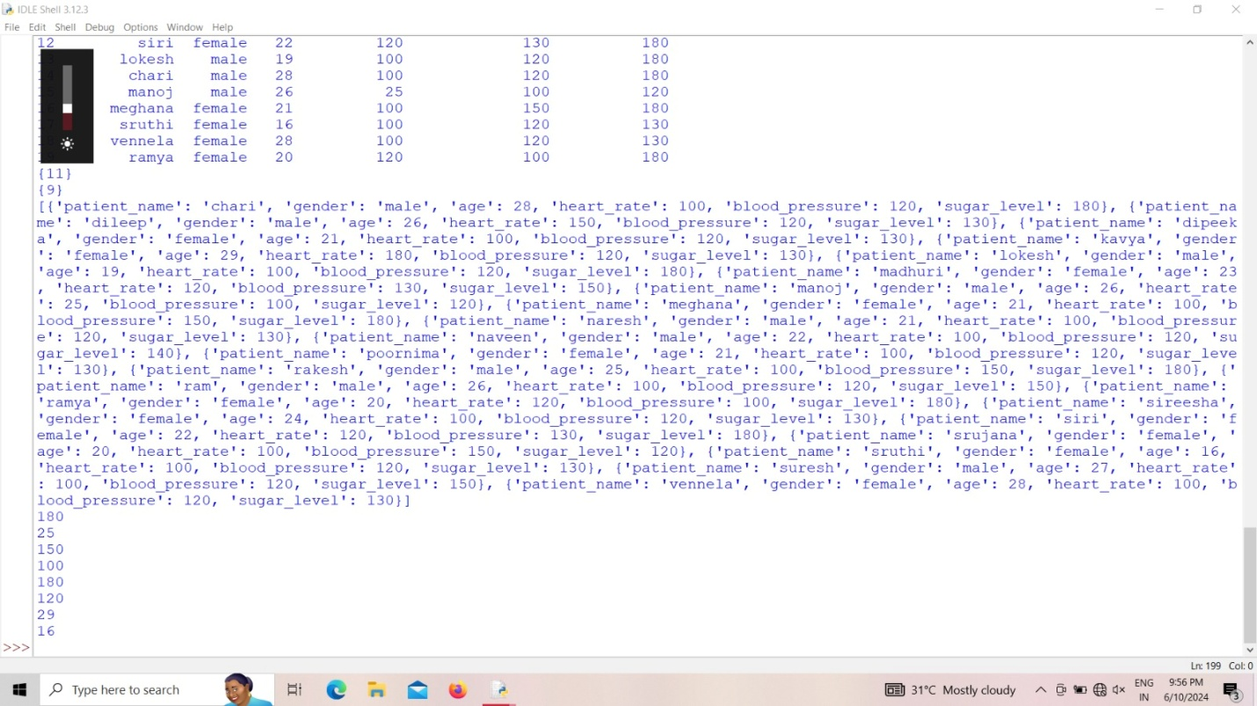

**Explanation:**

For this progect of patient pulse analysis, we can analysis the health status of the patients and their problems.

**1.User interaction**: First user can analysis the patient details ,gender age, health rate ,blood pressure, sugar levels

**2. How to approach**: For analysis the patient pulse analysis, we approach our mentors for the process and they gauid us how to analysis of patient pulse analysis. In that gaudiness we create a source or code to make a details of the patients health condition.

### Conclusion

Regular and systematic pulse analysis is vital for the early detection and management of various health conditions. This essential skill for healthcare providers requires minimal equipment and offers immediate, valuable information about a patient's cardiovascular status.