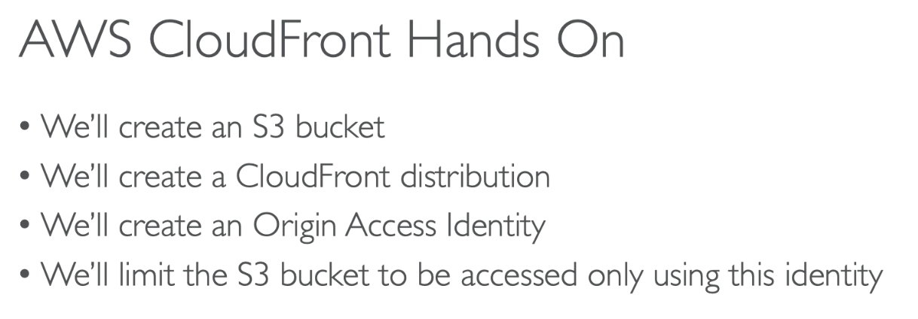

Create CloudFront Distribution
- S3 bucket
  - Create bucket, Name: my-content-through-cloudfront
  - Upload a few file to it
- CloudFront
  - Create distribution
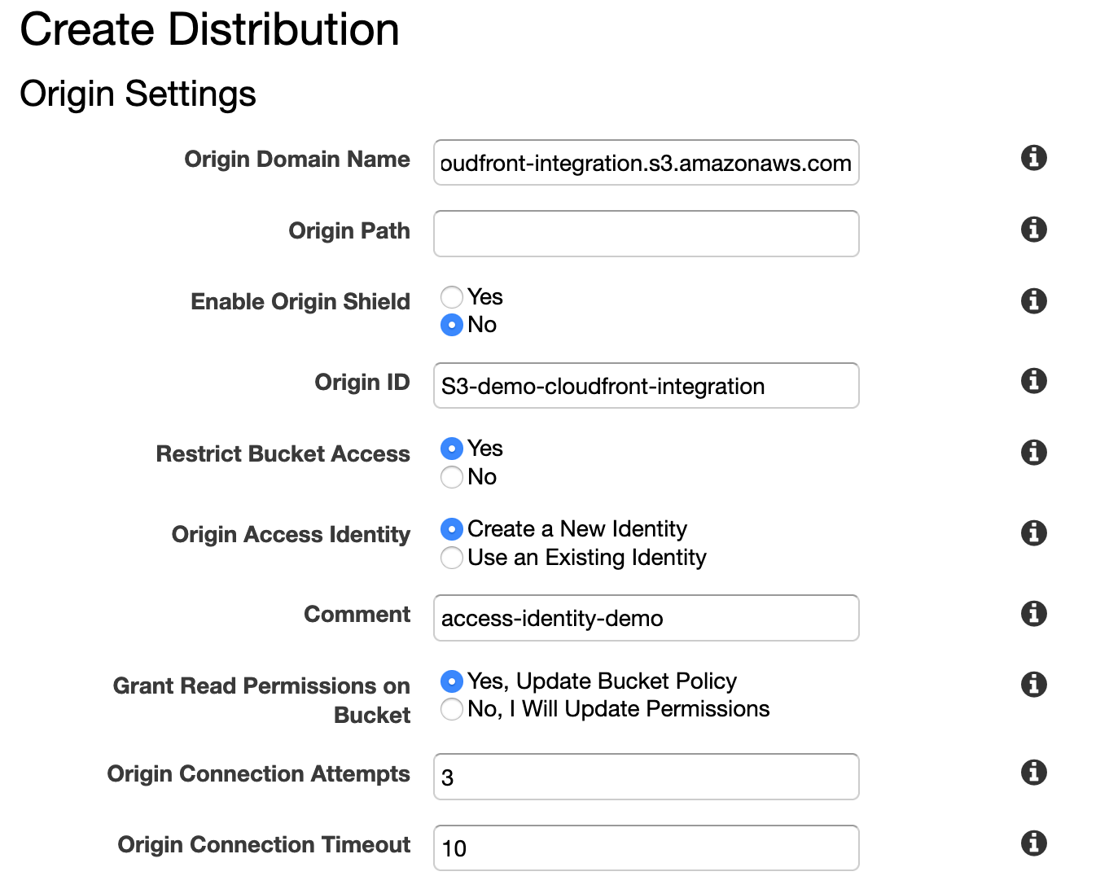
  - CloudFront distribution takes time to get created
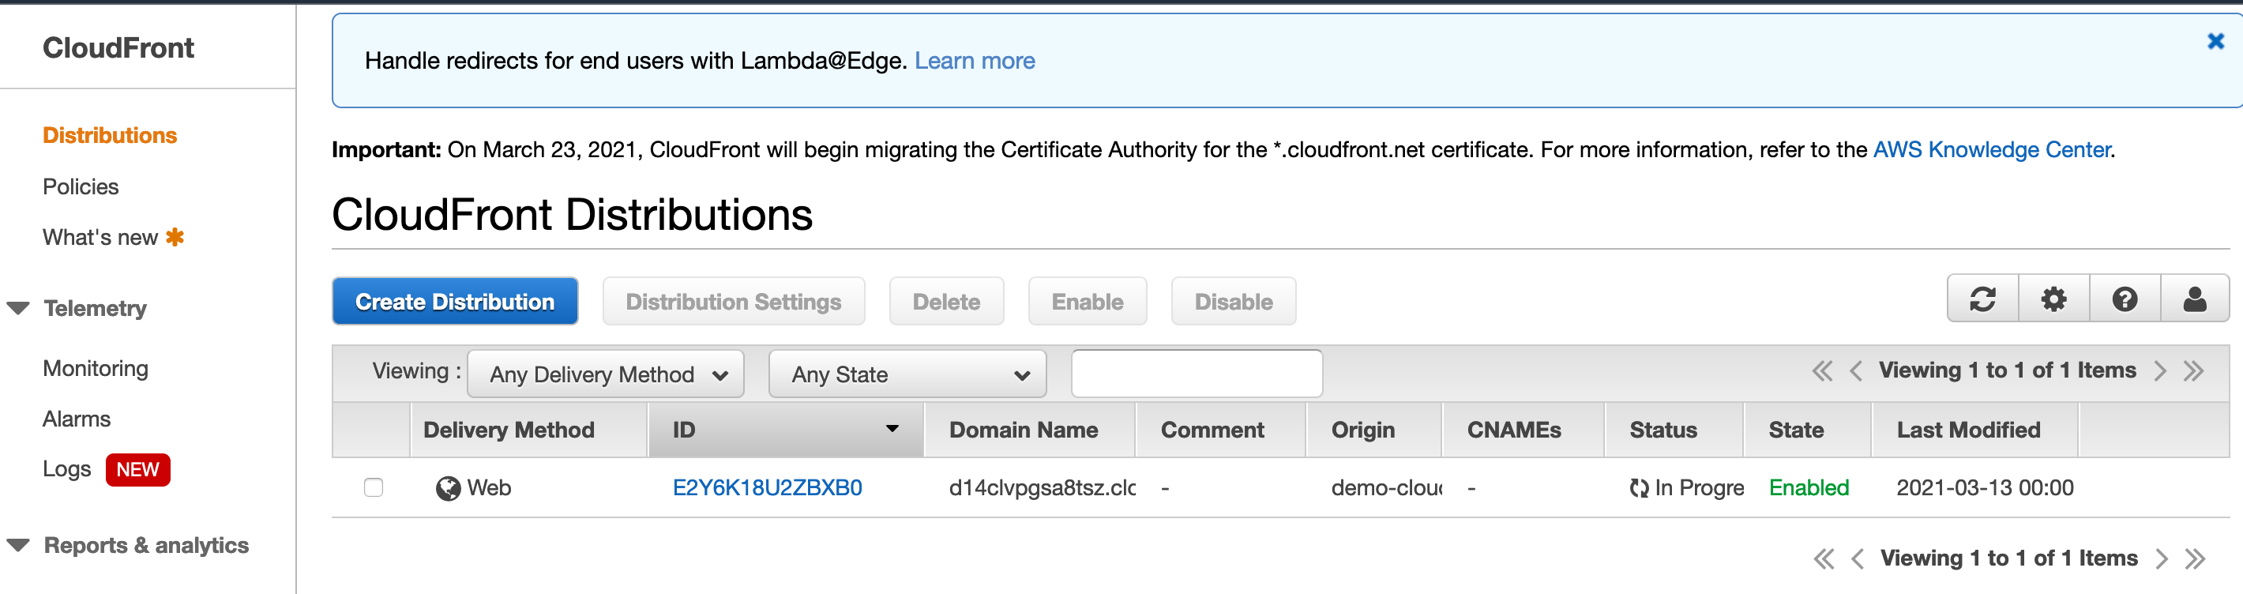
- Note that we have a Origin access identity (OAI) got created along with the distribution
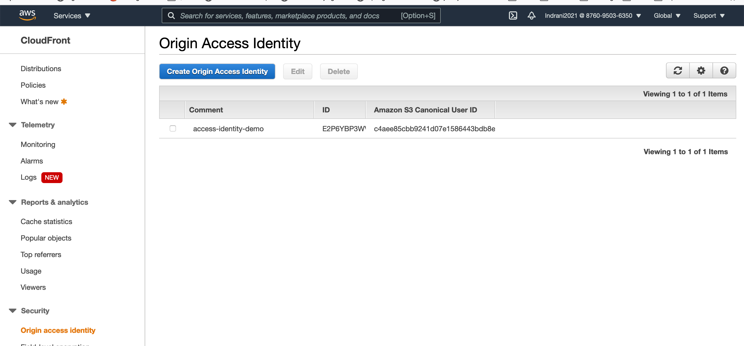

- Go to S3 bucket policy, see a policy has been created already
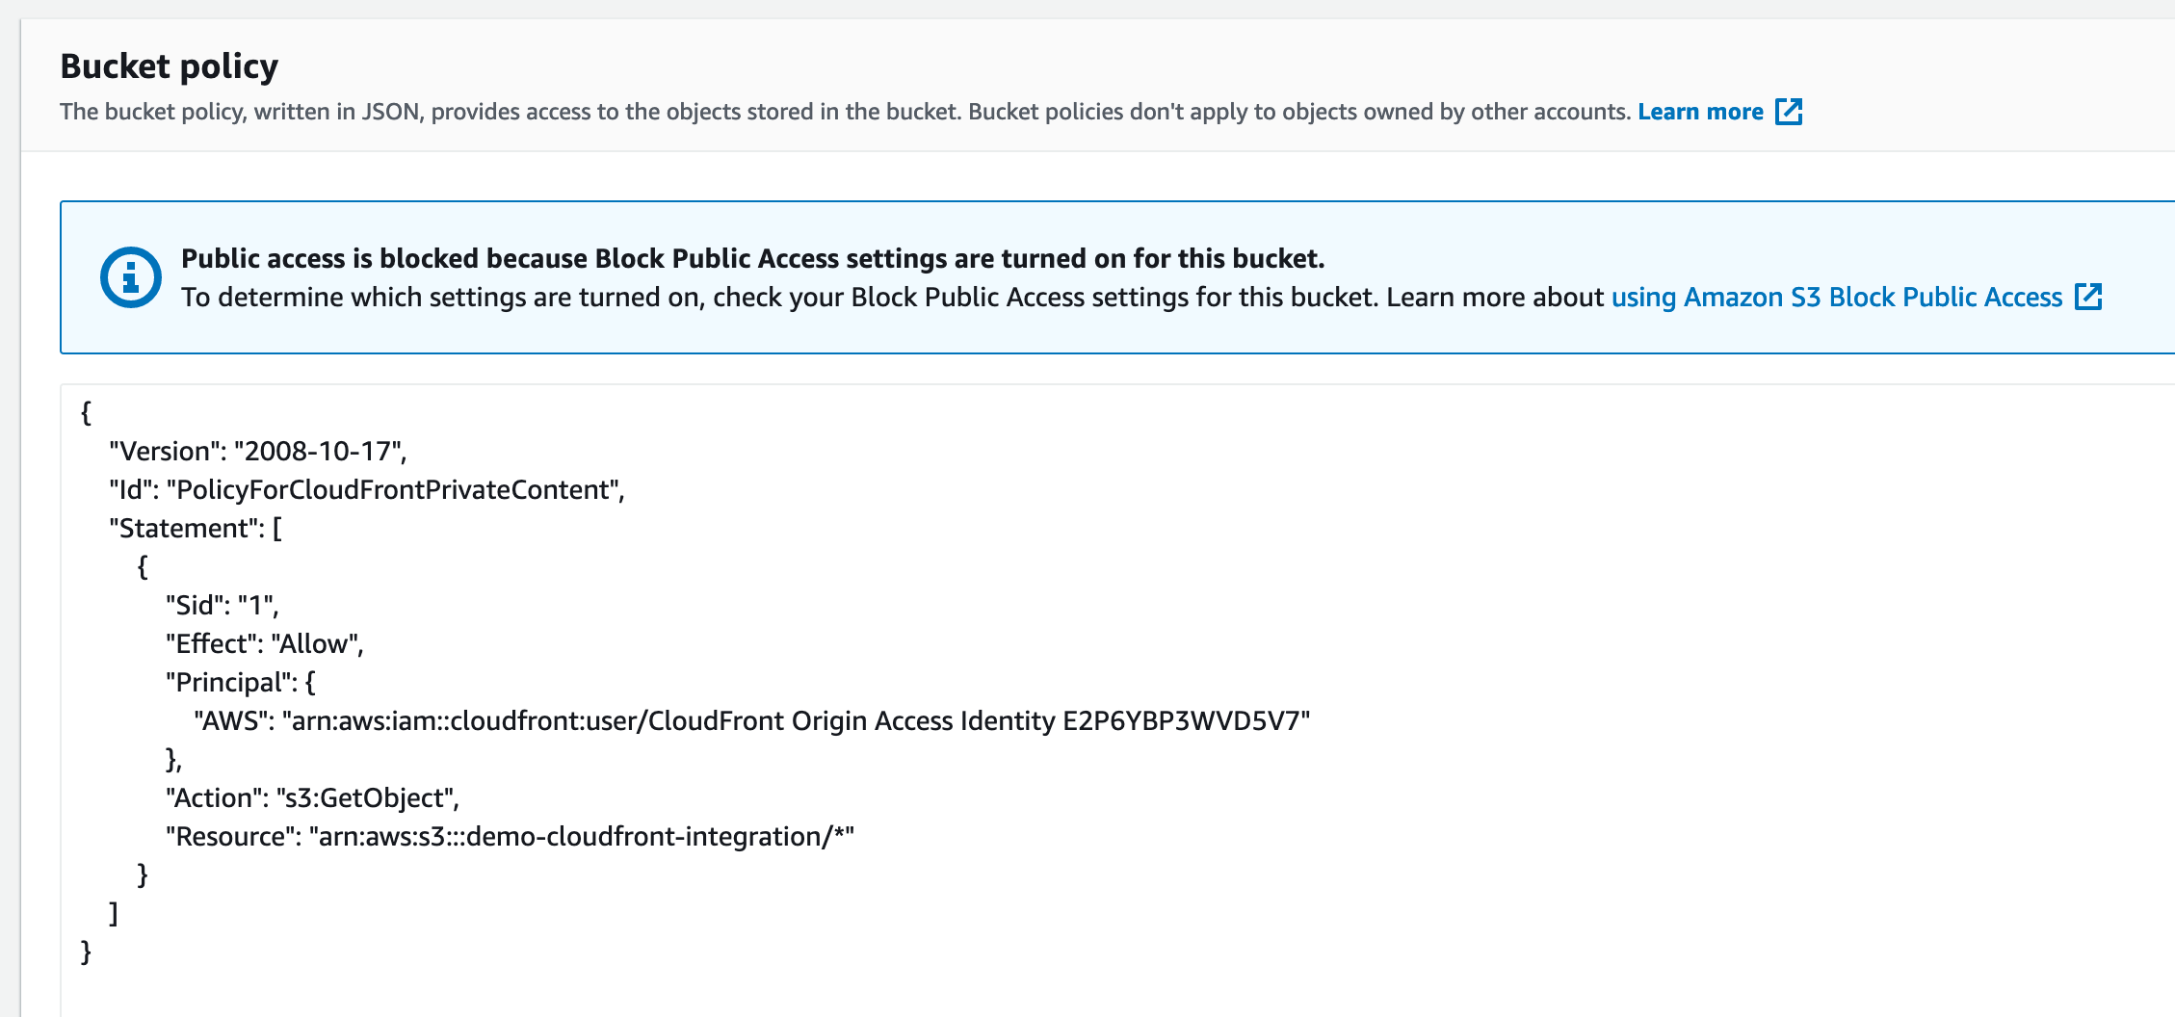

Test CloudFront distribution

https://<domain-name>/<S3-object-name>
https://d14clvpgsa8tsz.cloudfront.net/Indrani-white-background.png

copy domain name from cloudFront distribution page:
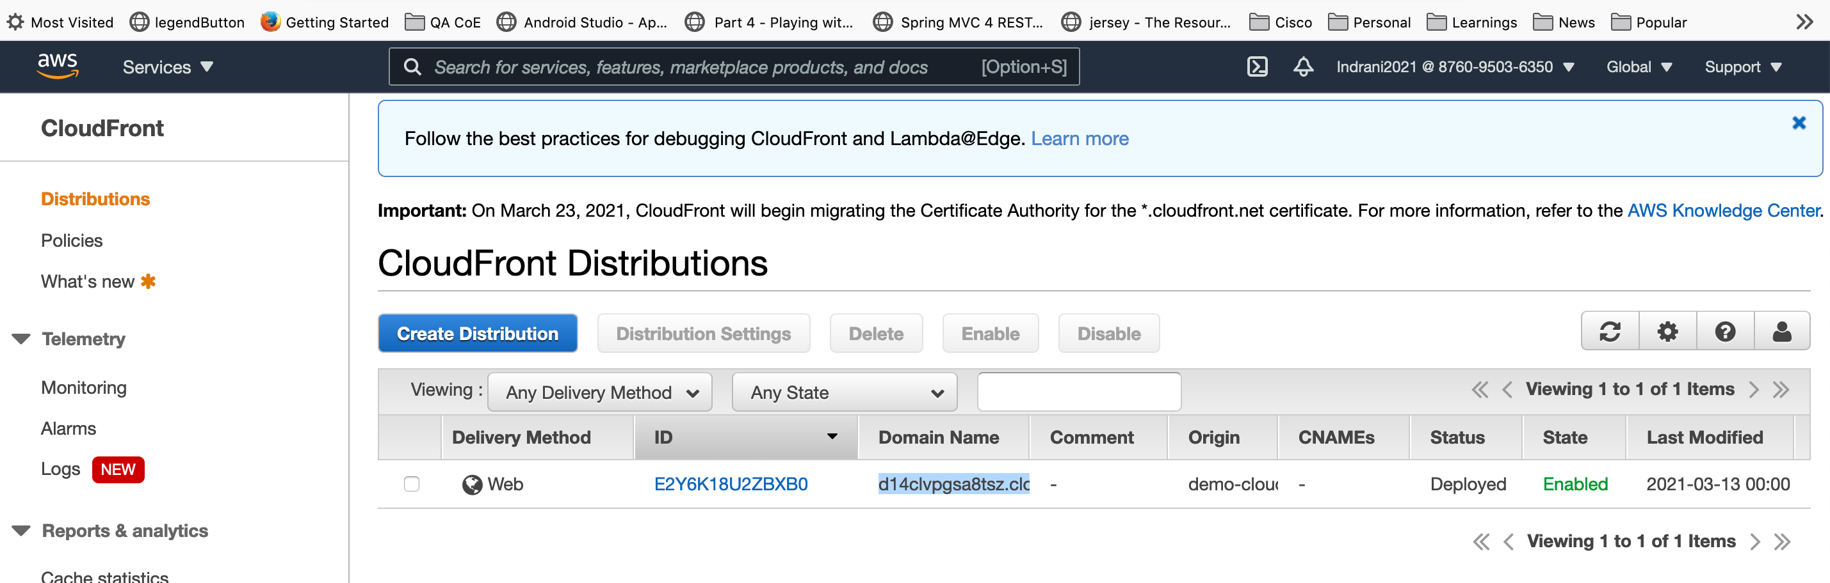
Note: objects in the S3 bucker should be public…

