# Book Summaries Hub Documentation

This document provides a comprehensive overview of the Book Summaries Platform project. It includes details on features, code structure, and implementation.

## Features

- Add a book summary including title, category, rating, and a detailed summary.  
- Choose from predefined categories such as Fiction, Non-Fiction, Biography, and Science.  
- Browse added summaries dynamically displayed on the webpage.  
- Responsive and user-friendly design with styled components.

## HTML (index.html)

The HTML structure provides the basic layout for the platform, including forms for adding summaries and sections to display them. Below is the code snippet:

<!DOCTYPE html>  
<html lang="en">  
<head>  
 <meta charset="UTF-8">  
 <meta name="viewport" content="width=device-width, initial-scale=1.0">  
 <title>Book Summaries Platform</title>  
 <link rel="stylesheet" href="styles.css">  
 <script defer src="script.js"></script>  
</head>  
<body>  
 <header>  
 <h1>📚 Book Summaries Platform</h1>  
 </header>  
 <main>  
 <section id="add-summary">  
 <h2>Add a Book Summary</h2>  
 <form id="summary-form">  
 <label for="title">Title:</label>  
 <input type="text" id="title" required>  
  
 <label for="category">Category:</label>  
 <select id="category">  
 <option value="Fiction">Fiction</option>  
 <option value="Non-Fiction">Non-Fiction</option>  
 <option value="Biography">Biography</option>  
 <option value="Science">Science</option>  
 </select>  
  
 <label for="rating">Rating (1-5):</label>  
 <input type="number" id="rating" min="1" max="5" required>  
  
 <label for="summary">Summary:</label>  
 <textarea id="summary" rows="5" required></textarea>  
  
 <button type="submit">Add Summary</button>  
 </form>  
 </section>  
  
 <section id="browse-summaries">  
 <h2>Browse Summaries</h2>  
 <div id="summary-list">  
 <p>No summaries added yet. Start by adding one!</p>  
 </div>  
 </section>  
 </main>  
 <footer>  
 <p>&copy; 2025 Book Summaries Platform</p>  
 </footer>  
</body>  
</html>

## CSS (styles.css)

The CSS styles ensure a visually appealing and consistent design. Below is the code snippet:

/* General Styles */  
body {  
 font-family: 'Poppins', sans-serif;  
 margin: 0;  
 padding: 0;  
 background-color: #f5f3f4;  
 color: #3c3b3d;  
 line-height: 1.6;  
}  
  
header {  
 background: linear-gradient(to right, #4b0082, #6a0dad);  
 color: #fff;  
 padding: 1.5rem;  
 text-align: center;  
 box-shadow: 0 4px 6px rgba(0, 0, 0, 0.2);  
}  
  
main {  
 max-width: 900px;  
 margin: 2rem auto;  
 padding: 1rem;  
}  
  
section {  
 margin-bottom: 2rem;  
 background: #fff;  
 border-radius: 15px;  
 padding: 1.5rem;  
 box-shadow: 0 6px 10px rgba(0, 0, 0, 0.1);  
}  
  
label {  
 font-weight: bold;  
 margin-bottom: 0.5rem;  
 display: block;  
}  
  
input, select, textarea, button {  
 width: 100%;  
 margin-bottom: 1rem;  
 padding: 0.75rem;  
 border: 1px solid #ddd;  
 border-radius: 10px;  
 font-size: 1rem;  
}  
  
button {  
 background: #6a0dad;  
 color: #fff;  
 border: none;  
 cursor: pointer;  
 font-weight: bold;  
 transition: background 0.3s ease;  
}  
  
button:hover {  
 background: #4b0082;  
}  
  
#summary-list {  
 background-color: #f8f6fa;  
 padding: 1.5rem;  
 border-radius: 15px;  
}  
  
.summary-item {  
 background: #faf9fc;  
 padding: 1rem;  
 border-left: 5px solid #6a0dad;  
 margin-bottom: 1rem;  
 border-radius: 10px;  
 box-shadow: 0 2px 4px rgba(0, 0, 0, 0.1);  
}  
  
footer {  
 text-align: center;  
 background: #4b0082;  
 color: #fff;  
 padding: 1rem;  
 margin-top: 2rem;  
}

## JavaScript (script.js)

The JavaScript handles the dynamic behavior of the platform, such as adding summaries and updating the display. Below is the code snippet:

const form = document.getElementById('summary-form');  
const summaryList = document.getElementById('summary-list');  
  
form.addEventListener('submit', (e) => {  
 e.preventDefault();  
  
 const title = document.getElementById('title').value;  
 const category = document.getElementById('category').value;  
 const rating = document.getElementById('rating').value;  
 const summary = document.getElementById('summary').value;  
  
 if (title && category && rating && summary) {  
 const summaryItem = document.createElement('div');  
 summaryItem.classList.add('summary-item');  
 summaryItem.innerHTML = `  
 <h3>${title}</h3>  
 <p><strong>Category:</strong> ${category}</p>  
 <p><strong>Rating:</strong> ${rating}/5</p>  
 <p>${summary}</p>  
 `;  
  
 summaryList.appendChild(summaryItem);  
 form.reset();  
  
 if (summaryList.children[0].tagName === 'P') {  
 summaryList.children[0].remove();  
 }  
 }  
});

## Some Insights

Adding the book Info

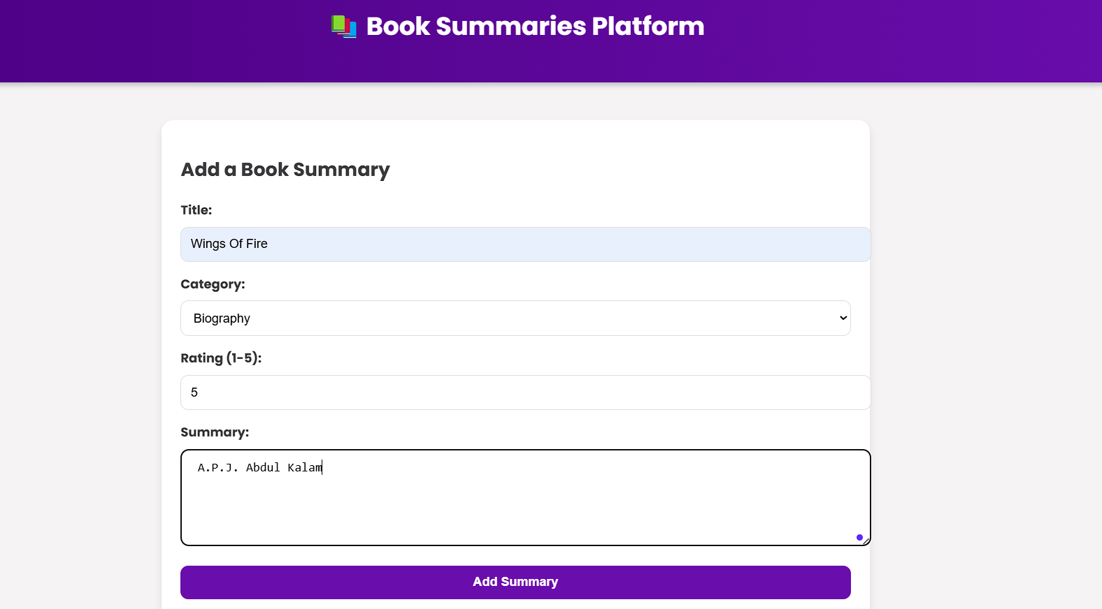

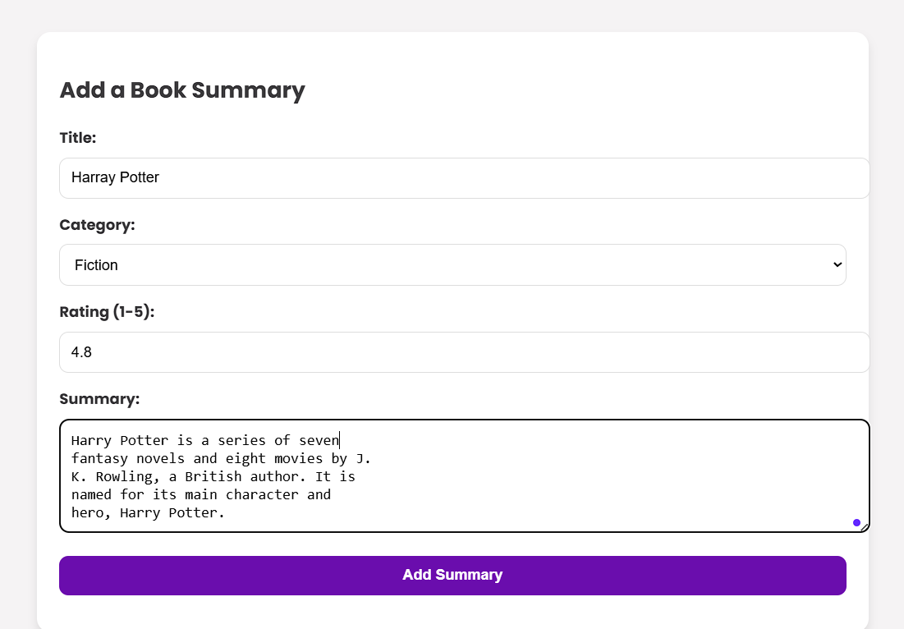

Summaries of added books

