
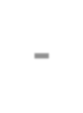

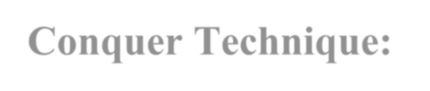

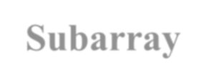

Divide-and-Conquer Technique:
Maximum Subarray problem

- Divide-and-Conquer is a general
algorithm design paradigm:
  - Divide the problem into a number of subproblems that are smaller instances of the same problem
  - Conquer the subproblems by solving
them recursively
  - Combine the solutions to the subproblems into the solution for the original problem
- The base case for the recursion are
subproblems of constant size
- Analysis can be done using recurrence
equations
a problem of size n
subproblem 1
of size n/2
Divide
subproblem 2
of size n/2

a solution to
the original problem
a solution to
subproblem 2
a solution to
subproblem 1
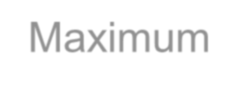
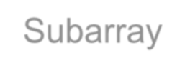
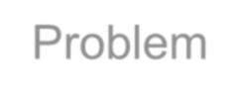
Maximum Subarray Problem

- Input: an array A[1..n] of n numbers
– Assume that some of the numbers are negative, because this problem is trivial when all numbers are nonnegative
- Output: a nonempty subarray A[i..j] having the largest sum S[i, j] = ai + ai+1 +... + aj

1 2 3 4 5 6 7 8 9 10 11 12 13 14 15 16
13 | -3 | -25 | 20 | -3 | -16 | -23 | 18 | 20 | -7 | 12 | -5 | -22 | 15 | -4 | 7

A

maximum subarray

Target array :
1 | -4 | 3 | 2

All the sub arrays:
1
 | -4
 |  | 3
 |  |  | 2
1 | -4
 | -4 | 3
 |  | 3 | 2

Max!
What is a maximum subarray?
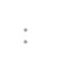
1
₋₄ Ans: The subarray with the largest sum
3

2

-3
What is the brute-
⁻¹ force time?
5

0
1 | -4 | 3
 | -4 | 3 | 2

1

2
1 | -4 | 3 | 2

All possible contiguous subarrays
  - A[1..1], A[1..2], A[1..3], ..., A[1..(n-1)], A[1..n]
  - A[2..2], A[2..3], ..., A[2..(n-1)], A[2..n]
  - ...
  - A[(n-1)..(n-1)], A[(n-1)..n]
  - A[n..n]

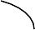
How many of them in total?
O(n2)
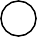

Algorithm: For each subarray, compute the sum.
Find the subarray that has the maximum sum.

Example: | 2 | -6 | -1 | 3 | -1 | 2 | -2
sum from A[1]: | 2 | -4 | -5 | -2 | -3 | -1 | -3
sum from A[2]: |  | -6 | -7 | -4 | -5 | -3 | -5
sum from A[3]: |  |  | -1 | 2 | 1 | 3 | 1
sum from A[4]: |  |  |  | 3 | 2 | 4 | 2
sum from A[5]: |  |  |  |  | -1 | 1 | -1
sum from A[6]: |  |  |  |  |  | 2 | 0
sum from A[7]: |  |  |  |  |  |  | -2

Outer loop: index variable i to indicate start of subarray, for 1 ≤ i ≤ n, i.e., A[1], A[2], ..., A[n]
  - for i = 1 to n do ...

Inner loop: for each start index i, we need to go through A[i..i], A[i..(i+1)], ..., A[i..n]
  - use an index j for i ≤ j ≤ n, i.e., consider A[i..j]
  - for j = i to n do ...

max = -∞
Time
complexity?
O(n2)
for i = 1 to n do begin
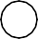
sum | = | 0
for | j | = i | to n | do

begin

sum = sum + A[j] if sum > max then max = sum
end
end

Possible locations of a maximum subarray A[i..j] of
A[low..high], where mid = ⎣(low + high)/2⎦
    - entirely in A[low..mid] (low ≤ i ≤ j ≤ mid)
    - entirely in A[mid+1..high] (mid < i ≤ j ≤ high)
    - crossing the midpoint (low ≤ i ≤ mid < j ≤ high)

crossing the midpoint

low mid high

entirely in A[low..mid]
mid +1

entirely in A[mid+1..high]

Possible locations of subarrays of A[low..high]

FIND-MAX-CROSSING-SUBARRAY (A, low, mid, high)
left-sum = -∞ // Find a maximum subarray of the form A[i..mid]
sum = 0
for i = mid downto low
sum = sum + A[i ] if sum > left-sum left-sum = sum
max-left = i
right-sum = -∞ // Find a maximum subarray of the form A[mid + 1 .. j ]
sum =0
for j = mid +1 to high sum = sum + A[j] if sum > right-sum
right-sum = sum
max-right = j
// Return the indices and the sum of the two subarrays
return (max-left, max-right, left-sum + right-sum)

A[mid+1..j]

low
i mid high

mid +1 j
A[i..mid]

A[i..j] comprises two subarrays A[i..mid] and A[mid+1..j]

mid =5

1 | 2 | 3 | 4 | 5 | 6 | 7 | 8 | 9 | 10
A 13 | -3 | -25 | 20 | -3 | -16 | -23 | 18 | 20 | -7
S[5 .. 5] =  S[4 .. 5] = |  |  | -3  17 ⇐ (max-left = 4)
S[3 .. 5] = |  | -8
S[2 .. 5] = | -11
S[1 ..
5] = 2 mid =5
1 | 2 | 3 | 4 | 5 | 6 | 7 | 8 | 9 | 10
A 13 | -3 | -25 | 20 | -3 | -16 | -23 | 18 | 20 | -7
S[6 .. 6] =  S[6 .. 7] = |  |  |  |  | -16 | -39
S[6 .. 8] = |  |  |  |  |  | -21

S[6 .. 9] = (max-right = 9) ⇒ -1
S[6..10] = -8
⇒ maximum subarray crossing mid is S[4..9] = 16
FIND-MAXIMUM-SUBARRAY (A, low, high)
if high == low
return (low, high, A[low]) // base case: only one element

else mid =
⎣low + high / 2⎦

(left-low, left-high, left-sum) =
FIND-MAXIMUM-SUBARRAY(A, low, mid)
(right-low, right-high, right-sum) =
FIND-MAXIMUM-SUBARRAY(A, mid + 1, high)
(cross-low, cross-high, cross-sum) =
FIND-MAX-CROSSING-SUBARRAY(A, low, mid, high)
if left-sum ≧ right-sum and left-sum ≧ cross-sum
return (left-low, left-high, left-sum)
elseif right-sum ≧ left-sum and right-sum ≧ cross-sum
return (right-low, right-high, right-sum)
else return (cross-low, cross-high, cross-sum)
Initial call: FIND-MAXIMUM-SUBARRAY (A, 1, n)

FIND-MAX-CROSSING-SUBARRAY : Θ(n),
where n = high − low + 1
FIND-MAXIMUM-SUBARRAY

T (n) =
⎧Θ(1)
if n
= 1,

⎨
⎩2T
(n / 2)+ Θ(n)
if n
- 1.

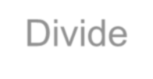
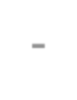

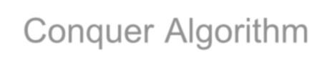
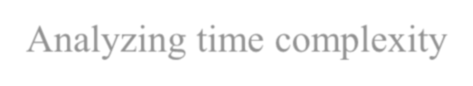
Divide-and-Conquer Algorithm
Analyzing time complexity

T(n) = 2T(n/2) + Θ(n)
= Θ(n lg n) (similar to merge-sort)

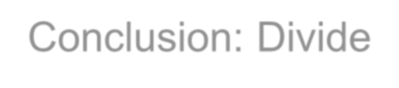
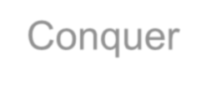
Conclusion: Divide-and-Conquer

  - This Divide and conquer algorithm is clearly substantially faster than any of the brute-force methods. It required some cleverness, and the programming is a little more complicated – but the payoff is large.

  - Divide and conquer is just one of several powerful techniques for algorithm design
  - Divide-and-conquer algorithms can be analyzed using recurrences
- Can lead to more efficient algorithms

