CSE 2233 Theory of Computing

Nabila Sabrin Sworna Lecturer
UIU

Terminology - Strings
- An alphabet is a finite, nonempty set of symbols. Conventionally, we use the symbol Σ for an
alphabet. For example,
  - i. Σ = 0, 1 , the binary alphabet.
  - ii. Σ = { 𝑎, 𝑏, 𝑐, … … … , 𝑧}, the set of all lower-case letters.
- A string over an alphabet Σ is a finite sequence of symbols, where each symbol is an element of Σ –
  - The string w where w = 𝑤1𝑤2𝑤3 … … … 𝑤𝑛 represents a string of length n where each 𝑤𝑖 ϵ ∑
  - The reverse of w is represented as 𝑤𝑅
  - The length of w denoted by |w|, is the number of symbols contained in w.
  - The empty string, denoted by 𝜀, is the string having length zero.
- Ex: if the alphabet Σ is equal to {0, 1}, then 10, 1000, 0, 101, and 𝜀 are strings over Σ, having lengths 2, 4, 1, 3, and 0 respectively.

- Power of an Alphabet:
Σ¹ -> Length is 1

Σ^{k} = set of string of length k, where each and every symbol of the strings belongs to Σ. Σ = {0, 1}
Σ¹ = {0, 1}
Σ² = {00, 01, 10, 11}
Σ³ = {000, 001, 011, 100, 101, 010, 110, 111} Σ⁰ = {𝜀}
Σ⁰, Σ¹, Σ², …., ΣΣ^{k}
⁺ = Σ¹ U Σ² U Σ³ ….
Σ* = {𝜀} U Σ
Language:

Σ = {a, b}
L = {any string that starts with a}
= {a, aa, ab, aaa, a, ….}

L = {any strings that starts with a and it’s length is 2}
= {aa, ab}

Terminology - Language
- Language: A set of strings all of which are chosen from some Σ∗ , where Σ is a particular
alphabet, is called a language.
- Regular Language: These languages are exactly the ones that can be described/recognized by Finite Automata. This language can be processed by computers having a very small amount of memory.
- Here,
- Computer is meant by a computational model that varies depending on the feature we want to focus on.

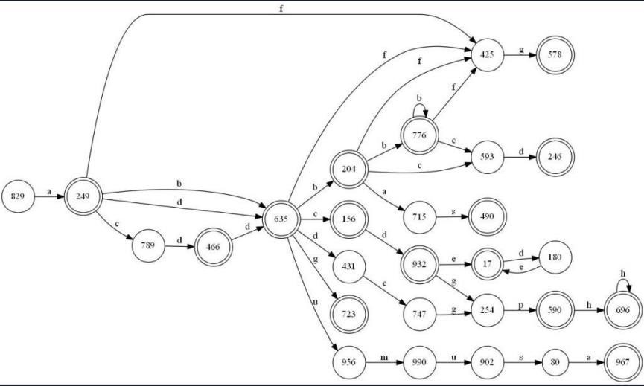

Finite automata are good models for computers with an extremely limited amount of memory.

What can a computer do with such a small memory?


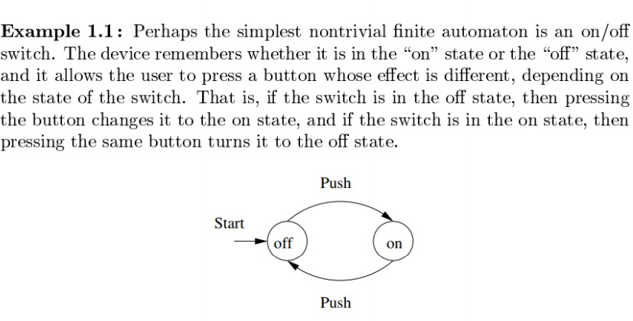

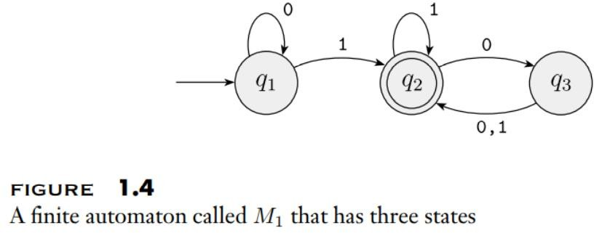
Finite Automata – Still not formal definition
- Finite Automata: A finite automaton (FA) is a simple idealized machine used to recognize patterns within input taken from some character set (or alphabet) ∑ . The job of an FA is to accept or reject an input depending on whether the pattern defined by the FA occurs in the input.

- Graphical Representation:
  - Node (for states)
  - Arcs (for transitions)
Formal definition of Finite Automaton – Finally.

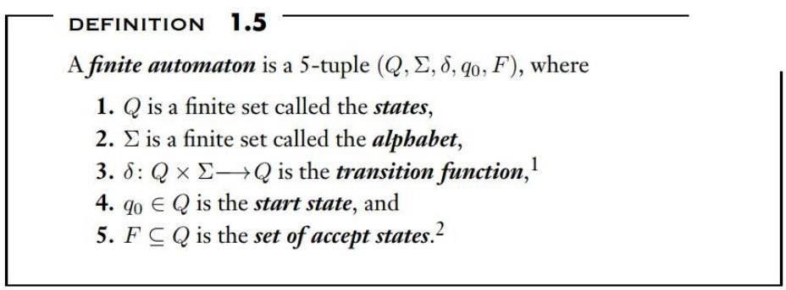

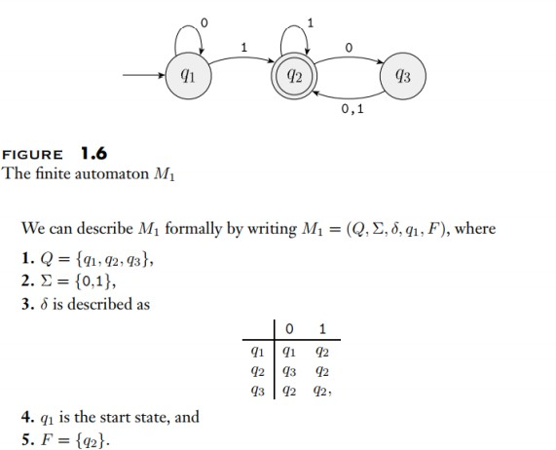

- If A is the set of all strings that machine M accepts
- We say that A is the language of machine M
- We write L(M) = A.
- We say that M recognizes A or that M accepts A.

FA- Machine M
- A machine may accept several strings, but it always
recognizes only one language.
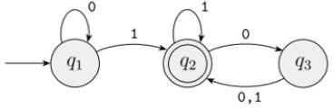

- If the machine accepts no strings, it still recognizes one language - the empty language ∅.
- For this example, we say if L(M) = A , then
A = {w| w contains at least one 1 and an even number of 0s follow the last 1}

The term “deterministic finite automata” refers to the fact that on each input there is one and
only one state to which the automaton can transition from its current state.

Σ = { a, b}
L : set of string of length 2
{aa, ab, ba, bb}

a, b
a, b
q0
q1
a, b
q2
a, b
q3

Σ = { 0, 1}
L : {a set of string that has 101 as substring}
{101, 0101, ….}

1, 0
0
1
q0
1
q1
0
q2
1
q3
0

Continued…
Q = {q0, q1, q2, q3}
Σ = {0, 1}
𝛿 is described as

 | 0 | 1
q0 | q0 | q1
q1 | q2 | q1
q2 | q0 | q3
q3 | q3 | q3

Thanks

