Paper Title* (use style: paper title)
*Note: Sub-titles are not captured in Xplore and should not be used

line 1: 1st Given Name Surname
line 2: dept. name of organization
(of Affiliation)
line 3: name of organization
(of Affiliation)
line 4: City, Country
line 5: email address or ORCID
line 1: 6th Given Name Surname
line 2: dept. name of organization
(of Affiliation)
line 3: name of organization
(of Affiliation)
line 4: City, Country
line 5: email address or ORCID

Abstract— Lorem ipsum dolor sit amet, consectetur adipiscing elit, sed do eiusmod tempor incididunt ut labore et dolore magna aliqua. Ut enim ad minim veniam, quis nostrud exercitation ullamco laboris nisi ut aliquip ex ea commodo consequat. Duis aute irure dolor in reprehenderit in voluptate velit esse cillum dolore eu fugiat nulla pariatur. Excepteur sint occaecat cupidatat non proident, sunt in culpa qui officia deserunt mollit anim id est laborum. Sed ut perspiciatis unde omnis iste natus error sit voluptatem accusantium doloremque laudantium, totam rem aperiam, eaque ipsa quae ab illo inventore veritatis et quasi architecto beatae vitae dicta sunt explicabo. Nemo enim ipsam voluptatem quia voluptas sit aspernatur aut odit aut fugit, sed quia consequuntur magni dolores eos qui ratione voluptatem sequi nesciunt. At vero eos et accusamus et iusto odio dignissimos ducimus qui blanditiis praesentium voluptatum deleniti atque corrupti quos dolores et quas molestias excepturi sint occaecati cupiditate non provident, similique sunt in culpa qui officia deserunt mollitia animi, id est laborum et dolorum fuga.
Keywords—component, formatting, style, styling, insert (key words)

Introduction
The past few years have undergone a tremendous advancement in artificial intelligence, especially deep learning, with new models continuously emerging and pushing the boundary of state-of-the-art (SOTA) performance [1]. In practical applications like sentiment classification, where models are used to automatically identify the emotional tone or opinion stated inside a text, this advancement is particularly prominent [2]. In the midst of all these advancements, a model known as BERT appeared. It later developed and gained recognition for its exceptional performance, serving as the basis for most numerous text classification tasks as of today.
BERT (Bidirectional Encoder Representations from Transformers) is a language model built on the transformer architecture. Contrary to processing text in a single direction as some earlier models did, it simultaneously draws attention to both preceding and succeeding words to develop contextual representations of the text [3]. In addition to establishing BERT as a fundamental baseline for text-related deep learning research, this bidirectional method allowed for significant advances across a variety of natural language processing (NLP) applications [4], [5]. Since then, several derivative models designed to meet more specialized requirements have been inspired by its success, including DistilBERT for efficiency [6], XLM-RoBERTa for cross-lingual jobs [7], and IndoBERT for the Indonesian language [8]. As these BERT-based models have develop, a glaring bias has emerged in the studies around them. Most efforts concentrate on improving performance metrics such as accuracy, F1-score, and other standard evaluation benchmarks, while relatively little attention is given to a different but equally important dimension: interpretability, or the extent to which a model's predictions can be understood and trusted by the people who rely on them [9], [10], [11], [12]. This is a critical flaw, because sentiment classification models are eventually deployed to assist human users, whether in business, research, or public-facing applications. Research study [13] revealed that model transparency is crucial for a black-box system in order to build user trust in the predictive decisions it provides.
Bridging this gap requires a way to observe what a model such as IndoBERT is doing when it makes a prediction. This is where explainable AI (XAI) methods become necessary. This research makes use of SHAP (SHapley Additive exPlanations) and Integrated Gradients (IG), two widely used XAI techniques that produce explanations by assessing the contribution of each input feature to a model's prediction [14], [15]. These methods make it possible to inspect a model's decision-making process rather than treating it purely as a black box. However, generating an explanation is only half of the problem. The explanation itself needs to be assessed to see if it is reliable and trustworthy, which raises the discussion of how interpretability itself should be measured.
Since interpretability is harder to pin down than performance. Where predictive performance is commonly assessed through standardized metrics such as accuracy, precision, recall, and F1-score, while interpretability lacks an equivalent, universally agreed-upon evaluation framework [16], [17], [18]. Numerous metrics have been proposed in the literature instead, including faithfulness, comprehensiveness, and robustness, each capturing a different facet of what it means for a model's explanation to be "interpretable" [19] . Given this diversity, no single metric can be considered a complete or definitive measure of interpretability, which means any research in this space must first define its own scope. This research focuses specifically on fidelity and stability, two dimensions commonly discussed in the interpretability literature [20], [21]. Fidelity concerns whether an explanation faithfully reflects the model's internal decision-making process, while stability concerns whether that explanation remains consistent under small perturbations to the input.
This performance-interpretability gap is quite noticeable for IndoBERT. Despite being widely adopted as the leading BERT-based model for Indonesian-language sentiment classification, IndoBERT has not been thoroughly evaluated from an interpretability standpoint [9], [10], [22], [23]. Most existing work on IndoBERT has centered on benchmarking its predictive accuracy against other models, leaving open the question of how well its predictions can be understood by the people who use them. We use fidelity and stability as the main evaluation metrics to assess how well SHAP and IG can explain IndoBERT's predictions in sentiment classification, treating this as our operational measure of the model's interpretability in this work. In this regard, the study endeavors to highlight how effectively existing SOTA models can be understood through XAI-based explanations, as opposed to simply predicting accuracy. This research makes two contributions. First, it provides an empirical interpretability evaluation of a popular Indonesian NLP model that has previously been assessed mostly based on performance. Second, it aims to inform more interpretability-conscious development and evaluation practices for BERT-based models moving forward.

Research Methodology
An overview of the research methodology is clearly illustrated in Fig. 1. This research began with a systematic literature review to gain an understanding of the current state of research in the same field, so that gaps or topics that have not yet been extensively explored could be identified. After identifying the gaps, research questions were formulated and became the focus of the research, followed by data collection for the development of the IndoBERT model. The data for this research will be obtained from previously conducted research, a dataset consisting of text posts from a student venting forum on an online platform belonging to a university community. This dataset will be labeled with stress level indicators for each student based on the text of their posts, with level zero indicating no stress, level one indicating mild stress, and level two indicating severe stress.
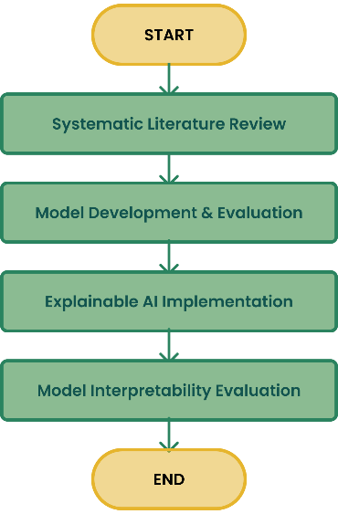
- The general approach carried out in this research
The data collected contain noises in the form of mentions or excessive characters that will be irrelevant to the model training process; therefore, a data “cleaning” process is necessary, which is commonly known as the preprocessing stage. This data cleaning process will include several steps, ranging from removing duplicates, removing unique or excessive characters, removing mentions of usernames or forum names, removing excessive whitespace, and converting all characters to lowercase (case folding). Once all the data has been cleaned, the process will proceed to the IndoBERT deep learning model development phase. This phase begins by dividing the data into three parts in an 80:10:10 ratio, where 80% is training data, 10% is validation data, and the remaining 10% is testing data. If an imbalance between classes is detected in the data, the WeightedRandomSampler, a PyTorch library tool, will be applied. This tool samples elements from the dataset with specific probabilities based on the weights assigned to each data point, addressing the imbalance by oversampling the minority class and/or undersampling the majority class.

- IndoBERT Fine-tuning development and evaluation stage
The process of fine-tuning the model will then make use of the cleaned and processed data. The "indobert-base-p2" variation from Indo4B will serve as the base model for this research [24]. To produce a classification prediction based on three label categories, whether the text indicates no stress, mild stress, or severe stress, a classification head will be incorporated as part of the model architecture fine-tuning process. During the model's development, several hyperparameter configurations were utilized to get the best outcomes. A learning rate of 1e-5, a batch size of 16, 10 epochs with an early halting mechanism if no progress is seen, and optimization using AdamW are some of the hyperparameters applied throughout the development phase. After the fine-tuning process was completed, the next step was to evaluate the model’s performance. The performance of the fine-tuned IndoBERT model was assessed based on standard metrics in machine learning: accuracy, precision, recall, and F1-score. The evaluation was conducted to ensure that the predictive performance of the resulting fine-tuned model was satisfactory before proceeding to the interpretability analysis phase.
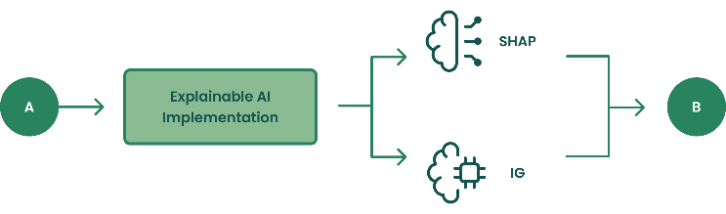
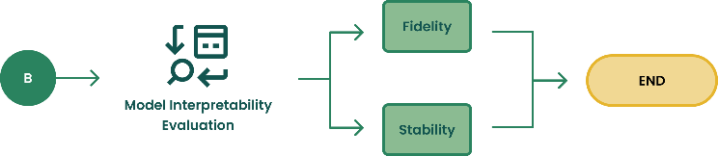
- Model development and interpretability evaluation stage using XAI, evaluated through fidelity and stability
With a fine-tuned IndoBERT model established, the next phase of this research focuses on generating explanations for the model's predictions using XAI techniques. Specifically, this research applies SHAP and IG to the fine-tuned model. SHAP is applied using the shap Python library within this research. The fine-tuned IndoBERT model is first wrapped in a HuggingFace text-classification pipeline, which returns prediction probabilities for all three stress-level classes. A SHAP explainer is then constructed using this pipeline, paired with a text masker (shap.maskers.Text) built from the model's own tokenizer, allowing SHAP to perturb the input text at the token level in a manner consistent with how the model itself processes text. For each test sample, the model's predicted label is first obtained, and SHAP values are computed specifically with respect to that predicted class. This yields a SHAP value for each sub word token in the input, representing its estimated contribution to the model's prediction. Since IndoBERT's tokenizer splits words into sub word units, SHAP values belonging to tokens originating from the same word are subsequently summed, producing a single attribution score per word rather than per sub word. This reconstruction step ensures that the resulting explanations remain interpretable at a linguistically meaningful level rather than being fragmented across sub word pieces.
In addition to SHAP, this research IG as a second explanation method, implemented using the Captum library. IG is computed with respect to the model's input embeddings, using a baseline defined as the sequence of embeddings corresponding to the tokenizer's padding token. Attributions are computed with respect to the model's predicted class, using 20 integration steps, and are calculated at the embedding dimension before being summed to obtain a single attribution score per token. The resulting token-level scores are then normalized using their L2 norm to standardize the scale of attributions across samples. As with SHAP, the resulting sub word-level attributions are merged into word-level scores by summed the attributions of sub word tokens belonging to the same word, ensuring consistency between the two explanation methods in how attributions are ultimately reported. All the process is repeated across all samples in the test set, and the resulting attributions, along with their corresponding scores, predicted labels, and sample identifiers, are compiled into a structured dataset for subsequent interpretability evaluation.
With the word-level attributions from both SHAP and IG compiled for all test samples, the next step is to evaluate how faithfully these attributions reflect the model's actual decision-making process. This is assessed using the faithfulness (infidelity) formula as in:
${\text{E}}_{\text{I}}\left[{\left({\text{Ι}}^{\text{T}}\text{Φ}\left(\text{x}\right) \text{-} \left(\text{f}\left(\text{x}\right) \text{- }\text{f}\left(\text{x} \text{-}\text{ Ι}\right)\right)\right)}^{\text{2}}\right]$ 
Where $\text{Φ}\left(\text{x}\right)$ denotes the attribution score computed for each input text $\text{x}$ in the test set using the interpretability method being evaluated, representing the estimated contribution of each token toward the model's prediction, and $\text{I}$ represent a perturbation mask indicating which tokens are masked from the input. While the original formulation of this metric defines $\text{I}$ as a random perturbation sampled from a distribution of possible masks, this research adopts a targeted variant in which $\text{I}$ is deterministically constructed from the top-k tokens identified as most influential by the explanation method for each input. This approach directly tests the specific claim made by each explanation, namely that its top-ranked tokens are the ones most responsible for the model's prediction. Masking these top-k tokens produces a new input denoted as $\text{x }\text{-}\text{ I}$. The model is subsequently run on this perturbed input to obtain $\text{f}\left(\text{x }\text{- }\text{I}\right)$, and the actual change in the model's output is calculated as the difference between the original and perturbed predictions, $\text{f}\left(\text{x}\right) - \text{f(x }\text{- }\text{I)}$. In parallel, the change in output as predicted by the attribution scores themselves is calculated as ${\text{I}}^{\text{T}}\text{Φ(x)}$, the sum of attribution scores assigned to the masked tokens. The squared error between the actual change and the predicted change is then computed for each input and averaged across all samples in the test set to obtain an overall infidelity score for each explanation method. A lower infidelity score indicates that the attribution scores more accurately reflect the tokens' true influence on the model's prediction, corresponding to higher faithfulness.
In addition to faithfulness, the stability of each explanation method is also evaluated, to assess whether the resulting attributions remain consistent when the input is slightly altered. This is measured using the formula shown in (2).
$\frac{\text{1}}{\text{N}} \sum_{\text{i=1}}^{\text{N}}{{\text{cos}}_{\text{sim}}}\text{(}{{\text{x}}_{\text{1}}}^{\left(\text{i}\right)}\text{, }{{\text{x}}_{\text{2}}}^{\text{(i)}}\text{)}$ 2
Where ${{\text{x}}_{\text{1}}}^{\left(\text{i}\right)}$​ denotes the explanation generated for the original, unperturbed input, and ${{\text{x}}_{\text{2}}}^{\text{(i)}}$ denotes the explanation generated for a perturbed version of the same input, for each of the $\text{N}$ samples in the test set. The perturbed input is obtained by applying synonym replacement, substituting selected words in the original text with equivalent single-word synonyms drawn from the Indonesian thesaurus dataset compiled from Tesaurus Bahasa Indonesia Pusat Bahasa (https://github.com/victoriasovereigne/tesaurus). Since this thesaurus maps words to single-word synonyms rather than multi-word phrases, the resulting perturbed input preserves the same token count and structure as the original, ensuring that the two resulting explanation vectors, ${{\text{x}}_{\text{1}}}^{\left(\text{i}\right)}$​ and ${{\text{x}}_{\text{2}}}^{\text{(i)}}$​, remain directly comparable. Cosine similarity is then computed between these two vectors to measure how consistent the explanation remains despite the semantically equivalent perturbation. A higher average cosine similarity across all $\text{N}$ samples indicates greater stability, meaning the explanation method produces consistent attributions even when the input wording changes slightly.

Result and Discussion
The dataset was obtained from …, which included 31,882 tagged raw data sets of student forum messages. The data breakdown is displayed in Fig. 4. The total number of data points was decreased to 30,953 after duplicates were discarded. 28,458 data with the label 0 (no indication of stress), 1,848 data with the label 1 (indication of mild stress), and 648 data with the label 2 (indication of severe stress) make up the data. The WeightedRandomSampler package was used in this work to make sure that the model construction was not skewed toward the majority class after it was determined from the details of the gathered data that the dataset was unbalanced.
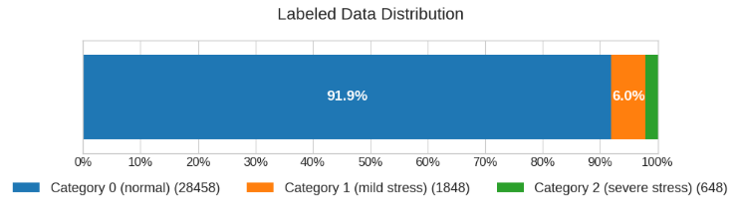
- Data Distribution Ratio
Following that, the data was cleaned as previously mentioned, which included eliminating unnecessary characters and excessive whitespace, among other things. A stratified split with an 80:10:10 ratio is then used to partition the cleaned data, yielding 24,444 data for the training set, 3,056 data for the validation set, and 3,056 data for the testing set.
The research moved on to the model construction and performance evaluation phase once all the data was prepared for additional processing. To achieve the best model outcomes, the model was developed through a fine-tuning procedure using the hyperparameter settings previously discussed in Chapter II. The outcomes of the training and validation procedures are displayed in Fig. 5, where the graph displays both little overfitting and steady development. The training and validation results differ very little, as both graphs demonstrate. This is seen in Fig. 5. (a), where the difference is only within a range of 0.05, and Fig. 5. (b), which displays even smaller deviations, with a difference of just 0.02. After completing the training and validation phases, the model moved on to the testing phase to measure its real performance. The model's performance details are displayed in the testing results as follows: 0.9942 accuracy, 0.9218 precision, 0.9624 recall, and 0.9412 F1-score.
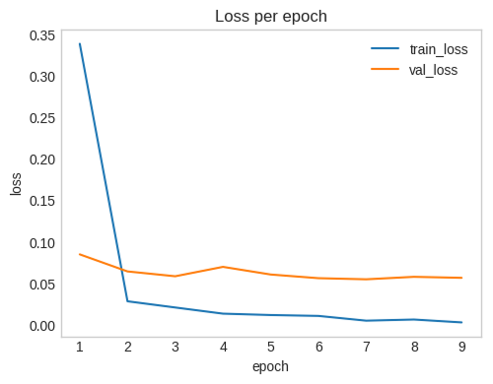
(a)
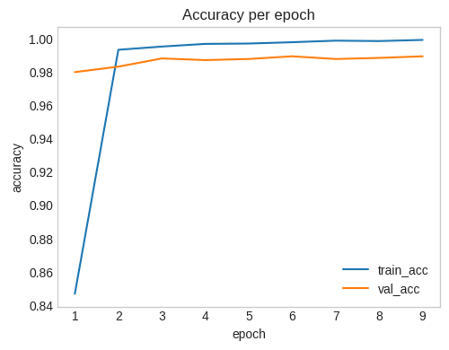
(b)
- Learning curves of the Fine-Tuned IndoBERT model, consisting of (a) the training and validation loss across epochs and (b) the training and validation accuracy across epochs
Overall, these results indicate that the model performed well, since every metric was close to 1. To examine the predictions in more detail, the testing phase also produced a confusion matrix, visualized as a heat map in Fig. 6. The visualization shows that the multi-label classification is not yet fully optimal, as some false positives and false negatives appear in each class. However, the proportion of misclassified samples remains very small compared to the correctly classified ones. Even though the model has not reached perfect performance, its per-class results are still satisfactory: Class 0 achieves a prediction success rate of 99.28% and Class 1 reaches 97.25%. Class 2, which represents the minority class, still attains a success rate of 92.18%.
The fact that all three classes exceed a 90% success rate implies that the model does not rely solely on the dominant classes to obtain its high overall scores. Instead, it has learned discriminative patterns that generalize across all classes, including the minority class, which is typically the most difficult to predict under class imbalance. The remaining errors, although not negligible, are small and spread thinly across the classes rather than concentrated in a single one, which suggests there is no severe bias toward any particular label. The gap between Class 0 and Class 2 (about 7%) does indicate that the minority class remains the weakest point, which is consistent with the limited number of training samples available for it. In practical terms, the model is reliable enough to support the classification task, while leaving room for improvement.
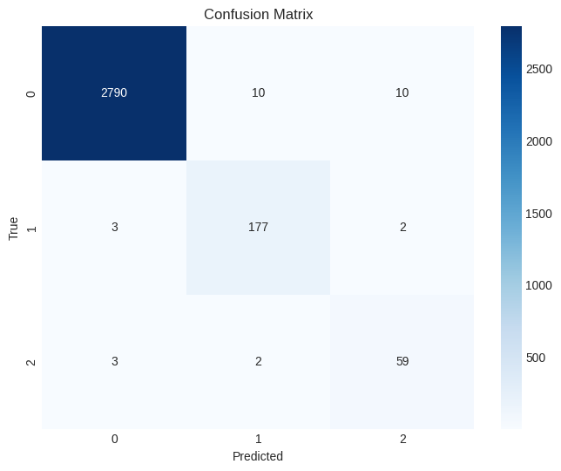
- Confusion Matrix representing Fine-Tuned IndoBERT model classification performance
Once the model was confirmed to perform satisfactorily, the study proceeded to the interpretability evaluation. Two XAI methods, SHAP and IG, were applied to explain the model's predictions, and the resulting word-level visualizations for each class are shown in Fig. 7.
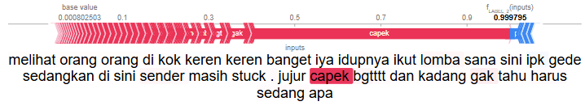
(a)
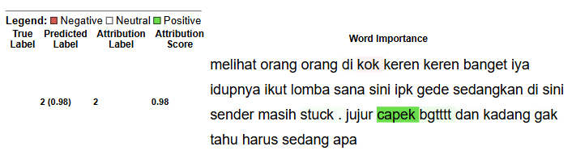
(b)
- Word attribution visualizations for the predicted classes using (a) SHAP and (b) IG
In both methods, each word is highlighted according to its attribution value, which indicates how much that word contributes to the predicted label, and the color intensity reflects the magnitude of that contribution. In the SHAP visualization, red indicates words with positive attribution, meaning they push the model toward the predicted label. Blue indicates words with negative attribution, meaning they push the model away from it. IG uses a different color scheme: green marks words with positive attribution that support the predicted label, while red marks words with negative attribution that counter it.
To assess the models' interpretability in terms of fidelity and stability, both XAI models will be applied to the complete test dataset; however, as previously stated, fidelity will be evaluated based on the value of the resulting fidelity error (infidelity). Table I displays the interpretability findings for the optimized IndoBERT model.
- Interpretability Measurement Results
XAI Model | Infidelity | Stability
SHAP | 0,0340 | 0,3453
IG | 0,0406 | 0,3536
The infidelity metric assesses how well the attribution values reflect the model's actual decision-making process, where a value closer to 0 indicates a more faithful explanation. The stability metric, on the other hand, measures the consistency of the explanations when the input is subjected to small perturbations, where a higher value indicates a more stable and reliable explanation. As shown in Table I, SHAP achieved an infidelity score of 0.0340, which is better than IG’s 0.0406, indicating that SHAP produces explanations that better represent the true predictive behavior of the model. However, for stability the opposite trend is observed, where IG scored 0.3536 compared to 0.3453 for SHAP, indicating that IG explanations are more stable than SHAP explanations when considering small input variations. When examined via the lens of the XAI models SHAP and IG, the IndoBERT model's overall performance produces findings that are satisfactory in terms of faithfulness but extremely worrying in terms of stability. In terms of fidelity, this means that the explanations given fairly depict how the model produces interpretability that is in line with the refined model. As for why the stability results are less than satisfactory, it is most likely due to the stability evaluation's perturbation method, which substitutes synonyms for words. The deep learning model will effectively return to a state of total ignorance about that term if it hasn't yet "learned" those synonyms.

Conclusion
The findings of this research show that the fine-tuned IndoBERT model achieved strong classification performance, with a testing accuracy of 0.9942, precision of 0.9218, recall of 0.9624, and F1-score of 0.9412. Per-class results further indicate that the model handled the minority class reasonably well, achieving a success rate of 92.18%, even though it remained the weakest-performing class compared to Class 0 (99.28%) and Class 1 (97.25%). Beyond predictive performance, this study also evaluated the interpretability of the model's predictions through SHAP and IG, using fidelity and stability as the evaluation metrics. The results show that both methods produced explanations that fairly depict how the model arrives at its predictions, as reflected in the satisfactory infidelity scores of 0.0340 for SHAP and 0.0406 for IG. However, the stability results were far less satisfactory, with scores of 0.3453 for SHAP and 0.3536 for IG. This is most likely caused by the synonym-substitution perturbation method used in the stability evaluation, since the model tends to respond poorly to synonyms it has not encountered during fine-tuning, effectively treating them as unfamiliar terms. In conclusion, the fine-tuned IndoBERT model can produce faithful and interpretable explanations of its predictions, but its explanations remain sensitive to lexical variation, which limits the robustness of its interpretability under input perturbation. It is also worth noting that these fidelity and stability results are specific to SHAP and IG as applied to this fine-tuned IndoBERT model, rather than general properties of either the model or the XAI methods in isolation
Although this research has achieved satisfactory results in both classification performance and interpretability evaluation, several key limitations remain that could be the focus of future development. The main limitation lies in the class imbalance present in the dataset, which is reflected in the comparatively lower prediction success rate for the minority class. This condition suggests that the model may still carry a slight bias toward the majority classes, which could affect the reliability of its predictions in real-world, imbalanced settings. Therefore, further research is encouraged to address this issue through more balanced data collection or more effective data augmentation techniques, to achieve more robust generalization across all classes. Another limitation concerns the relatively low stability scores obtained in this study, which are likely influenced by the synonym-substitution perturbation method used in the evaluation, since the model may respond poorly to synonyms that were not encountered during fine-tuning. Future work may therefore explore alternative perturbation methods, such as paraphrasing, back-translation, or character-level noise, to determine whether the instability observed is specific to synonym substitution or a more general property of the model's explanations. Future work may also explore additional XAI methods beyond SHAP and IG, or alternative interpretability metrics beyond fidelity and stability, to obtain a more comprehensive understanding of how well IndoBERT's predictions can be explained and trusted by end users.

Authors Contributions
I.W. initiated the research design, conducted the literature review, performed the data preprocessing, carried out the model development and experiments, analyzed the results, and drafted the manuscript. M.S.A. provided the initial conceptual direction of the study, supervised the research process, facilitated data collection and coordination with the psychology team, and critically reviewed, revised, and proofread the manuscript. Both authors have read and approved the final manuscript and are responsible for its content and integrity.

Acknowledgment
Lorem ipsum dolor sit amet, consectetur adipiscing elit, sed do eiusmod tempor incididunt ut labore et dolore magna aliqua. Ut enim ad minim veniam, quis nostrud exercitation ullamco laboris nisi ut aliquip ex ea commodo consequat. Duis aute irure dolor in reprehenderit in voluptate velit esse cillum dolore eu fugiat nulla pariatur.

References

[1] D. W. Otter, J. R. Medina, and J. K. Kalita, “A Survey of the Usages of Deep Learning for Natural Language Processing,” IEEE Trans. Neural Netw. Learn. Syst., vol. 32, no. 2, pp. 604–624, Feb. 2021, doi: 10.1109/TNNLS.2020.2979670.
[2] M. Wankhade, A. C. S. Rao, and C. Kulkarni, “A survey on sentiment analysis methods, applications, and challenges,” Artif. Intell. Rev., vol. 55, no. 7, pp. 5731–5780, Oct. 2022, doi: 10.1007/s10462-022-10144-1.
[3] J. Devlin, M.-W. Chang, K. Lee, and K. Toutanova, “Bert: Pre-training of deep bidirectional transformers for language understanding,” in Proceedings of the 2019 conference of the North American chapter of the association for computational linguistics: human language technologies, volume 1 (long and short papers), 2019, pp. 4171–4186.
[4] R. Bey et al., “Natural language processing of multi-hospital electronic health records for public health surveillance of suicidality,” npj Mental Health Research, vol. 3, no. 1, p. 6, Feb. 2024, doi: 10.1038/s44184-023-00046-7.
[5] D. Erokhin and N. Komendantova, “Social media data for disaster risk management and research,” International Journal of Disaster Risk Reduction, vol. 114, p. 104980, Nov. 2024, doi: 10.1016/j.ijdrr.2024.104980.
[6] V. Sanh, L. Debut, J. Chaumond, and T. Wolf, “DistilBERT, a distilled version of BERT: smaller, faster, cheaper and lighter,” Mar. 2020.
[7] A. Conneau et al., “Unsupervised Cross-lingual Representation Learning at Scale,” in Proceedings of the 58th Annual Meeting of the Association for Computational Linguistics, Stroudsburg, PA, USA: Association for Computational Linguistics, 2020, pp. 8440–8451. doi: 10.18653/v1/2020.acl-main.747.
[8] F. Koto, A. Rahimi, J. H. Lau, and T. Baldwin, “IndoLEM and IndoBERT: A Benchmark Dataset and Pre-trained Language Model for Indonesian NLP,” Nov. 2020.
[9] H. Imaduddin, F. Y. A’la, and Y. S. Nugroho, “Sentiment Analysis in Indonesian Healthcare Applications using IndoBERT Approach,” International Journal of Advanced Computer Science and Applications, vol. 14, no. 8, 2023, doi: 10.14569/IJACSA.2023.0140813.
[10] G. Z. Nabiilah, I. N. Alam, E. S. Purwanto, and M. F. Hidayat, “Indonesian multilabel classification using IndoBERT embedding and MBERT classification,” International Journal of Electrical and Computer Engineering (IJECE), vol. 14, no. 1, p. 1071, Feb. 2024, doi: 10.11591/ijece.v14i1.pp1071-1078.
[11] N. A. Putri Masaling and D. Suhartono, “Utilizing RoBERTa and XLM-RoBERTa pre-trained model for structured sentiment analysis,” International Journal of Informatics and Communication Technology (IJ-ICT), vol. 13, no. 3, p. 410, Dec. 2024, doi: 10.11591/ijict.v13i3.pp410-421.
[12] A. Kumar and V. H. C. Albuquerque, “Sentiment Analysis Using XLM-R Transformer and Zero-shot Transfer Learning on Resource-poor Indian Language,” ACM Transactions on Asian and Low-Resource Language Information Processing, vol. 20, no. 5, pp. 1–13, Sep. 2021, doi: 10.1145/3461764.
[13] D. Horvat, I. Boticki, P. S. K. Seow, and A. Drobnjak, “Explainable ai in the real world: Challenges and opportunities,” in International Conference on Computers in Education, 2023.
[14] S. Lundberg and S.-I. Lee, “A Unified Approach to Interpreting Model Predictions,” Nov. 2017.
[15] H. Moraliyage, G. Kulawardana, D. De Silva, Z. Issadeen, M. Manic, and S. Katsura, “Explainable Artificial Intelligence with Integrated Gradients for the Detection of Adversarial Attacks on Text Classifiers,” Applied System Innovation, vol. 8, no. 1, p. 17, Jan. 2025, doi: 10.3390/asi8010017.
[16] C.-K. Yeh, C.-Y. Hsieh, A. Suggala, D. I. Inouye, and P. K. Ravikumar, “On the (in) fidelity and sensitivity of explanations,” Adv. Neural Inf. Process. Syst., vol. 32, 2019.
[17] K. Galadima, P. Anthony, R. Ploszek, Š. Balogh, P. Zajac, and M. Homola, “Evaluating the Trustworthiness of LEMNA versus LIME and SHAP in Explainable Malware Detection,” in Proceedings of the 18th International Conference on Agents and Artificial Intelligence, SCITEPRESS - Science and Technology Publications, 2026, pp. 3353–3364. doi: 10.5220/0014429400004052.
[18] A. N. M. Sakib, Z. Wang, M. Roby, and Z. Zhang, “Empirical Characterization of Rationale Stability Under Controlled Perturbations for Explainable Pattern Recognition,” arXiv preprint arXiv:2604.04456, 2026.
[19] Q. Lyu, M. Apidianaki, and C. Callison-Burch, “Towards Faithful Model Explanation in NLP: A Survey,” Computational Linguistics, vol. 50, no. 2, pp. 657–723, Jun. 2024, doi: 10.1162/coli_a_00511.
[20] X. Zheng et al., “F-Fidelity: A Robust Framework for Faithfulness Evaluation of Explainable AI,” in International Conference on Learning Representations, Y. Yue, A. Garg, N. Peng, F. Sha, and R. Yu, Eds., 2025, pp. 12772–12804. [Online]. Available: https://proceedings.iclr.cc/paper_files/paper/2025/file/2231d1abdcc68d16c9861a58f3c25849-Paper-Conference.pdf
[21] D. Alvarez-Melis and T. S. Jaakkola, “On the Robustness of Interpretability Methods,” Jun. 2018.
[22] M. N. Zaidan, Y. Sibaroni, and S. S. Prasetyowati, “Learning rate and epoch optimization in the fine-tuning process for Indobert’s performance on sentiment analysis of Mytelkomsel app reviews,” Jurnal Teknik Informatika (Jutif), vol. 5, no. 5, pp. 1443–1450, 2024.
[23] R. I. Perwira, V. A. Permadi, D. I. Purnamasari, R. P. Agusdin, and others, “Domain-specific fine-tuning of IndoBERT for aspect-based sentiment analysis in Indonesian travel user-generated content,” Journal of Information Systems Engineering and Business Intelligence, vol. 11, no. 1, pp. 30–40, 2025.
[24] B. Wilie et al., “IndoNLU: Benchmark and Resources for Evaluating Indonesian Natural Language Understanding,” Oct. 2020.

