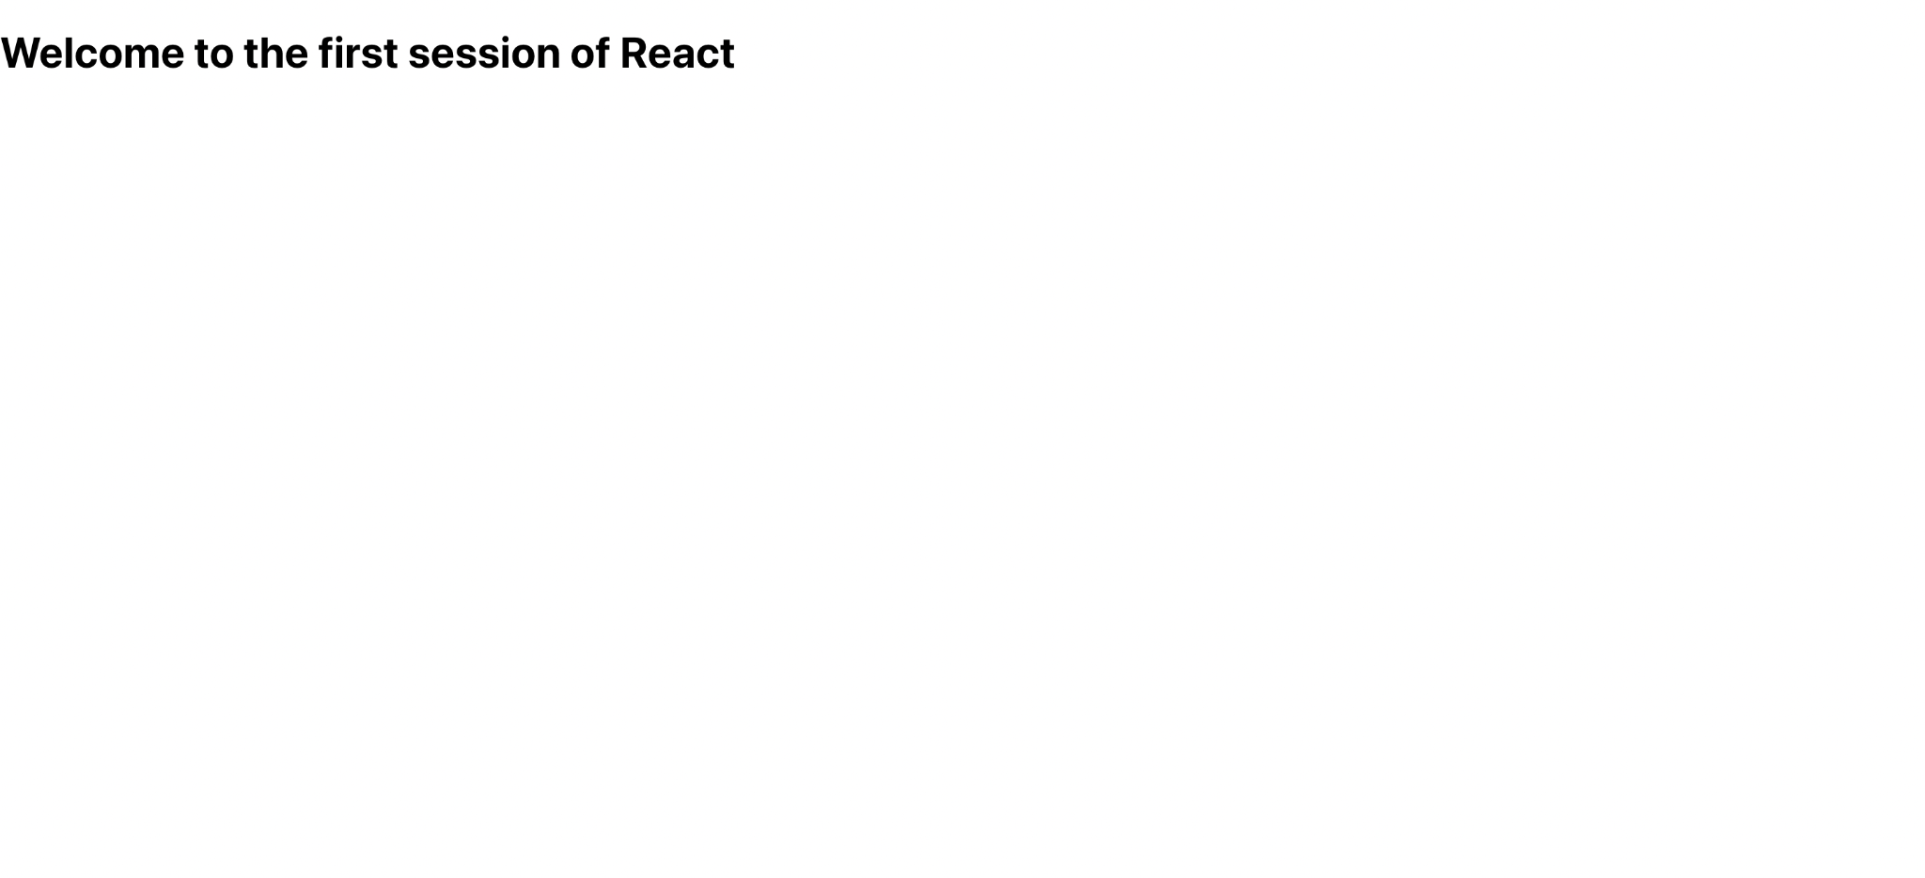

**1. Set up a react environment and Use create-react-app**

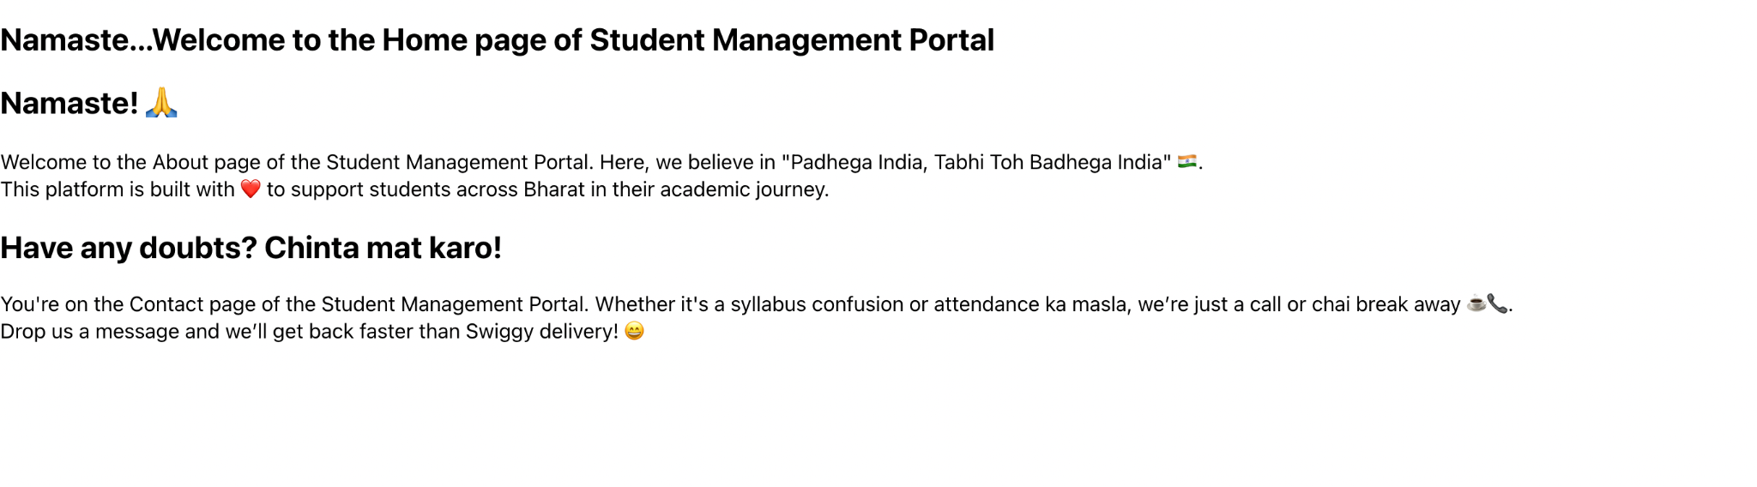

**2. · Create a class component**

**· Create multiple components**

**· Render a component**

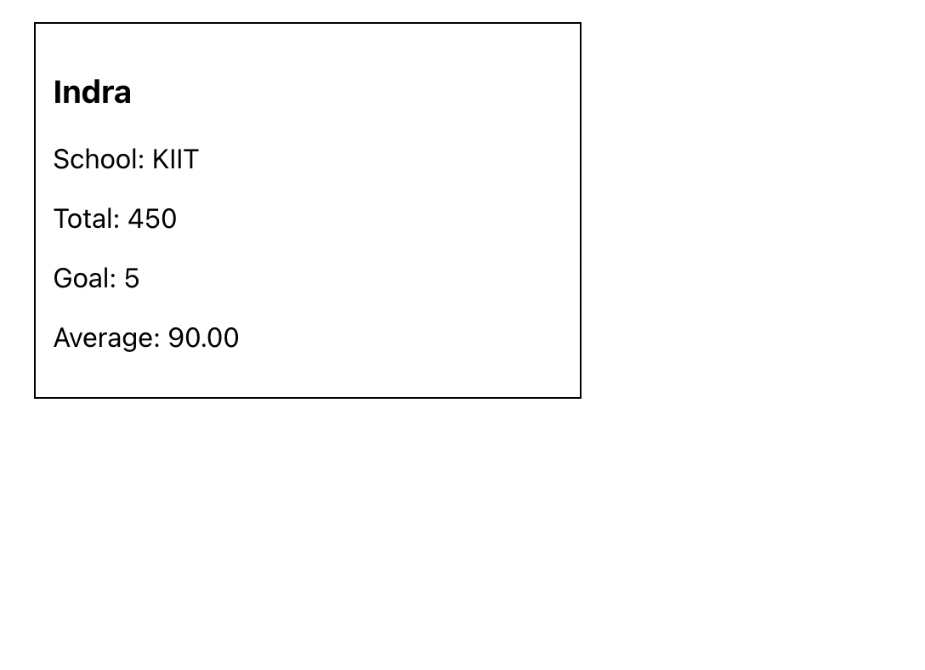

**·**

**3. Create a function component**

**· Apply style to components**

**· Render a component**

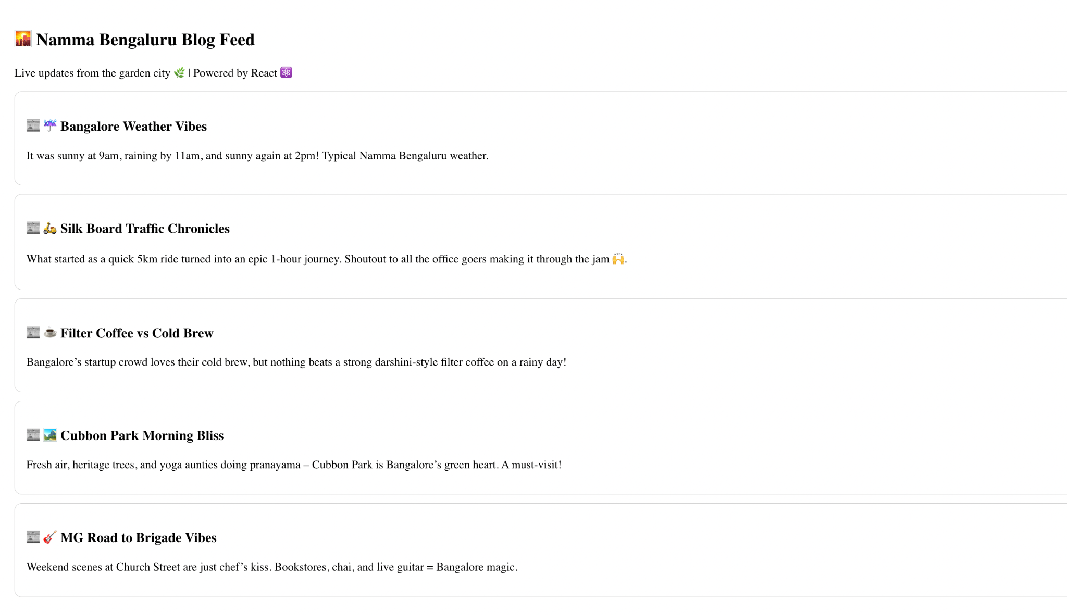

**4. · Implement componentDidMount() hook**

**· Implementing componentDidCatch() life cycle hook.**

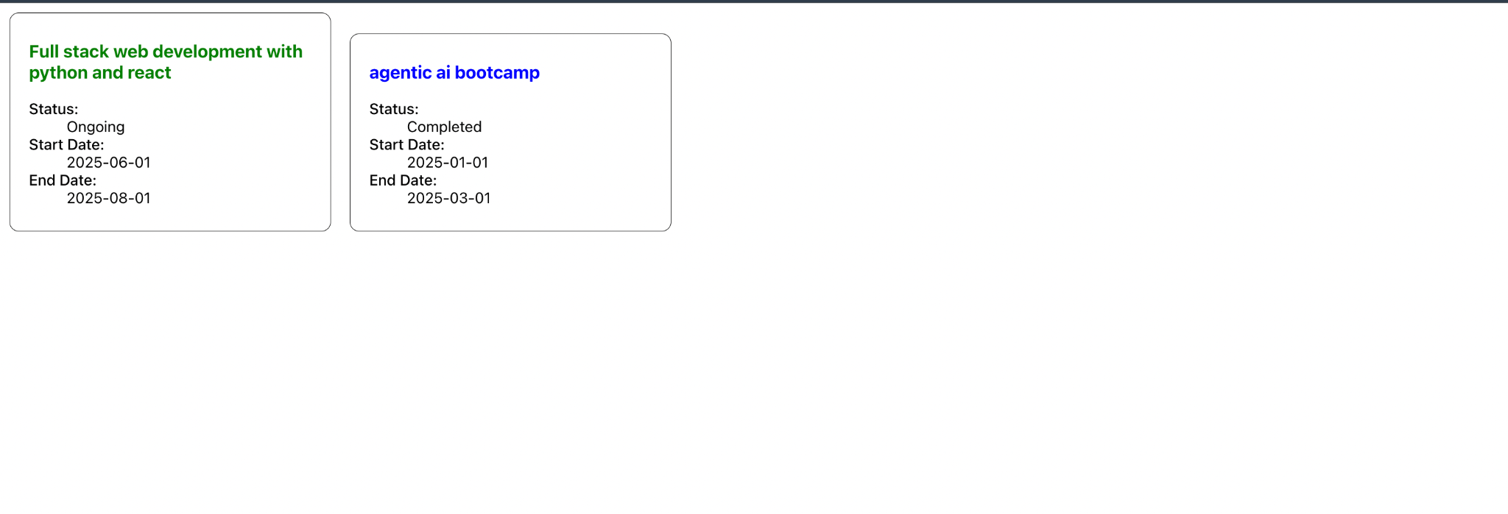

**5. · Style a react component**

**· Define styles using the CSS Module**

**· Apply styles to components using className and style properties**