Diabetic Retinopathy Classification from Retinal Images using Machine Learning Algorithms

Name of the Students: Tareq Mahmud (Roll No - 1507089), Indronil Bhattacharjee (Roll No - 1507105)

Name of the Supervisor: Al-Mahmud, Assistant Professor, Department of CSE, KUET

Abstract: Diabetic Retinopathy (DR) is one of the common eye diseases and is a diabetes complication that affects eyes. Diabetic retinopathy may cause no symptoms or only mild vision problems. Eventually, it can cause blindness. So early detection of symptoms could help to avoid blindness. In this paper, we present some experiments on some features of Diabetic Retinopathy like properties of exudates, properties of cotton wool. That can classify healthy, non-proliferative and proliferative stage of DR. Then perform feature selection methods for improving desired classification. Several classification methods like Support Vector Machine (SVM), Decision Tree (DT) and K-Nearest Neighbor (KNN) classifiers are used for best accuracy and sensitivity.

Keywords: Diabetic Retinopathy, Exudates, Microaneurysm, Cot-ton Wool spot, Contrast Limited Adaptive Histogram Equalization, Support Vector Machine, Decision Tree, K-Nearest Neighbor.

Methodology: Color fundus image of eye is provided as an input and by processing this we get the result whether the eye is affected with Diabetic Retinopathy and stages of DR. To detect Diabetic Retinopathy, we preprocess the im-age and apply classification techniques. We divide the to-tal process into 3 steps preprocessing, feature extraction and Diabetic Retinopathy classification. Preprocessing includes green channel extraction, Contrast Limited Adaptive His-togram Equalization, dilation, morphological process, me-dian filtering and thresholding. In the feature extraction phase, we extract several features like number of exudates, area of exudates, average color of pixels, number of microa-neurysm, cotton-wool spots and its properties etc. Finally, in the classification phase, we will detect whether Diabetic Retinopathy is present or not. And if present, whether it is Proliferative DR or Non-Proliferative DR.
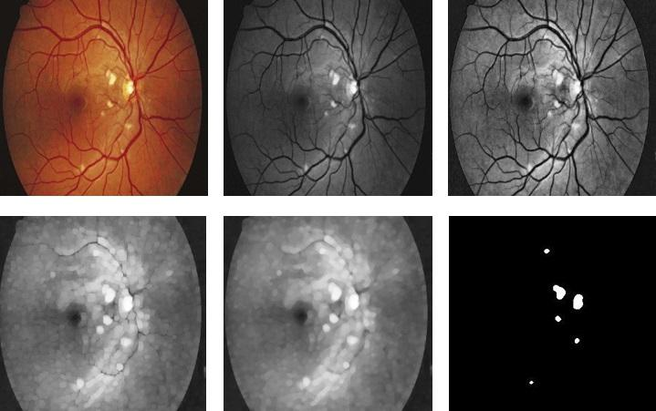

Fig. 1. Exudates detection from retinal image. (From top left) Input image, After Green Channel extraction, After CLAHE, (From bottom left) After dilation, Median Filtered, After Thresholding

Proposed System: Our proposed system for classifying Diabetic Retinopathy follows ten steps. The steps of the system are illustrated in the following-

Input: Colour fundus retinal images

Output: Whether Diabetic Retinopathy is present or not. And if present, whether it is PDR or NPDR.
Process:

Step 1: Take the input image.

Step 2: Preprocess the input image

Step 3: Exudates detection

Step 4: Microaneurysm detection

Step 5: Segmentation of optic disc

Step 6: Cotton wool detection

Step 7: Feature extraction

Step 8: Apply machine learning algorithms
(SVM, KNN, DT)

Step 9: Classify the Diabetic Retinopathy stages

Step 10: Detect whether it is healthy, PDR or NPDR

The features which are expected to be extracted for the classification are:

- Average Intensity of Exudates, 2. Number of Exudates, 3. Area of Exudates, 4. Number of microaneurysms, 5. Cotton Wool Area and Number 6. Cotton Wool Intensity 7. Cluster intensity.

We have used Support Vector Machine, Decision Tree and K-Nearest Neighbor classifiers for DR classification.This will classify into three classes as Healthy eye, Proliferative DR eye and Non-proliferative DR eye. These three classifiers are used for comparison of accuracy among them. Because, any of the classifier may not give us the expected output for a given feature, but gives excellent accuracy for other features. That is why Support Vector Machine, Decision Tree and K-Nearest Neighbor classifiers are used for better accuracy and sensitivity.

Conclusion: After studying the existing systems, we con-clude that our proposed technique will successfully detect Diabetic Retinopathy. Along with this, the proposed method will also classify Proliferative Diabetic Retinopathy and Non-Proliferative Diabetic Retinopathy.

