KNOWLEDGEOPS AI

Project Architecture, Code Breakdown & Swimlane
A presentation guide to the complete application, its key files, connected services, and end-to-end workflow.

PAGE 1 | WHOLE-PROJECT ARCHITECTURE
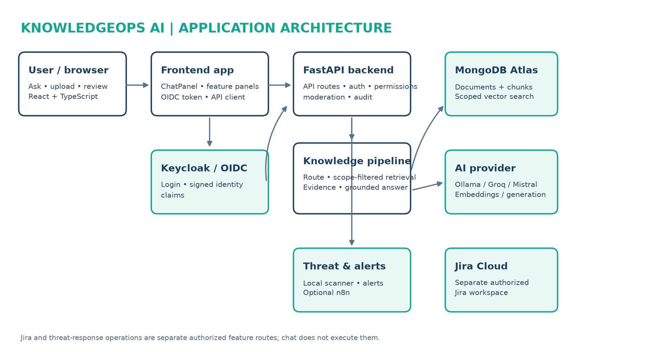
Main path: User → React frontend → FastAPI → verified identity and scope checks → retrieval and grounded generation → cited response and audit. Keycloak, MongoDB Atlas, and the configured model provider are external services. Jira and threat analysis are separate authorized feature routes.

PAGE 2 | FRONTEND, IDENTITY & API ENTRY

Frontend — the user-facing lane
App.tsx initializes the OIDC callback and loads the current user. ChatPanel.tsx captures a question and renders the result and citations. api/chat.ts sends POST /api/v1/chat; api/http.ts attaches the current bearer token.

Identity — who is making the request?
api/oidc.ts configures oidc-client-ts for authorization-code flow with PKCE. Keycloak authenticates the person and issues a signed token. core/auth.py verifies signature, issuer, audience, expiry, and claims; core/permissions.py maps trusted groups into capabilities and data scopes.

API — the controlled entry point
main.py configures FastAPI, CORS, request IDs, and routes. api/v1/router.py mounts feature APIs. api/v1/chat.py validates the request, requires chat:ask, runs moderation and orchestration, audits the result, and returns ChatResponse.

How the files connect
App.tsx → oidc.ts → http.ts → chat.ts → main.py → router.py → chat.py → auth.py / permissions.py. A verified user context is established before protected work begins.

PAGE 3 | CHAT ORCHESTRATION, RETRIEVAL & LLM

routing.py — classify intent
route_question() calls _classify_intent() to select a knowledge, analytical, workflow, or unsupported route, including required scope or clarification.

orchestration/service.py — connect the route to work
orchestrate_request() checks required scope, chooses a feature path, and sends knowledge questions to the index. Unavailable actions receive a planned response; chat does not execute Jira writes or threat-response actions.

knowledge/index.py and retrieval.py — find permitted evidence
get_knowledge_index() loads fictional seed files and stored chunks, then selects Atlas, Qdrant, or local retrieval. Search filters candidates by the user's allowed scopes. Hybrid mode combines vector and keyword rankings.

knowledge/mongodb_index.py — vector retrieval
MongoAtlasKnowledgeIndex creates a query embedding and runs Atlas Vector Search with server-side access-scope filtering, then combines ranked results with lexical search.

knowledge/generation.py + ai_providers.py — draft from evidence
generate_grounded_answer() abstains when there are no matching sources. Otherwise it passes retrieved evidence to a configured LangChain model. create_embeddings() and create_chat_model() connect Ollama or configured Mistral/Groq services.

moderation/guardrails.py — safety around model use
Input, retrieved text, and answer output are inspected. Evidence is treated as untrusted reference content; the model is asked to answer only from supplied evidence.

Sequence
chat() → route_question() → orchestrate_request() → index.search(question, user_scopes) → inspect retrieved text → generate_grounded_answer() → output check → response with citations.

PAGE 4 | INGESTION, STORAGE & OTHER FEATURES

Document upload and indexing
api/v1/knowledge_documents.py checks knowledge:manage, file type/size, duplicates, and ingestion configuration. PDF, Office, and text handlers extract sections. Security preflight and extracted-text inspection run before content is chunked and indexed. Original upload bytes are not retained.

MongoDB Atlas persistence
storage/mongodb_knowledge.py stores document metadata and chunks separately, enforces unique content hashes, and creates supporting indexes. knowledge/mongodb_index.py indexes and retrieves scoped vectors.

Jira Cloud — separate feature lane
api/v1/jira.py exposes dedicated endpoints; integrations/jira_cloud.py calls Jira REST using backend-only credentials. Reads require jira:read. Writes require jira:approve and explicit confirmation. Chat does not execute Jira operations.

Threat scans, alerts, and n8n
api/v1/threat_scans.py exposes authorized scans. threat_detection/ applies local rules; scans do not execute files or fetch submitted URLs. Findings may create redacted alerts. Analyst-confirmed response requests and optional n8n notifications are separate from automatic remediation.

Governance and audit
storage/audit.py records event metadata. Chat audit data includes route, outcome, and source count, not question/answer content. Request IDs and metrics are attached by main.py. Audit records and permissions support review and traceability.

External components at a glance
Keycloak: login and signed claims. MongoDB Atlas: document/chunk storage and vector search. Ollama, Groq, or Mistral: embeddings and/or answer generation according to configuration. Jira Cloud: separate ticket workflow. Optional n8n: event notification/confirmed workflow dispatch.

PAGE 5 | WHOLE-APPLICATION SWIMLANE
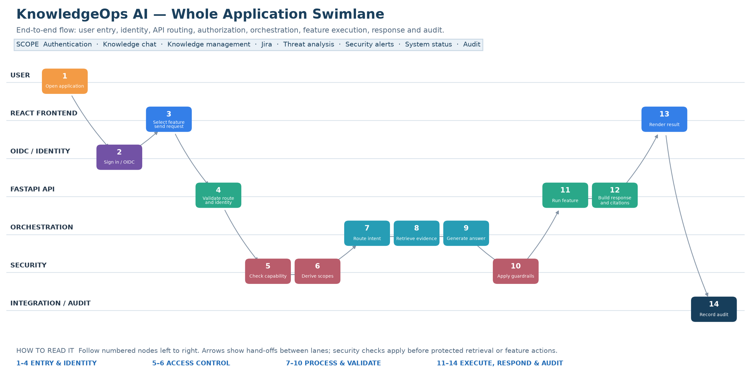
Follow the 14 numbered nodes from left to right. The lanes identify the responsible actor or component; arrows show hand-offs. Security checks apply before protected retrieval or feature actions. Feature-specific operations run only when implemented and authorized; Jira and threat workflows remain separate from chat.

