CaseStudy-2 creating relational entities using nested json data

(Json array table to dynamo db)

AWS Glue

1.Classifiers

2.Crawlers- We have created two crawlers. One for json data and one for dynamodb.

3.Table

4.Job

For Nested DATA

1.We have created one crawler for nested json data so that we can use that table name in jupyter code.

Devendpoint

NOTEBOOK

Jupyter

S3 Bucket- After running code on jupyter,here will get schema for building and tenants

Crawlers:We have to create two crawlers for newly created schema in S3 bucket & two crawlers for manually created tables in SQL using RDS endspoints.

Tables

Jobs-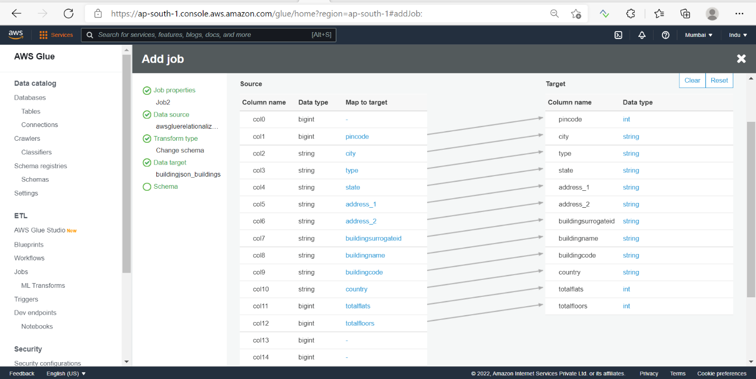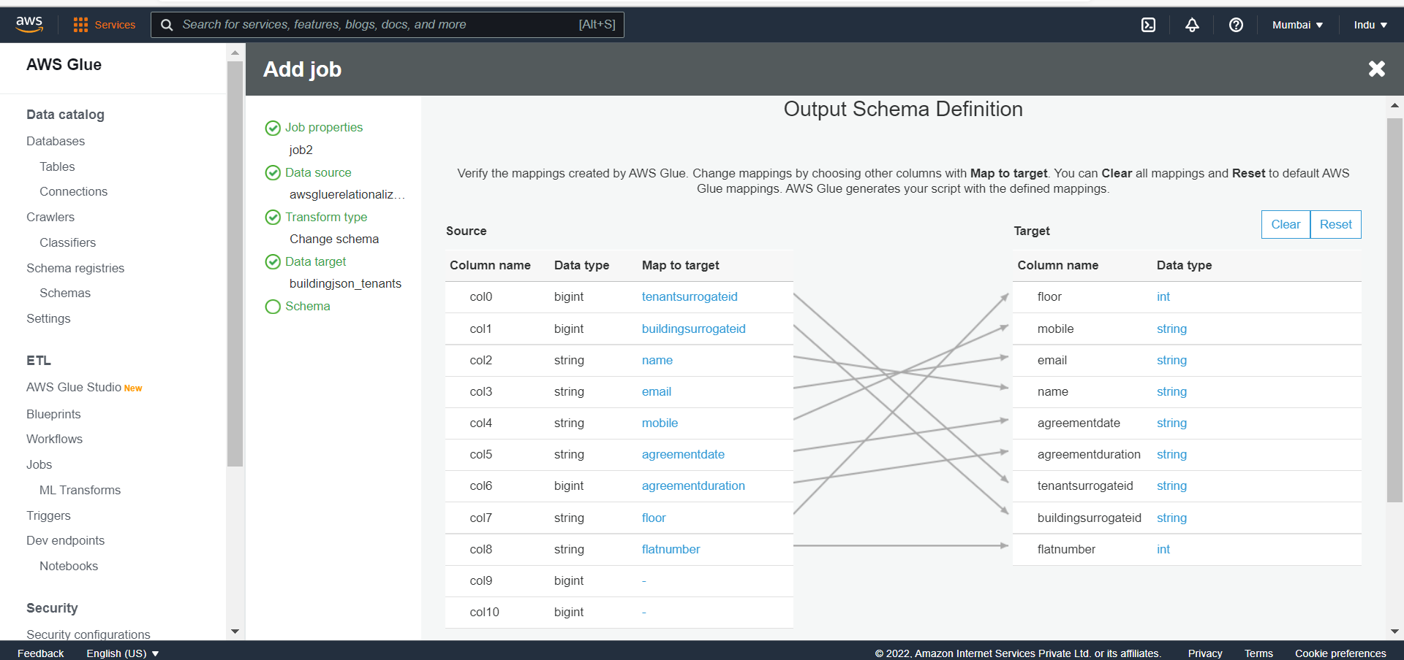

Building Table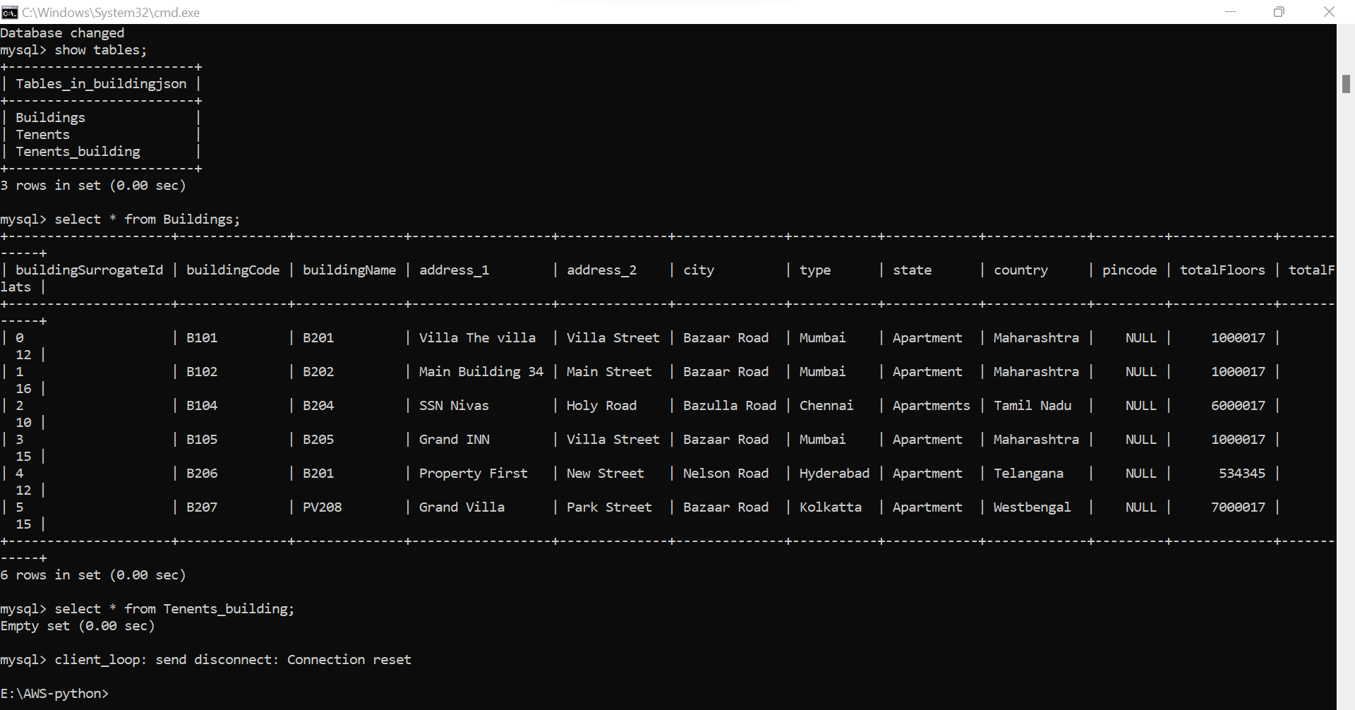

Tenants Table

Jobs for building and Tenants

Quick Sight for Buildings

Quick Sight for Tenants

