**Casestudy-1**

RDS Instance:

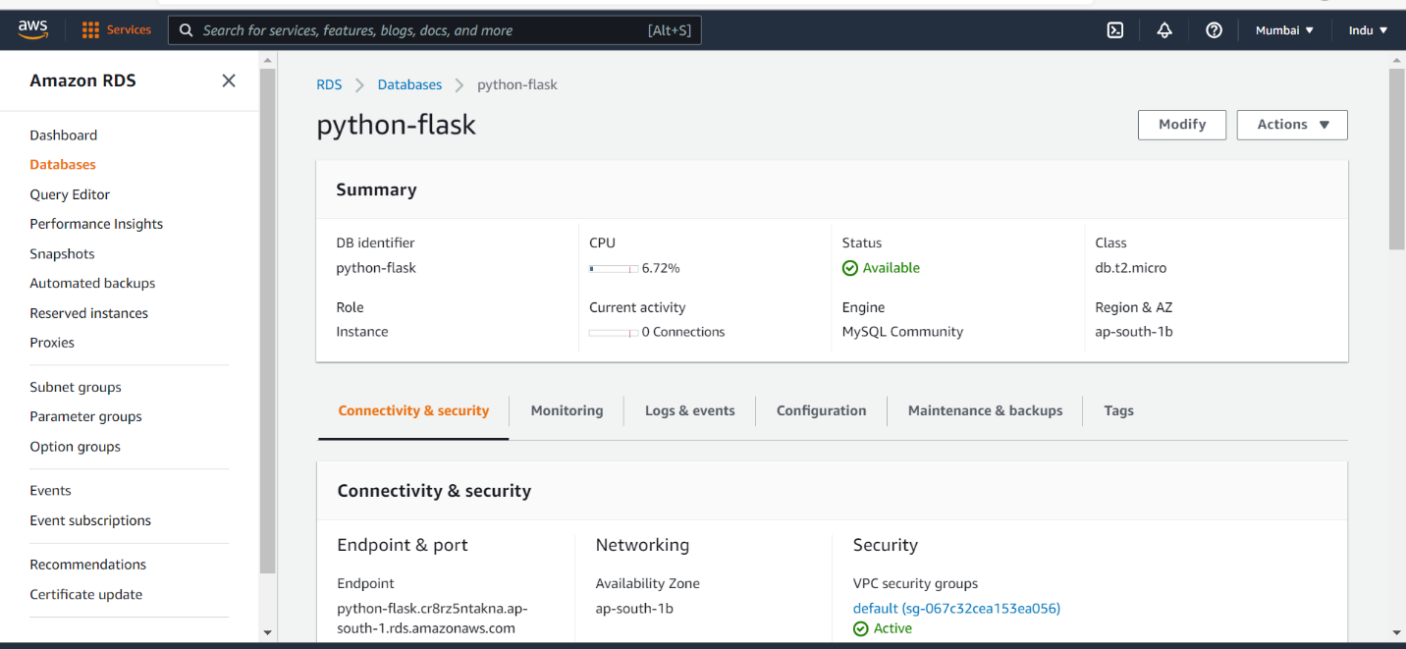

S3 Bucket: Put sales csv file into S3

LambdaFunction triggered to S3: Through event notification in S3 Bucket this lambda fun will be triggered

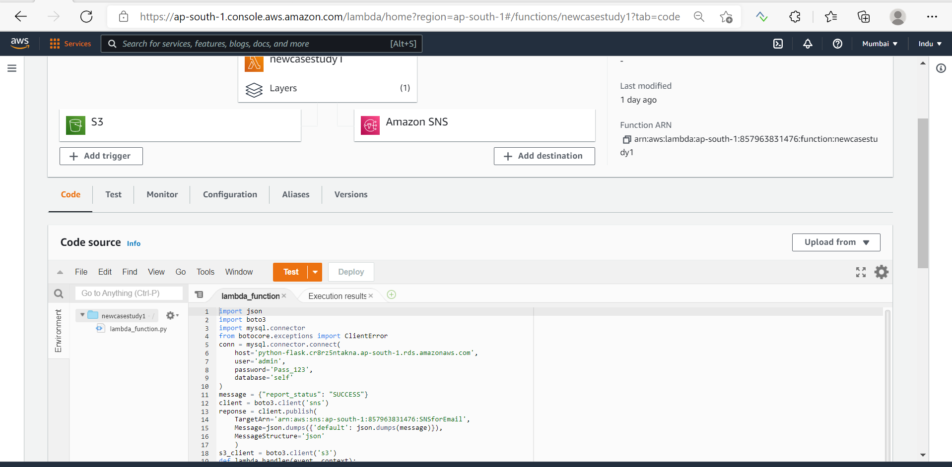

Lambda Layer: To make sql connection uploaded SQL Libraries as Lambda Layer in Lambda function

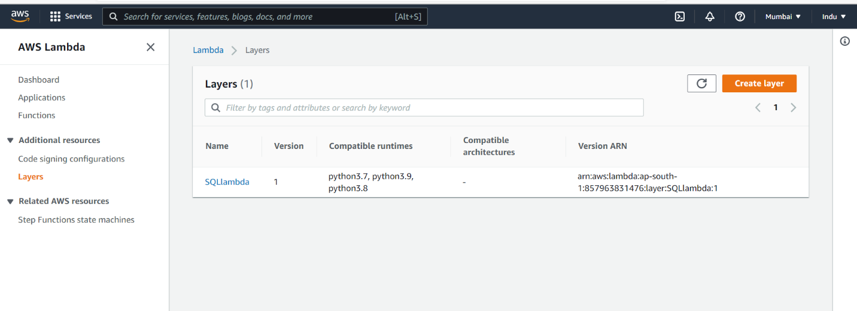

Cloud Watch Report: All the three records has been generated in cloud watch logs.

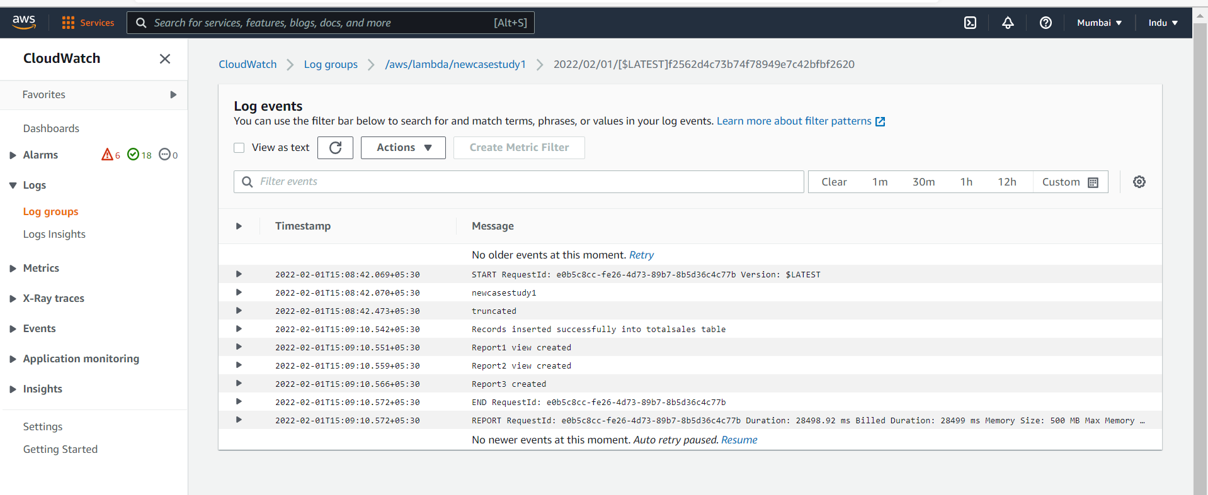

SNS Connection: On success of report getting e-mail through SNS connection in Lambda Function so created SNS and attached with same Lambda function in below screenshots

Sales_Copy Table: Created table in using RDS database

Report1 in RDS database after triggering the lambda function

Report2 in RDS database after triggering the lambda function

Report3 in RDS database after triggering the lambda function

SNS-Email : On completion of three reports an email will be triggered to my email id which I have given in SNS.

