Ise-1

Name-sudiksha neje

Roll no:c-02

Question 1:

Write a Python program to get a list, sorted in increasing

order by the last element in each tuple from a given list of

non-empty tuples.

Sample List : [(2, 5), (1, 2), (4, 4), (2, 3), (2, 1)]

Expected Result : [(2, 1), (1, 2), (2, 3), (4, 4), (2, 5)]

Output: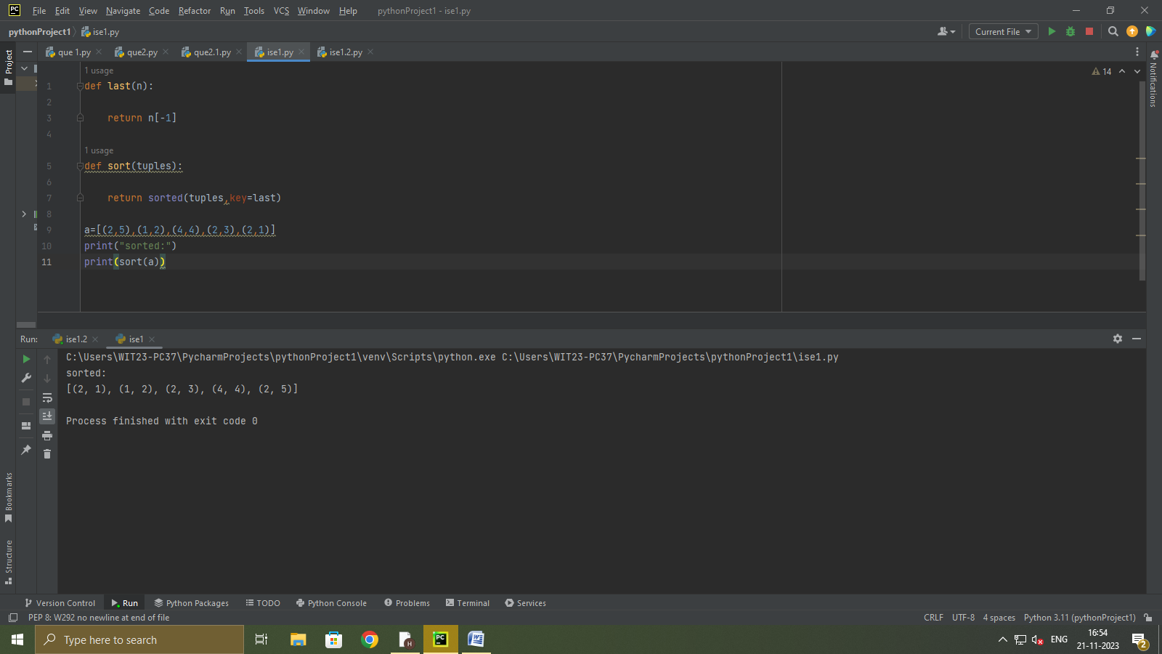

Question 2:

Implement a Python program to find the magic number of a

positive integer. A magic number is a single-digit number

obtained by repeatedly summing the digits of the original

number until a single digit is reached. For example, the

magic number of 19 is 1 because 1 + 9 = 10, and 1 + 0 = 1.

(note:A number is said to be a magic number if the sum of

digits of the number recursively equals to 1)

output:

