Beyond the Finish Line
  - User guide
Contribute to purpose. Leave a lasting impact.
Web platform • September 2026

What the platform helps you do
Connect assigned work, progress and authorised evidence to a thoughtful appraisal conversation. Agree practical development commitments, record the support needed, and follow through at Mid-Year and Year-End. Senior leaders use the same accountable process with additional leadership questions.

Your first visit
1. Open the invitation from HR. Confirm your first and last name, create a password of at least 12 characters, and accept the invitation. The business email is fixed by the invitation.
2. Sign in with that business email. The five-slide introduction appears after sign-in. You can replay it from Platform introduction in the sidebar.
3. Open My account and complete your professional profile. Confirm your reporting manager and joining date with HR if they are missing or incorrect.
4. Choose your responsibility using the WORKSPACE selector, then open the dashboard or My actions to find your next step.

One account with different responsibilities
My Work covers your own tasks, reflection and development. My Reviews covers evaluations involving you. My Team appears for managers. HR Workspace provides company, people and cycle administration. My Approvals appears for Head of HR; sensitive review actions also require appointment to that particular review.
Changing the workspace changes the view, not your identity or permissions. A manager can receive work from their own manager and assign work to direct reports using the same account.

How to use this guide
Page 2 covers your profile. Page 3 covers everyday work and growth. Page 4 explains employee and manager appraisals. Page 5 covers HR administration. Page 6 explains Head of HR validation and finalisation. Page 7 covers Steward and troubleshooting.

Your personal profile
Select My account in the sidebar, or your name in the top bar. Open the Profile tab. Every invited user has a profile linked to their own account.
1. Enter your first and last name, phone number, preferred contact email, designation and employment company. Add location, skills and a short professional biography as useful.
2. Choose Change photo and select a PNG or JPEG up to 2 MB. The platform stores a square crop. Photo changes save immediately; use Remove photo to return to initials.
3. Select Save profile for text changes and wait for the success message. Your name and designation update in the shared navigation.

Which details HR manages
Workspace membership, department, reporting manager, joining date and access responsibilities remain controlled by HR. “Since 2003” means the employee joined in 2003. The employment company field describes your professional profile; it does not move you into another workspace.
Contact email is separate from sign-in email. Contact HR to change your sign-in identity. The Security tab links to password recovery. The Notifications tab controls daily overdue reminders; workflow notifications still appear in My actions.
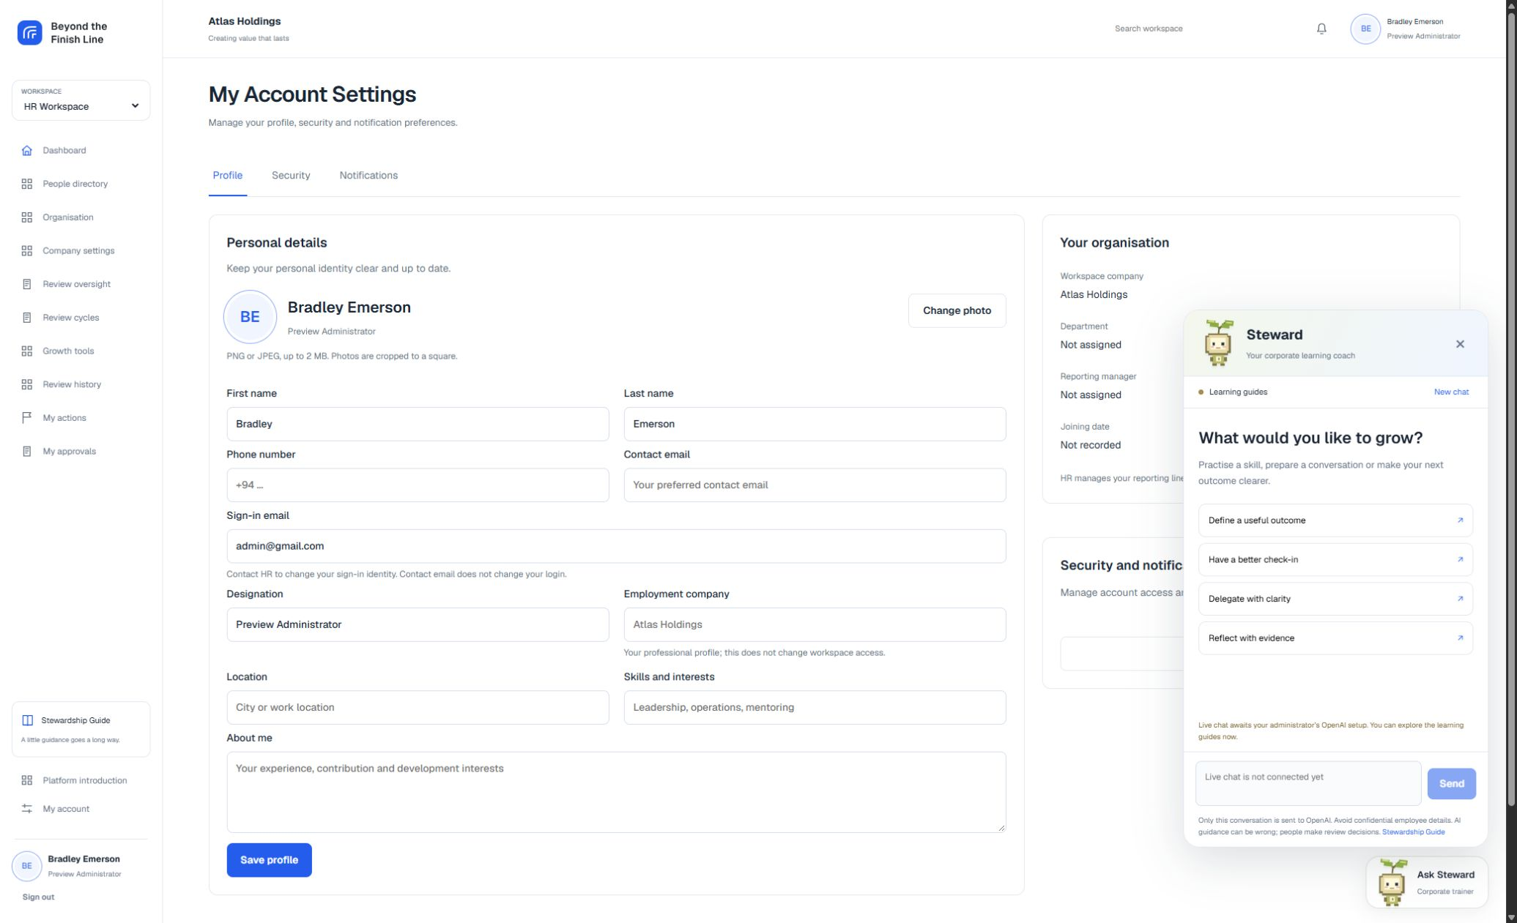
My Account Settings with the corner corporate trainer open.

Everyday work and lasting contribution

Keep work connected to an outcome
1. Open My Work and select an assigned item. Read the expected outcome, owner, deadline, priority and context before updating it.
2. Record progress as Not Started, In Progress, Blocked or Done. Explain the blocker, next step and support needed rather than changing only a percentage.
3. Add the result and supporting evidence. Use files and links you are authorised to share. A link in a growth record is not automatically approved appraisal evidence.
4. Mark the item Done when the agreed outcome is achieved. Continue the conversation with your manager when scope, ownership or the deadline needs to change.

Managers assign and delegate
In My Team, open Team Work and Assign work. Select an active direct report, describe the expected outcome, and set the deadline and priority. A manager can delegate part of their own assigned work; the child task remains connected to the parent outcome. If no owners are available, ask HR to confirm reporting relationships.

Use the dashboard as a prompt for action
Work status, overdue items, on-time delivery, completion trends and review progress describe recorded operational activity. They are not an automatic performance score. Empty charts mean no qualifying data has been recorded. Follow the linked work or reviews to understand the context.

Build your growth records
Open Growth tools to access Contributions and Evidence, Capability Map and Legacy Tracker. Add a title, category, specific example, outcome, support and an authorised evidence link where useful. Records save in your account; Edit updates them and Archive hides them without deleting them. Use Show archived records to restore an entry.
Contributions and Evidence captures mentoring, knowledge sharing and improvements beyond assigned tasks. Capability Map records strengths, development opportunities and support across four capability areas. Managers can add a separate observation for a direct report. Legacy Tracker captures what others can carry forward across people, knowledge, systems and culture.
Your entries are personal unless you choose to share with your reporting manager. Manager capability observations are visible to the employee. Each author edits only their own observations. Bring relevant examples into the formal reflection; Head of HR separately validates selected appraisal evidence.

Employee and manager appraisals

Two formal review cycles
HR opens Mid-Year and Year-End cycles. Your review appears in My Review or My Reviews. Year-End compares progress against the final Mid-Year record and agreed commitments. Day-to-day check-ins support the work but do not create extra formal evaluation cycles.

Employees prepare a reflection
1. Open your current review and complete the work-related reflection sections. Describe your contribution, constraints, capabilities, learning and support needed.
2. Select relevant evidence and explain what it demonstrates. Keep private pre-workshop reflections and personal WHY exercises outside the formal HR record.
3. Watch the draft-saving status. If the screen reports a stale version, retain your text and reconcile with the latest saved record; do not assume it was saved.
4. Review the completed form, then submit. Submission seals that form round. Corrections after submission require a documented revision through Head of HR.

Managers bring a separate perspective
Open Reviews I conduct from My Team. Complete the contribution and potential assessment, ECP, five pillars, stewardship tools, supporting examples and contextual diagnosis. Base observations on the review period and authorised evidence. Private drafts belong to their authors; shared visibility changes when forms are submitted.
When the employee is marked as a senior leader by HR, additional fields cover strategic outcomes, leadership support and sustainable systems. A senior manager’s own appraisal appears in their employee context; reviews they conduct appear in their manager context.
For Year-End, assess the Mid-Year commitments as Met, Partially Met or Missed and explain why before submitting the manager appraisal. The comparison must preserve the original Mid-Year agreement.

From conversation to improvement
After both submissions, the appointed Head of HR validates the sources and prepares the human assessment. The conversation brings employee and manager perspectives together. Agree three to five commitments with an owner, support, success measure and due date.
Employee and manager each acknowledge the shared record. Acknowledgement records receipt and discussion; it is not forced agreement. The employee can add comments. Raise a discrepancy before finalisation. Final records appear in Review History and remain read-only; development progress continues separately.

HR administration

Prepare the company and people
1. Open Company settings. Set the company name, tagline and logo URL. Use an approved image with a transparent background when appropriate. Company identity appears in the workspace header; it is not a separate sidebar profile card.
2. Open Organisation to add departments and job roles. Keep names meaningful and avoid duplicate entries.
3. Open People directory and Add employee. Record first and last name, business email, designation, department, role and employee joining date. Set manager or senior-leader indicators only when appropriate.
4. Open the employee’s profile to check their organisation details and send an access invitation. Delivery depends on the configured email service and background worker.
5. Inspect Management Structure using Reporting map, Unassigned or List view. Use Edit relationships to open the reporting-manager selectors in People directory. Managers must be active and reporting lines cannot create a cycle. Confirm the actual responsibility chain before launching reviews.

Configure and launch a cycle
Open Review cycles. Configure the year, Mid-Year or Year-End period and dates. Preview readiness and participants before launch. Each participating employee needs an active reporting manager. Appoint an independent Head of HR for review validation and finalisation. Year-End additionally requires the person’s final Mid-Year record.
Use the HR dashboard and Review oversight to monitor stage counts, outstanding submissions and overdue steps. Download the review progress CSV when needed. A general HR role provides administration and status oversight; it does not grant unrestricted access to every private review narrative or draft.

Resolve account and reporting issues
A profile’s employment company and designation do not grant access rights. HR manages the actual membership, reporting hierarchy and joining date. When access or assignment choices appear wrong, verify those records rather than changing a person’s display name or designation.
If an invitation expires, resend it from the employee profile. A used invitation cannot be accepted again. Existing users should use password recovery. Ask the deployment administrator to investigate queued invitations that do not arrive; avoid sharing a temporary password between users.

Keep the review process fair
Check that the appointed reviewer is independent and that people know what evidence will be considered. Encourage specific examples, context and support commitments. Use AI as an aid to the conversation; the authorised human reviewer remains accountable for the formal assessment.

Head of HR review and finalisation
These actions are available only to the Head of HR explicitly appointed to the review. Being Head of HR elsewhere in the company does not automatically authorise this review. Self-validation is not allowed.

Validate before analysing
1. Open My Approvals and select the review. Confirm that both the employee reflection and manager appraisal have been submitted.
2. Inspect each selected evidence source. Validate the relevant excerpt or exclude the source with a reason. Do not approve an unsupported claim merely because it appears in a submitted form.
3. Review the exact selected source set before requesting analysis. Only authorised submitted forms and validated evidence excerpts belong in the review analysis.
4. Request AI coaching when the review integration is available. Examine source references, missing evidence, differences in perspective and suggested coaching questions. Accept or reject the advice with your own notes.

Record the human assessment
Write the formal assessment and your rationale. AI does not finalise, rank or make an employment decision. If analysis is unavailable, record a human-only reason and continue through the authorised manual workflow. Do not treat a provider error or absent evidence as a poor-performance finding.

Agree the next chapter
Record the review conversation, including both perspectives. Create three to five development commitments. Assign each commitment to the employee or manager as appropriate, and identify support, a success measure and a due date. Vague commitments such as “improve leadership” need a concrete observable next step.
Request both participant acknowledgements. If a correction is required before finalisation, request a revision with a reason. A revision begins a new round and clears current acknowledgements while preserving earlier history; collect acknowledgements again for the revised record.

Save the final record
Finalise only when the required human assessment, conversation, commitments and both acknowledgements are complete. The platform saves an immutable snapshot with provenance and history. Current final records cannot be reopened through the application.
Employees and responsible managers continue updates in Development follow-up. Progress and new evidence do not rewrite the frozen agreement. At Year-End, use the saved Mid-Year baseline to discuss what changed, what was achieved and what support still needs to be provided.

Steward and everyday help

Your corporate trainer
1. Select Ask Steward in the bottom-right corner of any signed-in screen. The animated seedling opens a learning panel; it stays separate from the formal appraisal workspace.
2. Choose a built-in guide to define an outcome, improve a check-in, delegate clearly or reflect with evidence. These guides are labelled as written guidance, not AI-generated replies.
3. When the administrator connects OpenAI, type a training question and select Send. Use fictional or general examples instead of confidential employee details.
4. Reopen a saved conversation from the conversation selector, or choose New chat. Close the panel with its close button or Escape. Reduced-motion preferences stop the character animation.
Before OpenAI is configured, the panel says that live chat awaits administrator setup and the message box is disabled. The learning guides remain available. A configured service can still fail; the error message keeps your unsent draft so you can retry later.

What the trainer can see
The trainer sends only its conversation context to OpenAI. It does not automatically read profiles, appraisal forms or evidence. Saved conversations are scoped to your account and workspace. Training advice can be wrong and does not become a formal review assessment.

Help when something looks wrong
Missing work or review: check the WORKSPACE selector and ask HR to confirm your reporting relationship and review-cycle participation. Empty charts are not evidence of poor performance.
Save conflict: keep your text, reload the latest record and reconcile changes. A conflict is not a successful save. Submitted forms require a revision; final records remain locked.
Photo rejected: use a genuine PNG or JPEG no larger than 2 MB. Photos are cropped to a square. Ask HR about organisation details that are read-only.
Need an explanation: open Stewardship Guide or use the contextual help buttons. The optional role tours show the main controls. On a smaller browser window, use Menu; wider tables scroll within their own area.
Cannot sign in: use Forgot password or ask HR to resend an unused invitation. Sign out after using a shared computer. The deployment administrator follows TRAINER_SETUP.md to enable live training and the separate appraisal integration guide for review analysis.

