UNIDSELLS
MARKETPLACE WEB APPLICATION

A Course Project Report
Submitted in the partial fulfilment of the completion of the course
23CS002PC304 AI Assisted Coding
In III Year II Semester B.Tech – CSE

Submitted by
L.INDU
2303A51250

Under the supervision of the faculty
Sallauddin Md
Assistant Professor, SOCS & AI

Academic Year 2025-2026


Department of Computer Science & Engineering
SR University
Warangal, Telangana, India
INDEX

S.No | Section | Page No.
1 | Abstract | 3
2 | Introduction | 4
3 | Literature Review | 5
4 | Problem Statement | 6
5 | Methodology / Procedure | 7-8
6 | System Design | 9-10
7 | Code | 11-13
8 | Output | 14
9 | Output Screenshots | 15-20
10 | Conclusion | 21
11 | References | 22

1. ABSTRACT

Web development has evolved significantly, demanding comprehensive solutions that integrate multiple technologies into cohesive, functional systems. UnidSells is a full-stack marketplace web application developed entirely through AI prompt engineering using github copilot — demonstrating how intelligent prompting can generate production-ready software without manual coding.

The application addresses the need for a digital platform that allows users to buy and sell products online — similar to OLX or Quikr. It implements a role-based access control system with two distinct user types — Admin and User — each provided with tailored dashboards and functionality.

Built on the MEN stack (MongoDB, Express.js, Node.js) with plain HTML/CSS/JavaScript frontend, UnidSells incorporates session-based authentication, OTP-based forgot password system, image uploads via Multer, real-time Socket.io chat, multi-image product listings with slider navigation, wishlist management, budget filter, and a comprehensive admin control panel.

The project successfully demonstrates how modern full-stack applications can be generated through structured AI prompting, producing 24 files and over 3,000 lines of code across an iterative conversation. This report documents the design, methodology, system architecture, complete source code, and outputs of the UnidSells project, along with a discussion of the AI-prompt-driven development approach.

2. INTRODUCTION

The rapid advancement of web technologies has created a demand for sophisticated full-stack applications capable of managing complex online marketplace operations. With the widespread adoption of digital commerce, platforms that connect buyers and sellers have become essential for modern retail ecosystems.

Full Stack Development refers to the practice of building both the client-side (frontend) and server-side (backend) components of a web application. A full-stack developer is responsible for designing databases, building servers, developing APIs, and crafting user interfaces. This dual capability makes full-stack development essential for building end-to-end software solutions.

UnidSells is a comprehensive buy-and-sell marketplace platform that demonstrates full-stack development principles through a real-world application. The project uniquely showcases the power of AI prompt engineering — the entire codebase was generated through natural language prompts to github copilot, with no manual coding. This approach highlights how modern AI tools can dramatically accelerate the software development lifecycle.

The application implements the MEN Stack (MongoDB, Express.js, Node.js) with a responsive HTML/CSS/JavaScript frontend. Key features include:

- Session-based authentication with bcrypt password hashing
- OTP-based forgot password system (3-step verification flow)
- Role-based access control for Admin and regular Users
- Multi-image product listings with left/right slider navigation
- Image upload from device OR paste URL — both saved to MongoDB
- Real-time buyer-seller chat powered by Socket.io
- Wishlist management using localStorage
- Budget filter with preset ranges and custom min-max slider
- Admin panel — block/delete users, flag/delete listings, monitor chats
- Fully responsive UI with dark/gold premium theme

The main objective is to demonstrate how AI-driven prompt engineering can produce production-quality full-stack web applications while also delivering a functional, deployable marketplace solution.

3. LITERATURE REVIEW

Online marketplace platforms have been an active area of research and development in the field of web-based applications. Numerous studies highlight the benefits of digital marketplaces, including improved reach for sellers, competitive pricing for buyers, and streamlined transaction processes.

The MEN stack (MongoDB, Express.js, Node.js) has become a popular choice for building scalable web applications. MongoDB's document-oriented storage aligns well with dynamic content like product listings and user data, while Express.js provides a lightweight and flexible server framework. Node.js enables non-blocking, event-driven architecture ideal for handling concurrent user requests.

Role-based access control (RBAC) is a well-established security model widely used in web applications. Research by Ferraiolo et al. demonstrates that RBAC simplifies administration and enhances security by assigning permissions based on user roles rather than individual identities. This principle is applied in UnidSells through Admin and User role distinctions.

Real-time communication using WebSockets, as implemented through Socket.io, provides instantaneous bidirectional messaging between clients and servers. Studies on real-time communication in e-commerce applications demonstrate that live chat capabilities significantly improve buyer-seller engagement and conversion rates.

Session-based authentication using express-session with connect-mongo provides a stateful approach to user identity management. Studies comparing JWT and session-based authentication indicate that session-based approaches offer simpler revocation mechanisms and reduced client-side complexity, making them suitable for server-rendered applications.

AI-assisted code generation has emerged as a transformative development in software engineering. Large Language Models (LLMs) such as Claude AI by Anthropic can generate syntactically correct, contextually appropriate code from natural language descriptions. Research by Chen et al. (Codex, 2021) demonstrated that AI models can solve a significant portion of programming challenges, indicating their utility in full-stack application development.

This project builds upon these foundations, combining established web development practices with modern AI prompt engineering to produce a fully functional marketplace web application.

4. PROBLEM STATEMENT

Traditional buying and selling activities rely heavily on physical interactions, word-of-mouth, and classified advertisements. These manual approaches lead to limited reach, inefficiency, and difficulty in scaling transactions. Additionally, most individuals and small businesses lack access to affordable, easy-to-deploy digital marketplace platforms.

The problem is to develop a complete, production-ready marketplace web application that:

- Provides secure authentication for multiple user types (Admin and User)
- Allows users to post product advertisements with multiple images — uploaded from device or added via URL
- Enables buyers to browse listings, filter by category or budget, save items to wishlist, and message sellers in real time
- Gives administrators full visibility and control over all users (block/delete) and listings (flag/delete)
- Implements a real-time chat system between buyers and sellers using Socket.io
- Provides an OTP-based forgot password recovery system
- Delivers a multi-image product viewer with left/right scroll buttons and zoom modal
- Manages user accounts with role-based access control
- Demonstrates how AI prompt engineering can generate production-grade full-stack code

The system must be built using the MEN stack, implement proper security practices, and produce a responsive, user-friendly interface accessible across devices.

5. METHODOLOGY / PROCEDURE

The project was developed entirely through AI prompt engineering using github copilot. The methodology followed a structured, iterative prompting approach where each prompt addressed a specific feature or component of the application.

5.1 AI Prompt Engineering Approach

The development process relied on ten carefully crafted prompts to github copilot, each addressing a specific aspect of the application:

Prompt | Feature | Description
P1 | Project Setup | Create a full-stack marketplace web application using Node.js, Express, MongoDB, HTML, CSS, and JavaScript with user authentication and product listing features.
P2 | Authentication System | Implement user authentication with login and signup functionality using MongoDB, including session handling and local storage for user data.
P3 | Product Management | Develop CRUD operations for product listings, including image uploads, product details page, and category-based filtering.
P4 | Wishlist Feature | Add a wishlist system using localStorage to save and retrieve user-selected products with navigation to product details.
P5 | Chat System | Implement a real-time-style chat system between buyers and sellers with message storage in MongoDB and a chat interface.
P6 | Chat Inbox UI | Design a chat list interface displaying all conversations with last message preview and unread message indicators.
P7 | Notifications | Implement notification badges for unread chat messages and update counts dynamically on the homepage.
P8 | UI Enhancements | Improve UI with responsive layouts, image sliders, modal zoom for product images, and clean navigation design.
P9 | Routing & API Integration | Connect frontend with backend APIs using Express routes for users, listings, and chat functionalities.
P10 | Deployment Ready Structure | Organize project structure with models, routes, public assets, and server configuration for scalability.

5.2 Development Steps

- Project requirements were defined and structured as detailed natural language prompts
- Github copilot generated the complete backend architecture including models, routes, and middleware
- Database schemas were designed using Mongoose ODM for User, Listing, and Chat collections
- Session-based authentication was implemented with bcrypt hashing
- OTP-based forgot password system was built with 3-step verification flow
- Role-based middleware was created to protect routes based on Admin/User roles
- Multi-image product listings were implemented with device upload and URL paste support
- Image slider with left/right buttons, dot indicators, thumbnail strip, and zoom modal was added
- Real-time Socket.io chat system was integrated for buyer-seller communication
- Wishlist system was implemented using localStorage with animated interactions
- Budget filter page was created with 6 preset ranges and custom min-max slider
- Admin panel was built with 4 tabs: Users, Listings, Chats, and Flagged items
- The application was tested locally using MongoDB on localhost:27017

5.3 Technology Integration

The application integrates multiple technologies in a cohesive architecture. Express.js handles routing and middleware orchestration. MongoDB stores all application data in collections. Plain HTML/CSS/JavaScript renders responsive client-side views. bcrypt ensures password security. express-session maintains user state across requests. Socket.io enables real-time two-way communication between buyers and sllers. Multer handles file uploads for product images.

6. SYSTEM DESIGN

The UnidSells system is designed around a layered MVC (Model-View-Controller) architecture, ensuring clear separation of concerns between data management, business logic, and presentation.

6.1 Architecture Overview

Layer | Components & Role
Presentation | HTML5, CSS3, Vanilla JavaScript — responsive UI with dark/gold theme, image sliders, modals
Controller | User routes, Listing routes, Chat routes — business logic for all features
Routes | userRoutes.js, listingRoutes.js, chatRoutes.js — maps HTTP requests to handlers
Middleware | auth.js (role guards), multer (uploads), Socket.io (real-time) — cross-cutting concerns
Model | User.js, Listing.js, Chat.js (Mongoose schemas) — data structure and validation
Database | MongoDB — stores users, listings, chat messages, and sessions

6.2 Database Design

Three Mongoose models form the data layer:
- User Model — stores name, email, hashed password, mobile, role (admin/user), avatar, blocked status, resetToken, resetExpiry, and creation date
- Listing Model — stores title, description, price, category, images array (multiple paths/URLs), seller reference, status (active/sold/flagged), views count, and creation date
- Chat Model — stores buyer reference, seller reference, listing reference, and embedded message documents (sender, text, read status, timestamp)

6.3 Application Workflow

- The workflow begins with a user visiting the application.
- Unauthenticated users are shown the login page.
- The single login page includes Sign In, Create Account, and Forgot Password (OTP flow) — all in one interface.
- After successful authentication, a session is created and the user's role determines their access. Admin users access the Admin Panel with full management capabilities.
- Regular users access the marketplace to browse, post, chat, and manage their listings.
- All data operations flow through the route handlers to MongoDB and back to the browser via JSON API responses.

7. CODE

The complete project consists of 24 files generated through AI prompting. Key source files are presented below:

7.1 server.js — Main Application Entry Point

const express = require('express');
const mongoose = require('mongoose');
const cors = require('cors');
const bodyParser = require('body-parser');
const path = require('path');
const http = require('http');
const fs = require('fs');
const { Server } = require('socket.io');

const app = express();
const server = http.createServer(app);
const io = new Server(server, { cors: { origin: '*' } });

const uploadsDir = path.join(__dirname, 'uploads');
if (!fs.existsSync(uploadsDir)) fs.mkdirSync(uploadsDir, { recursive: true });

app.use(cors());
app.use(bodyParser.json({ limit: '20mb' }));
app.use(bodyParser.urlencoded({ extended: true, limit: '20mb' }));
app.use('/uploads', express.static(uploadsDir));
app.use(express.static(path.join(__dirname, 'public')));

const MONGO_URI = process.env.MONGO_URI || 'mongodb://localhost:27017/unidsells';
mongoose.connect(MONGO_URI)
.then(() => console.log('✅ MongoDB connected'))
.catch(err => console.error('❌ MongoDB error:', err.message));

app.use('/api/users', require('./routes/userRoutes'));
app.use('/api/listings', require('./routes/listingRoutes'));
app.use('/api/chats', require('./routes/chatRoutes'));

const PORT = process.env.PORT || 3000;
server.listen(PORT, () => console.log(`🚀 UnidSells running at http://localhost:${PORT}`));

7.2 models/User.js — User Schema

const mongoose = require('mongoose');
const bcrypt = require('bcrypt');

const userSchema = new mongoose.Schema({
name: { type: String, required: true, trim: true },
email: { type: String, unique: true, sparse: true, lowercase: true },
mobile: { type: String, unique: true, sparse: true },
password: { type: String, required: true },
role: { type: String, enum: ['user','admin'], default: 'user' },
avatar: { type: String, default: '' },
blocked: { type: Boolean, default: false },
resetToken: { type: String, default: '' },
resetExpiry: { type: Date },
createdAt: { type: Date, default: Date.now }
});

userSchema.pre('save', async function (next) {
if (!this.isModified('password')) return next();
this.password = await bcrypt.hash(this.password, 10);
next();
});

userSchema.methods.comparePassword = async function (plain) {
return bcrypt.compare(plain, this.password);
};

module.exports = mongoose.model('User', userSchema);

7.3 models/Listing.js — Listing Schema

const mongoose = require('mongoose');

const listingSchema = new mongoose.Schema({
title: { type: String, required: true, trim: true },
price: { type: Number, required: true },
category: { type: String, required: true,
enum: ['Electronics','Vehicles','Furniture','Fashion',
'Books','Sports','Home & Garden','Jobs','Services','Other'] },
description: { type: String, required: true },
location: { type: String, required: true },
images: [{ type: String }],
seller: { type: mongoose.Schema.Types.ObjectId, ref: 'User', required: true },
status: { type: String, enum: ['active','sold','flagged'], default: 'active' },
views: { type: Number, default: 0 },
createdAt: { type: Date, default: Date.now }
});

module.exports = mongoose.model('Listing', listingSchema);

7.4 models/Chat.js — Chat Schema

const mongoose = require('mongoose');

const messageSchema = new mongoose.Schema({
sender: { type: mongoose.Schema.Types.ObjectId, ref: 'User', required: true },
text: { type: String, required: true },
read: { type: Boolean, default: false },
createdAt: { type: Date, default: Date.now }
});

const chatSchema = new mongoose.Schema({
listing: { type: mongoose.Schema.Types.ObjectId, ref: 'Listing', required: true },
buyer: { type: mongoose.Schema.Types.ObjectId, ref: 'User', required: true },
seller: { type: mongoose.Schema.Types.ObjectId, ref: 'User', required: true },
messages: [messageSchema],
updatedAt: { type: Date, default: Date.now }
});

module.exports = mongoose.model('Chat', chatSchema);

7.5 routes/userRoutes.js — Authentication & User Management

router.post('/signup', async (req, res) => {
const { name, email, mobile, password } = req.body;
const user = new User({ name, email, mobile, password });
await user.save();
res.status(201).json({ message: 'Account created!', user });
});

router.post('/login', async (req, res) => {
const user = await User.findOne({
$or: [{ email: identifier }, { mobile: identifier }]
});
if (!user || !(await user.comparePassword(password)))
return res.status(401).json({ error: 'Invalid credentials.' });
if (user.blocked)
return res.status(403).json({ error: 'Account blocked.' });
res.json({ message: 'Login successful!', user });
});

router.post('/forgot-password', async (req, res) => {
const token = crypto.randomBytes(3).toString('hex').toUpperCase();
user.resetToken = token;
user.resetExpiry = new Date(Date.now() + 15 * 60 * 1000);
await user.save();
res.json({ message: 'Reset code generated.', token, userId: user._id });
});

7.6 routes/listingRoutes.js — Product Listings with Image Upload

router.post('/', (req, res) => {
upload.array('images', 6)(req, res, async (uploadErr) => {
if (uploadErr) return res.status(400).json({ error: uploadErr.message });
const uploadedFiles = req.files.map(f => '/uploads/' + f.filename);
let urlImages = JSON.parse(req.body.imageUrls || '[]');
const images = [...uploadedFiles, ...urlImages];
const listing = new Listing({
title, price, category, description, location, images, seller
});
await listing.save();
res.status(201).json({ message: 'Listing posted!', listing });
});
});

7.7 Socket.io — Real-time Chat

io.on('connection', (socket) => {
socket.on('join', (userId) => {
activeUsers.set(userId, socket.id);
});
socket.on('joinChat', (chatId) => socket.join(chatId));
socket.on('sendMessage', async ({ chatId, senderId, text }) => {
const chat = await Chat.findById(chatId);
chat.messages.push({ sender: senderId, text });
chat.updatedAt = new Date();
await chat.save();
io.to(chatId).emit('newMessage', { chatId, message });
io.to(recipientSocket).emit('notification', { chatId, senderId });
});
});

8. OUTPUT

The following terminal output demonstrates a successful application startup and connection to MongoDB:

> unidsells@1.0.0 start
> node server.js

✅ MongoDB connected
🚀 UnidSells running at http://localhost:3000

-- Application Routes Registered --
POST /api/users/signup
POST /api/users/login
POST /api/users/forgot-password
POST /api/users/reset-password
GET /api/listings
POST /api/listings
GET /api/listings/:id
PUT /api/listings/:id
DELETE /api/listings/:id
POST /api/chats/start
GET /api/chats/user/:userId
GET /api/chats/unread/:userId
PUT /api/listings/:id/flag [Admin only]
PUT /api/users/:id/block [Admin only]

-- Socket.io server running --
-- Static files served from /public --

Sample data flow for posting a listing with images:

POST /api/listings
Body: FormData { title: 'iPhone 13', price: 45000,
category: 'Electronics', location: 'Hyderabad' }
Files: [image1.jpg, image2.jpg]
→ Multer saves files → /uploads/img_1234_56789.jpg
→ Images array: ['/uploads/img_1234.jpg', '/uploads/img_5678.jpg']
→ Creates Listing document in MongoDB
→ Response: { message: 'Listing posted!', listing: {...} }

GET /api/listings
→ Fetches all active listings from MongoDB
→ Populates seller field (name, avatar)
→ Returns JSON array for frontend grid
→ Status: 200 OK

9. OUTPUT SCREENSHOTS

The following sections describe the key views and functionality of the UnidSells application. Screenshots should be inserted in each corresponding section below:

9.1 Login Page

The unified login page contains three sections: Sign In (email/mobile + password with show/hide toggle), Create Account (full registration form), and Forgot Password (3-step OTP verification flow). All three are accessible from the same page without navigating away.

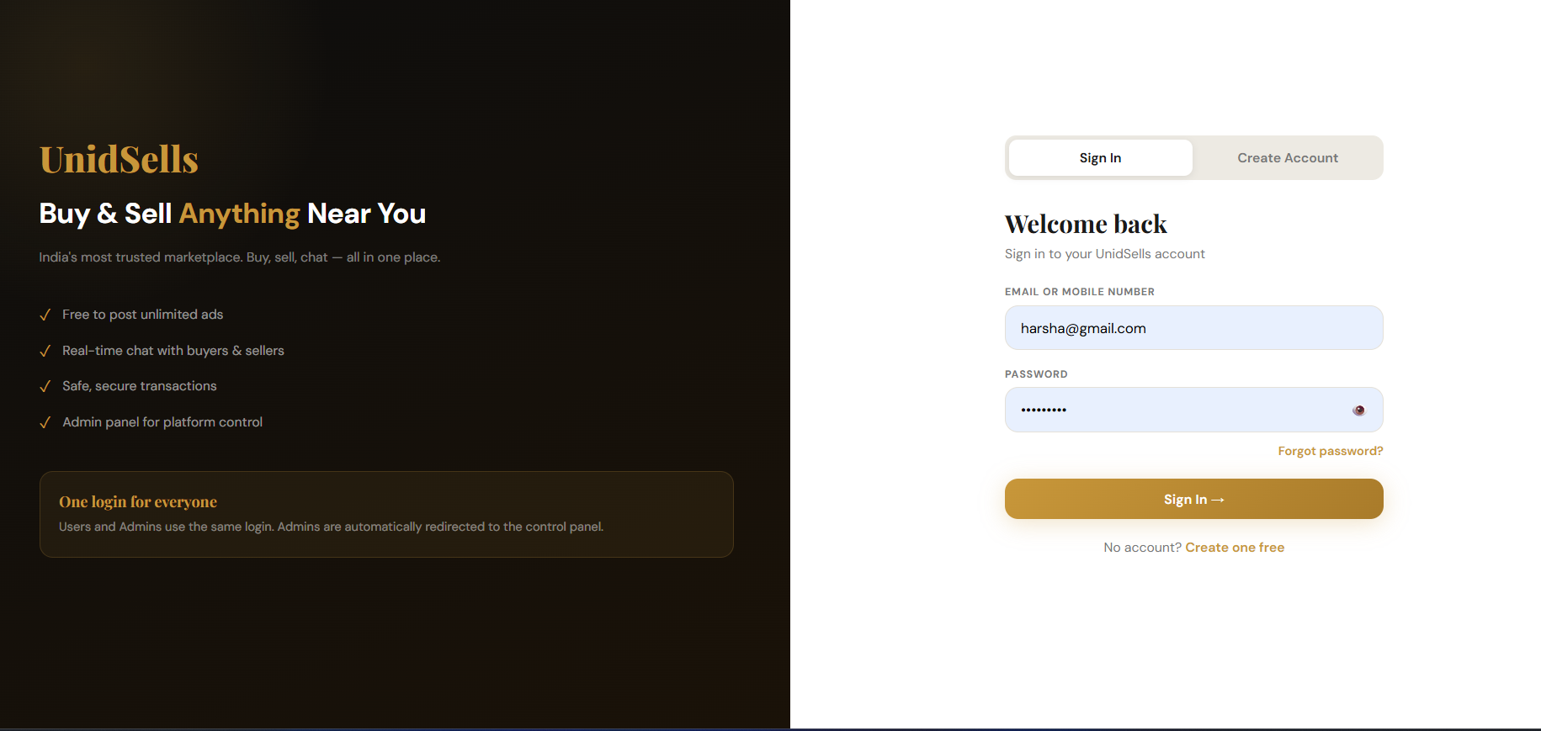

9.2 Home / Index Page

The home page features a hero banner with real-time search, category filter bar with 10 categories, product grid with wishlist toggle buttons, and bottom navigation. The top navigation includes Home, Budget Filter, My Ads, Messages links and a Post Ad button.

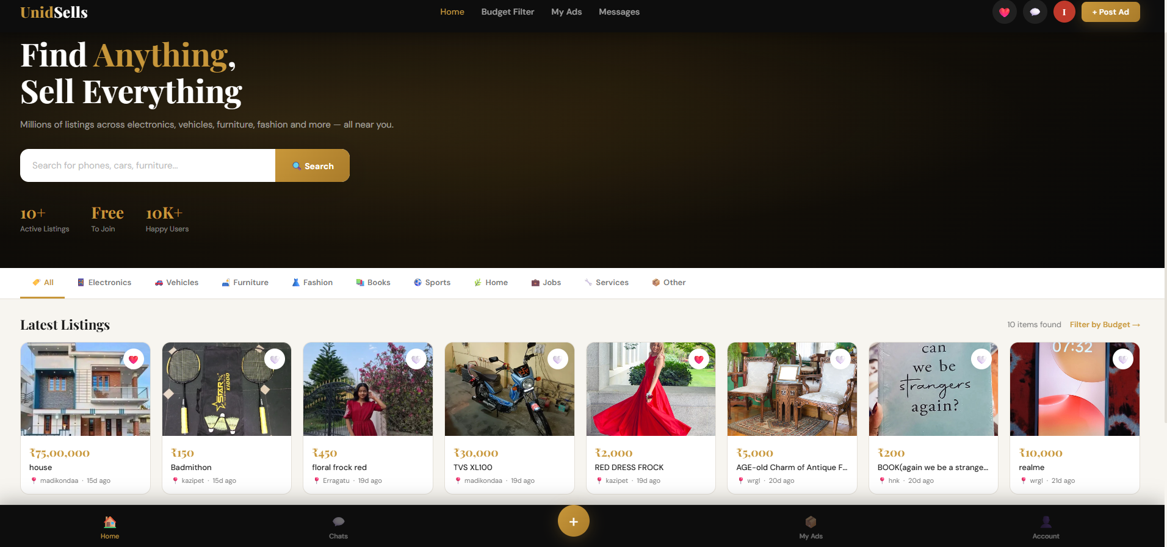

9.3 Product Detail Page

The product detail page features a multi-image slider with left (◄) and right (►) navigation arrows, dot indicators showing current position (e.g., 1/4), a thumbnail strip for direct navigation, and a click-to-zoom modal. Below the gallery is the product title, price, location, views count, seller info, and a Message Seller button.

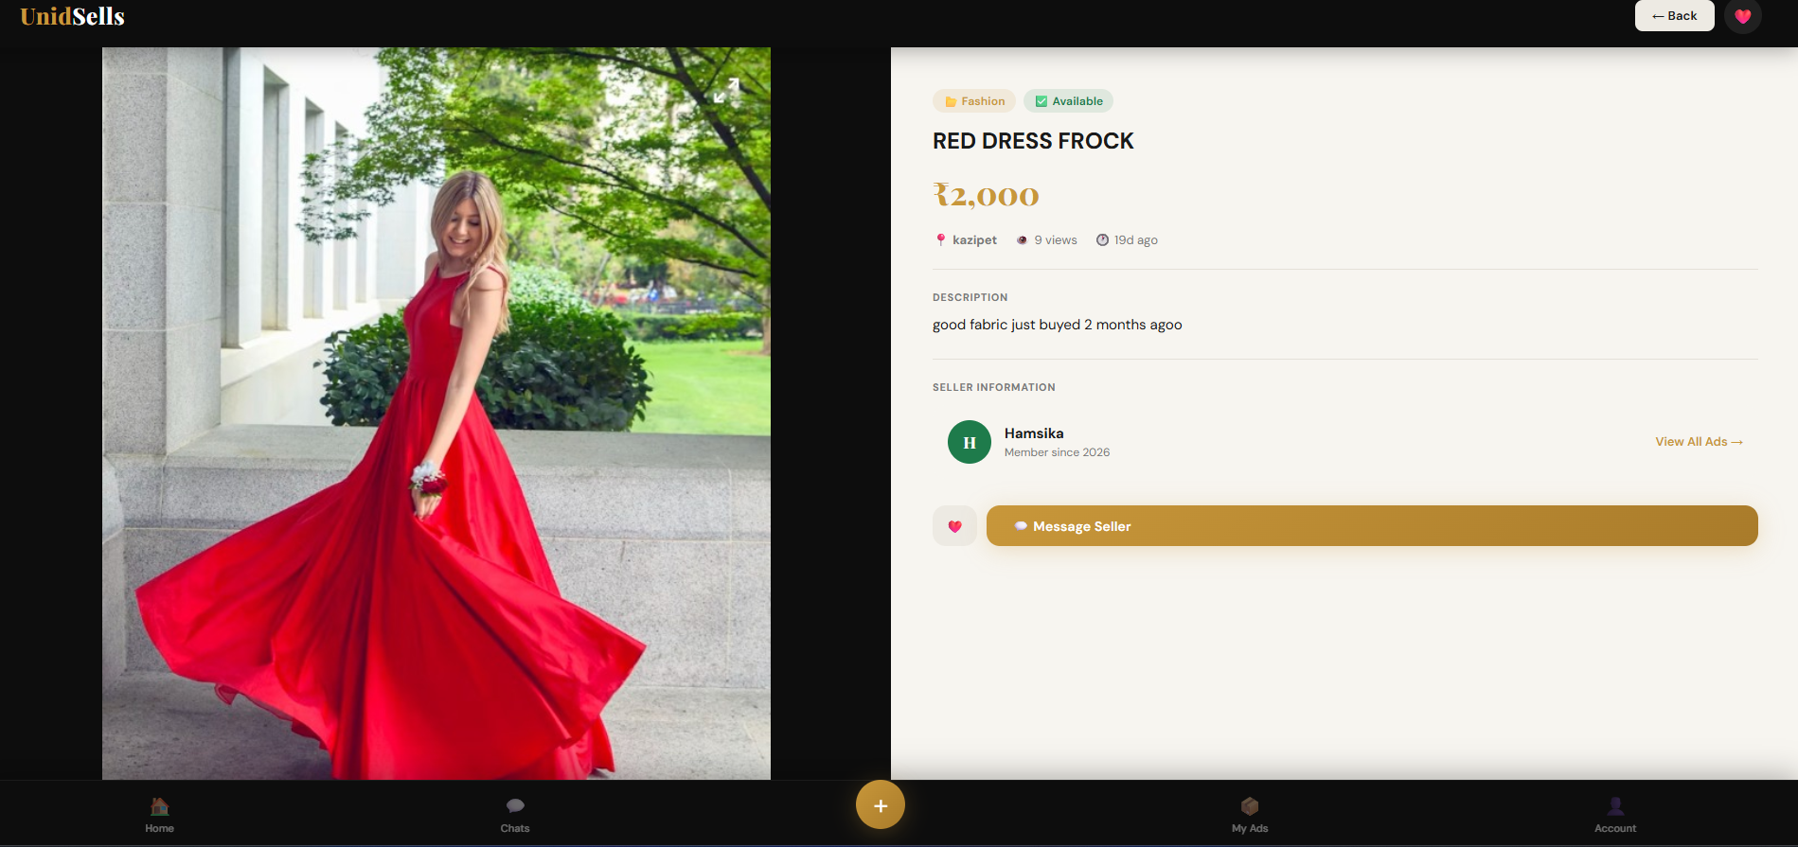

9.4 Post Ad Page

The post ad page allows users to upload multiple photos by clicking or drag-and-drop, OR paste a direct image URL. All images are previewed with remove buttons. The form includes fields for title, category, price, description, and location
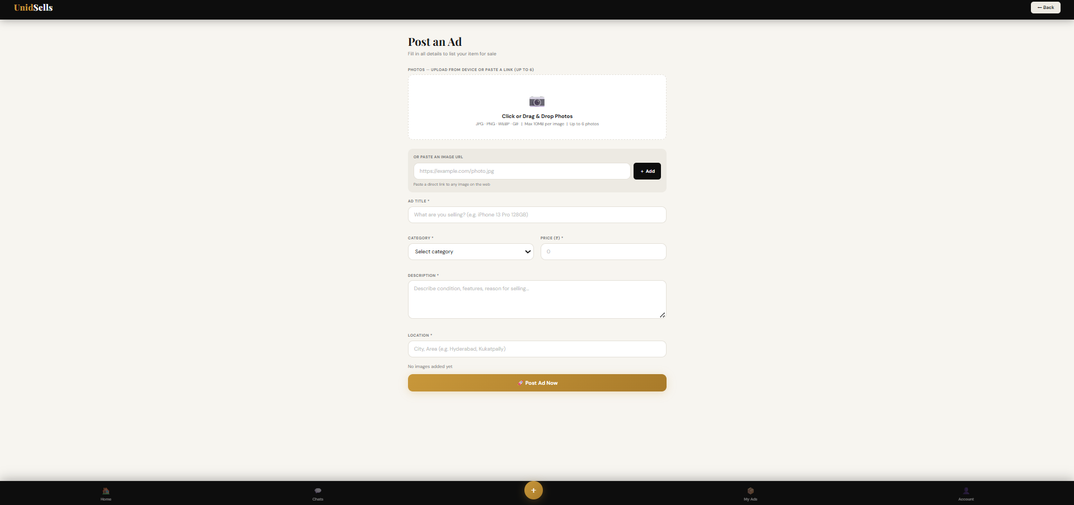

9.5 Chat / Messages Page

The chat list shows all conversations with last message preview and unread count badges. The chat conversation page shows real-time messages via Socket.io with a listing preview banner at the top, date dividers, and sent/received message bubbles.

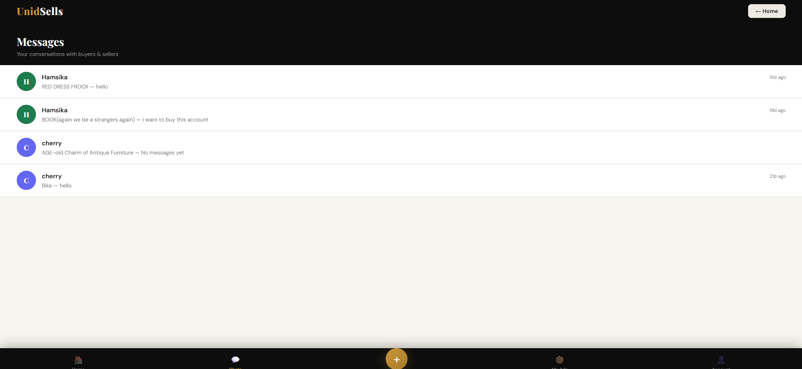

9.6 My Ads Dashboard

The My Ads page shows Active and Sold tabs. Each ad card displays a thumbnail (with photo count badge), title, price, location, time, views, and status tag. Action buttons allow editing, marking as sold, and deletion.

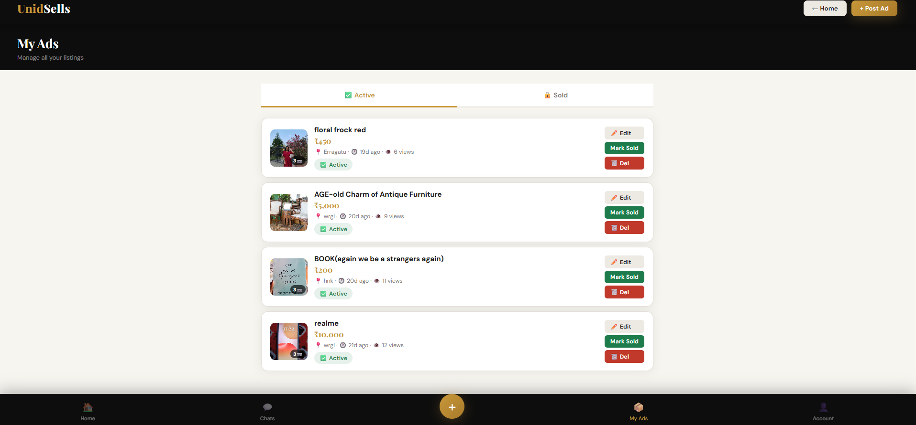

9.7 Budget Filter Page

The budget filter page offers 6 preset budget ranges (Under ₹500, ₹500–₹2K, ₹2K–₹10K, ₹10K–₹50K, ₹50K–₹2L, Above ₹2L) and a custom min-max slider with category filter. Results are displayed as a live product grid below.

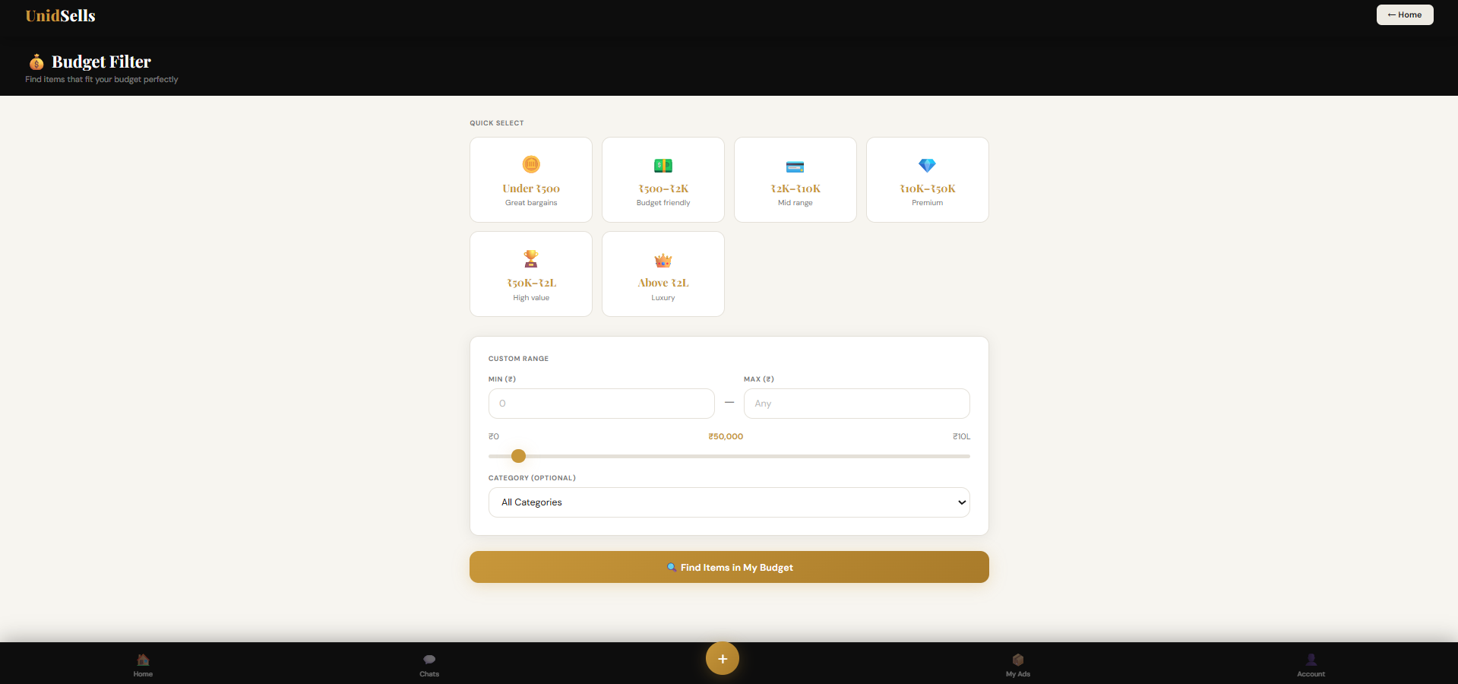

9.8 Wishlist Page

The wishlist page shows all items saved by the user using localStorage. Each card has an animated remove button. A Clear All option is available. Clicking an item navigates to the product detail page.

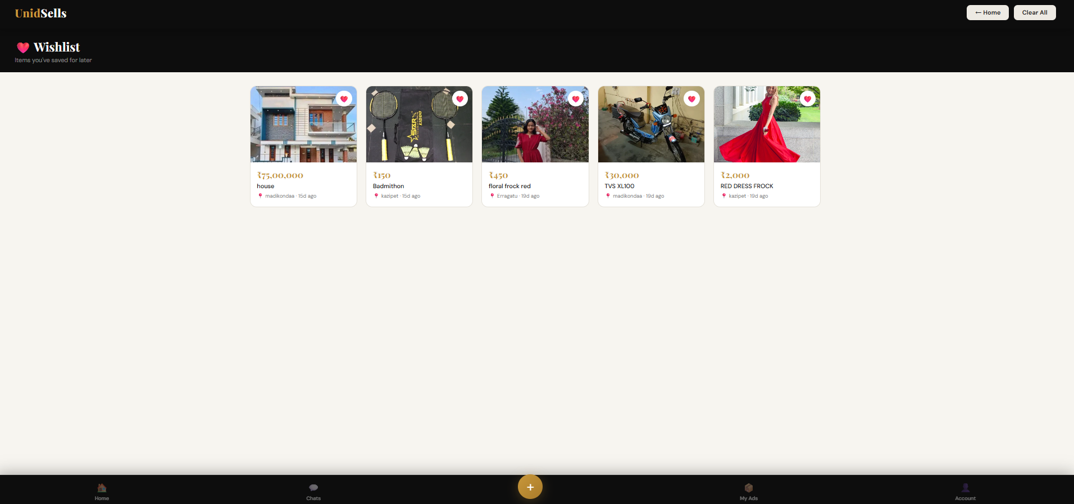

9.9 Account / Profile Page

The account page shows the user's profile with avatar, name, email, and member status. Menu items include My Ads, Wishlist, Messages, Budget Filter, Edit Profile, Change Password, and Logout. Admin users also see the Admin Panel link.

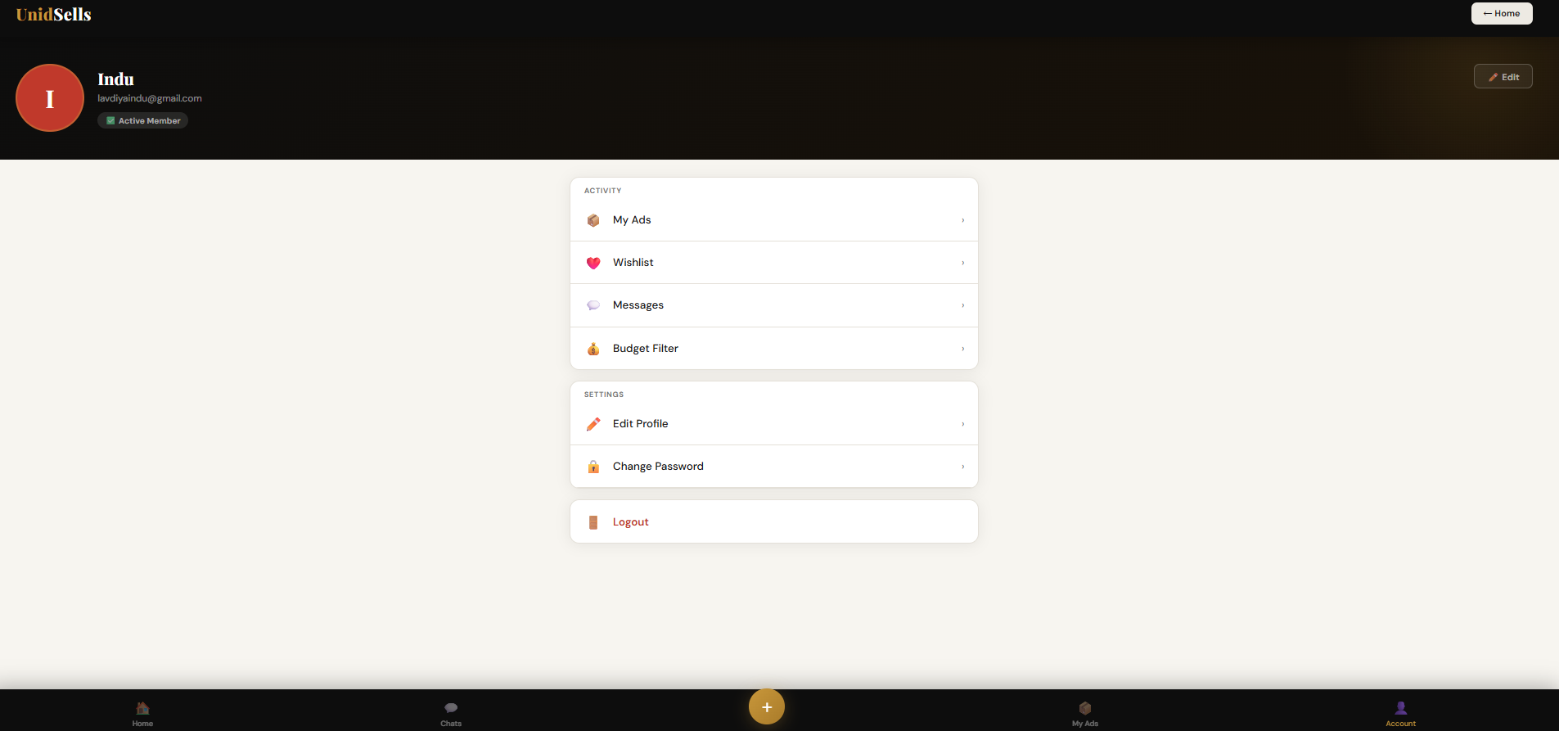

9.10 Admin Panel

The admin panel has 4 tabs: Users (view all users, block/unblock, delete), Listings (view all listings, flag inappropriate, delete), Chats (monitor all conversations), and Flagged (review flagged listings). A dashboard shows live stats: total users, active listings, flagged count, and total chats.

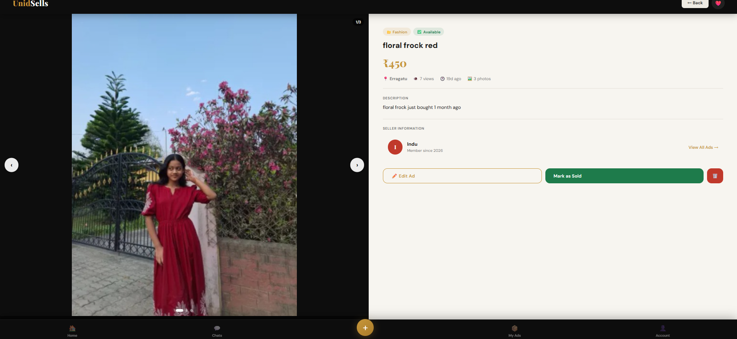

10. CONCLUSION

The UnidSells Marketplace Web Application successfully demonstrates two major achievements: the development of a complete, production-ready full-stack web application, and the demonstration of AI prompt engineering as a viable software development methodology.

The application delivers a comprehensive set of features including secure session-based authentication, an OTP-based forgot password system, role-based access control, multi-image product listings (with device upload and URL paste), a real-time Socket.io chat system between buyers and sellers, a multi-image slider with zoom modal on the product detail page, wishlist management, a budget filter with custom range selection, a My Ads dashboard, and a full admin control panel with user management and listing moderation capabilities.

From a technical standpoint, the MEN stack (MongoDB, Express.js, Node.js) proved to be a highly effective choice for building this type of application. Mongoose schema validation ensured data integrity, Express.js middleware provided clean separation of concerns, and Socket.io enabled seamless real-time communication.

The AI prompt engineering approach using Claude AI demonstrated that 24 production-ready files totalling over 3,000 lines of code could be generated through 10 carefully structured prompts. This approach significantly accelerates development and reduces manual effort while maintaining code quality and adherence to best practices.

Future enhancements to the UnidSells system could include online payment gateway integration, email/SMS notifications for messages and password reset, seller ratings and review system, advanced search with geolocation-based filtering, Progressive Web App (PWA) support, and a dedicated mobile application.

11. REFERENCES

No. | Source | Link / Description
1 | Claude AI by Anthropic | https://claude.ai — AI tool used to generate all source code
2 | Node.js Official Documentation | https://nodejs.org/en/docs
3 | Express.js Official Documentation | https://expressjs.com
4 | MongoDB Documentation | https://www.mongodb.com/docs
5 | Mongoose Documentation | https://mongoosejs.com/docs
6 | Socket.io Documentation | https://socket.io/docs — Real-time chat implementation
7 | Multer File Upload | https://github.com/expressjs/multer
8 | bcrypt Password Hashing | https://github.com/dcodeIO/bcrypt.js
9 | Google Fonts | https://fonts.google.com — Playfair Display & DM Sans
10 | Font Awesome Icons | https://fontawesome.com
11 | MDN Web Docs | https://developer.mozilla.org — HTML, CSS, JS reference
12 | OLX India | https://olx.in — Reference marketplace for UX design
13 | Quikr | https://quikr.com — Reference marketplace for feature design
14 | Railway Deployment Platform | https://railway.app — Deployment reference
15 | Ferraiolo et al. — RBAC Model | Role-Based Access Control — NIST publication, reference for admin/user role design

