|  |  |
| --- | --- |
|  | **Tableau visualizations** |

**DIFFERENT TYPES OF VISUALIZATIONS:** Data visualization is the graphical representation of information and data. By using visual elements like charts, graphs, and maps, data visualization tools provide an accessible way to see and understand trends, outliers, and patterns in data .

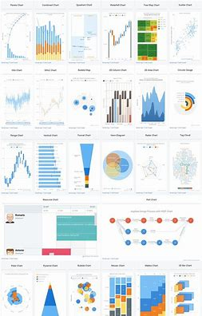

**U.INDU**

**BAR GRAPH:**

The bar chart or bar graph is one of the most common data visualization examples on this list. They’re sometimes also referred to as column charts. Bar charts are used to compare data along two axes. One of the axes is numerical, while the other visualizes the categories or topics being measured.

IMPORTANT:You can use a bar chart with vertical bars or horizontal bars. On vertical bar graphs, numerical values are on the y axis (vertical axis) and can be aligned to the left, right or center. On horizontal bars, they are on the x-axis (horizontal axis.)

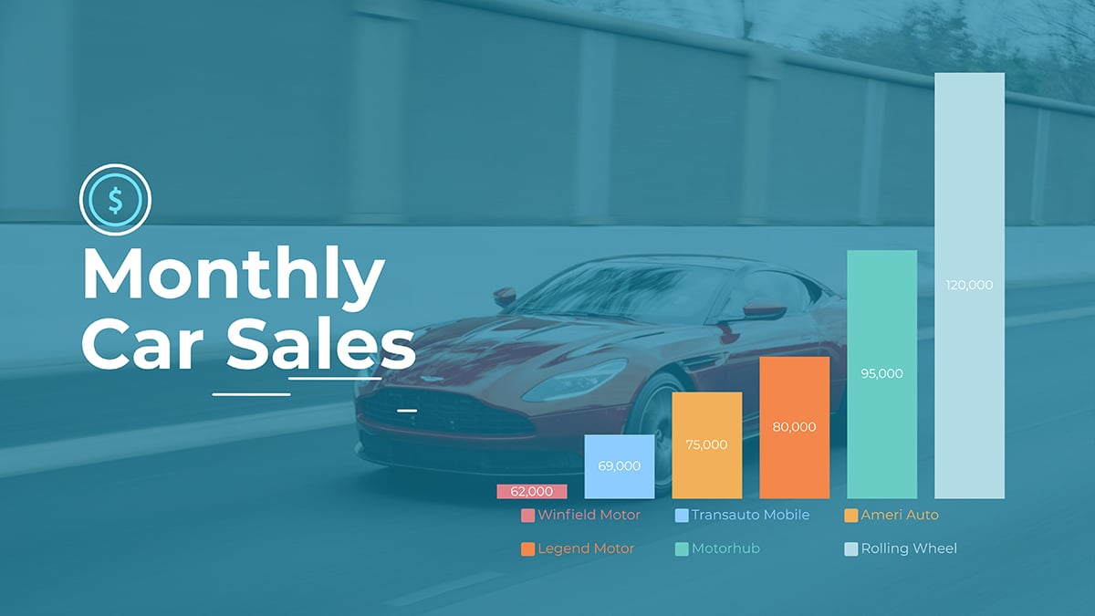

**Pie chart:**

The second most common data visualization on this list is the pie chart. The data in a pie chart represent parts of a whole. The entirety of the circle is the whole, and each wedge is a relevant section.

**IMPORTANCE:**The best type of data for a pie chart has no more than five or six parts. Any more than this makes the wedges too thin at the center. If more than three values are similar to each other, it will be difficult to discern the difference. The best pie charts use contrasting colors that fit well together, making each wedge visually different from the one next to it.

If you have more than six sections to visualize, consider using a donut chart instead. You can [animate your charts](https://visme.co/blog/create-animated-charts/" \t "https://visme.co/blog/data-visualization-types/_blank) or make them interactive to engage your audience.

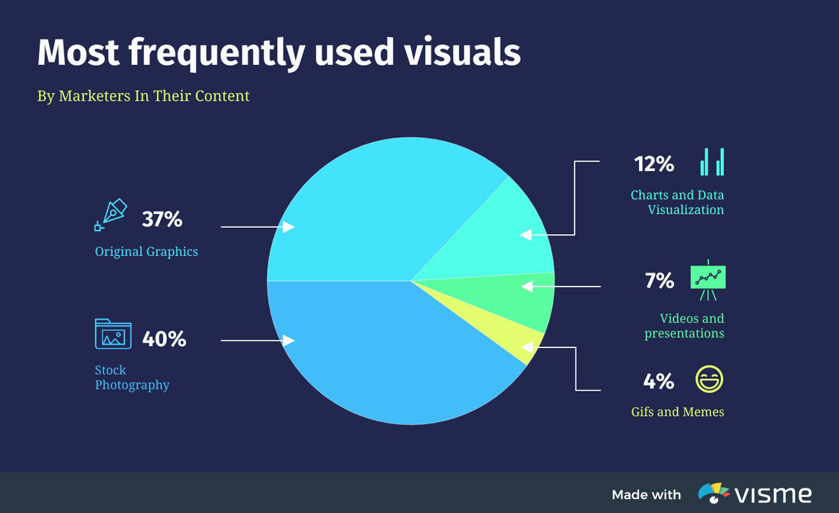

**Line chart:**

A line chart or line graph is a data visualization type that showcases changing data over time. Like a bar graph, the line chart has an x and y-axis. The difference is that both axes contain numerical values representative of the data.

**IMPORTANTANCE:**To create a line chart, input the relevant time frame along the x-axis and the quantitative measurement on the y-axis. Plot the data in the graph by connecting the time value and the numeric value. After plotting all the dots, connect them with a line.

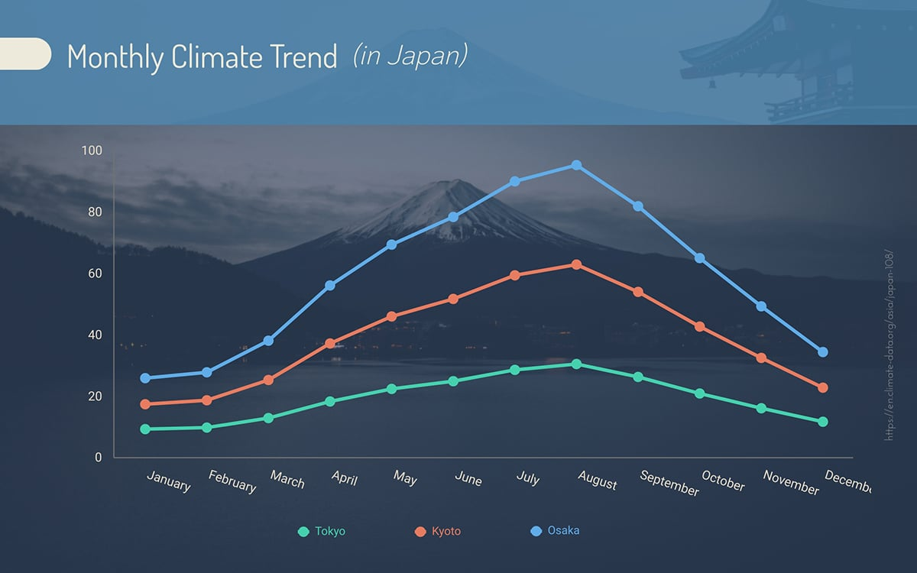

**SCATTER PLOTTER:**

A scatter plot is a data visualization type used to analyze the correlation between variables. The data is plotted on the chart as dots at the intersection of its two values.

**IMPORTANCE**:Use scatter plots where your variables are related to each other regarding a group of test subjects. Some of these could be the relation between weight and height in children under 18 years old, temperature-dependent sales in an ice cream shop, diabetes, and obesity rates.

**EX**:Take a look at the scatter plot example here; the values are square footage and price. Each dot in the graph represents a house. If you were to add a scatter for apartments with the same values, you’d use dots in a different color. When there are dots outside of the expected range, these are called outliers and should be taken into consideration when analyzing the data.

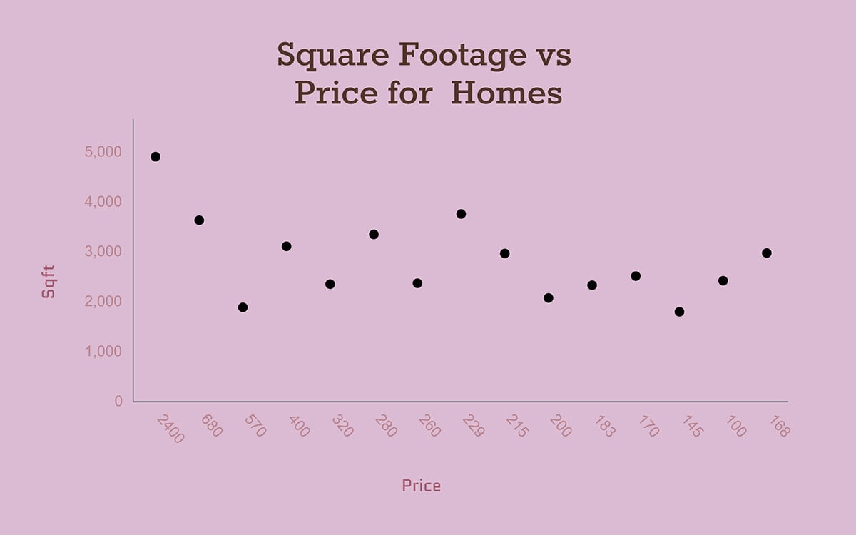

**BUBBLE CHART:**

A[bubble chart](https://www.visme.co/bubble-chart/" \t "https://visme.co/blog/data-visualization-types/_blank) (or bubble plot) is a variation of the scatter plot used to visualize relationships between three numeric variables and to identify patterns in data. Each bubble on the chart represents a data point and the size and position of the bubble correspond to a specific value.

Similar to a scatter plot, both the horizontal and vertical axes are value axes.  Besides the x values and y values, bubble charts have a third dimension—z (size) values.

**IMPORTANCE**:This bubble chart visualizes data related to employee turnover in an organization. The bubbles represent the employees who left the company. But you can customize it to suit your unique needs using a variety of [bubble chart templates](https://www.visme.co/templates/charts/bubble-charts/" \t "https://visme.co/blog/data-visualization-types/_blank).

For example, you can use color to represent different reasons for turnover, such as voluntary resignations, layoffs, or retirements.

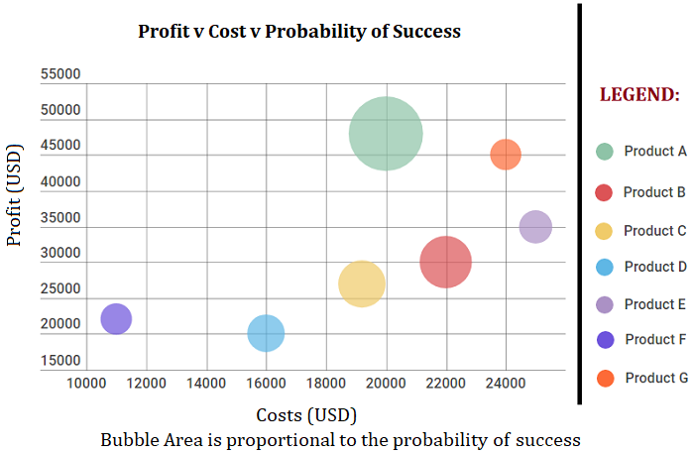

**AREA GRAPH:**

The area chart is a variation of the line chart. The difference is that the area between the baseline and the values plotted on the line is colored in. The color fill is semi-transparent so that the overlapping regions are easy to read.

**IMPORTANCE:**Even though you can switch any line chart into an area chart, it’s not always the best practice. An area chart can’t have more than four or five datasets simultaneously; the possibility of occlusion is too high. Area charts are sometimes stacked, separating the data into sections as part of whole relationships or as cumulative data.

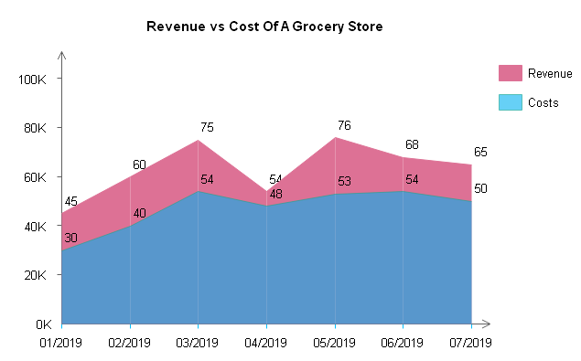

**TREE CHART:**

A tree chart, or tree diagram is more of a visual data visualization than one for detailed numerical data. The main idea in a tree chart is to visualize data as parts of a whole inside a category. For a more complex tree chart, layout different categories next to each other.

Choose a tree chart when your visualization doesn’t depend on granular numerical data. Better yet, if the data is hierarchical, a tree chart does a good job

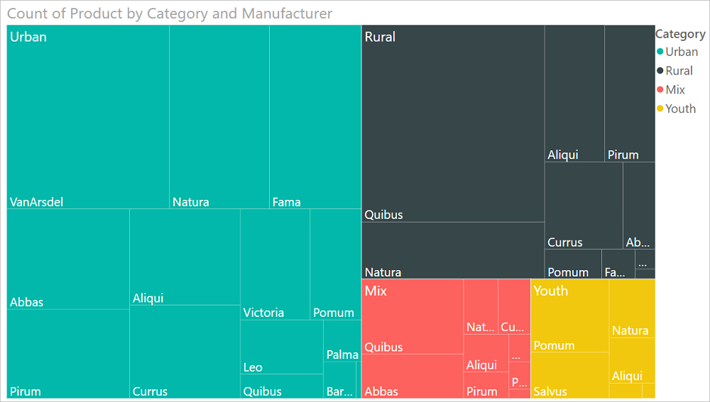

**GUAGE CHART:**

A gauge is another visualization type for percentages. The shape resembles a half donut and has a couple of uses. The simplest use is to show a percentage value with an arrow pointing to it. This is a great choice if you're dealing with a small amount of data.

Alternatively, use a gauge to demonstrate the status or goal of a project. Use a half donut chart with three of four equal values and color code for each section, such as Q1, Q2, Q3 and Q4.

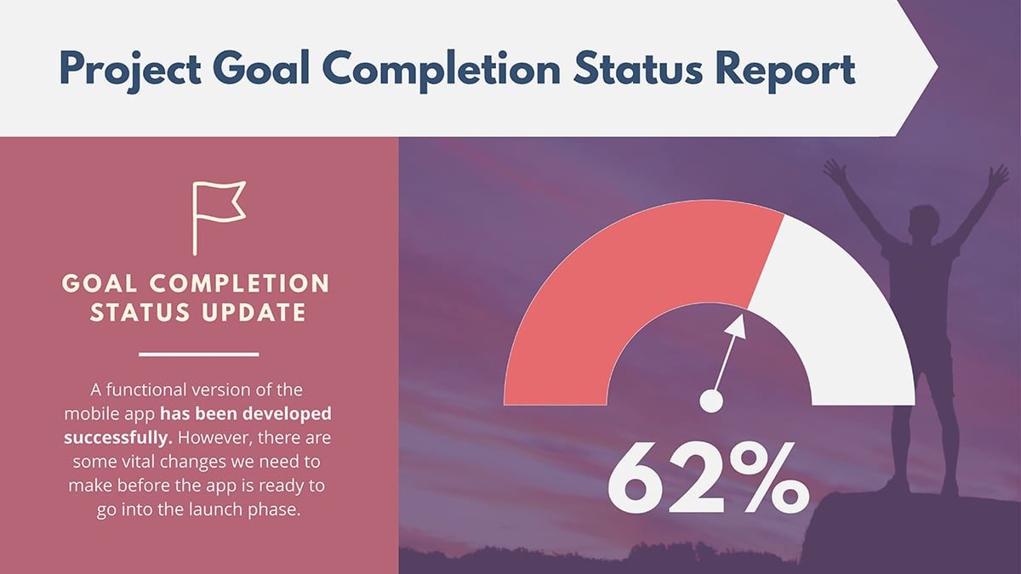

**HISTOGRAM:**

A histogram is similar to a bar graph but has a different plotting system. Histograms are the best data visualization type to analyze ranges of data according to a specific frequency. They’re like a simple bar graph but specifically to visualize frequency data over a specific time period.

Histograms can only be vertical, differently from how bar charts can be both vertical or horizontal.

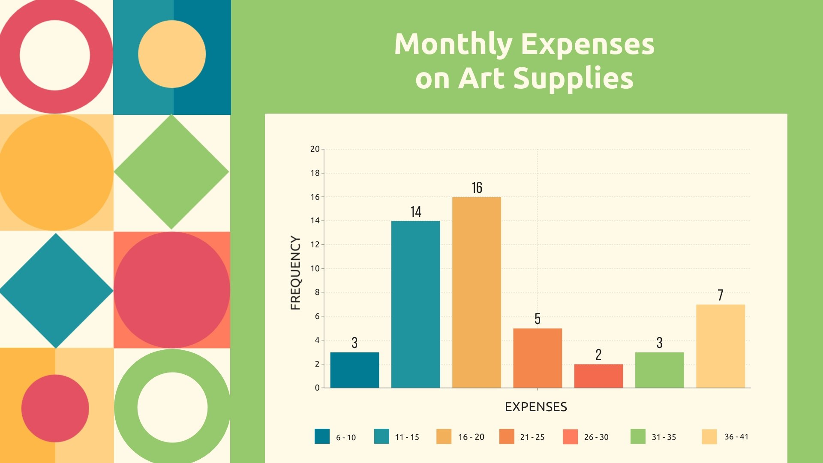

**DUAL AXIS GRAPH:**

****Dual axis charts****, also known as ****multiple axis charts**** or ****combination (combo) charts****, allow you to:

* [Plot KPIs of different scales or units of measures (UoM) on a single chart](https://inforiver.com/insights/dual-axis-charts-101-introduction-best-practices/).
* [Visualize relative trends that might not be immediately obvious when looking at the data separately](https://inforiver.com/insights/dual-axis-charts-101-introduction-best-practices/).
* [Combine two separate chart types in the same visual, with shared X axis and separate Y axes](https://flourish.studio/blog/dual-axis-charts/).

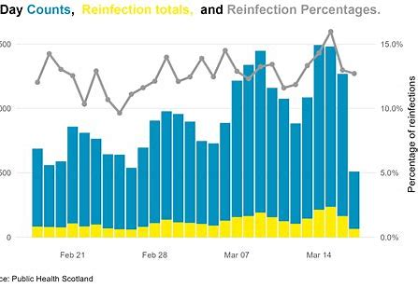

**GEOGRAPHICAL GRAPH:**

Geographical graph a data visualization technique that allows representing the data using different colors or shades of one color for different regions. Most often, it’s used to visualize how the variable varies across a certain geographic area. You can use this technique to communicate the correlation between the variable and a geographic location.

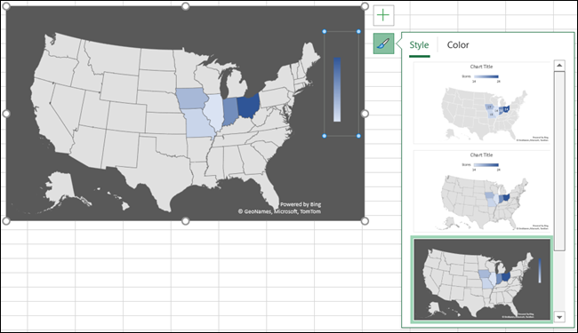



**Heat map:**

A heat map is a two-dimensional representation of [data](https://www.techtarget.com/searchdatamanagement/definition/data) in which various values are represented by colors. A simple heat map provides an immediate visual summary of information across two axes, allowing users to quickly grasp the most important or relevant [data points](https://www.techtarget.com/whatis/definition/data-point). More elaborate heat maps allow the viewer to understand complex [data sets](https://www.techtarget.com/whatis/definition/data-set).

A heat map is a way to represent data points in a data set in a visual manner. All heat maps share one thing in common -- they use different colors or different shades of the same color to represent different values and to communicate the relationships that may exist between the variables plotted on the [x-axis and y-axis](https://www.techtarget.com/whatis/definition/x-and-y-coordinates).

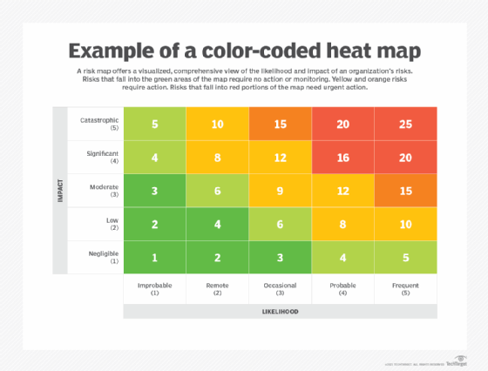

**GRANTT CHART:**

[Gantt charts](https://visme.co/blog/gantt-chart/" \t "https://visme.co/blog/data-visualization-types/_blank) are based on horizontal bar graphs but are different in a big way. In a [Gantt chart](https://clickup.com/blog/gantt-chart-project-management/" \t "https://visme.co/blog/data-visualization-types/_blank), it’s not about how the data changes over time but rather how long it takes to complete over a specific range of time.

Each item on the chart is represented by a rectangle that stretches from left to right. Each one has a different size, depending on how long each task takes to complete.

The best way to use a Gantt chart is with your team. Create one in Visme and share it with everyone via a link. If it needs to be adjusted, simply drag the corresponding rectangle to its new location on the chart.

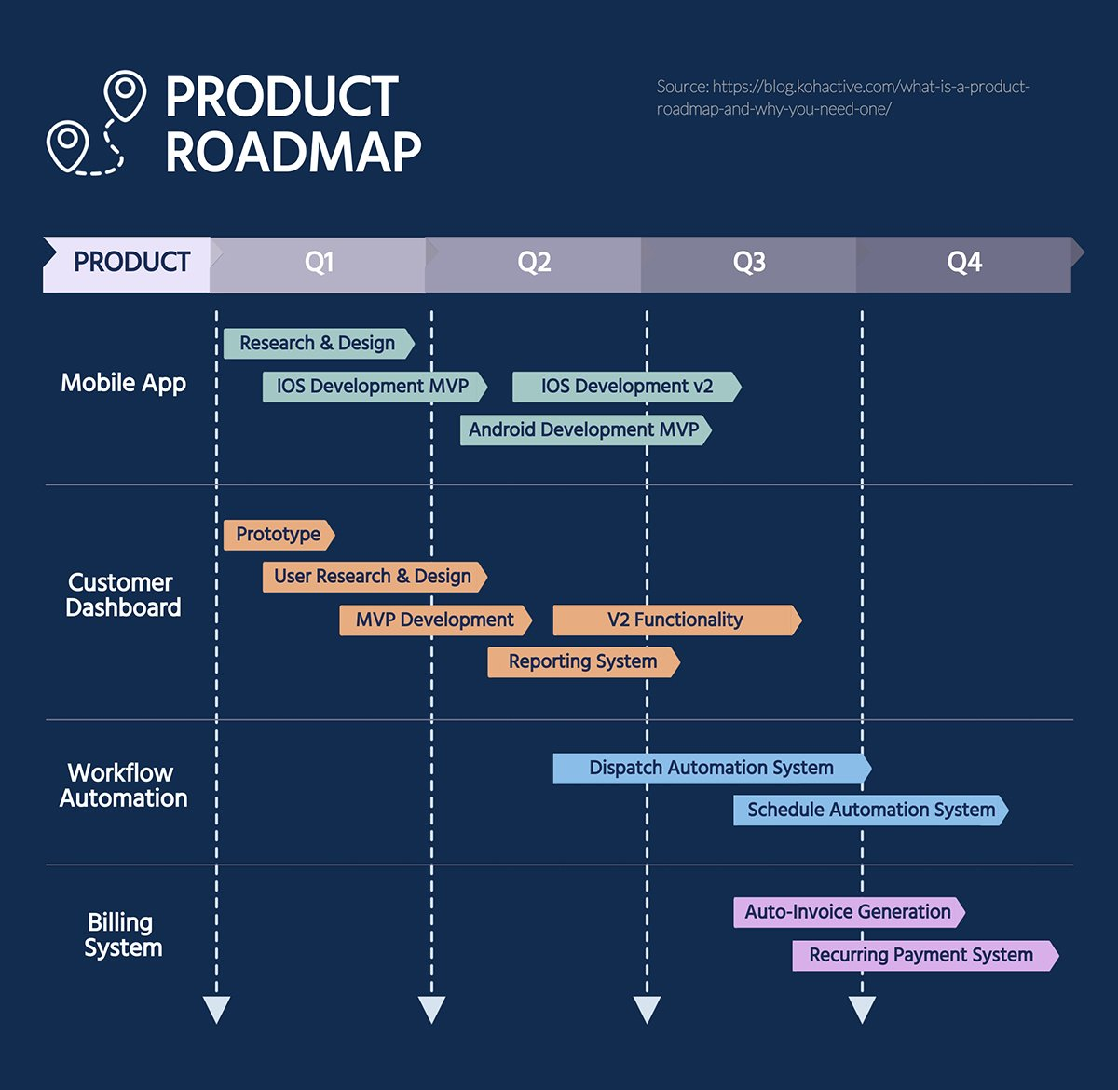

**BULLET CHART:**

Bullet graph is a bar marked with extra encodings to show progress towards a goal or performance against a reference line. Each bar focuses the user on onemeasure, bringing in more visual elements to provide additional detail. The bullet graph, designed by Stephen Few, replaces meters and gauges that dominated early dashboards and reports. It provides more information in a smaller space; making it A ideal for a compact dashboard.

The bullet graph depicts a single primary measure. It includes measures from other fields to enhance the graphical display for analysis. One might display the current year’s revenue, measured against a goal, while contrasting it with performance from a previous year. The axis measuring the data uses tick marks and labels to support analysis at a glance. Bullet graphs, being a form of bar chart, start at zero to support visual interpretation of the data.

