Product Design
Design Model:
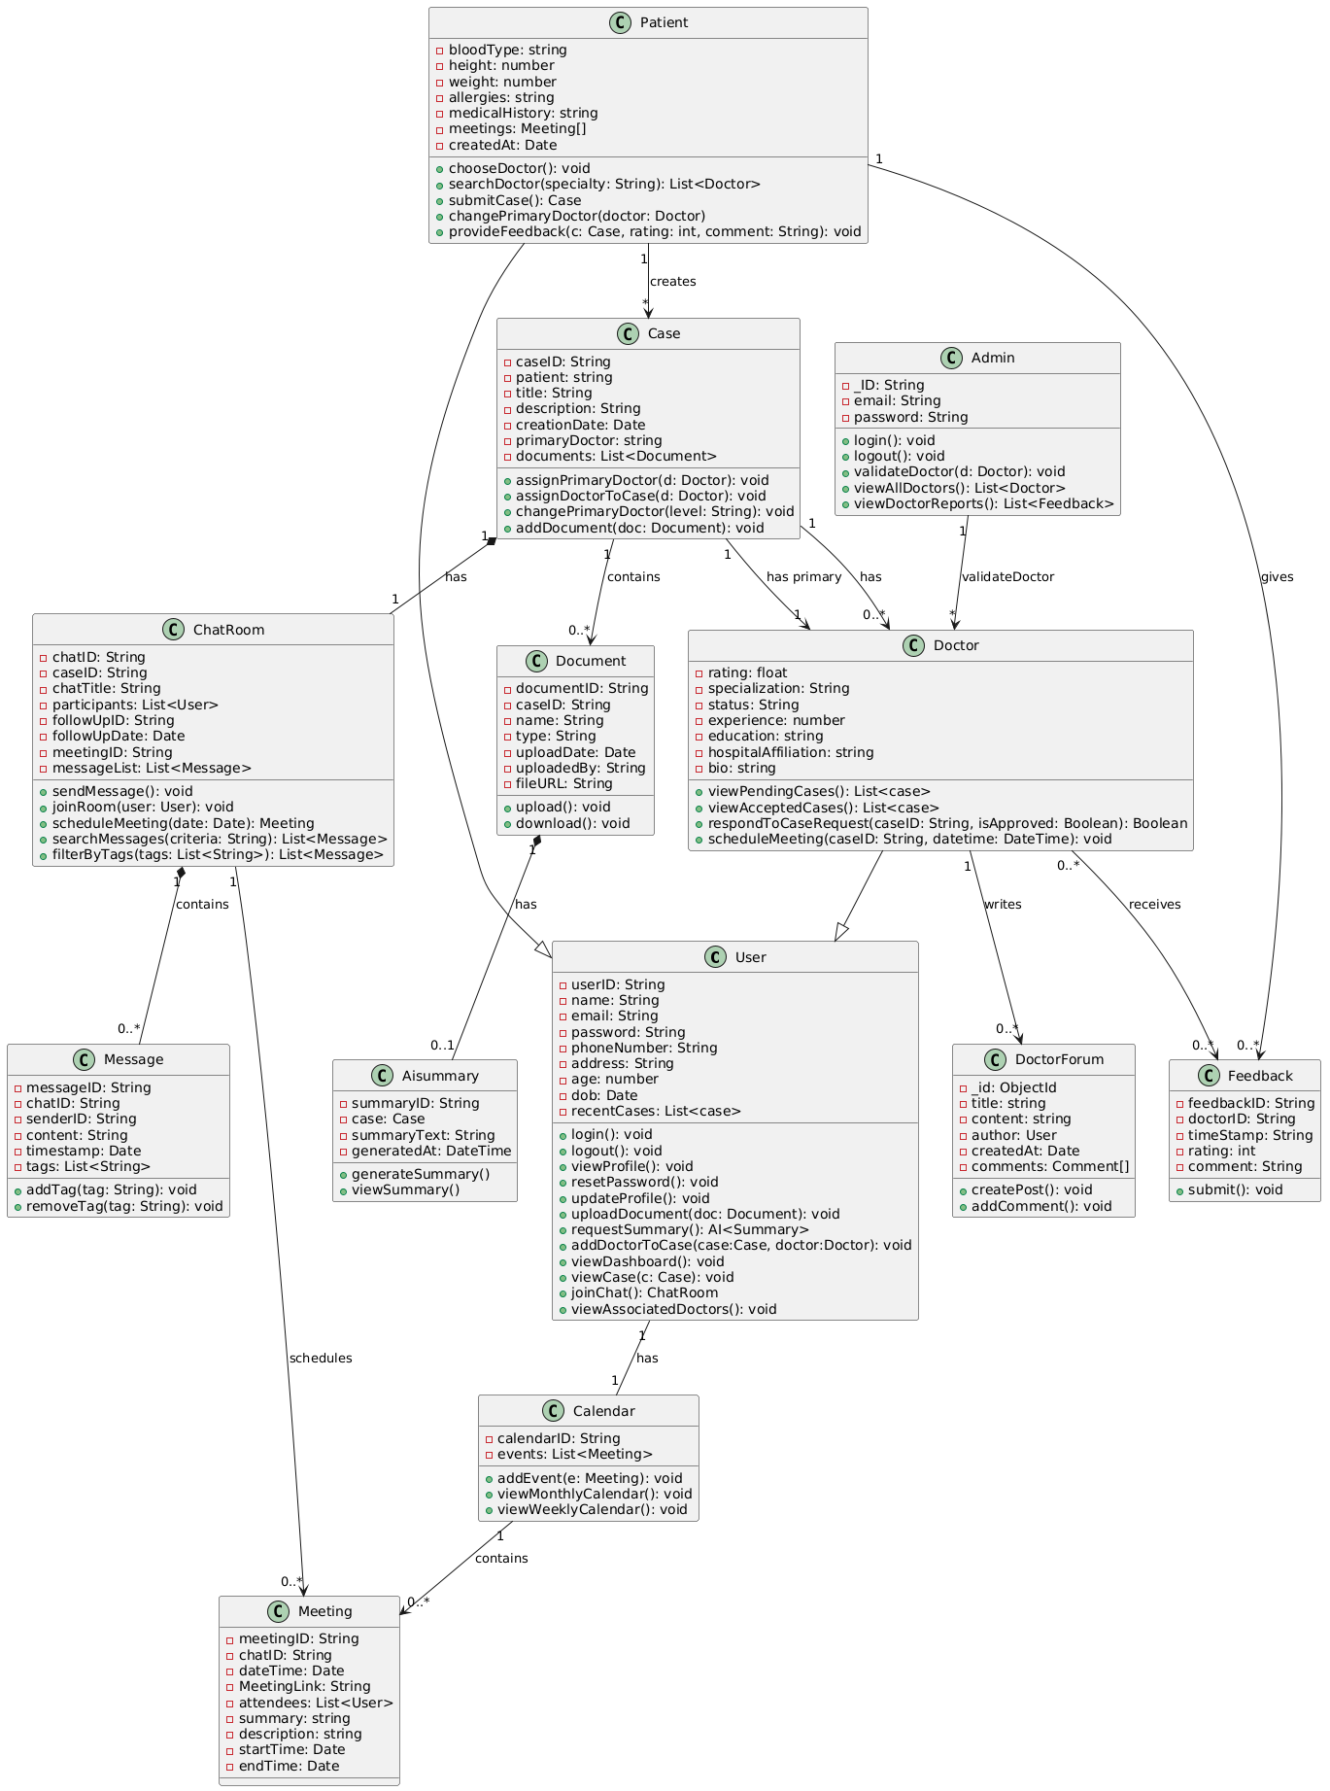
Description of the Classes:
<Class No. 1>  User | Class state  - userID: A unique identifier for each user.  - name: The user’s full name.  - email: The contact email address.  - password: User's encrypted password for authentication  - phoneNumber: Contact phone number.  - address: User's physical address.  - Age: User’s age  - Dob: date of birth of user  Class behavior  - login(): Authenticates and initiates a user session.  - logout(): Terminates the session.  - viewProfile(): Displays user details.  - resetPassword(): Allows user to change their password  - updateProfile(): Modifies user profile information.  - uploadDocument(): Uploads medical or supporting documents.  - requestSummary(): getting AI summary of uploaded document.  - addDoctorToCase(case : Case, doctor : Doctor): Associates an additional doctor with a case.  - viewDashboard(): Displays an overview of case statuses and updates.  - viewCases(): Retrieves a list of history entries detailing past case events  - joinChatRoom(chat : ChatRoom): Joins a discussion chat room related to a case.  - viewAssociatedDoctors(): View all the doctors in the application
<Class No. 2>  Patient | Class state  - Inherits the basic user attributes from User (userID, name, email).  - Maintains associations with cases, documents, and history entries relevant to the patient.  - Bloodtype: patients’s blood type  - Height: patient’s height  - Weight: patient’s weight  - Allergies: patient’s allergies if any  - MedicalHIstory: any past medical record of patient  - createdAt: date on which account was made  Class behavior  - chooseDoctor(): Selects a doctor for the case.  - searchDoctor(criteria : String): Searches for doctors matching specific criteria.  - changePrimaryDoctor(): Allows changing the primary doctor of the case.  - submitCase(): Creates and submits a new case.  - provideFeedback(doctorId: String, rating: int, comment: String): Submits rating and comments for a doctor.
<Class No. 3>  Doctor | Class state  - Inherits the basic user attributes from User.  - Associated with multiple cases either as the case manager or as a board member.  - May be linked to chat rooms for real-time discussion on cases.  - rating: Average rating based on patient feedback.  - specialization: Doctor's medical specialty area  - status: Approval status (pending, approved, rejected)’  - experience: doctor’s experience in years  - education: doctor’s education  - hospitalAffiliation: hospital the doctor is affiliated at  Class behavior  - viewPendingCases(): Lists case requests awaiting acceptance  - viewAcceptedCases(): Lists all cases assigned to the doctor  - respondToCaseRequest(caseId: String, isApproved: Boolean): Accepts or rejects a case request.  - scheduleMeeting(caseId: String, dateTime: DateTime): Schedules a consultation or board meeting.
<Class No. 4>  Admin | Class state  - _ID: admin id  - Email: admin’s email  - Password: password for admin login  Class behavior  - Login(): login as admin  - Logout(): admin logout  - validateDoctor(doctor : Doctor): Checks and validates a doctor’s credentials.  - viewAllDoctors(): Lists all registered doctors.  - viewDoctorFeedbacks(): Reviews patient feedback about doctors.
<Class No. 5>  Case | Class state  - caseID: Unique identifier for the case.  - patient: The patient who submitted the case.  - title: Brief title describing the case.  - description: Detailed description of the medical issue.  - creationDate: When the case was created.  - Primary Doctor: The doctor assigned to manage the case.  - board: A list of doctors who form the case review board.  - documents: Collection of medical documents related to the case  - Linked to a dedicated ChatRoom for discussions and an AICaseSummary for automated summaries.  Class behavior  - assign PrimaryDoctor(doctor : Doctor): Sets or changes the primary doctor  - addDoctor(doctor : Doctor): Adds a new doctor to the case board.  - scheduleFollowUp(date : Date): Schedules a follow-up appointment or review meeting in the chat.  - changePrimaryDoctor(doctorId: String): Sets or changes the primary doctor.  - addDocument(document: Document): Associates a document with the case
<Class No. 6>  Chat Room | Class state  - chatID: Unique identifier for the chat room.  - caseID: The case associated with the chat room.  - participants: A list of users (patients, doctors, admins) engaged in the conversation.  - FollowUp details: Includes followUpID, followUpDate, and followUpStatus for tracking follow-up activities.  - Meeting details: Contains meetingID, meetingDate, and meetingAgenda for scheduled meetings.  - messages: Collection of all messages in the chatroom.  Class behavior  - sendMessage(msg : String): Sends a message to all participants in the chat room.  - joinRoom(user : User): Adds a user to the chat room.  - scheduleMeeting(date : Date, agenda : String): Organizes a new meeting within the chat room.  - searchMessages(criteria: String): Finds messages matching search terms.  - filterByTags(tags: List<String>): Filters messages by assigned tags.
<Class No. 7>  Message | Class state  - messageId: Unique identifier for the message.  - chatroomId: The chat room containing this message.  - senderId: User who sent the message.  - content: The actual message text.  - timestamp: When the message was sent.  - tags: List of categorization tags for filtering.  Class behavior  - addTag(tag: String): Assigns a new tag to the message.  - removeTag(tag: String): Removes a tag from the message.
<Class No .8>  Meeting | Class state  - meetingId: Unique identifier for the meeting  - chatId: The case associated with the meeting.  dateTime: When the meeting is scheduled to occur.  - duration: Length of the meeting in minutes.  - attendees: List of users invited to attend.  - meetingLink: URL for the virtual meeting.  - Summary: title of the meet  - Description: description of the meet  - StartTime: the start time of the meet  - endTime: the end time of the meet
<Class No. 9>  AI Summary | Class state  - summaryID: Unique identifier for the summary.  - case: The associated documentfor which the summary is generated.  - summaryText: The actual summary text generated by the AI.  - generatedAt: Timestamp marking when the summary was produced.  Class behavior  - generateSummary(): Triggers the AI process to create a summary.  - viewSummary(): Retrieves the generated summary text for display.
<Class No. 10>  Feedback | Class state  - feedbackId: Unique identifier for the feedback.  - timestamp:When the feedback was submitted  - doctorId: The doctor being rated  - comment: Detailed feedback text.  - rating: Numerical score (typically 1-5).  Class behavior  - submit(): Records the feedback in the system.
<Class No. 11>  Documents | Class state  - documentId: Unique identifier for the document.  - caseId: The case associated with the document.  - name: Document name or title.  - type: Document file type or category.  - uploadDate: When the document was uploaded.  - uploadedBy: User who uploaded the document  - fileUrl: Link to access the actual file  class behavior  - upload(): Stores the document in the system.  - download(): Retrieves the document file.
<Class No. 12>  Calendar | Class state  - userId: The user associated with this calendar.  - events: List of meetings scheduled for the user.  Class behavior  - addEvent(meeting: Meeting): Adds a meeting to the calendar.  - viewMonthlyCalendar(): Displays events for the month.  - viewWeeklyCalendar(): Displays events for the week
<Class No. 13>  DoctorForum | Class state  - _id: id of the post  - Title: title of the post  - Content: content of the post  - Author: author of the post  - createdAt: time at which the post was created  - comments: comments on the post  Class Behavior  - createPost(): creates of a post  - addComment(): adds comment on a post

Sequence Diagram(s)

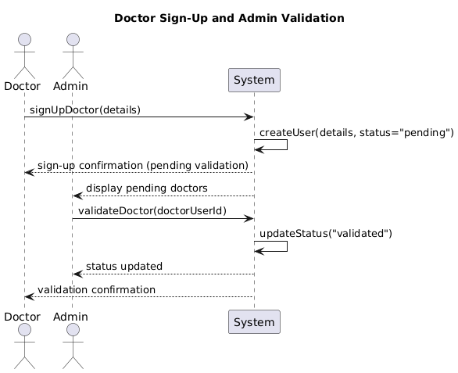
UseCase 1

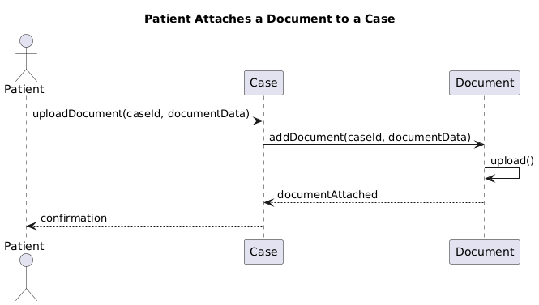

UseCase 2

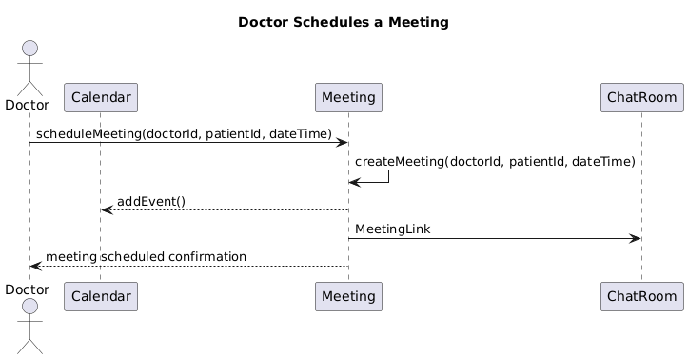

UseCase 3

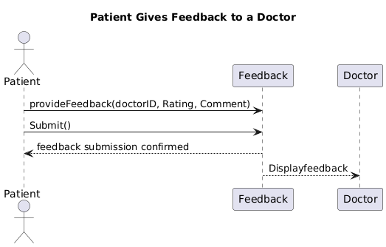

UseCase 4

Design Rationale

1. User Role Management
- Alternatives Considered:
  - Single User Class with Role Attributes:
    - Pros: Simpler class hierarchy, less initial code duplication.
    - Cons: Increased risk of role-specific logic intermingling, harder to enforce distinct behaviors.
  - Abstract User Base with Subclasses (Patient, Doctor, Admin):
    - Pros: Clear separation of responsibilities, easier to maintain and extend role-specific functionality.
    - Cons: Slightly more complex class hierarchy.
- Final Decision: Adopt the abstract base class User with separate subclasses for Patient, Doctor, and Admin.
2. Case Discussion and Communication
- Alternatives Considered:
  - Standalone Chat Module:
    - Pros: Modular, could be reused for different types of communications.
    - Cons: Integration with case functionalities (e.g., follow-up scheduling, board meetings) would require extra glue code and coordination.
  - Integrated ChatRoom Class with Extended Functionalities:
    - Pros: Initially, a single ChatRoom handled every type of discussion. Later, we refined the approach to support two distinct types of chatrooms for doctors: one dedicated to patient-doctor interactions and another exclusively for doctor-doctor communications. This separation enhances clarity and security in communication channels while still directly supporting real-time discussions, follow-up scheduling, and board meeting functionalities within the case context.
    - Cons: Increases the complexity of the ChatRoom class by having multiple types of chatrooms, which requires additional logic for routing messages and managing access controls.
- Final Decision: Implement an integrated ChatRoom system that distinguishes between patient-doctor and doctor-doctor chatrooms, alongside additional operations for follow-up and board meeting scheduling.

