R Notebook

library(jtools)  
library(kableExtra)

## Warning: package 'kableExtra' was built under R version 4.3.3

Linear regression can estimate non-linear relationship between variables.

set.seed(13371337)  
x <- rnorm(1000, 0, 2)  
y <- -x^2 + rnorm(length(x), 0, 1)

plot(y ~ x)

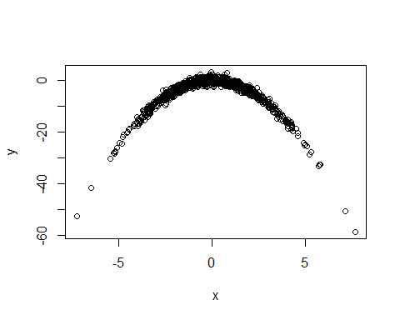

silly_mod <- lm(y ~ x)  
summ(silly_mod)

Observations

1000

Dependent variable

y

Type

OLS linear regression

F(1,998)

1.21

R²

0.00

Adj. R²

0.00

Est.

S.E.

t val.

p

(Intercept)

-4.45

0.20

-22.20

0.00

x

-0.10

0.10

-1.10

0.27

Standard errors: OLS

plot(y ~ x)  
abline(silly_mod, lwd = 2)

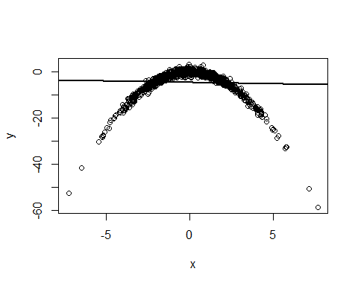

better_mod <- lm(y ~ x + I(x^2))  
summary(better_mod)

##   
## Call:  
## lm(formula = y ~ x + I(x^2))  
##   
## Residuals:  
## Min 1Q Median 3Q Max   
## -3.3253 -0.6314 -0.0072 0.6760 3.6607   
##   
## Coefficients:  
## Estimate Std. Error t value Pr(>|t|)   
## (Intercept) 0.001436 0.037458 0.038 0.969   
## x -0.005901 0.014487 -0.407 0.684   
## I(x^2) -1.001403 0.004881 -205.155 <2e-16 ***  
## ---  
## Signif. codes: 0 '***' 0.001 '**' 0.01 '*' 0.05 '.' 0.1 ' ' 1  
##   
## Residual standard error: 0.9651 on 997 degrees of freedom  
## Multiple R-squared: 0.9769, Adjusted R-squared: 0.9768   
## F-statistic: 2.107e+04 on 2 and 997 DF, p-value: < 2.2e-16

effect_plot(better_mod, x, interval = TRUE, plot.points = TRUE)

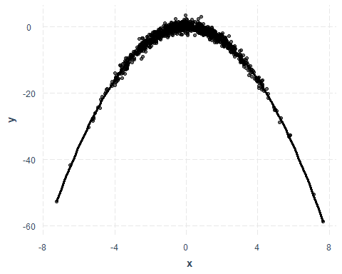

cor.test(~ x + y, method = "kendall")

##   
## Kendall's rank correlation tau  
##   
## data: x and y  
## z = 0.57485, p-value = 0.5654  
## alternative hypothesis: true tau is not equal to 0  
## sample estimates:  
## tau   
## 0.01214014