

**SE4050**

**Deep Learning**

**4th Year, 1st Semester**

**<** Labsheet 03 – Answer **>**

Submitted to

Sri Lanka Institute of Information Technology

**<IT21170966>**

**<Thennakoon T.M.I.C>**

In partial fulfillment of the requirements for the

Bachelor of Science Special Honors Degree in Information Technology

<18/08/2024>

**Task 06**

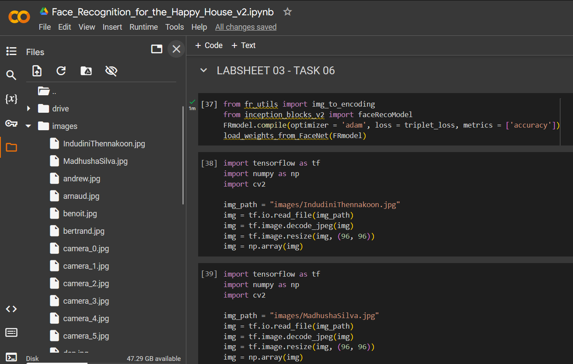



**Task 07**

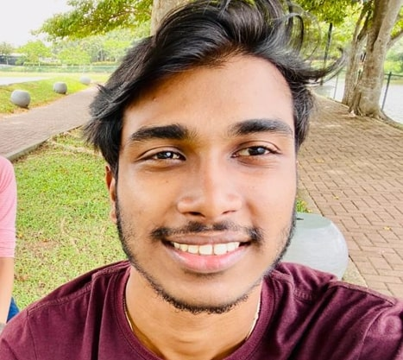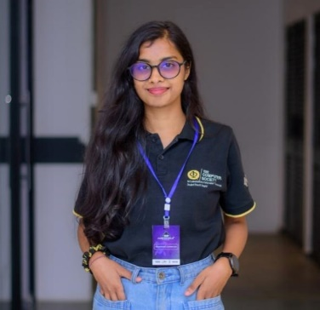

Figure 2 - Madhusha Silva

Figure 1 - Indudini Thennakoon

**Face Verification**

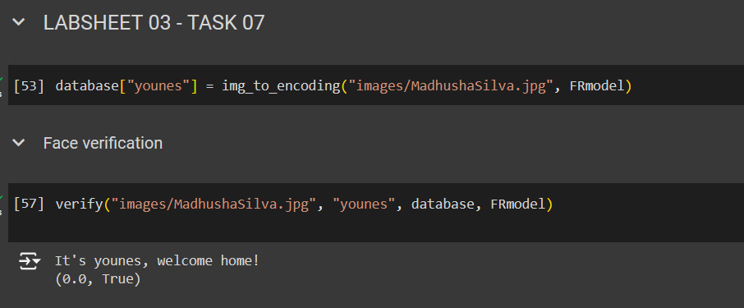

**Face Recognition**

