

**SE4050**

**Deep Learning**

**4th Year, 1st Semester**

**<** Labsheet 07 – Answer **>**

Submitted to

Sri Lanka Institute of Information Technology

**<IT21170966>**

**<Thennakoon T.M.I.C>**

In partial fulfillment of the requirements for the

Bachelor of Science Special Honors Degree in Information Technology

<28/09/2024>

**GitHub Link -** [**https://github.com/IndudiniThennakoon/SE4050-DL/tree/labsheet7**](https://github.com/IndudiniThennakoon/SE4050-DL/tree/labsheet7)

**TASK 02**

**2) When above AE is used without activation functions, it is called a linear AE. Explain the relationship between linear AE and principal component analysis (PCA). Write the answer in a word file.**

**Answer :**

The relationship between a linear autoencoder (AE) and Principal Component Analysis (PCA) can be understood by examining their common goal of dimensionality reduction and the mathematical similarities when no activation functions are used in the autoencoder.

Principal Component Analysis (PCA) - PCA is a linear dimensionality reduction technique that transforms data into a new coordinate system, such that the greatest variance by any projection of the data lies on the first coordinate (called the first principal component), the second greatest variance on the second component, and so on.

Linear Autoencoder (AE) - An autoencoder is a type of neural network that is trained to **reconstruct its input** by learning a compressed representation (encoding) in its hidden layers.

**TASK 04**

**4) Observe the model performance improvements between the above two models and give reasons for the observed improvements.**

**Answer :**

The graphs above display mean squared and the training and validation loss over 30 epochs for both the dense-layer autoencoder (FFNN) and the convolutional autoencoder (CNN).  
  
Mean Squared and the training and validation loss of the dense-layer autoencoder (FFNN)

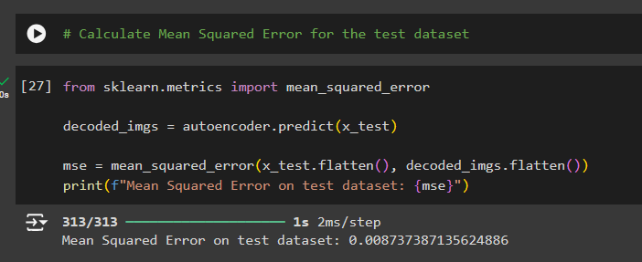

Mean Squared and the training and validation loss of the convolutional autoencoder (CNN)

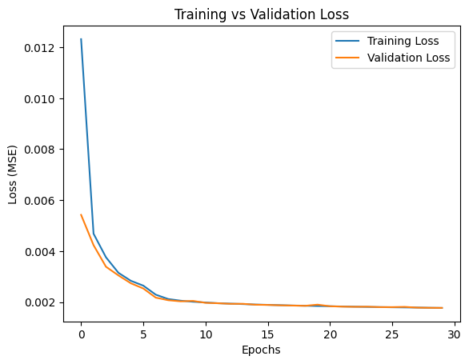

The **CNN-based autoencoder** shows lower overall training and validation losses compared to the **FFNN-based autoencoder**. CNNs are generally better at capturing spatial relationships in image data (like Fashion MNIST) because they use convolutional filters, which are designed to handle pixel locality, edges, and patterns. This improves the ability to compress and reconstruct the images more effectively.

**Reasons for Performance Improvement**

1. **Spatial Hierarchy in CNNs**: CNNs utilize filters that scan over small parts of the image, allowing them to capture hierarchical patterns such as edges and textures. This feature makes them more efficient for image reconstruction tasks compared to dense layers, which treat all pixel information as equal and lack spatial awareness.
2. **Parameter Efficiency**: CNNs typically use fewer parameters for similar tasks by sharing weights across the image, while dense layers require unique weights for every input feature. This parameter efficiency leads to better generalization and reduced overfitting, which can explain the smoother validation loss curve in the CNN model.
3. **Better Reconstruction**: The improved performance of CNNs in image-related tasks translates to better reconstruction accuracy, as seen in the lower Mean Squared Error (MSE) values.

**TASK 06**

**6) Observe the model performance improvements between the Image De-noising AE and the Vanilla CNN AE. Explain the reasons for the observed improvements.**

**Answer :**

The **Image Denoising Autoencoder (AE)** and the **Vanilla CNN AE** both use convolutional neural networks for reconstructing images. However, the key difference lies in the addition of noise in the input images for the Image Denoising AE.

**Observations:**

* **Vanilla CNN AE**:

This model is a straightforward autoencoder where the input images are directly reconstructed from their compressed latent representations. The training might exhibit some overfitting because the model is reconstructing images that it has already seen without any additional perturbations or regularizations. While it can achieve decent reconstruction, the generalization to unseen or slightly altered images may be limited.

* **Image Denoising AE**:

In this model, noise is deliberately added to the input images before feeding them into the autoencoder. The task becomes more challenging since the model has to learn how to remove noise and recover the clean version of the image, which in turn helps it generalize better to real-world data where noise or imperfections are often present. The addition of noise acts as a regularization technique, preventing the model from simply memorizing the training images and thereby reducing overfitting.

**Reasons for Improvements:**

1. **Regularization through Noise**: By adding noise to the input images, the model is forced to learn a more robust mapping from noisy input to clean output. This acts as a form of regularization and helps the model generalize better to unseen data, leading to improved performance on the test set.In contrast, the Vanilla CNN AE may focus too much on memorizing the training data and may not perform well when faced with noisy or slightly altered images.
2. **Generalization Ability**: The Image Denoising AE has to learn how to generalize beyond just memorizing pixel values. Since it is trained on noisy data and evaluated on clean reconstructions, the model learns to filter out noise and recover meaningful image features. This leads to better generalization in scenarios where noise or variations are present in the real-world data. The Vanilla CNN AE might struggle with generalization, especially if there’s noise in the input or the test set differs slightly from the training set.
3. **Handling Variations in Data**: The noise factor in the Image Denoising AE helps the model become more robust to variations in the input data (like slight shifts, rotations, or noise). This adaptability improves its performance in real-world applications. The Vanilla CNN AE, without any noise, might become overly sensitive to minor variations in the input data, leading to poorer performance when faced with noisy or imperfect images.

**TASK 07**

**7) Explain the differences between AE and Variational AE (VAE).**

**Answer :**

AEs focus on accurate reconstruction, while VAEs are designed for both reconstruction and generation, with a probabilistic approach to learning latent space.

1. Latent Space Representation:

- **AE:** Encodes input into a deterministic latent space. Each input has a specific, fixed latent representation.

- **VAE:** Encodes input into a probabilistic latent space, learning distributions (mean and variance) for each input. The latent representation is sampled from these distributions, allowing for variation in outputs.

2. Generative Capabilities:

- **AE:** Primarily used for reconstruction tasks but lacks the ability to generate diverse new data.

- **VAE:** Designed as a generative model, allowing the generation of new data by sampling from the learned latent space distribution.

3. Training Objective:

- **AE:** Minimizes reconstruction error (e.g., Mean Squared Error) to learn mappings between input and latent space.

- **VAE :** Uses a combined loss: reconstruction loss and **KL divergence** (which ensures that the latent space follows a normal distribution).