MEDICAL DIAGNOSTIC CENTER
ServiceNow-Based Diagnostic Appointment and Report Management System

PROJECT REPORT
BY
INDUJA A

A custom ServiceNow Service Portal application for diagnostic test booking, appointment management, sample collection and diagnostic report access.

Project Area | Details
Platform | ServiceNow
Application Interface | Service Portal
Application Type | Healthcare / Diagnostic Test Management
Core Users | Patients, Lab Technicians, system administrators
Major Functions | Test selection, slot booking, validation, approval, confirmation, sample collection, report upload and system alerts
Automation | Flow Designer, Business Rules, Scheduled Jobs
Security | Roles, ACLs and patient-level filtering

TABLE OF CONTENTS
S. No. | Content | Page No.
1 | Project Overview | 1
2 | Background and Motivation | 2
3 | Problem Identification | 3
4 | Project Goals | 4
5 | Project Coverage | 5
6 | Current Practice and Developed Solution | 6
7 | System Requirements | 7
8 | Actors and Responsibilities | 8
9 | Major Functional Areas | 9
10 | Appointment Processing Flow | 11
11 | Technical Architecture | 11
12 | Data Structure and Relationships | 12
13 | Portal Design and Implementation | 13
14 | Diagnostic Services Catalog | 14
15 | Appointment Registration Module | 15
16 | Schedule Availability and Validation | 16
17 | Charge and Payment Handling | 17
18 | Collection and Appointment Status Flow | 18
19 | Diagnostic Report Handling | 19
20 | Alerts and Communication | 20
21 | Automation Components | 21
22 | Security and Authorization | 22
23 | Testing, Issue Resolution and Deployment | 23
24 | Enhancements and Final Summary | 24

Project Overview
The Medical Diagnostic Center is a custom healthcare management solution developed on the ServiceNow platform using Service Portal. The application provides a single portal where patients can review available diagnostic services, request an appointment, follow its progress and obtain the related diagnostic report.
The implementation combines a Service Portal front end with ServiceNow records, workflow automation and access-control mechanisms. Instead of depending on disconnected manual processes, the project organizes the diagnostic lifecycle into a structured sequence: test selection, appointment booking, slot validation, payment or confirmation, approval when required, sample collection, processing, report upload and report availability.
The work also applies ServiceNow development features including custom data tables, reference relationships, portal pages and widgets, Client Scripts, UI Policies, GlideRecord, Flow Designer, Business Rules, Scheduled Jobs, system alerts, roles and ACL configuration.
An important design consideration is to make the process easy to follow for both portal users and administrative staff. Patients should see only the actions relevant to them, while lab personnel and system administrators receive the permissions needed to manage operational activities.

Key Benefits
- Centralized diagnostic appointment records.
- Reduced risk of slot conflicts and overbooking.
- Automated status movement and system alerts.
- Patient-specific access to appointments and reports.
- Structured administration of tests, prices, slots and records.
- A scalable foundation for future integrations and analytics.

Background and Motivation
A diagnostic center coordinates several activities simultaneously, including patient requests, scheduling, sample handling and report preparation. Patients need to select tests, lab personnel need to process samples, and system administrators need to maintain test information, appointment schedules and reports. When these activities are managed manually or through separate systems, information can become difficult to track.
ServiceNow offers the data, automation, security and interface capabilities required to organize these activities into one application. In this project, Service Portal is used as the main patient interface. Custom application components connect the portal experience with ServiceNow records and automated processes.
The project is designed around a diagnostic test appointment rather than a general hospital management system. The focus is therefore on diagnostic services, appointment scheduling, sample collection, report processing and communication.

Project Vision
The intended outcome is a patient-oriented portal that handles the major booking activities within one application instead of relying on separate manual communication.

Project Principles
- Simple user experience.
- Accurate and validated appointment data.
- Automation wherever a rule is repeatable.
- Least-privilege access to sensitive records.
- Reusable and maintainable ServiceNow components.
- Clear status tracking from booking to report completion.

3. Problem Identification
In a conventional setup, patients and staff may depend on calls, paper-based forms, registers and separate messages to manage diagnostic appointments. These approaches can create delays and make it harder to maintain a consistent record of every appointment.
The project addresses the following practical problems:
Patients may not have a single place to view available diagnostic services.
Appointment slots may be selected without reliable availability validation.
Booking, payment, approval and confirmation activities may require manual coordination.
Patients may not receive timely updates about appointment status.
Sample collection and report processing can be difficult to track.
Medical reports need controlled access so that a patient can view only the appropriate information.
system administrators need a structured way to maintain tests, prices, slots and assignments.
Manual status updates can cause records to remain in an incorrect state.

Solution Approach
The developed solution connects the different stages into a single appointment lifecycle. A booking begins in the Service Portal and becomes a ServiceNow booking record. Validation and workflow logic control what happens next. Once the diagnostic process progresses, the appointment status and related report information are updated. system alerts keep the patient informed at important stages.

4. Objectives

Primary Objectives
- Develop a custom Medical Diagnostic Center application on ServiceNow.
- Provide a user-friendly Service Portal for patients.
- Allow patients to browse and select diagnostic services or packages.
- Support appointment date and time-slot selection.
- Validate slot availability before confirming a booking.
- Automate booking and appointment lifecycle activities.
- Support payment confirmation and optional administrative approval.
- Support home sample collection information where applicable.
- Allow authorized laboratory users to update sample and report information.
- Allow patients to securely view their reports.
- Send system alerts at important workflow stages.
- Use roles and ACLs to protect application data.

Secondary Objectives
- Demonstrate low-code and configuration capabilities of ServiceNow.
- Use scripting only where business logic requires it.
- Create reusable components for future enhancements.
- Provide a maintainable foundation for external integrations.

5. Project Coverage

In Scope
Area | Included Capability
Patient Portal | Test browsing, booking, appointment tracking, report access
Diagnostic Catalog | Test name, description, price and related configuration
Appointments | Date, time, test, patient, status and collection information
Validation | Date and slot validation, duplicate/overlap prevention
Workflow | Submission, confirmation, approval where applicable, lifecycle updates
Payment | Payment information and confirmation status
Sample Collection | Collection status and home collection details
Reports | Report record, upload by authorized staff and patient access
system alerts | Booking, payment, reminder, report and cancellation messages
Administration | Catalog, pricing, slots, assignments and workflow settings
Security | Roles, ACLs and patient-level filtering

Out of Scope
The project does not attempt to replace a complete hospital information system. Advanced external payment gateway integration, SMS gateway integration, doctor portal integration and large-scale enterprise analytics are treated as future enhancement areas.

6. Current Practice and Developed Solution

Existing / Manual Approach
- Test information may be communicated manually.
- Appointments can require phone or counter coordination.
- Availability checking may depend on staff records.
- Status updates may be communicated separately.
- Reports may require manual follow-up.
- Access control may be difficult when records are stored across different systems.

Proposed ServiceNow Approach
Requirement | Proposed Solution
Test discovery | Service Portal test catalog
Booking | Guided appointment booking page
Availability | Server-side validation and slot records
Workflow | Flow Designer
Data storage | Custom application tables
Record relationship | Reference fields
Automation | Flows, Business Rules and Scheduled Jobs
Communication | Event-driven email system alerts
Security | Roles and ACLs
Reports | Controlled report records and portal access

The proposed approach improves consistency because the appointment becomes the central record connecting the patient, selected diagnostic test, payment information, collection activity and report.

7. System Requirements

Functional Requirements
- The system shall display available diagnostic services.
- The patient shall be able to select a test or package.
- The patient shall select an appointment date and available slot.
- The system shall validate the selected slot before booking.
- The system shall calculate applicable charges.
- The system shall create an booking record after successful submission.
- The workflow shall support confirmation and approval conditions.
- The system shall support cancellation and rescheduling according to configured rules.
- Authorized staff shall update sample collection and processing status.
- Authorized lab personnel shall upload or attach reports.
- Patients shall view only their own permitted reports.
- The system shall send system alerts at configured stages.
- system administrators shall manage diagnostic catalog and scheduling configuration.

Non-Functional Requirements
- Usability: simple and responsive portal interface.
- Security: role-based and record-level access.
- Maintainability: reusable widgets and scripts.
- Reliability: validation before important record updates.
- Scalability: modular data and workflow design.
- Traceability: status history, workflow execution and system logs.

8. Actors and Responsibilities
Role | Main Responsibilities | Typical Access
Patient | Browse tests, create bookings, view own appointments, receive updates, view own reports | Own patient-related records
Lab Technician | Manage collection/process steps and upload reports | Assigned operational records
Administrator | Manage catalog, pricing, slots, assignments, approvals and configuration | Administrative records
Lab Manager / Approver | Review bookings requiring approval | Approval-related records

Patient Journey
A patient starts with test selection and continues through booking, confirmation, sample collection, processing and report availability. The portal should expose only the actions needed for the current status.

Laboratory Journey
lab personnel work with appointments and samples. After collection, the sample moves to processing. Once the report is ready, the report record is made available to the appropriate patient.

Administrative Journey
system administrators maintain the data that controls the application: diagnostic services, prices, slot configuration, technician assignments, workflow conditions and access settings.

9. Major Functional Areas
The functional design follows an end-to-end diagnostic appointment lifecycle.

Core Flow
- Test Selection
- Slot Booking
- Validation
- Approval if applicable
- Payment / Confirmation
- Sample Collection
- Processing
- Report Upload
- Report Availability
- Completion

Important Patient Actions
- Select a diagnostic test.
- Select date and time.
- Provide required booking information.
- Choose home collection when offered.
- Review calculated charges.
- Submit the appointment.
- Track status.
- View the report when it becomes available.

Important Staff Actions
- Review operational appointments.
- Manage sample collection.
- Update processing status.
- Upload the completed report.
- Maintain appointment information within authorized permissions.

Important Admin Actions
- Maintain catalog and prices.
- Configure slots.
- Assign technicians.
- Manage workflow and approval conditions.
- Monitor application records and errors.

10. Appointment Processing Flow
The appointment process acts as the main thread connecting the portal, database records and automated actions. It connects the patient-accessible portal to the backend records and automation.
- Patient opens the diagnostic center portal.
- Available tests or packages are displayed.
- Patient selects the required test.
- Patient chooses an available appointment date and time slot.
- System validates the date and slot.
- System checks for conflicting or overlapping appointments.
- System calculates the applicable charge.
- appointment request is submitted.
- Flow Designer evaluates whether approval is required.
- If approval is required, the configured approver reviews the request.
- Payment confirmation is recorded when payment is part of the process.
- Appointment is confirmed and the patient receives a notification.
- Sample is collected according to the appointment type.
- Appointment moves through processing.
- Authorized staff uploads the diagnostic report.
- System marks the report as ready and notifies the patient.
- Appointment is eventually marked completed.

Cancellation / Rescheduling
Cancellation or rescheduling changes the booking record and triggers the configured rules. The system can also communicate the new status and apply applicable cancellation or refund logic.

11. ServiceNow Architecture
The solution uses a layered architecture so that the user interface, application data, business logic, automation and security can be managed independently.
Layer | ServiceNow Components | Purpose
Presentation | Service Portal, Pages, Widgets | patient-accessible interaction
Client Logic | Client Scripts, UI Policies, AngularJS | Dynamic interface behavior
Server Logic | Business Rules, Script Includes, GlideRecord | Validation and reusable logic
Automation | Flow Designer, Events, Scheduled Jobs | Lifecycle automation
Data | Custom Tables, Reference Fields | Persistent application records
Security | Roles, ACLs, Server-side filtering | Controlled access
Monitoring | System Logs, Flow Execution Details | Troubleshooting and audit support

Architecture Principle
The portal should not be treated as the security boundary by itself. Important authorization and validation decisions should be enforced on the server side using ServiceNow roles, ACLs and server scripts.

Scoped Application
The application can be developed in a scoped application to provide organized application files, controlled naming and better maintainability.

12. Data Structure and Relationships
The data model separates patients, tests, appointments, reports and payment information. Reference fields connect related records while preserving a clear ownership structure.
Table / Record Type | Important Information
Patient | Patient identity and contact details
Diagnostic Services Catalog | Test name, description, category, price, availability
Appointment | Patient, test, date, slot, status, collection type, charge
Report | Appointment reference, report information, upload/availability status
Payment | Appointment reference, amount, payment status and transaction information
Slot Configuration | Date/time availability, capacity and configuration
Technician Assignment | Appointment/sample and assigned technician information

Relationships
- Patient → Appointment: One-to-Many.
- Appointment → Report: One-to-One in the intended design.
- Appointment → Diagnostic Test: Many-to-One.
- Appointment → Payment: linked payment record.
- Appointment → Technician Assignment: operational assignment relationship.
Reference fields are important because they avoid unnecessary duplication of patient and test information. A related appointment can retrieve the patient or test record when needed.

13. Service Portal Design
Service Portal is used as the user-facing layer through which patients interact with the application. The design is organized around clear pages and reusable widgets rather than exposing backend tables directly.

Suggested / Implemented Portal Areas
- Homepage / Test Selection
- Appointment Booking
- My Appointments
- Booking Confirmation
- Payment Information
- Report Download / View
- Status and notification areas

Custom Widget Responsibilities
Widget | Purpose
Test Catalog Widget | Display available diagnostic services and packages
Booking Widget | Collect appointment details
Slot Widget | Show available time slots
Booking Summary | Show selected test, date and calculated amount
Appointment Tracking | Show patient's appointments and statuses
Report Widget | Display report availability and permitted report information

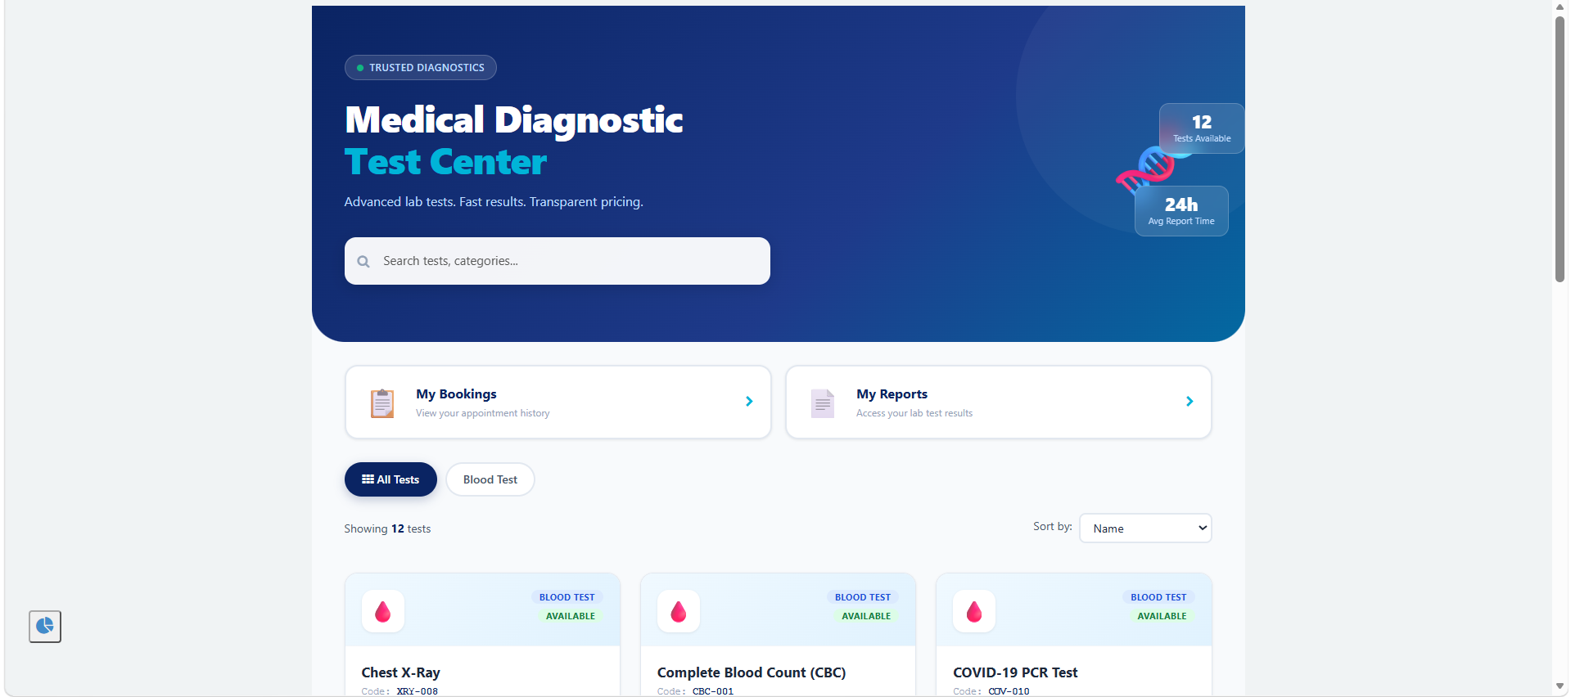

Technology Used
Widgets can use HTML and CSS for structure and presentation, AngularJS for client interaction, and server/client scripts for data processing. Server-side code is responsible for secure record retrieval and validation.

14. Diagnostic Services Catalog
The Diagnostic Services Catalog is the starting point for the booking process. system administrators maintain the tests that patients can select.

Typical Test Information
Field | Purpose
Test Name | Name shown to the patient
Test Code | Unique identifier
Description | Short explanation of the test
Category | Classification of the test
Base Price | Default test charge
Availability | Whether the test can currently be booked
Home Collection | Whether home collection is supported
Duration | Expected operational time where configured
Examples used during the project included common diagnostic services such as CBC, Lipid Profile and COVID-related testing. The catalog design allows additional tests to be added without redesigning the portal.

Catalog Management
system administrators can create, update or deactivate catalog records according to their role. The portal should display only records that are intended to be bookable.
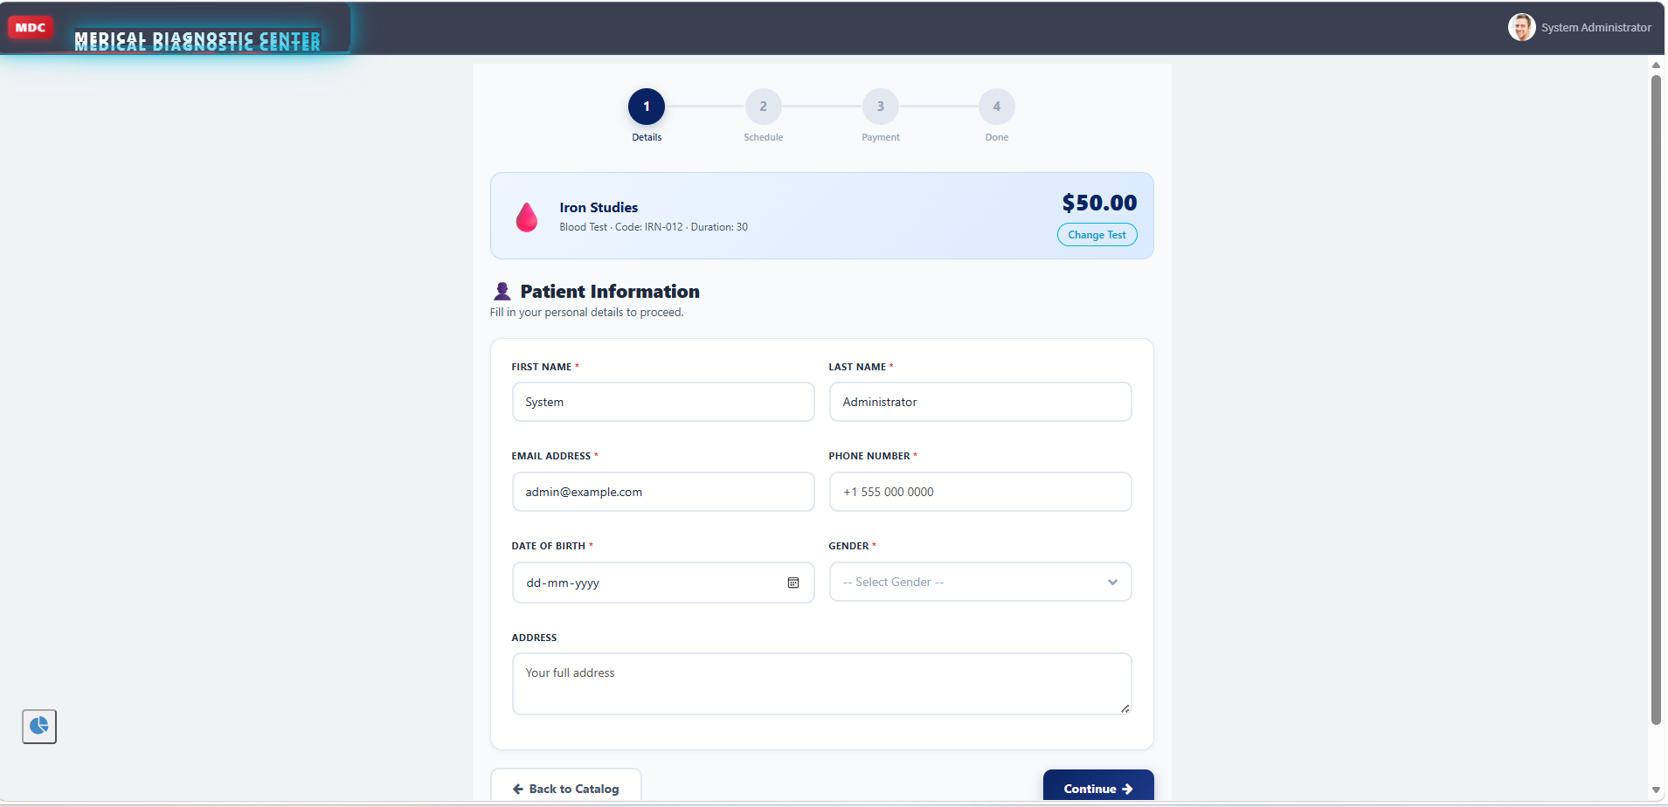

Design Benefit
Separating the catalog from appointments prevents the appointment form from containing hardcoded test information. Price and test details can therefore be maintained centrally.

15. Appointment Registration Module
After a patient chooses a diagnostic service, the booking module captures the required information and creates an organized appointment request.

Booking Data
- Patient reference.
- Selected diagnostic test.
- Appointment date.
- Selected time slot.
- Home collection selection.
- Collection address/details when applicable.
- Calculated amount.
- Payment status.
- Approval status where applicable.
- Appointment lifecycle status.

Booking Process
Receive the selected test from the test catalog.
Display eligible appointment dates and slots.
Collect required patient and appointment information.
Validate the date and slot on the server.
Calculate the total charge.
Create the booking record.
Start the configured workflow.
Send the relevant confirmation or pending-approval message.
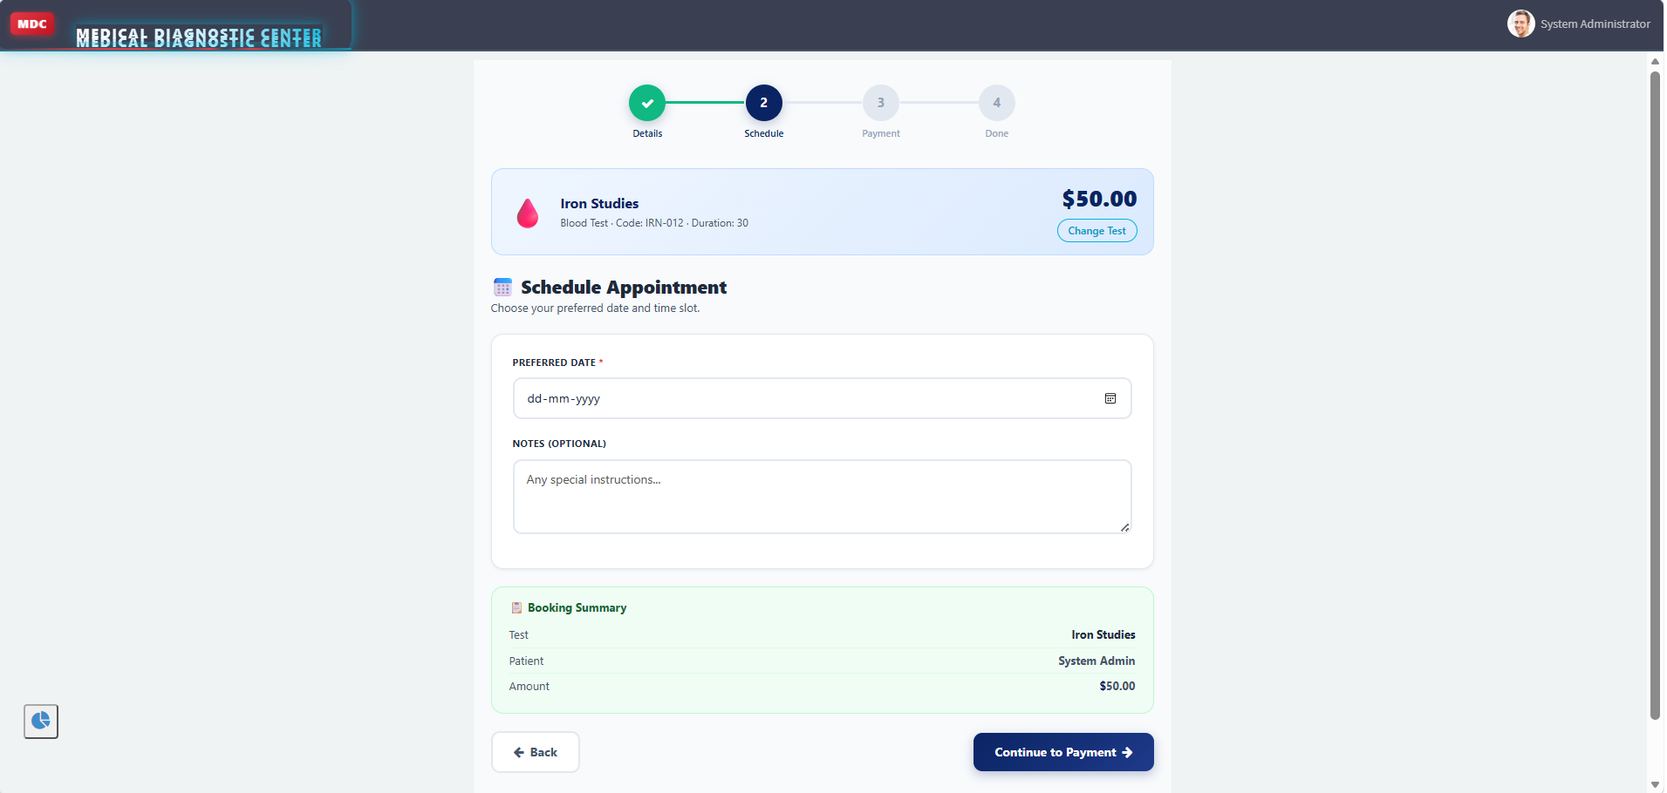

Validation Rules
- Appointment date should not be invalid or outside the configured booking window.
- Selected slot must exist and be bookable.
- The same slot should not exceed its configured capacity.
- Required home collection information must be provided when selected.
- Price should be retrieved from trusted server-side data rather than relying only on browser values.

16. Schedule Availability and Validation
Appointment scheduling needs validation because available staff, rooms and collection capacity are limited. The application therefore validates availability before accepting a booking.

Availability Logic
When the patient selects a date, the system identifies configured slots for that date. It then checks how many active appointments occupy each slot. A slot is available only when the current booking count is within the configured capacity.

Overlap Prevention
Server-side validation should check existing appointments before inserting a new appointment. This is important because two users could attempt to select the same slot at nearly the same time.

Example Logic
Read requested date and slot.
Find the configured slot.
Check active appointments for the same date and slot.
Compare the count with capacity.
Reject the request when capacity is reached.
Create the appointment only after the validation succeeds.
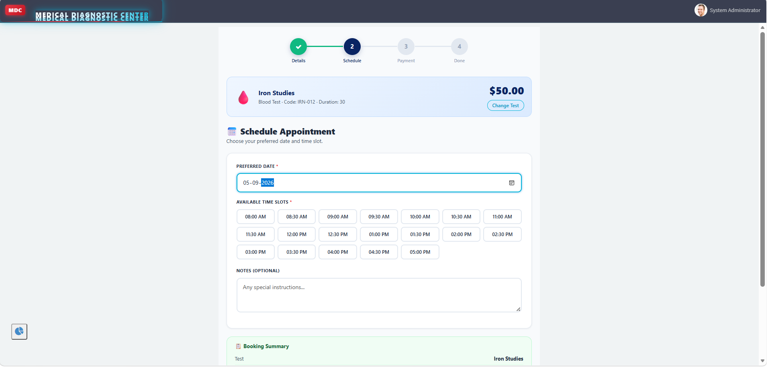

17. Charge and Payment Handling
The project supports dynamic pricing so that the final charge can reflect the selected diagnostic test, package, collection option and configured discount rules.

Pricing Components
Component | Example Rule
Base Test Price | Price stored in the diagnostic catalog
Package Price | Configured price for a test package
Home Collection | Additional charge where applicable
Discount | Configured discount condition
Final Amount | Calculated total used for payment information
The calculation should be performed using trusted server-side values. A browser can display an estimated amount, but the final amount stored in the appointment or payment record should be generated from authoritative application data.

Payment Status
- Pending
- Confirmed
- Failed where supported
- Refunded when cancellation rules require it

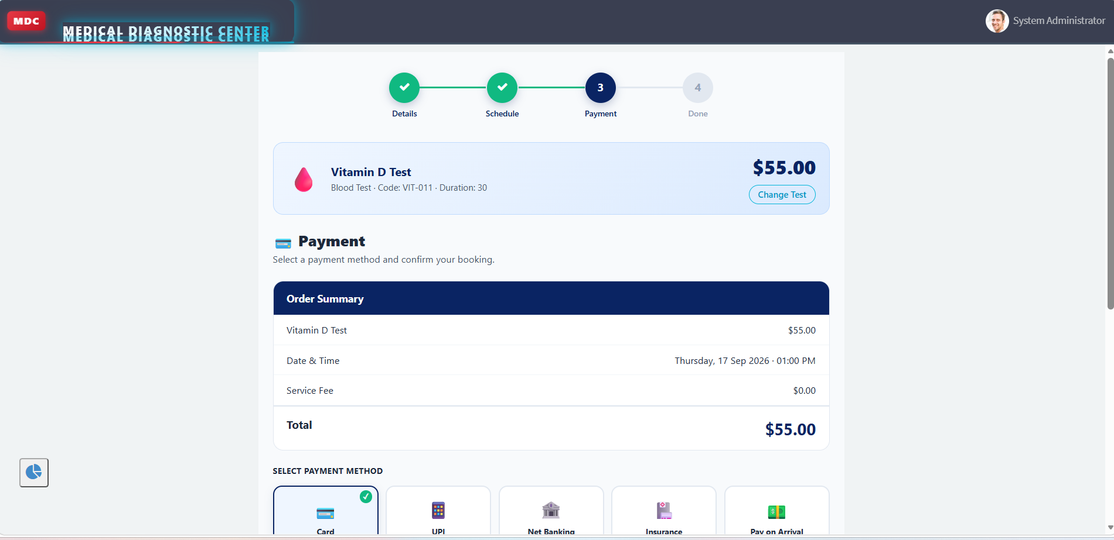

Payment Workflow
After a booking is submitted, the configured workflow can wait for payment confirmation or continue through an approval process according to the project configuration. Payment-related updates should be restricted to authorized roles.

18. Approval and Governance
Some diagnostic bookings may require additional review. The project therefore supports configurable approval logic through Flow Designer.

Approval Conditions
- High-value tests or packages.
- Administrative review requirements.
- Special collection requirements.
- Other configured business conditions.

Approval Flow
appointment request is submitted.
Flow evaluates the configured condition.
If approval is not required, the workflow proceeds to confirmation.
If approval is required, an approver is assigned.
Approver accepts or rejects the request.
Appointment status and approval status are updated.
Patient receives the appropriate notification.

Governance
Approval tracking provides a structured record of who reviewed a request and what decision was made. Status fields and audit history support traceability.

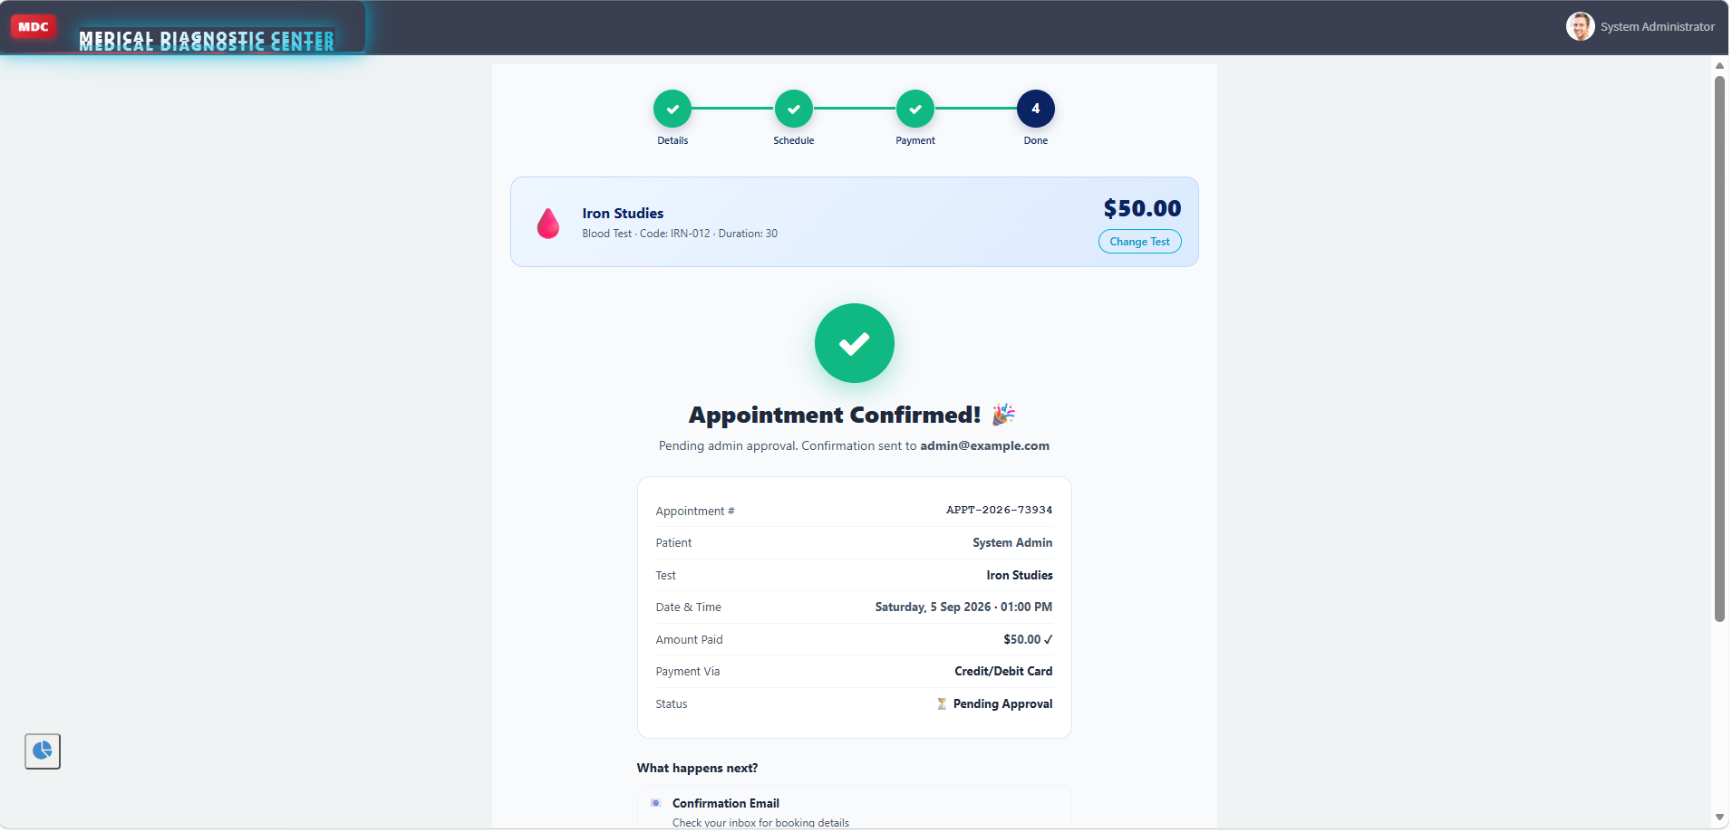

Approver Roles
The intended design can assign approval work to an Administrator or Lab Manager depending on the configured condition.

19. Collection and Appointment Status Flow
After confirmation, the appointment moves into operational stages. The status lifecycle provides a simple way to understand what has happened and what should happen next.

Status Lifecycle
Status | Meaning
Scheduled | Appointment is confirmed and scheduled
Sample Collected | Required sample has been collected
Processing | Laboratory processing is in progress
Report Ready | Report has been uploaded and is available
Completed | Diagnostic appointment lifecycle is complete
Cancelled | Appointment was cancelled
Missed | Patient did not attend or collection did not occur as configured

Home Sample Collection
When home collection is selected, the booking form can conditionally display collection-related fields. UI Policies and Client Scripts can control visibility, while server-side validation ensures required information is present.
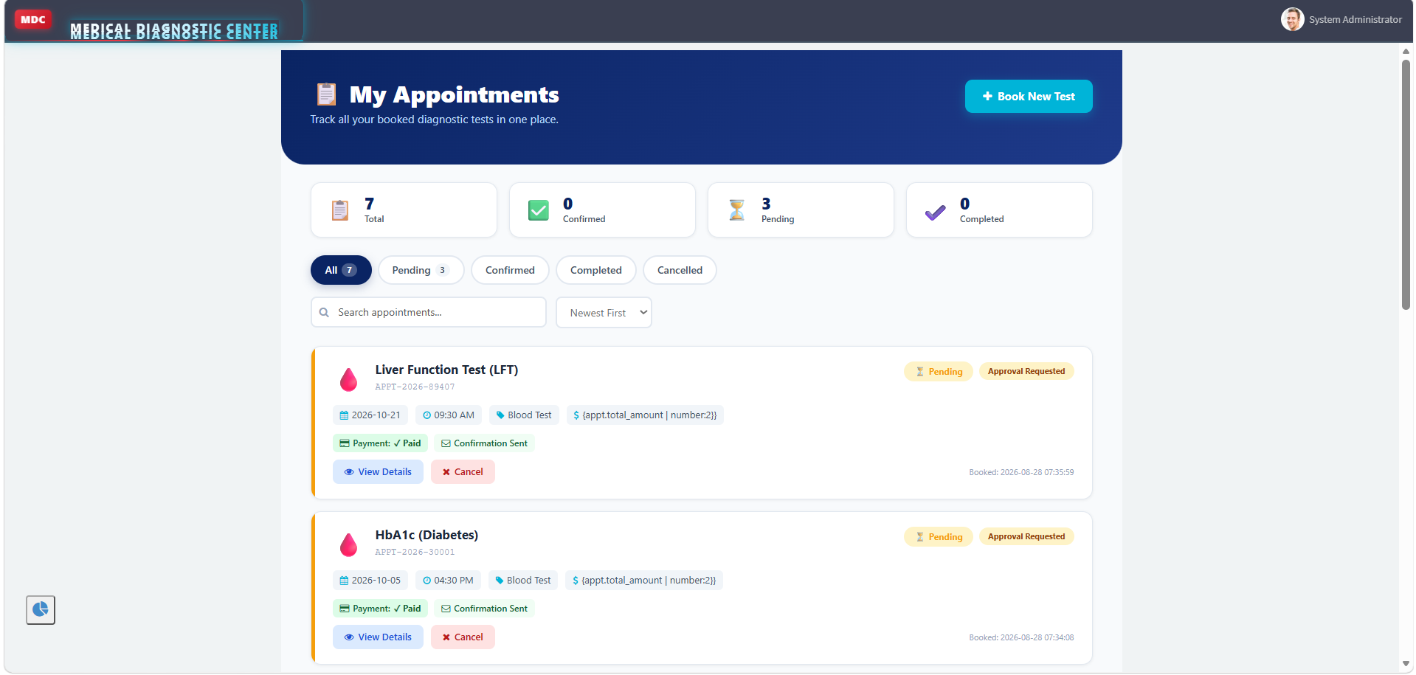

20. Diagnostic Report Handling
The report module manages the final output of the diagnostic process. A report record is linked to the corresponding appointment so that the result can be traced back to the patient's diagnostic request.

Report Lifecycle
Appointment reaches sample-collected or processing stage.
lab personnel process the sample.
Authorized staff upload or attach the report.
Report record is updated to indicate availability.
Patient receives a report-ready notification.
Patient opens the portal and views the permitted report.
Appointment can be marked completed.

Report Table Design
Field | Purpose
Report Number | Unique report identifier
Appointment | Reference to the diagnostic appointment
Patient | Patient relationship or derived reference
Report File / Content | Uploaded diagnostic report
Status | Processing / Ready / Completed as configured
Uploaded By | Traceability for staff upload
Report Date | Date associated with report availability

Patient Access
The portal should filter report records by the logged-in patient's identity. The patient must not be able to retrieve another patient's report by changing a record identifier in the browser.

21. Alerts and Communication
system alerts keep users informed without requiring them to repeatedly check the system.

Notification Events
Stage | Notification
Booking Submitted | appointment request acknowledgement
Payment Confirmed | Payment / booking confirmation
Approval | Approval or rejection update
Appointment Reminder | Reminder before scheduled appointment
Sample Collection | Collection status update when configured
Report Ready | Report availability alert
Cancellation | Cancellation confirmation
Rescheduling | Updated appointment information

Dynamic Email Content
Email system alerts can populate patient name, test details, appointment date and time, payment amount and report links using notification variables and email scripts.

Good Notification Practice
- Use clear subject lines.
- Show only relevant appointment information.
- Avoid exposing unrelated patient records.
- Provide a safe link to the portal report or appointment page.
- Trigger messages only after the underlying record update succeeds.

Communication Goal
The notification system should reduce uncertainty for patients and reduce repetitive status enquiries for staff.

22. Business Rules, Flows and Scheduled Jobs

Business Rules
Business Rules are suitable for server-side actions that must happen when records are inserted, updated or deleted. Examples include validation, automatic field updates and controlled status changes.

Flow Designer
Flow Designer is used for readable, configurable automation. Typical flows include appointment submission, payment confirmation, approval, report upload, cancellation and system alerts.

Scheduled Jobs
- Send appointment reminders.
- Mark missed appointments.
- Update status after defined conditions.
- Clean up expired pending bookings.
- Perform other recurring background operations.

GlideRecord
GlideRecord is used in server-side scripts to query and update ServiceNow records. In this project it can support slot validation, appointment retrieval, pricing lookup and patient-specific data retrieval.

Script Includes
Reusable server-side logic can be placed in Script Includes to reduce duplication. Examples include slot validation or shared pricing calculations.

Monitoring
- Flow Execution Details for failed flow actions.
- System Logs for platform errors.
- gs.info() for controlled debugging.
- GlideRecord trace analysis where required.
- Service Portal preview for interface testing.
- Debug Security Rules for ACL troubleshooting.

23. Security and ACL Design
Because the application handles patient and diagnostic information, access must be restricted according to user responsibility. The project uses ServiceNow roles, ACLs and server-side filtering to ensure that users receive only the access necessary for their responsibilities.

Access Model
Area | Patient | Lab Technician | Admin
Own appointment read | Yes | As authorized | Yes
Create appointment | Yes | As authorized | Yes
Upload report | No | Yes | Yes
View patient report | Own only | Assigned/authorized | Yes
Modify catalog | No | No | Yes
Modify payment | No | Restricted | Yes
Workflow configuration | No | No | Yes

Patient-Level Filtering
Portal widgets should retrieve appointments and reports using the logged-in user's identity. This prevents a patient from seeing records belonging to another patient.

ACL Types
- Table-level create, read, write and delete ACLs.
- Field-level ACLs for sensitive information.
- Role-based restrictions for administrative functions.
- Report upload permissions limited to authorized laboratory users.

Security Testing
Use impersonation, role-based test users and Debug Security Rules to verify that allowed users can perform their tasks while unauthorized users are denied.

24. Testing, Troubleshooting, Deployment and Future Enhancements

Testing Strategy
Test Area | Validation
Test Catalog | Correct tests and prices are displayed
Booking | Required fields and valid dates
Slot | Capacity and overlap validation
Workflow | Approval and confirmation paths
Payment | Status changes and restricted updates
Reports | Correct upload and patient-only access
system alerts | Correct trigger and content
Security | Role and ACL behavior
Portal | Page navigation and widget behavior

Troubleshooting Lessons
During ServiceNow development, common issues can include missing portal buttons, empty catalog results, records not appearing in related tables, incorrect reference display, notification configuration problems and dashboard permission messages. These issues should be investigated systematically by checking table data, reference fields, widget server scripts, ACLs, flow conditions, logs and portal configuration rather than changing multiple components at once.

Deployment
Complete functional and security testing.
Capture application configuration using Update Sets where applicable.
Move configuration to the target instance.
Perform smoke testing.
Verify portal pages, system alerts, Business Rules and Flow executions.
Monitor logs after deployment.

Future Enhancements
- External payment gateway integration.
- SMS system alerts.
- Doctor portal integration.
- Expanded analytics and dashboards.
- Integration with external laboratory systems.
- Mobile-focused patient experience.

25. Conclusion and References

Conclusion
The Medical Diagnostic Center project demonstrates how ServiceNow can be used to build a structured healthcare application using Service Portal, custom tables, scripting, Flow Designer and platform security. The solution connects patient actions with laboratory operations through a clear appointment lifecycle.
The completed design establishes a base for service selection, scheduling, validation, payment confirmation, approval, sample collection, report processing and patient alerts. Its modular design also makes it possible to add new tests, workflows and integrations without redesigning the complete application.
From a ServiceNow learning perspective, the project demonstrates practical use of application development concepts including Service Portal widgets, Client Scripts, UI Policies, GlideRecord, Business Rules, Flow Designer, Scheduled Jobs, email system alerts, ACLs and troubleshooting tools.

Project Outcome
- Patient-friendly diagnostic booking experience.
- Structured appointment and report records.
- Automated workflow and communication.
- Controlled access based on user roles.
- Maintainable ServiceNow application structure.
- Clear scope for future integrations.

References / Learning Sources
- ServiceNow platform documentation and developer learning resources.
- Service Portal development concepts and widget documentation.
- ServiceNow Flow Designer documentation.
- ServiceNow Access Control and security documentation.
- ServiceNow GlideRecord and server-side scripting documentation.
- ServiceNow notification and email scripting documentation.

Final Statement
The Medical Diagnostic Center is designed as a practical ServiceNow application that combines user experience, workflow automation, data management and security into one end-to-end diagnostic service portal.

