PSG COLLEGE OF TECHNOLOGY, COIMBATORE – 641 004
DEPARTMENT OF COMPUTER APPLICATIONS
AY 2025-2026 MCA First Year Semester 2
ENTERPRICE COMPUTING HACKATHON
Design Abstract
I. Team Detail

Roll No. | Name of the student | Name of the mentor
25MX305 | BHUVISHA SRI PRIYA P | Poornima
25MX315 | INDUJA
25MX318 | JEEVA SILVIYA J
25MX352 | TAMILINI

II. Title of the Application
Student Performance Predictor
III. Abstract
The Student Performance Predictor is a web-based application that uses machine learning techniques to analyze student data and predict whether a student is likely to pass or fail. The system allows users to upload datasets containing details such as attendance percentage, previous exam marks, and study hours, which are then processed and used to train a classification model like Decision Tree or Random Forest. The application not only provides predictions for each student but also highlights the most influential factors affecting performance through feature importance analysis. It presents the results in a simple and interactive visual format, including charts and summary tables, making it easy for teachers and parents to understand. Additional features such as individual student prediction, downloadable reports, and model accuracy evaluation enhance its usability. Overall, the project aims to support early identification of at-risk students and enable timely intervention to improve academic outcomes.

IV. Existing System

Existing systems for predicting student performance are often limited in scope and accessibility, typically focusing either on research-based models or institutional analytics tools. Many academic studies and machine learning models use algorithms such as Decision Trees, Random Forests, and Neural Networks to predict student outcomes based on factors like attendance, previous marks, and study behavior. While these models achieve good accuracy, they are usually implemented in research environments and are not easily accessible to teachers or non-technical users. Educational institutions and learning management systems also use predictive analytics to identify at-risk students, but these systems are often complex, require large-scale data integration, and lack simple user interfaces. Additionally, most existing solutions do not provide clear visual explanations such as feature importance or easy-to-understand reports for decision-making. As a result, there is a lack of a simple, user-friendly, and interactive web-based system that allows users to upload data, generate predictions, and interpret results effectively.

V. Proposed System

The proposed system is a user-friendly web-based Student Performance Predictor that leverages machine learning techniques to predict whether a student is likely to pass or fail based on input data such as attendance, previous marks, and study hours. The system allows users to upload student data in CSV format or enter individual student details manually to obtain instant predictions. It uses classification algorithms such as Decision Tree or Random Forest to ensure accurate and reliable results. In addition to predictions, the system provides feature importance analysis to highlight the key factors influencing student performance. The results are presented through clear visualizations, including charts and summary tables, making them easy to understand for non-technical users like teachers and parents. The application also includes features such as model accuracy display and report download options, ensuring a complete and practical solution for early identification of at-risk students and effective academic intervention.

VI. Objectives of the Proposed Application

- Accurate Prediction:To predict whether a student will pass or fail using machine learning based on input data like attendance and marks.
- Data Upload & Processing:To allow users to upload CSV files containing student records and generate predictions efficiently.
- Visual Representation:
To present results using charts and tables for easy understanding by non-technical users.
- User-Friendly Interface:
To design a simple and intuitive system that can be easily used by teachers and parents.
- Report Generation:
To enable downloading of prediction results in CSV or PDF format for future use.
- Early Intervention Support:
To help identify at-risk students early so that timely support can be provided.

VII. Scope / Use
- Academic Performance Prediction:
The system focuses on predicting student pass/fail outcomes using basic academic and behavioral data.
- Educational Use:
It can be used by schools, colleges, teachers, and parents to monitor and improve student performance.
- Data-Driven Decision Making:
Helps educators take informed decisions by analyzing student data and identifying at-risk students early.
- User Accessibility:
Designed as a simple web application that can be used by non-technical users without specialized knowledge.
- Visualization & Reporting:
Provides clear charts and reports to understand trends and performance factors effectively.
- Scalability:
Can be extended to include more features like additional student parameters, advanced models, or integration with school systems.
- Limitations:
The accuracy depends on the quality and quantity of input data and may not consider external factors like personal or environmental influences.

VIII. Technology to be used (Specific Framework etc.)

• Frontend (HTML, CSS, JavaScript):
Used to design the user interface for data input, result display, and interaction.
• Backend (Python with Flask):
Handles server-side logic, file processing, and communication between frontend and machine learning model.
• Machine Learning (scikit-learn - random forest logistic regression):
Used to build classification models like Decision Tree or Random Forest for prediction.
• Data Processing (pandas):
Helps in reading, cleaning, and manipulating the uploaded CSV data.
• Visualization (Chart.js):
Used to display charts such as feature importance and prediction statistics.
• Dataset (CSV format-Kaggle ):
Provides student performance data for training and testing the model.
• Development Tools (VS Code ):
Used for coding, debugging, and running the application.

IX. Functional Requirements of the Application

- User Data Input:
The system should allow users to upload a CSV file or manually enter student details.
- Data Processing:
The system should read, clean, and preprocess the input data for prediction.
- Prediction Generation:
The system should predict whether each student will pass or fail using a trained model.
- Feature Importance Display:
The system should show which factors most influence the prediction.
- Visualization:
The system should display results using charts and tables for better understanding.
- Model Accuracy Display:
The system should show the accuracy of the trained model.
- Report Download:
The system should allow users to download prediction results in CSV or PDF format.
- Individual Prediction:
The system should provide instant prediction for a single student’s input.

X. Non-Functional Requirements of the Application

- Usability:
The system should be simple and easy to use for non-technical users like teachers and parents.
- Performance:
The system should process data and generate predictions quickly.
- Scalability:
The system should handle increasing amounts of student data efficiently.
- Reliability:
The system should provide consistent and accurate results.
- Security:
The system should ensure that uploaded student data is handled safely and securely.
- Maintainability:
The system should be easy to update and improve in the future.
- Compatibility:
The system should work across different browsers and devices.
- • Availability:
The system should be accessible whenever required without frequent downtime.

XI.MODULES

• Data Input Module:
Handles uploading of CSV files and manual entry of student details for prediction.
• Data Preprocessing Module:
Cleans and prepares the input data by handling missing values and formatting it for the model.
• Prediction Module:
Uses machine learning algorithms to predict whether a student will pass or fail.
• Feature Importance Module:
Identifies and displays the key factors affecting student performance.
• Visualization Module:
Presents results using charts and tables for easy understanding.
• Model Evaluation Module:
Calculates and displays the accuracy of the trained model.
• Report Generation Module:
Generates downloadable reports in CSV or PDF format.
• User Interface Module:
Provides a simple and interactive interface for users to interact with the system.

XII.CLASSES
• Student Class:
Represents student details such as name, attendance, marks, and study hours.
• Dataset Class:
Handles loading and storing of student data from CSV files.
• Preprocessor Class:
Cleans and prepares the data by handling missing values and formatting inputs.
• Model Class:
Implements the machine learning algorithm (Decision Tree/Random Forest) for training and prediction.
• Prediction Class:
Manages the prediction process and stores results (pass/fail).
• FeatureImportance Class:
Calculates and provides information about important features affecting predictions.
• Report Class:
Generates reports in CSV or PDF format based on prediction results.
• UserInterface Class:
Handles interaction between the user and the system (input forms, displaying results).

XIII.FLOW CHART
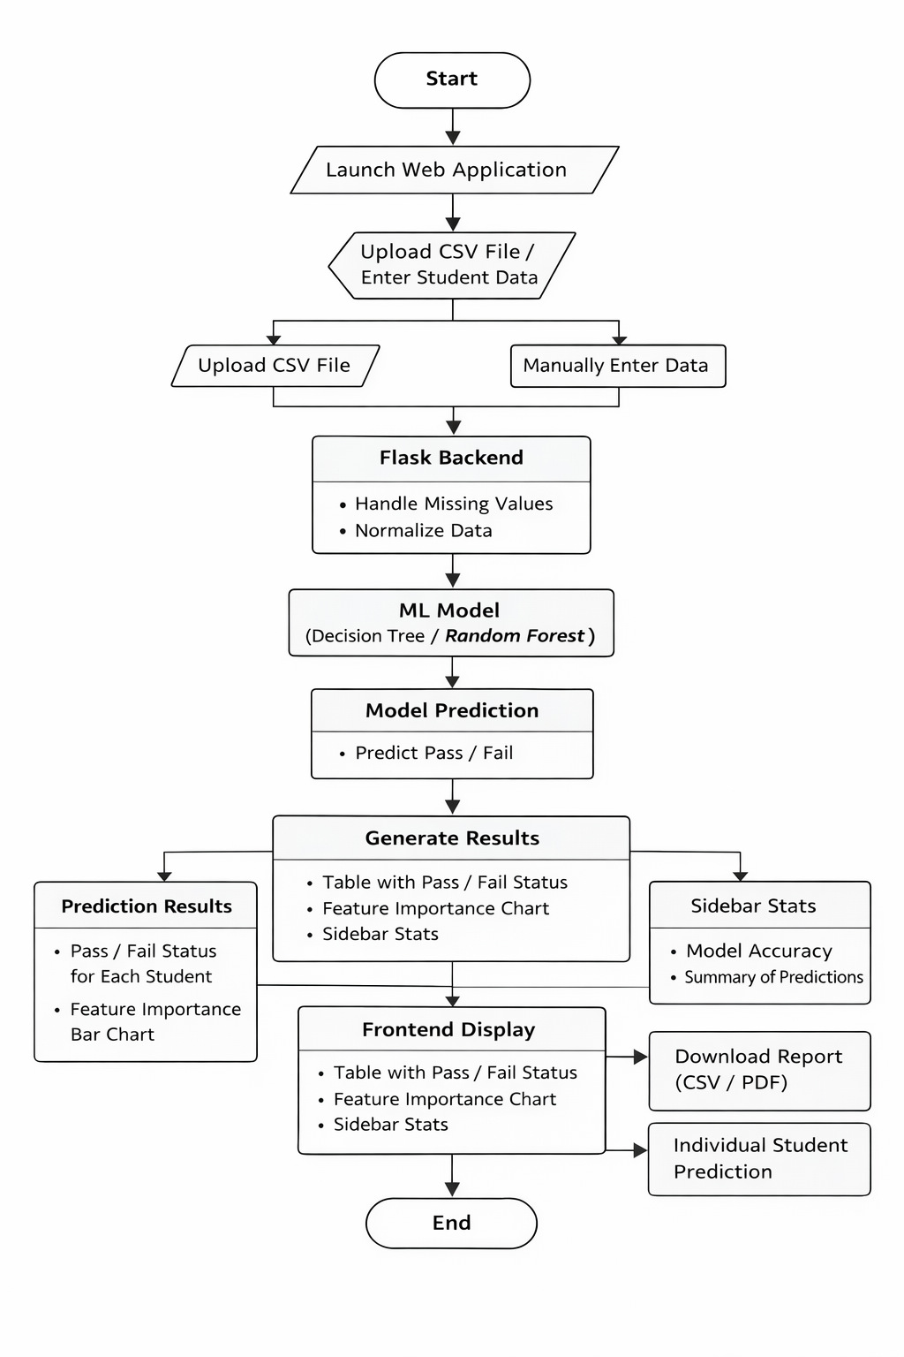

3-Tier Architecture with MVC Design in the Backend
