Build a Real-Time Job Analytics Portal

Domain: Data Analyst

Contact: [indumathi123indumathi@gmail.com](mailto:indumathi123indumathi@gmail.com)

Introduction:

The project aims to provide a comprehensive job analytics portal using Netlify's online deployment and Tableau's data visualization capabilities. By integrating these technologies, we can offer an interactive and easily navigable platform for analyzing data and trends in the job market, which is crucial for analysts, employers, and job seekers in today's data-driven environment.

Objectives:

Creating a real-time job analytics portal using Tableau and hosting it on Netlify is an exciting project. It combines data visualization and web deployment to offer valuable insights into the job market. The main goals include gathering comprehensive job market data from reliable sources, such as Kaggle, and ensuring the dataset includes crucial attributes like job titles, roles, companies, locations, salaries, and posting dates. Using Python libraries like NumPy and pandas, the data will be cleaned and pre-processed to handle missing values, standardize categorical variables, and ensure data consistency. The cleaned data will then be imported into Tableau to create interactive dashboards visualizing key metrics, such as job distribution by role, company, and location, salary ranges, and job posting trends. Filters and interactive elements will be used to allow users to explore the data dynamically. Finally, the Tableau dashboard will be exported to Tableau Public and hosted on Netlify, making it accessible to users via a web link. This project aims to provide real-time insights, interactive visualizations, and accessibility, making it a valuable tool for understanding the job market. By combining Tableau’s powerful data visualization capabilities with Netlify’s seamless web deployment, this project will create a comprehensive and user-friendly job analytics portal.

Activities and Tasks:

The primary objectives include collecting comprehensive job market data from reliable sources such as Kaggle, and ensuring the dataset includes key attributes like job titles, roles, companies, locations, salaries, and posting dates. The data will be cleaned and pre-processed using Python libraries like NumPy and pandas to handle missing values, standardize categorical variables, and ensure data consistency. The cleaned data will then be imported into Tableau to create interactive dashboards that visualize key metrics such as job distribution by role, company, location, salary ranges, and job posting trends. Filters and interactive elements will be used to allow users to explore the data dynamically. Finally, the Tableau dashboard will be exported to Tableau Public and hosted on Netlify, making it accessible to users via a web link. This project aims to provide real-time insights, interactive visualizations, and accessibility, making it a valuable tool for understanding the job market. By combining Tableau’s powerful data visualization capabilities with Netlify’s seamless web deployment, this project will create a comprehensive and user-friendly Job Analytics Portal.

These are the tasks given:

1. Draw a chart between the Job Portal and Company.
2. Draw a chart for the top 10 companies that have the maximum number of Data Engineer roles and Data Scientist job titles, excluding Asian countries, with a preference for females. Ignore countries starting with the letter ‘C’ and those with a latitude below 10. The job posting date should be between 01/01/2023 and 06/01/2023, and the qualification should be B.Tech.
3. Draw a chart where the country is either India or Germany, the qualification is B.Tech, and the work type is Full-time. The experience should be more than 2 years, and the job titles should be Data Scientist, Art Teacher, or Aerospace Engineer, with a salary range of more than $10k. The details for India should be in orange color and for Germany in green. The job portal should be Indeed, with a preference for females, and the job posting date should be before 08/01/2023. This chart should work between 12 PM to 6 PM.

Skills and Competencies:

**1. Data Collection and Integration**

* **Data Sourcing**: Ability to identify and gather relevant job market data from platforms like Kaggle for large data sources.
* **Data Integration**: Skills in combining data from multiple sources to create a comprehensive dataset for an understandable interface.

**2. Data Cleaning and Preparation**

* **Python Programming**: Proficiency in using Python libraries such as NumPy and pandas for data cleaning and pre-processing.
* **Data Transformation**: Ability to handle missing values, standardize categorical variables, and ensure data consistency.

**3. Data Analysis and Visualization**

* **Tableau**: Expertise in using Tableau to create interactive and visually appealing dashboards for understandable datasets.
* **Data Visualization**: Skills in designing charts, graphs, and other visual elements to effectively communicate insights with users.
* **Interactive Elements**: Knowledge of adding filters and interactive features to enhance user experience in data visualization.

**4. Web Deployment**

* **Web Development**: Basic understanding of HTML, CSS, and JavaScript for customizing the web interface.
* Netlify: Experience in using Netlify to deploy and host web applications to ensure the dashboard is accessible online.

**5. Analytical and Problem-Solving Skills**

* **Data Analysis**: Strong analytical skills to interpret data and derive meaningful insights.
* **Problem-solving**: Ability to troubleshoot issues that arise during data mining and visualization.

**6. Communication and Collaboration**

* **Effective Communication**: Ability to present data-driven insights clearly and concisely to stakeholders.
* **Collaboration**: Skills in working with cross-functional teams, including data scientists, developers, and business analysts.

**7. Continuous Learning**

* **Adaptability**: Willingness to learn new tools and technologies as needed for a good career.
* **Staying Updated**: It is used to Keep up with the latest trends in data analytics, visualization, and web development.

Feedback and Evidence:

Using Tableau to create a Real-Time Job Analytics Portal and then posting it on Netlify is a truly amazing project that demonstrates a lot of useful abilities. Strong data-gathering skills are demonstrated by acquiring and integrating job market data from sites like Kaggle with success. Employing Python tools for preprocessing and data cleaning, including NumPy and pandas, exhibits your ability to handle data, deal with missing values, standardize categorical variables, and ensure data consistency. Using filters and interactive elements to enable dynamic exploration, you may demonstrate how to turn raw data into insightful insights by importing the cleaned data into Tableau and building interactive dashboards. Your knowledge of web deployment is evident when you publish the Tableau dashboard on Netlify and make it available online, making the portal responsive and user-friendly.

I have added some screenshots of my project as Evidence:

Step 1: Open Kaggle and download the relevant dataset.

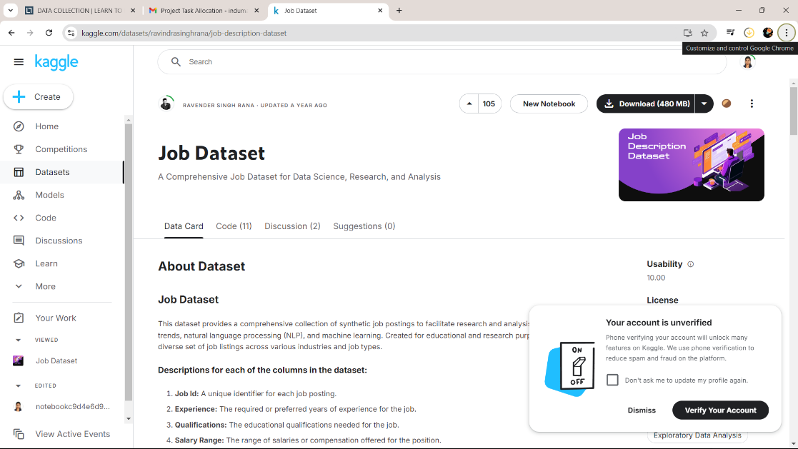

Step 2: Download the job dataset into pc.

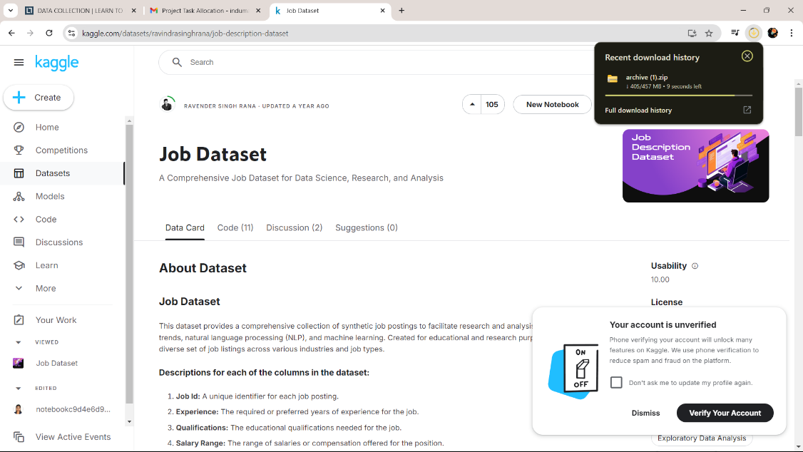

Step 3: Data cleaning and pre-processing using Python libraries such as NumPy and pandas in the Kaggle notebook.

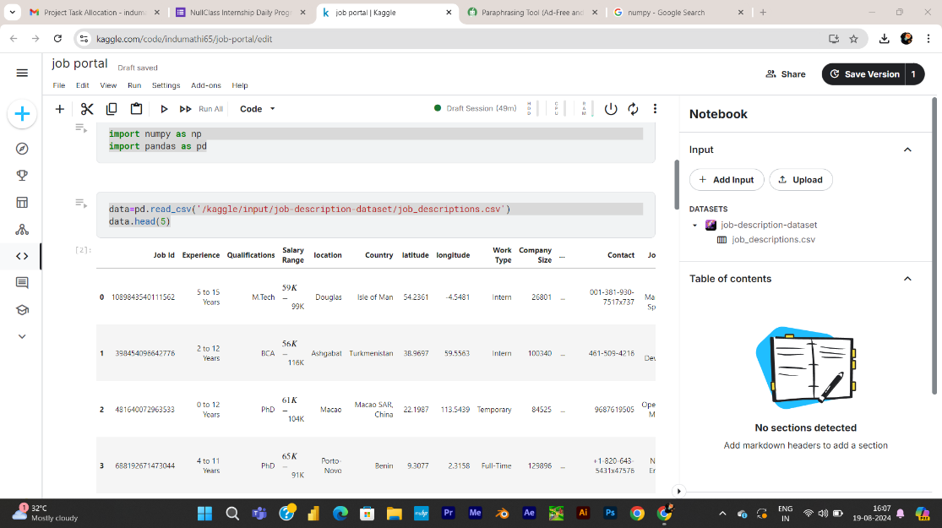

Step 4: Open Tableau and Create a Job Portal Analysis using Charts, Filters, Colour bars, and other visualization tools.

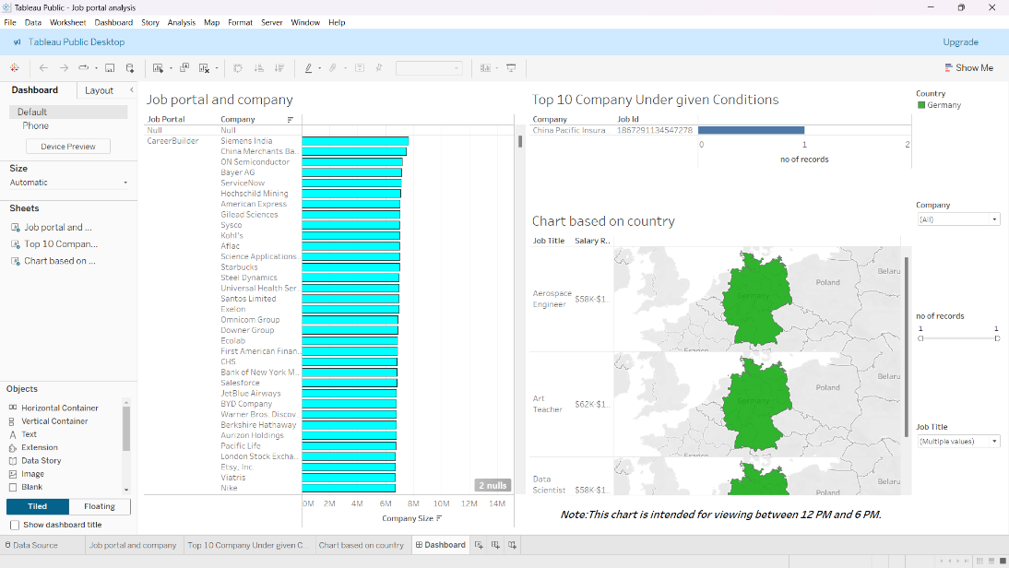

Step 5: Save the Tableau file as Public By server.

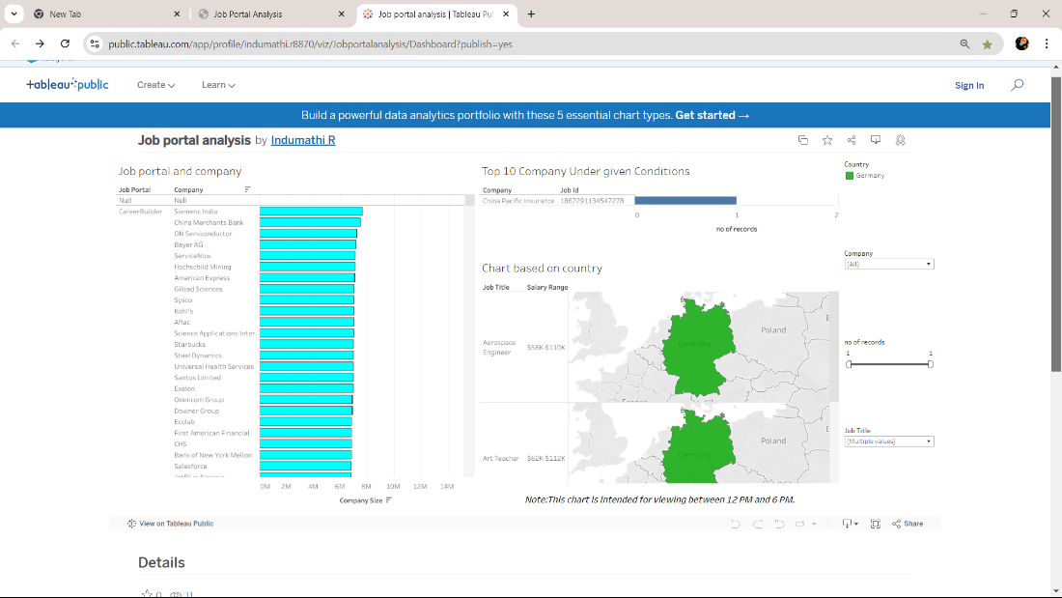

Step 6: Create a web page by using the Basic understanding of HTML, CSS, and JavaScript.

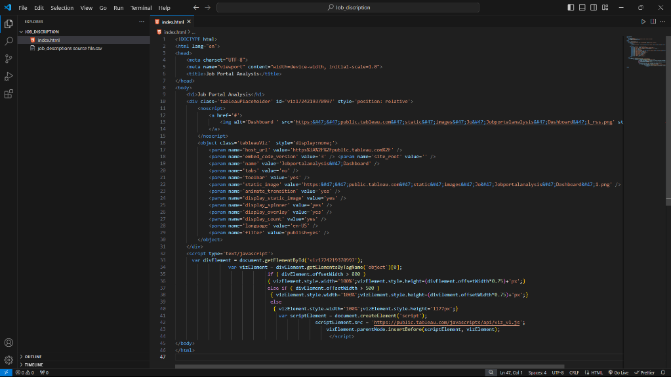

Step 7: customizing the web interface.

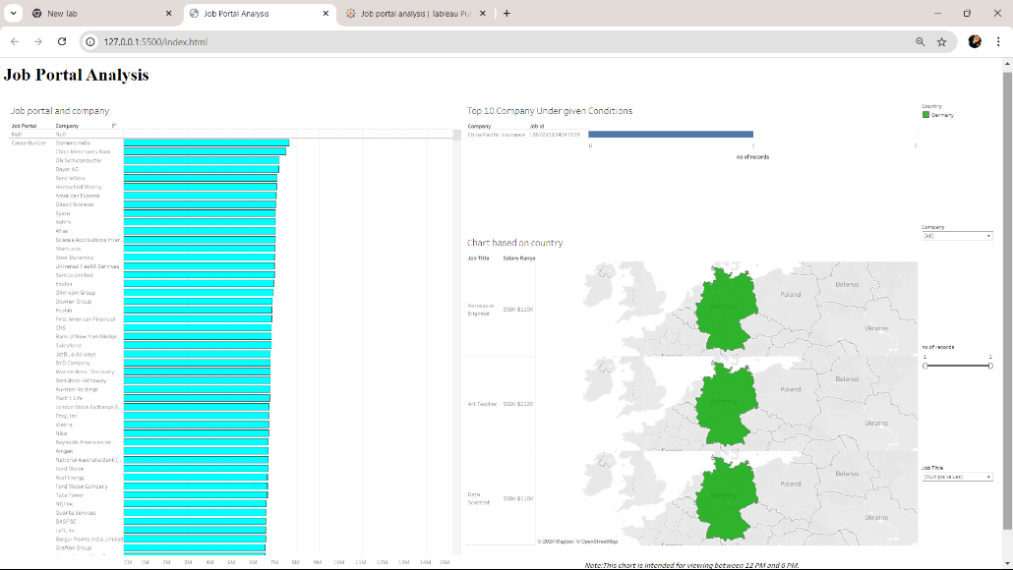

Step 8: Open Netlify to upload a web file to create a site.

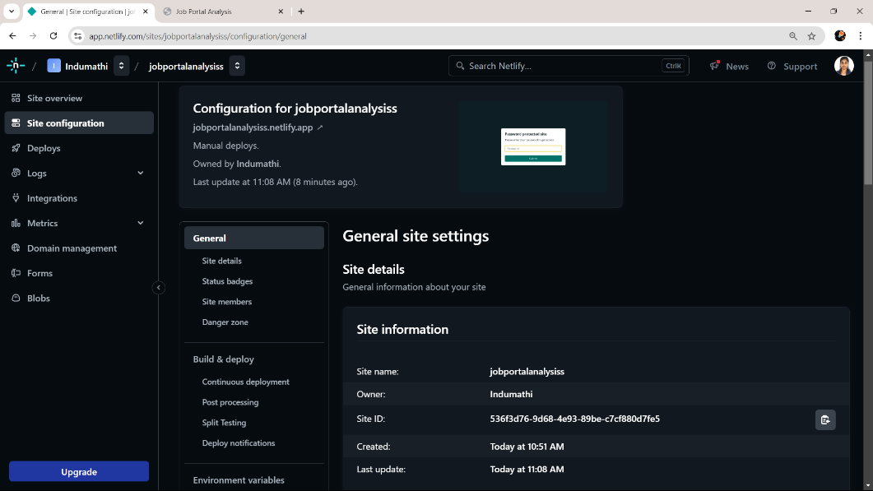

Step 9: Publish the site through Netlify.

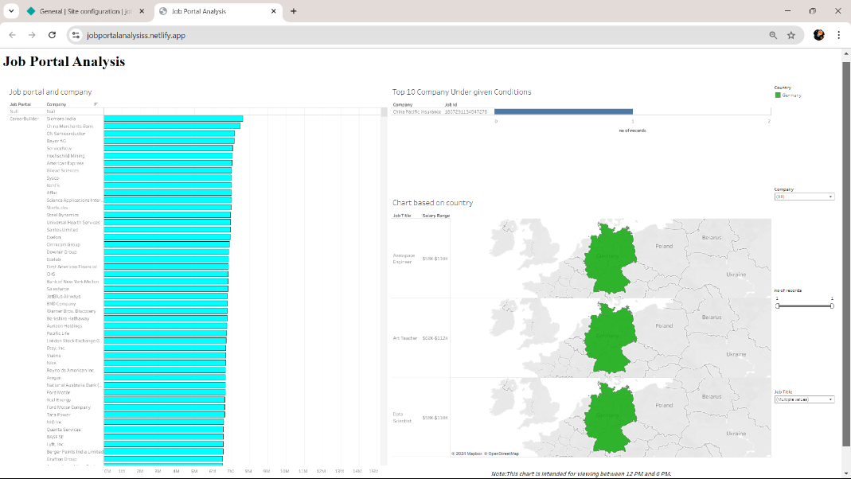

Challenges and Solutions:

**Challenges in Creating a Dashboard in Tableau:**

* ***Challenge:*** Large datasets can slow down the dashboard.
* ***Solution:*** Use data extracts instead of live connections where possible. Optimize your data queries and reduceperformance.

**Challenges in Publishing on Netlify:**

* ***Challenge:*** Make sure the dashboard is responsive and works well on different devices.
* ***Solution****:* Use responsive design techniques in your HTML and CSS. Test the dashboard on various devices to ensure it scales and functions properly.

Outcomes and Impact:

***Outcome:***

Through interactive dashboards that offer comprehensive insights into employment patterns, skill demands, and job market trends, this project can greatly improve data visualization. Tableau's capability to establish connections with real-time data sources allows the portal to provide real-time updates, guaranteeing that users are constantly in the know. Because recruiters and job seekers may make better decisions based on visually represented data trends and patterns, decision-making is enhanced. Users can concentrate on particular metrics or geographical areas using customizable views, which helps to better tailor the data to their needs. Tableau's interactive features—like drill-downs, tooltips, and filters—improve the portal's usability and engagement. By ensuring easy accessibility from any location, publishing on Netlify expands the portal's audience and improves its usability.

*Impact:*

The results include improved recruitment efficiency through focused efforts and skill gap analysis, as well as the provision of job seekers with market awareness and information about the talents that are in demand. This may result in a quicker hiring process, better hiring quality, and a quicker time to hire. Companies can also customize their training initiatives in response to recognized skill gaps, and job seekers can gain a better understanding of employment opportunities and make more educated decisions about their careers.

Netlify Link:

<https://jobportalanalysiss.netlify.app>

Conclusion:

In conclusion, using Tableau to create a job analysis site and Netlify to host it presents a potent blend of cutting-edge data visualization and easily accessible web deployment. By offering real-time, interactive dashboards that provide crucial insights into skill demands and job market trends, this strategy enhances data-driven decision-making. Tableau's engaging and customizable features let users customize their views to fit certain requirements, which improves the relevance and usefulness of the data. By ensuring that the portal can be quickly accessed from any location, publishing on Netlify increases the site's usefulness and reach. All things considered, this initiative not only increases the effectiveness of hiring and empowers job searchers, but it also cultivates a deeper comprehension of the job market in general, which eventually helps to make more strategic and informed hiring and career decisions.