Day2

- Android-Button
- Android-Textbox

Created a basic sign-in page with fields of username and password
Added social media icons and vector assets
verified the output with a Login button with onclicklistener.
//username: admin
//password: admin

A message will be displayed: Either “Login Successful” or “Login Failed”
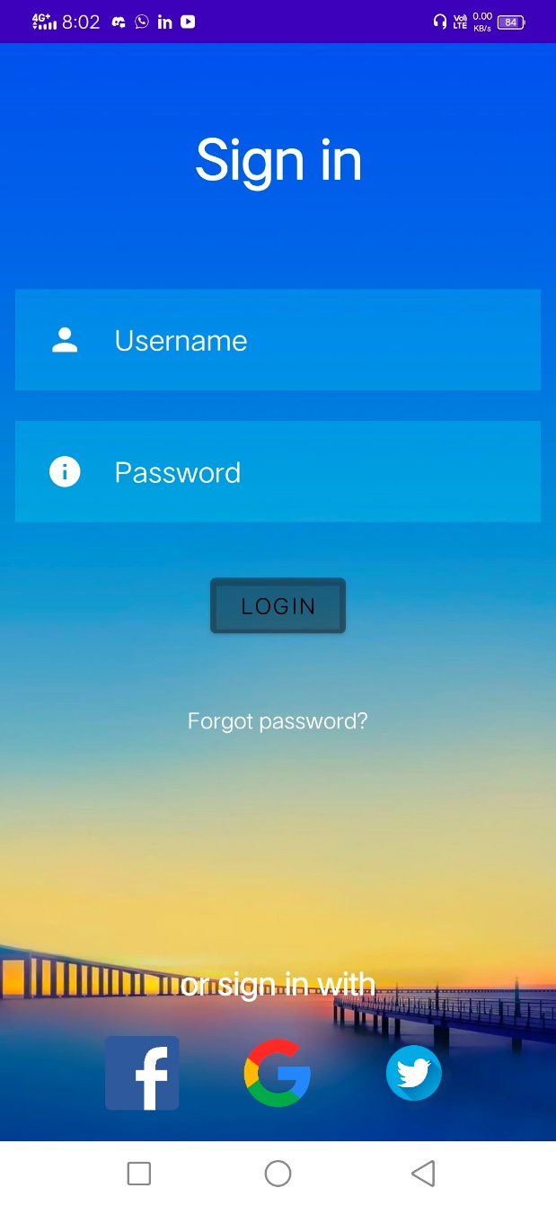

Sample output onclicking the login button

