Day-1

- Installed Android Studio on windows 11

- completed configuration of my first sample application

- created a basic application in android studio
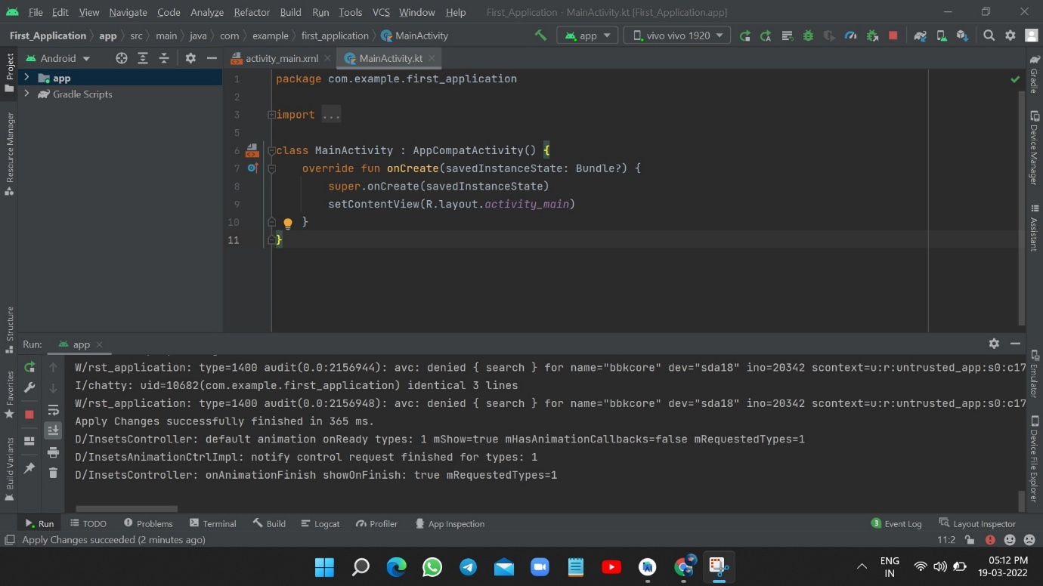

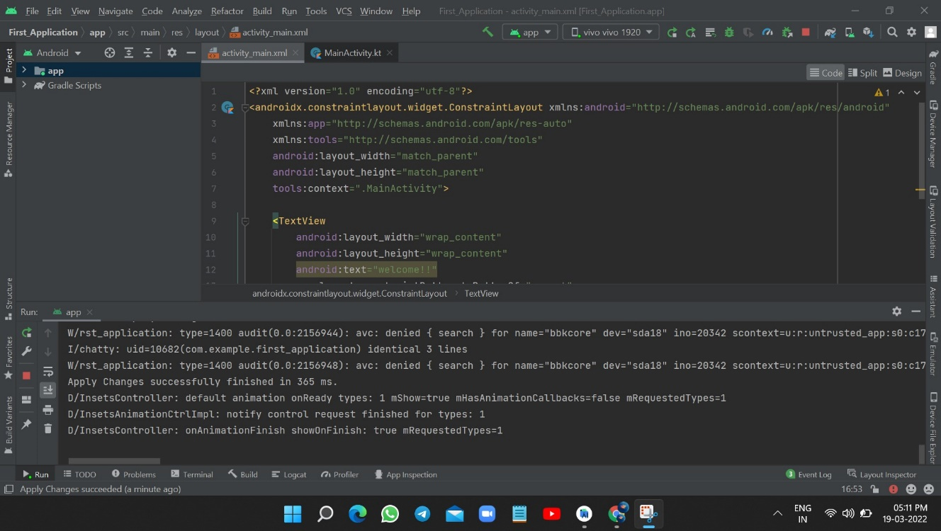
- run the app and tested through the device(mobile)

