1. Problem Statement and Objective:

This project aims to analyze student academic data to identify the factors affecting their performance. It studies the relationship between study hours, part-time jobs, subject marks, and overall grades to generate meaningful insights and support course recommendations.

The project aims to demonstrate data cleaning techniques in Excel and create an interactive Power BI dashboard to generate meaningful academic insights for better decision-making.

2. Data Sources

Source Description and Timeline: Mendeley Data, 2025
Cite: Kaifi, Khushter (2025), “Student Dataset Updated”, Mendeley Data, V1, doi: 10.17632/gdxnvsr555.1
Domain: Education / Academic Analytics / Student Performance Analysis

3. Column Description:
- To analyse student academic performance to identify the key factors influencing grades and overall achievement.
- To study the relationship between study hours, part-time job status, and subject marks to understand their impact on student performance.
- To evaluate subject-wise performance trends and identify strengths and weaknesses among students.
- To examine course recommendation patterns based on academic performance and preferences to support informed academic decision-making.

4. Attribute (Column /Features) Details:
Student: The student data sheet contains 9000 records of students and twelve attributes.
Attribute Name | Data Type | Description
Student_ID | String( Text) | Unique identifier for each student (after removing names)
Gender | Categorical | Gender of the student (Male/Female)
Study_Hours | Numeric (Integer) | Number of hours the student studies per day
Part_Time_Job | Categorical (Yes/No) | Indicates whether the student has a part-time job
Math | Numeric (Integer) | Marks scored in Mathematics
Physics | Numeric (Integer) | Marks scored in Physics
Chemistry | Numeric (Integer) | Marks scored in Chemistry
Average_Marks | Numeric (Decimal) | Average of marks in Math, Physics, and Chemistry
Grade | Categorical | Final academic grade of the student
Course_Recommendation | Categorical | Recommended course based on performance
Preference_Keywords | Text | Areas of interest or academic preferences of the student

Course_Profile: The course profile sheet contains 36 records and five attributes.
Column | Description | Data type
Cutoff Marks | Minimum marks required for the eligibility of the course | Number
Preference | Individual technology/field name (after splitting into rows) | Text

List of courses: The course list sheet contains 37 records and three attributes
Column Name | Description | Data Type
ListofCourses | Name of the course (e.g., B.Tech CSE, AI, etc.) | Text
RatingOfCourses | Rating given to the course (e.g., 4.5 out of 5) | Number (Decimal)
CourseCode | Unique identifier for each course | Text

Tools and Technologies:
Microsoft Excel
Excel was used for initial data cleaning and transformation. The following tasks were performed:
- Removing duplicate records
- Handling missing values
- Correcting data types
- Trimming extra spaces
- Splitting multi-value columns
- Creating calculated columns (Total Marks, Average Marks, Performance Category)
- Performing preliminary analysis using Pivot Tables
Excel helped prepare structured and clean data before importing it into Power BI.

🔹 Microsoft Power BI
Power BI was used for advanced data modeling, analysis, and visualization.
The following tasks were performed:
- Creating relationships between tables
- Designing a proper data model (Star Schema)
- Writing DAX measures (Total Students, Average Marks, Job Count, etc.)
- Building interactive dashboards
- Creating slicers for filtering (Gender, Grade, Course, etc.)
- Generating insights through charts, KPIs, and reports.
- Power BI enabled interactive exploration of student performance and course trends.
Here is your short, neat, and professional documentation version ready for submission:

Student Academic Performance Analysis & Course Recommendation System

1. Data Cleaning & Transformation
The raw datasets contained missing values, duplicate records, inconsistent formatting, and multi-valued fields. To ensure data accuracy and reliability, the following transformations were performed using Excel, Power Query:
- Removed duplicate records.
- Handled missing values appropriately.
- Trimmed extra spaces and standardized text formats.
- Removed special characters.
- Split comma-separated Preference/Skill columns into rows for normalization.
- Assigned correct data types (Text, Whole Number, Decimal Number).
- Converted datasets into structured tables.

2. Dataset Preparation

🔹 Student_Dataset
- Converted raw data into a structured table.
- Removed the Phone Number column (not required for analysis).
- Replaced empty values in the Preference column with “No Preference”.
- Added calculated columns for performance evaluation.
Calculated Columns:
Total Marks
=SUM([@Math]+[@Physics]+[@Chemistry])

Average Marks
=AVERAGE(([@Math]+[@Physics]+[@Chemistry])/3)
Performance Category
=IF(J4="A","Excellent",
IF(J4="B","Good",
IF(J4="C","Average",
IF(J4="D","Poor",
IF(J4="F","Failed","")))))

🔹 Course_Profile
- Converted into table format.
- Cleaned and trimmed columns.
- Split Preference column using comma delimiter into rows to normalize skills.

🔹 List_of_Courses
- Cleaned and standardized text values.
- Corrected data types.

3. Data Normalization & Data Model
To improve scalability and analytical performance, the flat dataset was transformed into a structured Star Schema Model.

Dimension Tables

Dim_Course
- Course_ID (Primary Key)
- Course_Code
- Course_Name

Dim_Preference
- Preference_ID (Primary Key)
- Preference_Name

Fact Tables

Fact_Course
Stores measurable course-related data:
- Course_ID (Foreign Key)
- Rating_Courses
- CutOff_Marks

Fact_Student
Stores measurable student performance data:
- Student_ID (Primary Key)
- Course_ID (Foreign Key)
- Math_Marks
- Physics_Marks
- Chemistry_Marks
- Total_Marks
- Average_Marks
- Grade
Fact tables contain numeric values used for aggregation and analysis.

Bridge Table

Bridge_Course_Preference
- Course_ID
- Preference_ID
- This table resolves the many-to-many relationship between courses and skills, as each course contains multiple preferences.

Pivot Analysis Performed:
- Grade Distribution Analysis
  - Count of students by Grade (A, B, C, D, F).
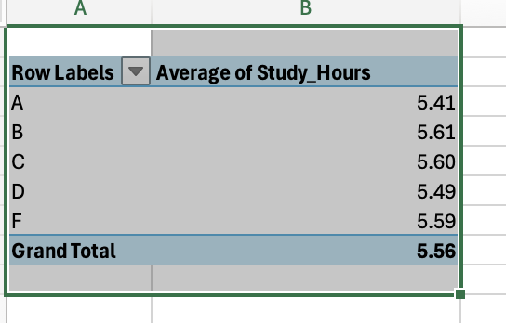

- Part-Time vs Academic Performance
  - Compared student grades based on Part-Time job status.
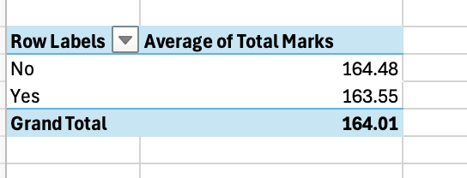
- Average Marks Analysis
  - Calculated average marks grouped by:
    - Gender
    - Study Hours
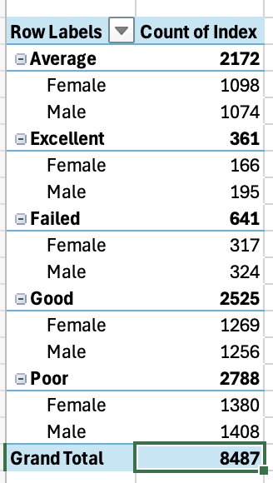

Course Rating Distribution:
RatingOfCourses vs Count of CourseCode
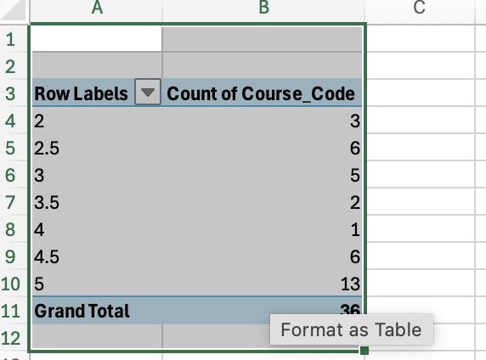

Total Students
Total Students =
COUNTROWS(Fact_Student_Performance)
- Counts all students in Fact_Student_Performance
- Can be used in a Card visual

Average Marks (Overall)
Average Marks =
AVERAGE(Fact_Student_Performance[Average])
- Computes the mean of Average marks for all students
- Can be used in a Card or Table

Average Marks per Subject
Avg Math = AVERAGE(Fact_Student_Performance[Math])
Avg Physics = AVERAGE(Fact_Student_Performance[Physics])
Avg Chemistry = AVERAGE(Fact_Student_Performance[Chemistry])
- Replace subjects with all relevant columns
- Shows performance distribution by subject

Performance Category (Calculated Column)
Performance_Category =
SWITCH(
TRUE(),
Fact_Student_Performance[Average] >= 85, "High",
Fact_Student_Performance[Average] >= 60, "Medium",
"Low"
)
- Classifies students based on Average marks

Student Average (Measure for Row Context)
Student Avg =
AVERAGE(Fact_Student_Performance[Average])
- Used in course recommendation measures

Course Recommendation (Per Student)
Course Recommendation =
VAR StudentAvg = [Student Avg]
VAR StudentPref = SELECTEDVALUE(Dim_Student[Preference_Keywords])

RETURN
CONCATENATEX(
FILTER(
ALL(Dim_Course),
Dim_Course[Cutoff_Marks] <= StudentAvg
&&
CALCULATE(
COUNTROWS(Bridge_Course_Preference),
Bridge_Course_Preference[Preference_Keyword] = StudentPref
) > 0
),
Dim_Course[Course_Name],
", "
)

Data Modelling and Data Relationship:

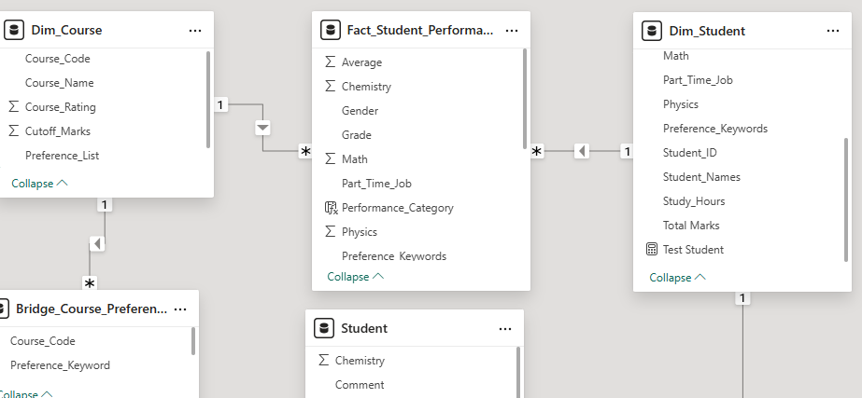
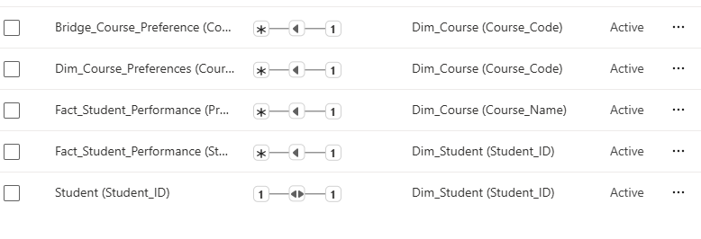

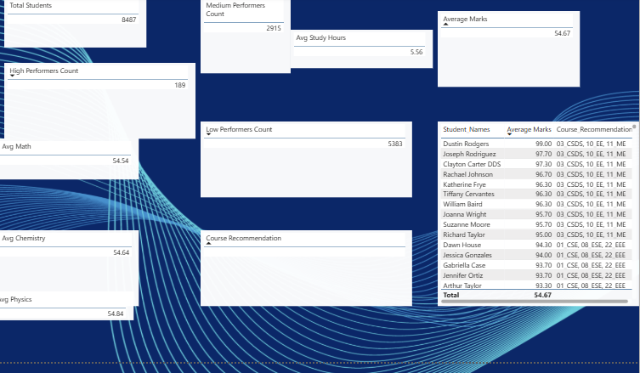

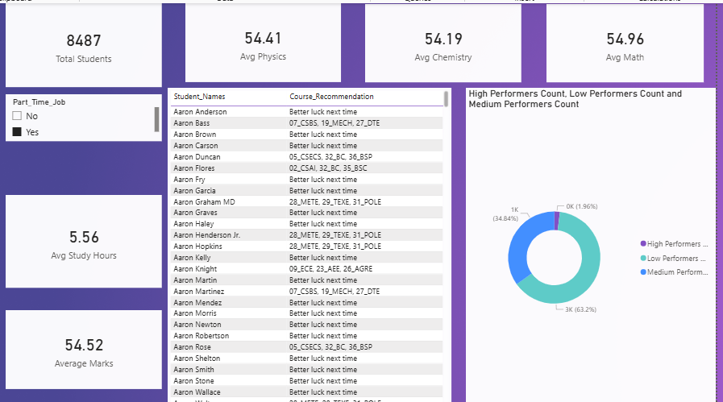

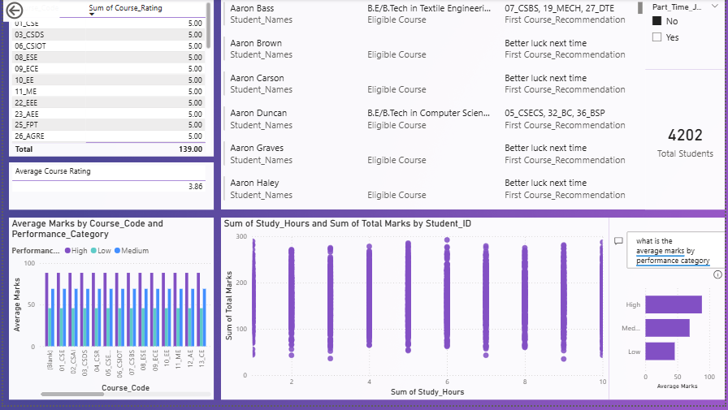

Overall Dashboard Evaluation
The dashboard effectively presents:
- Total Students: 8,487
- Average Marks: ~54.67
- Average Study Hours: 5.56
- Subject averages (Physics, Chemistry, Math) are consistent (~54–55)
- Performance distribution (High / Medium / Low)
- Course-wise performance comparison
- Study hours vs marks relationship
- Course rating insights
- Part-time job filtering
Academic Performance Snapshot

Performance Distribution Trend
- Majority of students fall into the Medium performance category (~63%)
- Low performers account for around 34%
- High performers represent a very small percentage (~2–3%)**

Insight:
The academic performance distribution is heavily centered in the medium range, indicating moderate academic consistency but limited excellence. Subject Performance Trend
- Physics, Chemistry, and Math averages are nearly identical (~54–55)

Insight:
Curriculum difficulty appears balanced across subjects.
No subject stands out as significantly harder or easier. Study Hours vs Total Marks Trend
From the scatter plot:
- Students studying between 5–8 hours tend to score higher.
- Very low study hours (<3) correlate with lower marks.
- Increasing study hours beyond 8–9 hours does not significantly increase marks.

Insight:
There is a positive but diminishing relationship between study hours and performance.
This suggests:
- Moderate consistent study is more effective than extreme study hours.
Course-Wise Performance Trend
From the "Average Marks by Course Code":
- Performance across courses is relatively similar.
- No course shows extreme underperformance.
- Some courses have slightly higher high-performer averages.

Insight:

Course design appears standardized.
Performance variation is more student-dependent than course-dependent.
Course Rating Trend
- Most courses have ratings near 5.
- Overall average course rating: 3.86

Insight:
Students generally perceive courses positively.
However, ratings may not strongly correlate with academic performance. 6. Part-Time Job Influence
Using the slicer:
- Students with part-time jobs may show slightly reduced average marks.
- Study hours for part-time students may be lower.

Insight:
Time management plays a role in academic outcomes.
However, part-time employment does not drastically reduce performance — impact is moderate.
Impact Assessment
- Student performance is concentrated in the medium category.
- Academic averages remain stable across subjects.
- Study hours average around 5–6 hours daily.
- Course ratings are generally positive.
- Performance differences across courses are minimal.

Trend-Based Projections
Moderate study hours lead to moderate performance.
- Very few students invest high effort to reach high-performance category.
- Balanced curriculum results in uniform subject averages.
- Part-time employment slightly limits study time.
- Recommendation system may not aggressively differentiate high vs medium performers.
Root Cause:
The system produces consistent but not exceptional academic outcomes.If current trends continue:
- Medium performers will remain dominant.
- High performer percentage will stay low.
- Slight increase in part-time employment could reduce overall average marks.
- Without intervention, academic growth will plateau around 55–60%

Strategic Recommendations

Increase High Performer Percentage
- Introduce academic excellence programs.
- Offer advanced study workshops.
Improve Low Performer Support
- Early intervention system.
- Personalized mentoring.
- Study hour monitoring.

Enhance Recommendation Logic
- High performers → Advanced courses
- Medium → Skill-based improvement courses
- Low → Foundation / remedial programs

Support Part-Time Students
- Flexible academic planning
- Recorded sessions
- Study planning tools
Conclusion
The dashboard reveals that:
- The institution maintains stable but moderate academic performance.
- Study hours positively influence marks but only up to an optimal level.
- Performance distribution is skewed toward medium achievers.
- Course structure is balanced across departments.
- Improvement opportunities exist in high-performance cultivation and low-performance intervention.
Overall, the data suggests:
The academic ecosystem is stable but requires targeted strategies to elevate excellence and reduce underperformance.

