1. Project Title
Social Media Engagement Dashboard using Power BI

2. Objective
The objective of this project is to analyze user activity and engagement on a social media platform by tracking posts, likes, comments, and user behavior patterns.

3. Problem Statement
Social media platforms need to:
- Monitor user engagement
- Identify active users
- Understand interaction patterns
- Improve content strategy
This dashboard helps visualize and interpret engagement metrics effectively.

4. Dataset Description
The dataset includes:
- Usernames – Unique users
- Posts – Number of posts created
- Likes – Total likes received
- Comments – User interactions
- Email Domains – User distribution by email provider

5. Tools & Technologies Used
- Power BI – Dashboard creation
- DAX – Measures and KPIs
- Data Cleaning – Preprocessing dataset

6. Dashboard Overview

Key KPIs:
- Total Users: 50
- Total Posts: 50
- Total Comments: 15
- Total Likes: 16

Visual Insights from Dashboard:

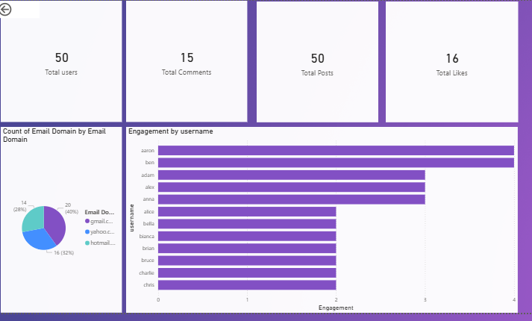

1. User Engagement by Username
- Users like aaron and ben show the highest engagement (~4 interactions)
- Mid-level engagement: adam, alex, anna
- Lower engagement users fall around 2 interactions
Insight: A small group of users drives most engagement.

2. Email Domain Distribution
- Majority users use Gmail (~40%)
- Followed by Yahoo (~32%)
- Then Hotmail (~28%)
Insight: Gmail dominates user base — useful for targeted communication.

7. Data Cleaning & Preparation
- Removed duplicate users
- Standardized usernames
- Aggregated likes, posts, and comments
- Categorized email domains

8. Data Modeling
- Created measures:
  - Total Users
  - Total Posts
  - Total Likes
  - Total Comments
  - Engagement Score (Likes + Comments)

9. Key Insights
- Engagement is concentrated among a few users
- Most users are passive with low interaction
- Gmail is the dominant email provider
- Overall engagement (likes & comments) is relatively low compared to posts

10. Business Recommendations
- Reward highly engaged users (top contributors)
- Encourage inactive users via notifications or incentives
- Focus campaigns on Gmail users
- Improve content to increase likes and comments

11. Conclusion
This project demonstrates how Power BI can be used to analyze social media engagement effectively. The dashboard provides quick insights into user activity and helps improve engagement strategies.

