Question 01
public class Queue_String {
private int front;
private int rear;
private int maxSize;
private int count;
String[] arr;
Queue_String(int max){
maxSize=max;
arr=new String[maxSize];
front=0;
rear=-1;
count=0;
}
public boolean isQueueEmpty(){
if(rear<front){
return true;
}else{
return false;
}
}
public boolean isQueueFull(){
if(rear==maxSize-1){
return true;
}else{
return false;
}
}
public void appened(String item){
if(isQueueFull()){
System.out.println("\nQueue is full\n");
}else{
System.out.println("inserting "+item);
arr[++rear]=item;
count++;
}
}
public String serve(){
if(isQueueEmpty()){
System.out.println("\nQueue is empty.\n");
return "";
}else{
String item=arr[front++];
count--;
return item;
}
}
}

import java.util.Scanner;
public class A {
public static void main(String[] args) {
Queue_String queue=new Queue_String(2);
Scanner scn=new Scanner(System.in);
System.out.print("Enter first string: ");
queue.appened(scn.next());
System.out.print("Enter second String: ");
queue.appened(scn.next());
StringBuilder newText= new StringBuilder(queue.serve());
newText.append(queue.serve());
System.out.println(newText);
}
}

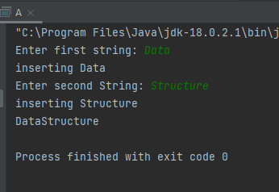

Question 02
public class Queue_Char {
private int front;
private int rear;
private int maxSize;
private int count;
char[] arr;
Queue_Char(int max){
maxSize=max;
arr=new char[maxSize];
front=0;
rear=-1;
count=0;
}
public boolean isQueueEmpty(){
if(rear<front){
return true;
}else{
return false;
}
}
public boolean isQueueFull(){
if(rear==maxSize-1){
return true;
}else{
return false;
}
}
public void append(char item){
if(isQueueFull()){
System.out.println("\nQueue is full\n");
}else{
System.out.println("inserting "+item);
arr[++rear]=item;
count++;
}
}
public char serve(){
if(isQueueEmpty()){
System.out.println("\nQueue is empty.\n");
return '0';
}else{
char item=arr[front++];
count--;
return item;
}
}
}

import java.util.Scanner;
public class B {
public static void main(String[] args) {
Queue_Char queue=new Queue_Char(20);
Scanner scn =new Scanner(System.in);
System.out.print("Enter your number: ");
String number=scn.next();
int d=number.length()/2;
char[] textArr=number.toCharArray();
for(char x:textArr){
queue.append(x);
}
for(int i=0;i<d;i++){
char c=queue.serve();
queue.append(c);
}
while (!(queue.isQueueEmpty())){
System.out.println(queue.serve());
}
}
}

Question 03
same queue class that we used in second question can be used for this question.

import java.util.Locale;
import java.util.Scanner;
public class C {
public static void main(String[] args) {
Queue_Char queue=new Queue_Char(5);
Scanner scn=new Scanner(System.in);
queue.append('A');
queue.append('E');
queue.append('I');
queue.append('O');
queue.append('U');
System.out.print("Enter your word: ");
char[] text=scn.next().toUpperCase(Locale.ROOT).toCharArray();
char vowel;
while (!(queue.isQueueEmpty())){
vowel= queue.serve();
for (char x:text){
if(x == vowel){
System.out.println(x);
}
}
}
}
}

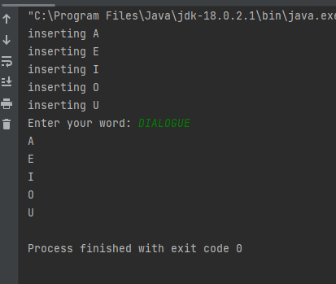

Question 04
public class Node_int {
int data;
Node_int next;
}

public class D {
public static void main(String[] args) {
Queue_int queue=new Queue_int();
for(int i=1;i<=5;i++){
insertElement(i,queue);
}
rotate(2,queue);
while (!(queue.isQueueEmpty())){
System.out.println(queue.serve());
}
}
public static void insertElement(int x,Queue_int q){
q.append(x);
}
public static void rotate(int r,Queue_int q){
for (int j=0;j<r;j++){
int n=q.serve();
q.append(n);
}
}
}

Question 05
public class Node_char {
char data;
Node_char next;
}

public class Queue_char_linked {
Node_char front;
Node_char rear;
int queueSize;
Queue_char_linked(){
front=null;
rear =null;
queueSize=0;
}
public boolean isQueueEmpty(){
if(queueSize==0){
return true;
}else{
return false;
}
}
public char serve(){
if (isQueueEmpty()){
System.out.println("Queue is empty.");
return 0;
}else{
char n=this.front.data;
this.front=front.next;
queueSize--;
return n;
}
}
public void append(char data){
Node_char oldRear=rear;
rear=new Node_char();
rear.data=data;
rear.next=null;
if(isQueueEmpty()){
front=rear;
}else{
oldRear.next=rear;
}
queueSize++;
}
}

import java.util.Scanner;
public class E {
public static void main(String[] args) {
Scanner scn=new Scanner(System.in);
Queue_char_linked queue=new Queue_char_linked();
System.out.println("Enter the word:");
String text=scn.nextLine();
char[] textArr=text.toCharArray();
for(char x:textArr){
queue.append(x);
}
char checkLetter;
boolean allRepeat=true;
outer:
while(!(queue.isQueueEmpty())){
checkLetter= queue.serve();
int c=0;
for(char x:textArr){
if(checkLetter==x){
c++;
}
}
if(c<2){
System.out.println("The first non-repeating character is: "+checkLetter);
allRepeat=false;
break outer;
}
}
if(allRepeat){
System.out.println("All the characters are repeated.");
}
}
}

