SKIN PLANT

List of Cameras:
- SKIN-CAM-1- OCR For Character count for Line 1
- SKIN-CAM-2- Foreign Particle in Filled Jar for Line 1
- SKIN-CAM-3- OCR for Character count Line 2
- SKIN-CAM-4- Camera for Foreign Particle in Empty Jar for Line 1
- SKIN-CAM-5- Foreign Particle in Empty Jar for Line 2
- SKIN-CAM-6- Foreign Particle in Filled Jar for Line 2

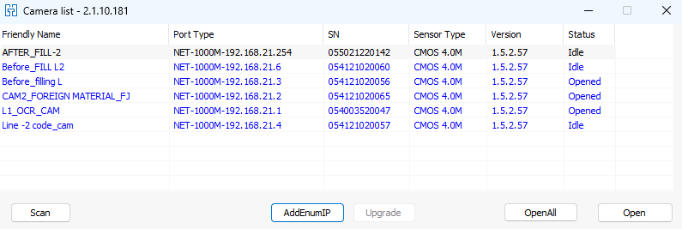

Steps to Run Skin Plant Cams:
- Double click on CODE BUTTON and select Line 1 or Line 2
- Initial UI is as shown below
- Once the Line 1 or Line 2 is selected, select the SKU which is running among the options. E.g: select Japan 80 gm if the production of Japan is going on
- Click the Ubuntu and minimize to access the dashboard

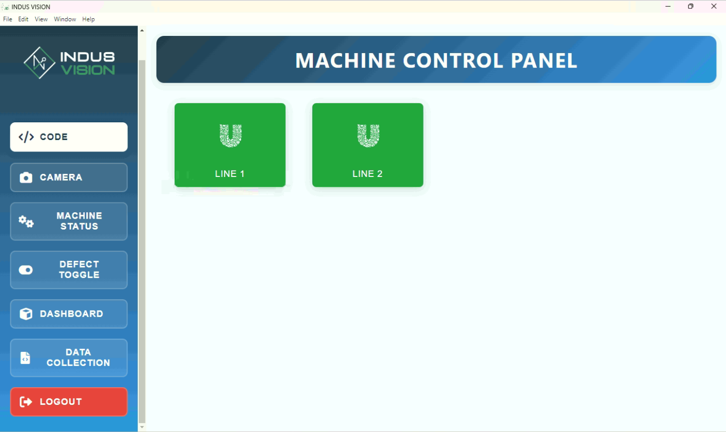

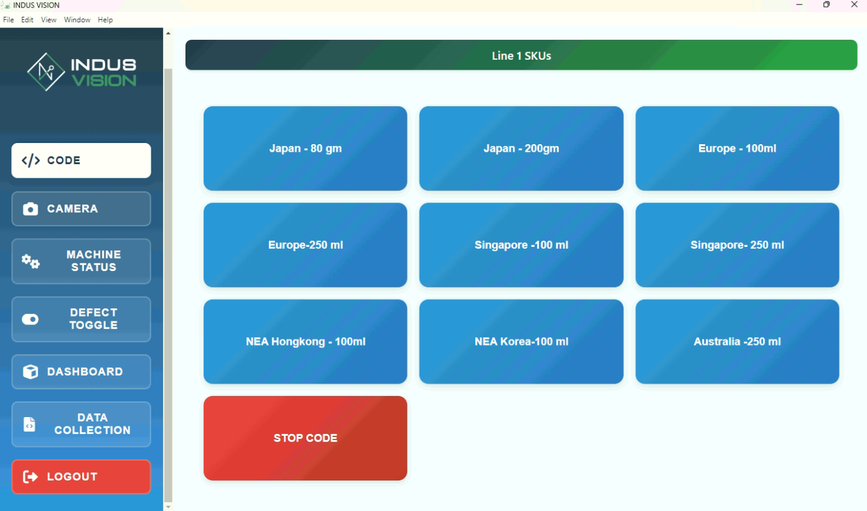

Steps to Stop Skin Plant Cams:
- Click the “stop” button to stop the logic execution.

6.Click the Ubuntu and minimize to access the dashboard

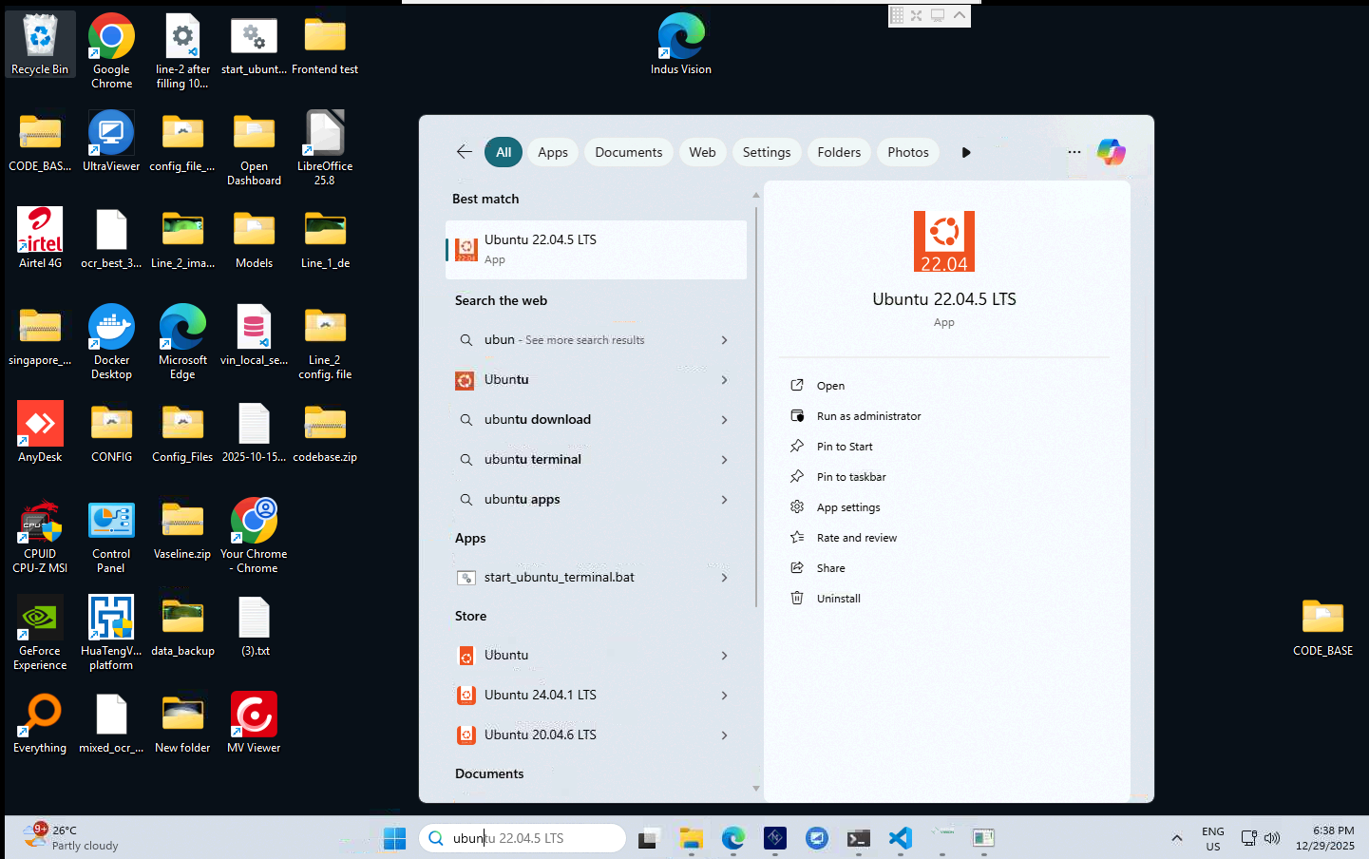

Defect and Non-Defect Sample Images:

Non-Defect:
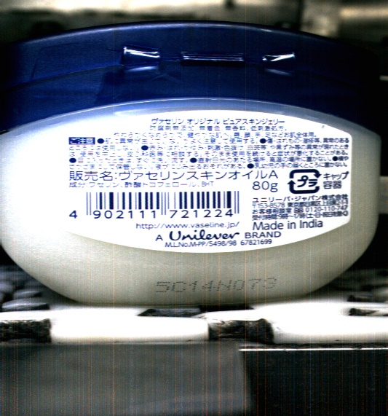
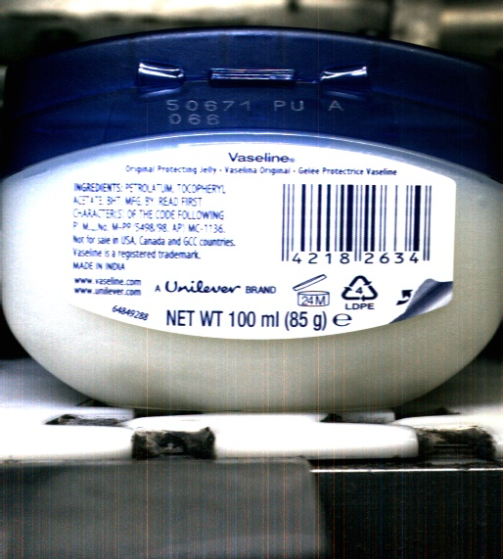

a.Non_Defective_Jar_of_Singapore b.Non_Defective_Jar_of_Japan_80g

Defects:

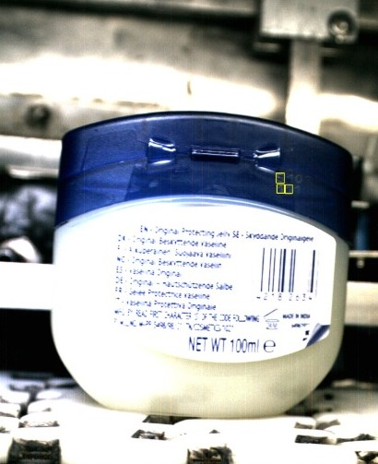
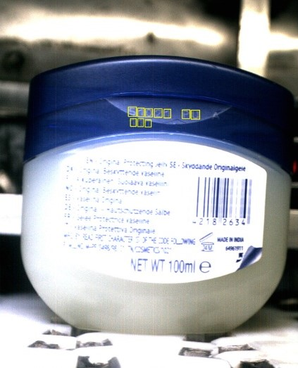
- Cap Mismatch b. Code Error
Non Defective Sample For Foreign Particle

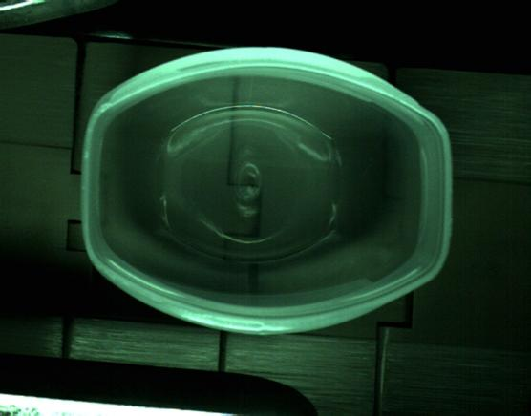
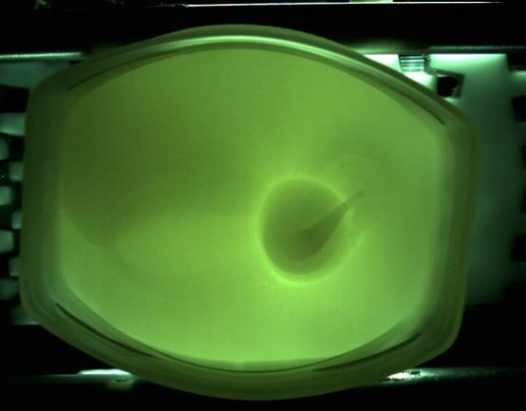
- Before Filling b. After Filling

Defective Sample For Foreign Particle
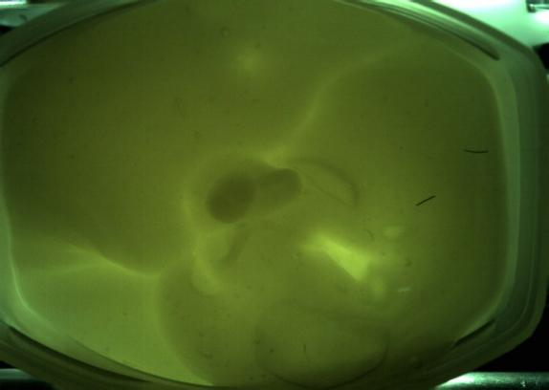
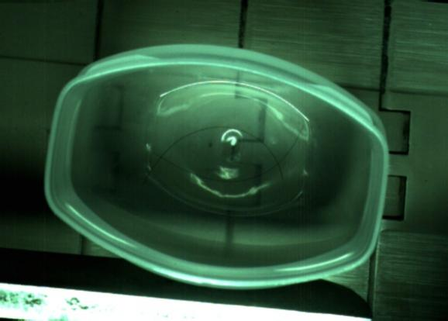

- Before Filling b. After Filling

NOTE:

- Cameras need to clear the buffer once execution of the code is stopped. Kindly wait for at least 15-20 sec before restarting the codes.
- Any kind of obstruction or change in foreground or background or the camera view and lighting conditions could lead to failure of model and lead to increase in false positive or leave defects.
- Make sure to open only 1 UI for each logic. Opening multiple UIs for the same logic would lead to failure in execution of the logic.
- The codes need to be stopped if different SKU needs to be chosen in UI for the changes to be applied.

Device Specifications:

Device name DESKTOP-C9C7R2B
Processor 12th Gen Intel(R) Core(TM) i7-12700F 2.10 GHz
Installed RAM 16.0 GB (15.9 GB usable)
Device ID 2F9A1A14-F15F-48EA-A51E-69D94B151D82
Product ID 00330-53390-58708-AAOEM
System type 64-bit operating system, x64-based processor
Pen and touch No pen or touch input is available for this display.

