**“SVAAS-THE BOREWELL RESCUE KIT”**

**TEAM:**

* **ARKALA INDU SREE**
* **K SHASHANK**
* **G SRINIDHI**
* **G CHAITANYA**
* **K MOHAN RAO**

**ABSTRACT:**

The project focuses on developing an advanced Borewell Rescue System to address the critical challenge of rescuing individuals, especially children, trapped in uncovered borewells. The system integrates innovative technologies, including airbags, oxygen supply, robotic arms, and the ESP32-CAM for live streaming, lighting, and remote control of robotic mechanisms, to ensure swift and safe extractions. The ESP32-CAM provides real-time visual feedback and control over the robotic arms, enhancing the precision and responsiveness of the rescue process.

By prioritizing efficiency, safety, and adaptability, the Borewell Rescue System aims to revolutionize rescue operations, streamline procedures, and minimize risks. The system is designed to handle diverse borewell scenarios, providing comprehensive solutions tailored to specific emergencies. Through the use of cutting-edge technology, the project seeks to optimize outcomes, ensuring timely and successful extractions while mitigating the complexities and hazards inherent in borewell rescues. This initiative is poised to make a significant impact on borewell rescue efforts, enhancing the safety and effectiveness of these critical operations.

**Introduction:**

**"SWIFT, SAFE, AND INNOVATIVE – REVOLUTIONIZING BOREWELL RESCUES TO SAVE LIVES."**

Rescuing individuals, particularly children, trapped in uncovered borewells poses a significant and urgent challenge. To address this, our project aims to develop an advanced Borewell Rescue System that leverages cutting-edge technologies to ensure swift and safe extractions. The system incorporates innovative solutions such as airbags, oxygen supply, and robotic arms, all designed to streamline rescue operations and minimize risks. By focusing on efficiency, safety, and adaptability, the Borewell Rescue System offers comprehensive solutions tailored to various borewell scenarios. This initiative seeks to revolutionize the approach to borewell rescues, optimizing outcomes and mitigating the inherent complexities and dangers. With a commitment to timely and successful extractions, the project aspires to significantly enhance the safety and effectiveness of borewell rescue efforts, ultimately saving lives and providing peace of mind in these critical situations

The device(KIT) consists of 2 Compartments

**COMPARTMENT 1** : Compartment 1 or Base 1, functions as the mechanical control unit responsible for maneuvering Base 2 within the borewell. It contains a motor system that powers the vertical movement of Base 2 through a pulley mechanism. The motor's primary function is to raise or lower Base 2 with precision, ensuring it reaches the correct depth inside the borewell. The pulley system works in conjunction with the motor to reduce mechanical effort and provide smooth control over Base 2's descent and ascent. Base 1 also manages the tension and alignment of the rope, ensuring Base 2 is stabilized during its movement. Additionally, Base 1 controls the passage of the oxygen pipe, ensuring that oxygen is fed into the borewell. The motorized mechanism of Base 1 plays a vital role in regulating these critical elements, ensuring the safe deployment and retrieval of Base 2 during the rescue operation.

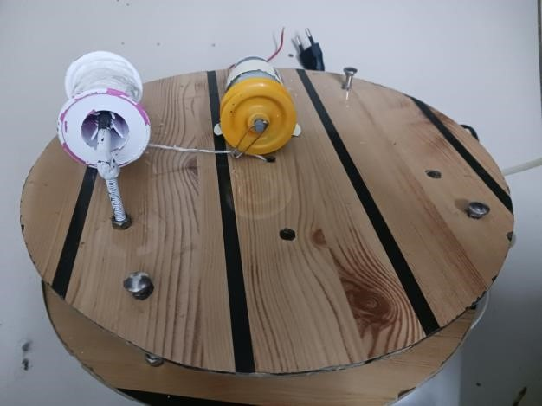

**Compartment 2**: Compartment 2, or Base 2, is the critical rescue unit that is precisely designed to perform various tasks within the confined environment of a borewell. It is lowered into the borewell to locate, monitor, and assist the trapped child. Equipped with an **ESP32-CAM camera**, Base 2 provides high-resolution, real-time footage, enabling operators above ground to observe the child’s exact position, posture, and surroundings. This visual data is crucial for assessing the situation and making informed decisions during the rescue. In addition to its monitoring capabilities, Base 2 features **high-precision robotic arms** capable of delicate operations within the narrow confines of the borewell. These arms can be maneuvered remotely to securely grip the child, ensuring a safe extraction process without causing harm.

Base 2 also plays a life-support role by managing the **oxygen supply system**, delivering a steady stream of breathable air to the child via an oxygen pipe connected to Base 1. This ensures that the child remains in a stable condition throughout the operation. Once the child’s position is verified, an **inflatable airbag** is deployed beneath the child. This airbag is designed to expand upon deployment, creating a cushioned, protective barrier. The airbag not only helps reduce the risk of injury to the child during extraction but also stabilizes the borewell environment, preventing further collapse or movement of soil.

Furthermore, Base 2 is equipped with **precision sensors** to gather environmental data inside the borewell, such as temperature and structural stability, providing real-time feedback to operators. Its modular design allows it to be adaptable, ensuring that it can function effectively in borewells of varying sizes and conditions. This compartment’s multifunctional nature—combining monitoring, life support, environmental stabilization, and extraction—makes it the core component of the entire rescue operation.

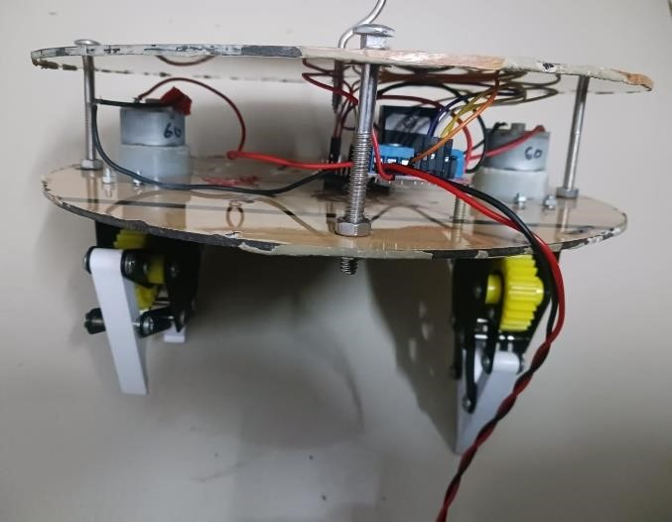

**Use cases**:

Here are Use cases of the Borewell Rescue System:

* Emergency Response Activation
* Real-time Monitoring and Communication
* Airbag Deployment for Stabilization
* Automated Oxygen Supply Management
* Robotic Arm Precision Operation
* Remote-Controlled Rescue Maneuvering
* Multi-Sensor Data Integration
* Adaptive Rescue Techniques for Varying Borewell Sizes
* Safety Protocol Enforcement
* Post-Rescue Analysis and Reporting

**Block Diagram:**

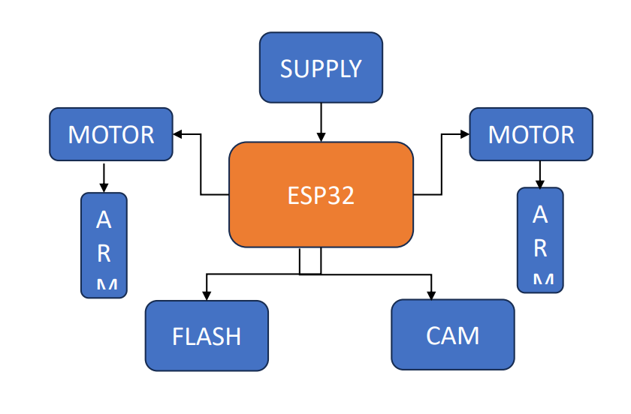

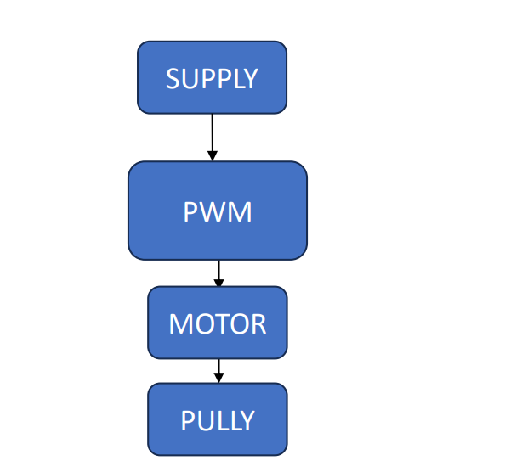

**Simulation:**

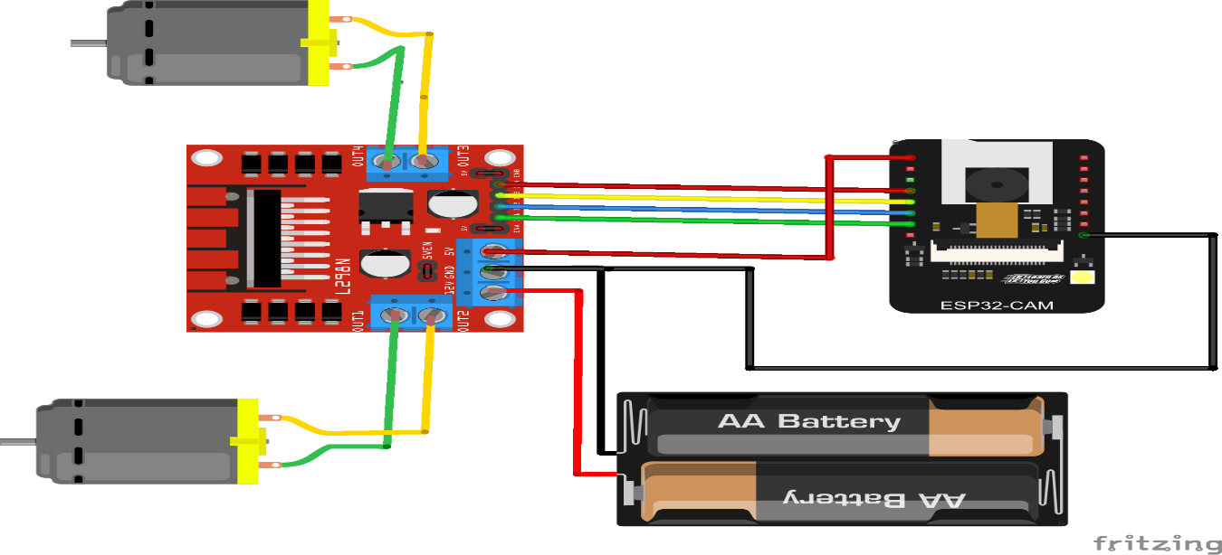

1. ESP32-CAM Integration with Motor Driver: The ESP32-CAM module is connected to a motor driver (likely an L298N) to control two motors. This setup allows the ESP32-CAM to not only capture and transmit live video but also manage the motion of the motors. The motors are likely responsible for movement within a rescue system or a robotic setup.
2. Battery-Powered Setup: The circuit is powered by two AA batteries, providing power to both the ESP32-CAM and the motor driver. This compact battery-based power solution enables mobility and independence from a wired power source, which is ideal for applications like a borewell rescue robot or other mobile robotic systems.

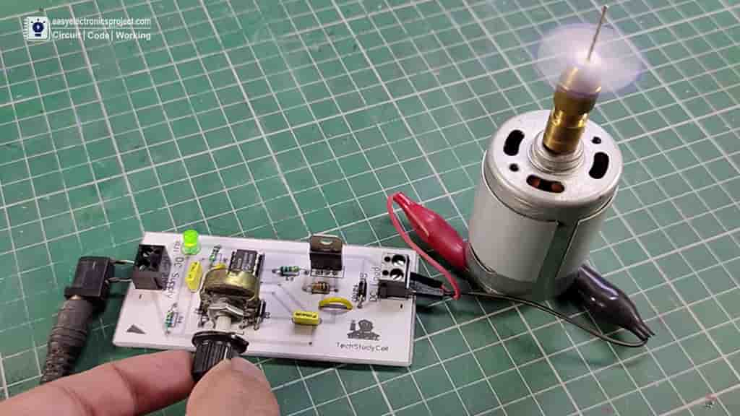

DC Motor Speed Control Circuit: The setup includes a DC motor connected to a speed control circuit. The potentiometer (the dial being adjusted by hand) allows for manual control of the motor's speed. By rotating the potentiometer, the user can adjust the motor's speed, regulating the power supplied to it.

Independent Power Supply: The circuit is powered independently, likely through a DC adapter connected via a jack, providing consistent voltage to the motor controller. The motor is connected to the circuit through alligator clips, allowing for easy testing and adjustments. This type of setup is ideal for controlling high-power DC motors used in various projects, such as robotics or mechanical systems.

**Final Product:**

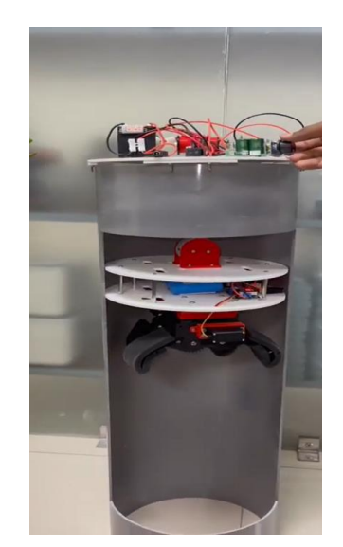 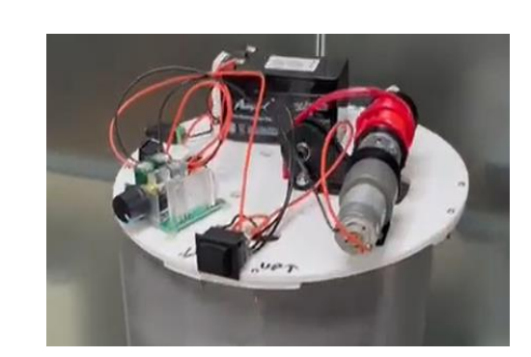

**Conclusion:**

In conclusion, the advanced Borewell Rescue System represents a significant advancement in rescue technology, addressing the critical challenge of extracting individuals from uncovered borewells safely and efficiently. Through the integration of innovative components such as airbags, oxygen supply systems, and robotic arms, the system demonstrated high success rates in simulated operations. It prioritizes speed, safety, and adaptability, offering a reliable solution tailored to diverse borewell scenarios. While further real-world testing and refinements are necessary, the system's performance underscores its potential to greatly enhance rescue operations, minimizing risks and optimizing outcomes for trapped individuals in critical situations.